Species Report

Phalaenopsis cochlearis Holtt. 1964
SUBGENUS Phalaenopsis SECTION Fuscatae Sweet 1968₃

Description:

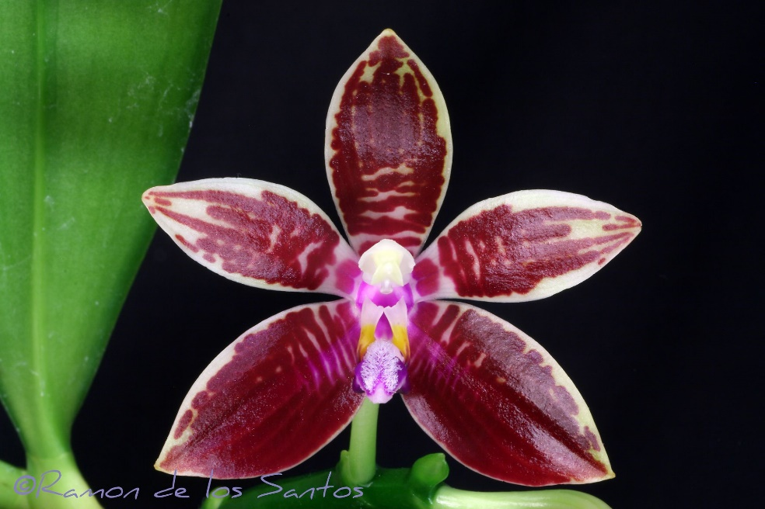
A small sized, warm growing epiphyte at elevations of 450 to 700 meters in limestone areas and on limestone cliffs with 2 to 4, oblong-ovate to oblong-elliptic, prominently veined on top leaves that blooms in the spring and summer on a suberect, branched, 12 to 20" [30 to 51 cm] long, few to several flowered, slightly fractiflex towards the apex inflorescence with ovate-cucullate, acute floral bracts. ³
Lithophytes and epiphytes. Leaves oblong-elliptic to elliptic-obovate, subacute, to 22 x 8 cm. Inflorescences panicles to 50 cm long, many-flowered, the peduncle erect, the branches arching-subpendent, to 6 cm long, the floral bracts ovate, concave, to 0.5 cm long. Flowers with shallowly convex segments, glossy, clear pale yellow, the base of the petals with a solitary trans-verse brown bar, the lip brighter yellow with radiating reddish brown stripes, the column white at the base becoming pale yellow toward the apex. Dorsal sepal oblong-elliptic, obtuse, to 2 X 0.9cm, the lateral sepals obliquely oblong to elliptic, acute, to 2.2 x 0.7 cm. Petals oblong, acute, to 1.8 x 0.5 cm. Lip three-lobed, to 1.2 cm long, to 1 cm wide across the expanded lateral lobes, the lateral lobes oblong-oblanceolate, subtruncate with the corners extended as teeth, the midlobe obovate-suborbicular, broadly obtuse-rounded, concave, with five raised ridges, the callus biseriate, subequal, the posterior callus sulcate, notched-bilobed, the anterior callus subsimilar, not sulcate. Column straight, dilated at the apex, to 0.7 cm long. Pedicel and ovary to 2 cm long. Phalaenopsis cochlearis is unusual in the section by having flat sepals and petals, unmarked sepals, and almost unmarked petals. It is distinctive for its unmarked pale yellow segments and could hardly be con-fused with any other species in the genus. Shortly after its original description P cochlearis was brought into cultivation. The wild-collected plants were grown, selfings and sib-crosses were distributed, and experimental hybrids were made. Very quickly thereafter both the adult plants and seedlings died off, and the species became rare in cultivation, which situation remains largely unchanged. The species is exceedingly rare in modern collections. Even many of the top phalaenopsis breeders do not own a plant of P cochlearis. Clearly some critical cultural details are missing. ¹
Synonyms:

Polychilos cochlearis [Holttum] Shim 1982 ³
Distribution/Habitat:

Discovered in 1964 in Sarawak at 1500-2000 ft. (457-610 m) in limestone areas. It is also found on limestone cliffs at Bau, Borneo.. -- Source: Charles Baker). Found in Malaysia and Sarawak, Borneo in forests on limestone at elevvations of 500 to 700 meters. ¹
Awards:

Origin | HCC | AM | FCC | CBM | CCE | CCM | Total
 | 0 | 1 | 0 | 1 | 0 | 1 | 3
Years |  | 1986 |  | 1966 |  | 1982

Hybrids: F-1

1970-1979 | 1980-1989 | 1990-1999 | 2000-2009 | 2010-2019 | 1060-1969 | 2020-2029 | Total
13 | 5 | 3 | 3 | 2 | 2 | 4 | 32

Hybrids: Progeny

1970-1979 | 1980-1989 | 1990-1999 | 2000-2009 | 2010-2019 | 2020-2029 | 1960-1969 | Total
19 | 12 | 28 | 8 | 10 | 4 | 2 | 83

Significant Progeny

Phalaenopsis Amblearis AM/AOS
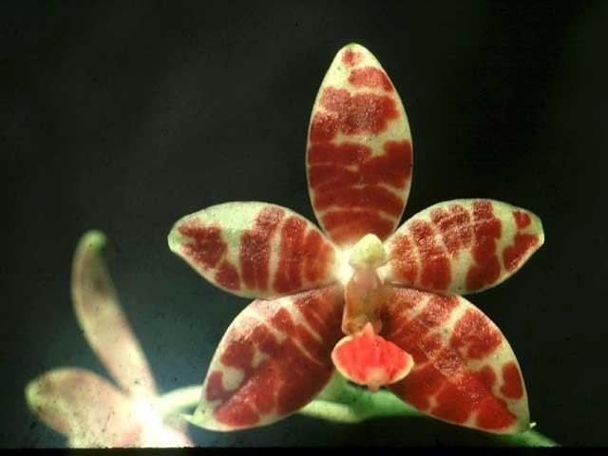
Amblearis is a primary between P. amboinensis nad P. cochlearis registered in 1972 by H. Wallbrunn. It has 6 F-1 and 16 progeny and has 1 AM, 2 HCC and 1 JC from the AOS. The extent of the markings varies considerably in the offspring.

Phalaenopsis Frank McClain HCC/AOS

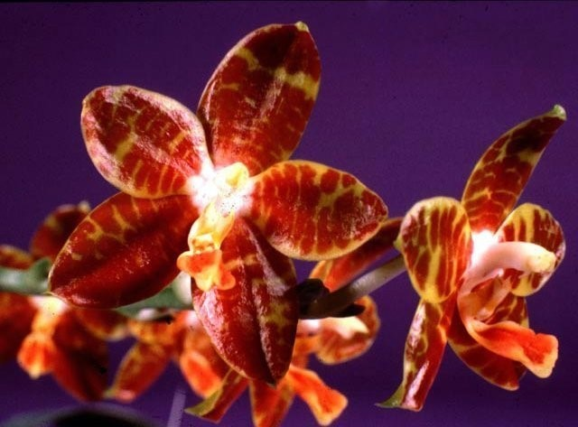
Frank McClain id a Amblearis backcross to P. amboinensis. It makes a heavily pigmented, vibrant hybrid.

References:

Aldridge, Peggy. 2008. An Illustrated Dictionary of Orchid Genera. Selby Botanical Garden Press.
¹Christenson, Eric A. 2001. Phalaenopsis- A Monograph.Timber Press.
² Cribb, CJ. 2014. Epidendroidae. In: Pridgeon AM, Cribb PJ, Chase MW, Rasmussen F, eds. Genera Orchidacearum, Vol. 6. Oxford: Oxford University Press, 344-349.

³Jay Pfahl's IOSPE at www.orchidspecies.com
⁴OrchidWiz.Database X7.1
http://apps.kew.org/wcsp/qsearch.do

https://secure.aos.org/aqplus/SearchAwards.aspx

