Species Report

Phalaenopsis fuscata Rchb. f. 1874
SUBGENUS Phalaenopsis SECTION Polychilos (Breda) Rchb. f. ³

Description:

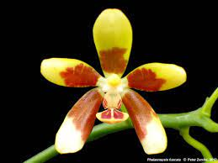
A small to medium sized, hot to warm growing epiphyte with a stem enveloped completely by imbricate leaf sheaths with a few to several, spreading, deflexed, obovate-oblong, thick acute leaves. This species produces yellow flowers with orange brown barring, and the lip is unusual. The sepals tend to be rolled backwards and are cupped. The orchid flowers in the spring and summer on a lateral, to 18 to 24" [45 to 60 cm] long, racemose or paniculate, many flowered inflorescence with fragrant , waxy flowers that open successively over a long period. The inflorescence has small bracts and 2 to 3 flowers per branch. Very similar to P kunstleri but differs mainly in the longer column. ³
Epiphytes. Leaves oblong-obovate to oblong-elliptic, acute, fleshy, " y, to 30 x 10 cm. Inflorescences many-flowered panicles, to 40 cm ng, with the peduncle erect and the rachis arching-pendent, the oral bracts ovate-triangular, acute, concave, to 0.5 cm long. Flowers glossy, rigid, the sepals and petals yellow with a coalesced field of brown is at the base, with strongly revolute margins ("soda straws"), the lip yellow with longitudinal brown stripes, the column yellow. Dorsal sepal elliptic-ovate, obtuse, to 1.7 x 1 cm, the lateral sepals obliquely elliptic, obtuse, to 1.7 x 1 cm. Petals oblong-elliptic to elliptic-obovate, obtuse, to 1.5 x 0.8 cm. Lip three-lobed, to 1.4 cm long, to 1.4 cm across the ex-panded lateral lobes, the lateral lobes subfalcate oblong-elliptic, sub-truncate with a rounded apex, the corners extended as small teeth, the midlobe obovate-suborbicular, obtuse-rounded, concave with a low median keel, the callus biseriate, the posterior callus sulcate, bilobed, the lobes divergent, the anterior callus smaller, shallowly bifid. Col-umn erect, straight, to 9 mm long. Pedicel and ovary 2-3 cm long. Phalaenopsis fuscata and P kunstleri are the only two Phalaenopsis species that have bicolored sepals and petals with the basal halves brown and the apical halves yellow. They both also have sepals and petals with strongly revolute margins (see under P kunstleri for a discussion of the technical differences). Sweet described the inflorescences of P fuscata as few-flowered, which is true of wild-collected specimens and the newly established cultivated plants then available to him. In my experience this is any-thing but true, and mature plants of P fuscata regularly produce pani-cles in cultivation. Although each branch is relatively few-flowered, plants of P fuscata are quite floriferous in their entirety. The only record of the species for the Philippines is the cultivated type plant of P. denisiana from 1897. It has never been recollected in the Philippines, and it is quite possible this record was mislabeled. ¹
Synonyms:

Phalaenopsis denisiana Cogn. 1899; Polychilos fuscata (Rchb. f.) Shim 1982 ³
Distribution/Habitat:

Malaya, Vietnam, Borneo, and the Philippines. In Malaya, plants have been collected with certainty from Kota Gelanggi and Tembeling in Pahang. In Borneo, plants are found in Sabah and Kalimantan where they grow in shady locations beside streams in lowland and hill forests from near sea level to about 3300 ft. (1000 m). Although reported as occurring in Vietnam and the Philippines, details of habitat location and elevation in those regions have not been reported. -- Source: Charles Baker ⁴ Found in the shady lowland and hill forests of Sumatra, peninsular Malaysia, Borneo and the Philippines? at elevations of sealevel to 1000 meters on trees near streams in shady forests ³

Awards:

Origin | HCC | AM | FCC | CBM | CCE | CCM | Total
 | 1 | 2 | 0 | 1 | 0 |  | 4
Years | 1982 | 2009-2918 |  | 1963

Hybrids: F-1

1960-1969 | 1970-1979 | 1980-1989 | 1990-1999 | 2000-2009 | 2010-2019 | 2020-2029 | Total
11 | 46 | 23 | 10 | 8 | 7 | 1 | 105

Hybrids: Progeny

1960-1969 | 1970-1979 | 1980-1989 | 1990-1999 | 2000-2009 | 2010-2019 | 2020-2029 | Total
13 | 78 | 95 | 42 | 25 | 31 | 8 | 292

Significant Progeny

Phalaenopsis KS Fragrance AM/AOS
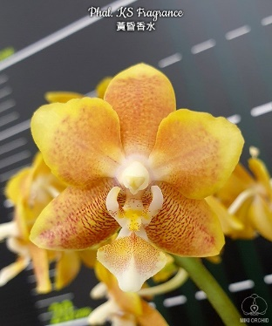
Registered in 2009, KS Fragrance has received 3 AM and has sired 9 progeny.

References:

Aldridge, Peggy. 2008. An Illustrated Dictionary of Orchid Genera. Selby Botanical Garden Press.
¹Christenson, Eric A. 2001. Phalaenopsis- A Monograph.Timber Press.
² Cribb, CJ. 2014. Epidendroidae. In: Pridgeon AM, Cribb PJ, Chase MW, Rasmussen F, eds. Genera Orchidacearum, Vol. 6. Oxford: Oxford University Press, 344-349.

³Jay Pfahl's IOSPE at www.orchidspecies.com
⁴OrchidWiz.Database X7.1
http://apps.kew.org/wcsp/qsearch.do

https://secure.aos.org/aqplus/SearchAwards.aspx

