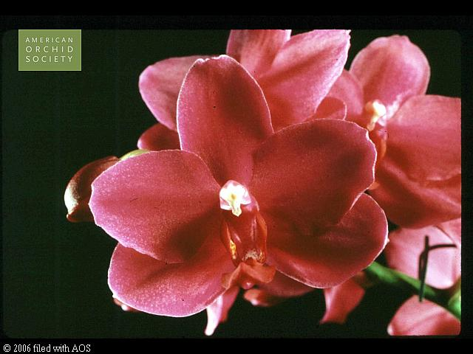
Phalaenopsis Grebe AM/AOS 86 Points
Eight flowers and four buds on two inflorescences; sepals and petals wine-red; lip chartreuse, mid-lobe overlaid wine-red, side lobes spotted red; column red, anther cap white; substance firm; texture matte

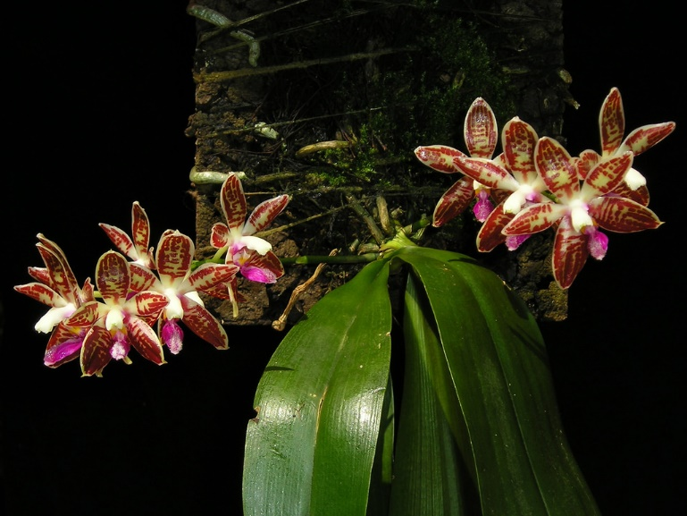
Phalaenopsis corningiana CCM/AOS 84 Points
Thirty stellate flowers on six 15 cm inflorescences well displayed on a four growth plant, 50 by 34 cm grown in sphagnum on a wooden plaque; sepals and petals cream, heavily striped red-mahogany; lip fuschia, apex cream; columncream; substance heavy; texture waxy.

Phalaenopsis tetraspis HCC/AOS 75 Points
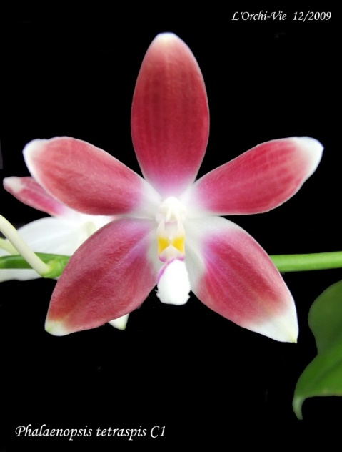
Fourteen flowers on three inflorescences; sepals and petals white, irregularly overlaid brick red except apex, lip white, mid lobe violet basally, side lobes golden yellow; column and anther cap white; substance firm; texture waxy.

Phalaenopsis Germaine Vincent AM/AOS 81 Points
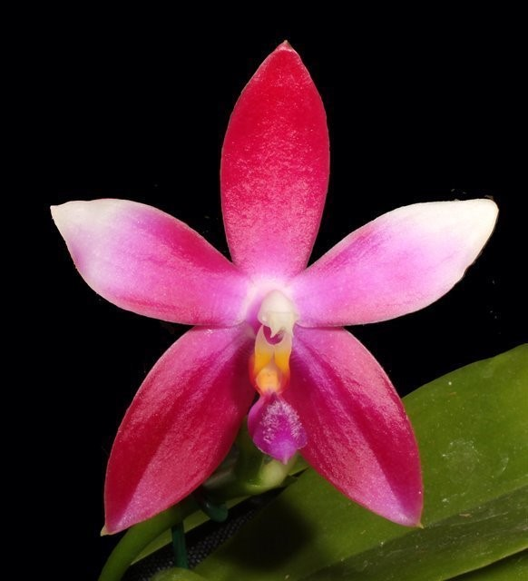
Six flat flowers on three pendent inflorescences; sepals rose red,; petals white, basal half overlaid light rose red; lip mid lobe pubescent, deep red, side lobes orange-yellow; column fuschia, anther cap white; substance firm; texture glossy.

Phalaenopsis Ruth Wallbrunn HCC/AOS 76 Points
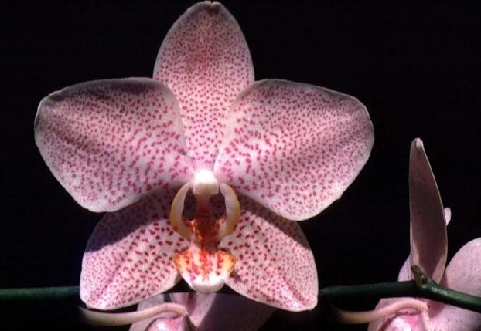
Four flat flowers and three buds on one erect inflorescence; sepals and petals cream, finely and evenly spotted rose; lip cream, linearly spotted orange-red; substance firm; texture matte.

