Phalaenopsis- Section Zebrinae Species

SPECIES PROGENY AWARDS AWARD TYPE RANGE TEMP/LHT BLOOM TIME
F-1/Total AOS Peak
corningiana | 71/248 | 14 | 6 AM, 2 CBM, 1 CCE, 2 CCM, 3 HCC | Borneo | Hot/Lo | May
inscriptiosinensis | 24/26 | 2 | 1 AM, 1 CHM | Sumatra | Warm/Lo | Jun
speciosa | 133/497 | 42 | 18 AM, 1 CBR, 2 CCM, 4 CHM, 1 FCC, 12 HCC, 4 JC | Andaman and Nicobar Islands | Hot/Lo | Oct
sumatrana | 169/5,527 | 19 | 9 AM, 2 CBM, 2 CCM, 4 HCC, 2 JC | Widespread Asia | Hot/Lo | May
tetraspis | 133/497 | 42 | 18 AM, 1 CBR, 2 CCM, 1 FCC, 12 HCC, 4 JC | Andaman and Nicobar Islands | Hot/Lo | Oct
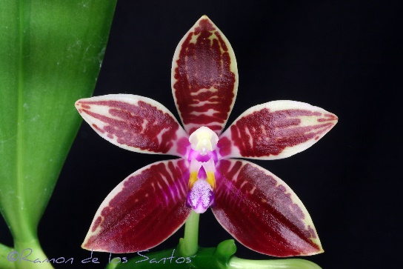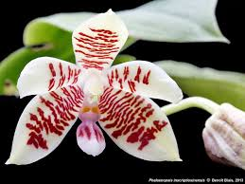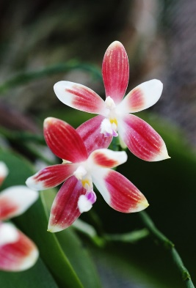

Phal corningiana Phal inscriptiosinensis Phal speciosa

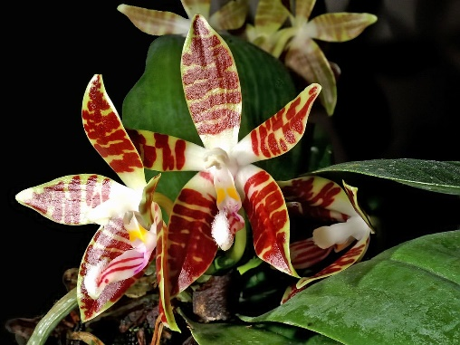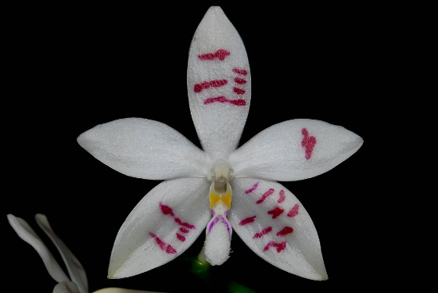
Phal sumatrana Phal tetraspis

