Species Report

Phalaenopsis corningiana Rchb.f. 1879
SUBGENUS Phalaenopsis SECTION Zebrinae Pfitz. 1989₃

Description:

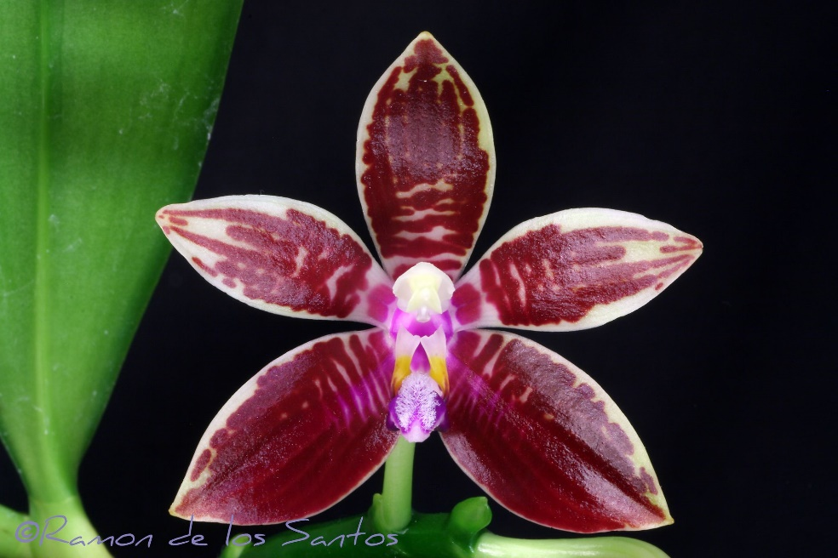
A small sized, hot to warm growing epiphyte with oblong to obovate leaves that blooms in the spring and summer on a shorter than the leaf, 12" [30 cm] long, zigzag, sequentially opening, few flowered inflorescences and carrying very fragrant flowers. ³
Leaves elliptic-obovate, tapered to the conduplicate base, rounded, acute, to 32 x 11 cm. Inflorescences arching to sub pendent racemes or panicles, to 30 cm long, the floral bracts triangular, acute, concave, to 5 mm long. Flowers fragrant, the sepals and petals cream to greenish cream overlaid with brown barring, the bars transverse to-ward the base of the segments and typically longitudinally aligned to-ward the apex, extreme individuals bear nearly solid red flowers, the lip white with broad longitudinal purple stripes all but obscuring the ground color, the column white. Dorsal sepal oblong-elliptic, obtuse or minutely notched, convex, to 40 x 13 mm, the lateral sepals obliquely oblong-obovate, obtuse, shallowly convex, to 30 x 15 mm. Petals ob-long-oblanceolate, bluntly subacute, to 35 x 12 mm. Lip three-lobed, to 20 mm long, to 17 mm wide across the expanded lateral lobes, the lateral lobes erect, oblong-elliptic, truncate with the elongate corners, the posterior corner falcate, the midlobe oblong, obtuse, with a central raised keel, with a boss of dense trichomes at the apex, the callus apparently uniseriate, sulcate, bifid, at the base continuous with a structure analogous to a posterior keel, forming a sunken pit. Column arching, with a coarsely erose-dentate hood over the anther bed. Pedicel and ovary to 4 cm long. Confusion has ever surrounded the identity of this species and the various darker color morphs of P sumatrana, compounded by repeated misidentifications of P sumatrana as P corningiana in horticulture. In addition, P corningi-ana is rare in cultivation, and most growers are therefore unacquainted with it. Though these two species are closely related sister species, once you have seen true P. corningiana, there is no mistaking it for P sumatrana. Maynard Michel (pers. comm.) relates that true P. corningiana came into cultivation in the 1970s in California, where a large seedling population was raised. But most growers found P corningiana difficult to grow, and the species soon became rare again in cultivation. Plants currently in cultivation, however, do not appear to be any more difficult to grow than P. sumatrana and other species in this section. In addition to the differences in callus morphology, P. corningiana has been distinguished from P sumatrana by the pattern of markings on the sepals and petals. In P corningiana the markings are arranged in longitudinal stripes toward the apex of the sepals and petals. In contrast, the markings in P sumatrana are always transverse (from side to side), all the way to the apex of the sepals and petals. That difference does work most of the time, but it is a moot point in heavily pigmented clones of either P corningiana or P sumatrana, where the pattern of the markings is obscured. The best character with which to separate these sister species is the floral fragrance. Phalaenopsis corningiana has wonderfully scented flow-ers reminiscent of old-fashioned ribbon candy. Phalaenopsis sumatrana, on the other hand, has a mildy acrid fragrance without any of the spicy tones of candy. Maynard Michel suggested the strong difference in fragrance between the species, and I was able to confirm these differences with side-by-side flowering plants in the collection of Jerry and Yoko Fischer in Minneapolis. Differences in floral fragrances implies separate pollinators and a degree of biological isolation in nature. I follow Sweet in placing P sumatrana var. sanguinea in synonymy, although his drawing of the type shows a callus more similar to true P sumatrana than P corningiana. In this regard, special note should be taken of the solid red clone recently illustrated in the Orchids of Bor-neo (vol. 1, pl. 16e, as P sumatrana), which matches the phase of P corningiana described as P sumatrana var. sanguinea. No transfer of this varietal name is taken here pending the re-sults of studies in Borneo on the geographic distribution of these color morphs in nature. Sweet (1980) recorded the inflorescences of P. corningiana as "much shorter than the subtending leaves." This was a bias from the very limited horticultural material available at the time. Weak or first-bloom seedlings typically bear short, few-flowered racemes. More robust plants typically have panicles somewhat longer than the leaves, similar to those found in P sumatrana. ¹
Synonyms:

Phalaenopsis cumingiana Rchb. f. 1881; Phalaenopsis sumatrana subvar. sanguinea (Rchb.f.) A.H.Kent 1891; Phalaenopsis sumatrana var sanguinea Korth. & Rchb. f. 1860; Polychilos corningiana (Rchb. f.) Shim 1982 ³
Distribution/Habitat:

Borneo, on limestone cliffs at 1500-2000 ft. (460-610 m). Plants are usually found near waterfalls 10-20 ft. (3-6 m) above the ground on huge, mossy trees. They die quickly if moved to the lowlands. -- Source: Charles Baker). Found in Borneo at elevations of 450 to 610 meters on limestone cliffs near waterfalls on huge mossy trees 20 feet up.¹
Awards:

Origin | HCC | AM | FCC | CBM | CCE | CCM | Total
 | 3 | 6 | 0 | 2 | 1 | 2
Years | 1983-2001 | 1970-2014 |  | 1970-1972 | 2005 | 1988-1997

Hybrids: F-1

1970-1979 | 1980-1989 | 1990-1999 | 2000-2009 | 2010-2019 |  |  | Total
12 | 24 | 10 | 6 | 19 |  |  | 71

Hybrids: Progeny

1970-1979 | 1980-1989 | 1990-1999 | 2000-2009 | 2010-2019 | 2020-2029 |  | Total
12 | 52 | 87 | 32 | 59 | 6 |  | 248
Significant Progeny

Phalaenopsis Grebe AM/AOS
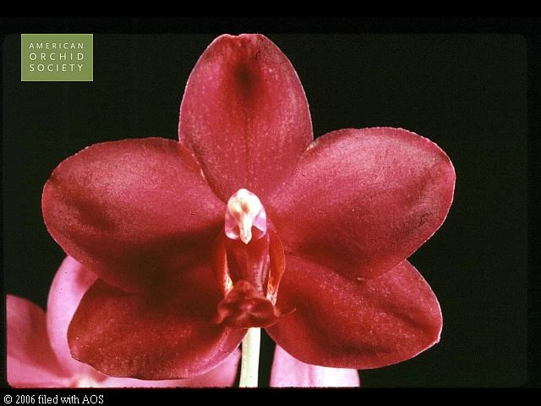
Grebe is one of Corning’s Violet F-1’s. It has 3 progent and has been awarded 8 times by the AOS including an AQ, 4 AM and 2 HCC. The other parent, Pretty Nice is a standard size Phal which fills and rounds out the hybrid nicely.

Phalaenopsis Corning’s Violet AM/AOS

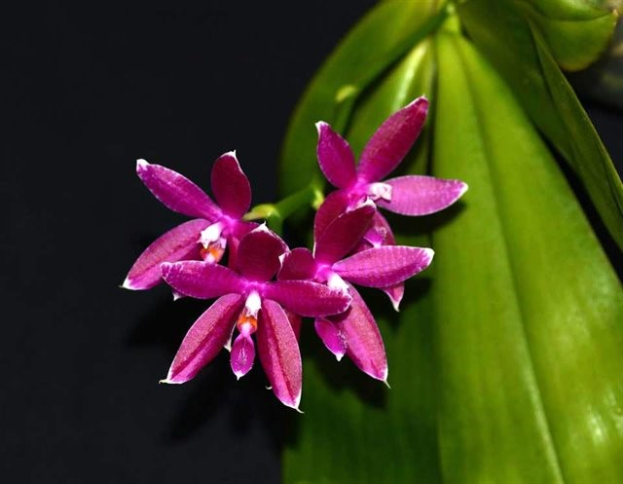
Corning’s Violet is a primary between P. violacea nad P. corningiana registered in 1976 by C. Cheviak. It has 42 F-1 and 146 progeny and has 2 AM and 3 HCC from the AOS. The offspring have a range favoring one or the other parent.

References:

Aldridge, Peggy. 2008. An Illustrated Dictionary of Orchid Genera. Selby Botanical Garden Press.
¹Christenson, Eric A. 2001. Phalaenopsis- A Monograph.Timber Press.
² Cribb, CJ. 2014. Epidendroidae. In: Pridgeon AM, Cribb PJ, Chase MW, Rasmussen F, eds. Genera Orchidacearum, Vol. 6. Oxford: Oxford University Press, 344-349.

³Jay Pfahl's IOSPE at www.orchidspecies.com
⁴OrchidWiz.Database X7.1
http://apps.kew.org/wcsp/qsearch.do

https://secure.aos.org/aqplus/SearchAwards.aspx

