Species Report

Phalaenopsis inscriptiosinensis Fowlie 1983
SUBGENUS Phalaenopsis SECTION Zebrinae Pfitz. 1989₃

Description:

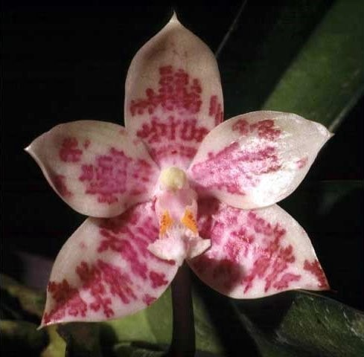
A small to medium sized, hot to warm growing epiphyte with an abbreviated stem carrying 3 to 5, elliptic-oblong, undulate leaves that blooms in the summer on a racemose, decurved, 3 to 4.4" [7.5 to 11 cm] long, 2 to 5 flowered inflorescence with persistent triangular bracts carrying sequentially opening flowers with only 2 to 3 open at a time.
This species is often cited as a synonym of P sumatrana but differs in having smaller flowers and no tuft of hairs on the distal tip of the labellum and the calli arise from a basal thickening and are very difficult to see even under magnification.. ³
Epiphytes with short stems. Leaves three to five, elliptic-oblong, 8-16 x 4-8 cm. Inflorescences unbranched racemes, decurved, two- to five-flowered, the flowers opening sequentially with one or two open at a time, the peduncle terete, 7-11 cm long, the peduncular bracts sparse, distant, tubular, ovate, obtuse, clasping, the floral bracts triangular, concave, 6-8 mm long. Flowers to 3.5 cm wide, white or pale yellow +/-greenish suffusion toward the apices, the sepals and petals with intricate transverse bands of cinnamon brown, the sidelobes of the lip with bright yellow-orange anterior teeth, the midlobe of the lip white with dark red longitudinal stripes along the

lower two-thirds, the column white, the sepals and petals convex with revolute margins. Dorsal sepal oblong-elliptic, obtuse, 17-19 x 7-9 mm, the lateral sepals subsimilar, divergent, apiculate, 16-18 x 9-11 mm. Petals oblong-oblanceolate, obtuse, to 13 x 6 mm. Lip three-lobed, the lateral lobes truncate, the lateral corners continued as small teeth, to 4 mm long, the midlobe oblong, subacute, 8 x 4 mm, with a central carinate keel, almost glabrous (Fowlie records "finely and barely ciliate, so much so as to appear bare"), the callus biseriate, the calli subsimilar and subequal, each bluntly bifid. Column hooded. Pedicel and ovary 1.8-2 cm long. The degree of variation in flower color in this species is unknown. Most of the specimens in cultivation are derived from limited original stock that has been artificially propagated in cultivation. I am accept-ing the plant illustrated by Fowlie as P paucivittata (Fowlie 1985a:51) as an extremely darkly patterned P inscriptiosinensis. It is certainly closer than most of the material in cultivation to Korthals' early drawing in having markings to near apices of the sepals and petals. Fowlie described the leaves of P inscriptiosinensis as "undulate," but both published photographs by him show leaves that are neither especially undulate nor with undulate margins. ¹

Synonyms:

Phalaenopsis sinensis Hort. 1983³
Distribution/Habitat:

Central Sumatra above and east of Pakanbaru, on forest trees below 3000 ft. (914 m-- Source: Charles Baker Found in central Sumatra on forest trees at elevations below 914 meters ¹
Awards:

Origin | HCC | AM | FCC | CBM | CCE | CHM | Total
 | 0 | 1 | 0 | 0 | 0 | 1 | 2
Years |  | 1970-2014 |  |  |  | 1994

Hybrids: F-1

1970-1979 | 1980-1989 | 1990-1999 | 2000-2009 | 2010-2019 |  |  | Total
 | 5 | 4 | 8 | 7 |  |  | 24

Hybrids: Progeny

1970-1979 | 1980-1989 | 1990-1999 | 2000-2009 | 2010-2019 | 2020-2029 |  | Total
 | 5 | 4 | 8 | 7 | 2 |  | 26

Significant Progeny

There are no significant progeny.

References:

Aldridge, Peggy. 2008. An Illustrated Dictionary of Orchid Genera. Selby Botanical Garden Press.
¹Christenson, Eric A. 2001. Phalaenopsis- A Monograph.Timber Press.
² Cribb, CJ. 2014. Epidendroidae. In: Pridgeon AM, Cribb PJ, Chase MW, Rasmussen F, eds. Genera Orchidacearum, Vol. 6. Oxford: Oxford University Press, 344-349.

³Jay Pfahl's IOSPE at www.orchidspecies.com
⁴OrchidWiz.Database X7.1
http://apps.kew.org/wcsp/qsearch.do

https://secure.aos.org/aqplus/SearchAwards.aspx

