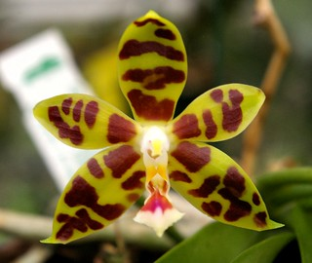
Phalaenopsis Mambo AM/AOS 86 Points
Twenty-seven flat, full flowers on three inflorescences; sepals and petals chartreuse, barred and splotched mahogany; lip cream, mid-lobe basal half rose, side lobes rolled cylindrical, golden yellow; substance heavy, texture waxy.

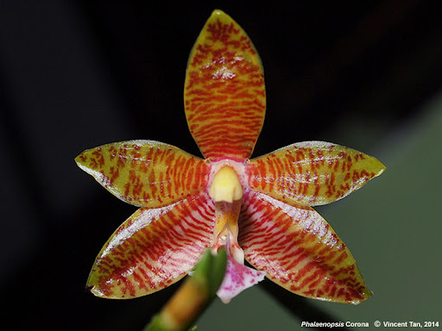
Phalaenopsis Corona HCC/AOS 77 Points
Five flowers and three buds on three inflorescences; sepals and petals olive green, thin barred red-mahogany; lip mid-lobe pink, blotched rose, side lobes rolled inward, orange; column cream; substance heavy; texture waxy.

Phalaenopsis pantherina HCC/AOS 75 Points
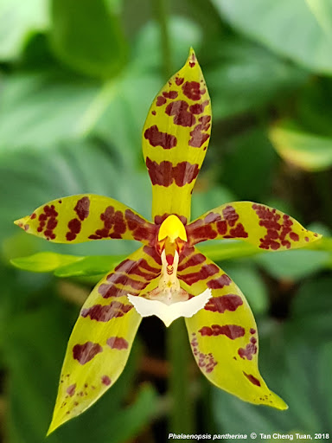
Three stellate flowers and two buds on a 20 cm inflorescence; sepals and petals chartreuse, barred and blotched mahogany; lip mid-lobe cream, side-lobes golden; column and anther cap golden; substance heavy; texture waxy.

