Phalaenopsis- Section Polychilos Species

SPECIES PROGENY AWARDS AWARD TYPE RANGE TEMP/LHT BLOOM TIME
F-1/Total AOS Peak
mannii | 173/1532 | 36 | 18 AM, 1 CBM, 1 AQ, 1 CCE, 4 CCM, 2 CHM, 6 HCC | India & Vietnam | Hot/Lo | May
cornu-cervi | 112/459 | 95 | 35 AM, 1 CCE, 20 CCM, 4 CHM, 2 FCC, 28 HCC, 4 JC | SE Asia | Warm/Lo | Aug
panthera | 18/35 | 4 | 2 AM, 1 CHM, 1 CBR | Borneo | Hot/Lo | Oct
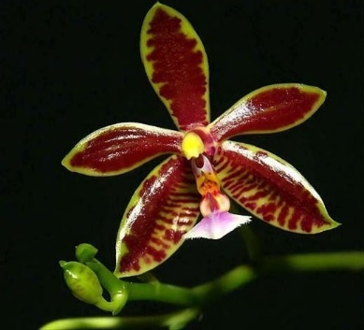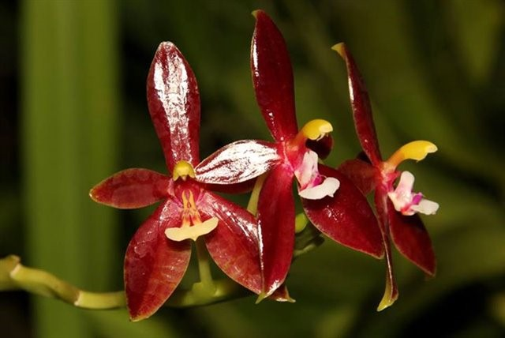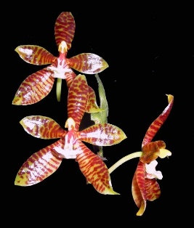

Phal mannii Phal cornu-cervi Phal panthera

