Species Report

Phalaenopsis mannii Rchb.f. 1879
SUBGENUS Phalaenopsis SECTION Polychilos (Breda) Rchb.f. ₃

Description:

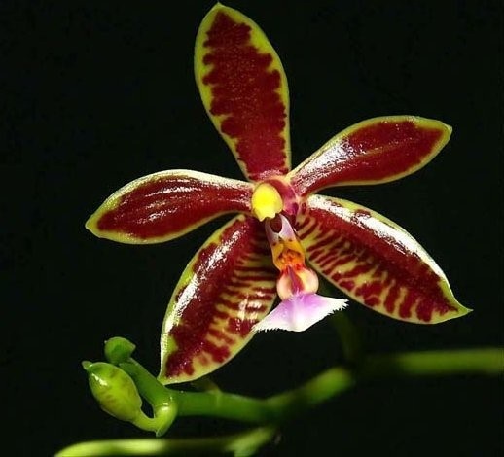
A small to just medium sized, warm to cool growing, pendulous epiphytic species with a short stem enveloped by imbricating leaf bases carrying 4 to 5, oblong-oblanceolate to oblong-ligulate, shiny, fleshy, acute, medium green leaves. They like shady areas with high humidity and a distinctly drier winter rest that helps initiate spring blooming on a slender, pendulous, to 18" [45 cm] long, racemose or rarely paniculate, laxly many [to 70] flowered inflorescence that is as long as the leaves with small ovate-lanceolate bracts with mandarin orange scented, waxy, long-lived flowers appearing in succesion. ³
Leaves elliptic-obovate, tapered to the conduplicate base, rounded, acute, to 32 x 11 cm. Inflorescences arching to sub pendent racemes or panicles, to 30 cm long, the floral bracts triangular, acute, concave, to 5 mm long. Flowers fragrant, the sepals and petals cream to greenish cream overlaid with brown barring, the bars transverse to-ward the base of the segments and typically longitudinally aligned to-ward the apex, extreme individuals bear nearly solid red flowers, the lip white with broad longitudinal purple stripes all but obscuring the ground color, the column white. Dorsal sepal oblong-elliptic, obtuse or minutely notched, convex, to 40 x 13 mm, the lateral sepals obliquely oblong-obovate, obtuse, shallowly convex, to 30 x 15 mm. Petals ob-long-oblanceolate, bluntly subacute, to 35 x 12 mm. Lip three-lobed, to 20 mm long, to 17 mm wide across the expanded lateral lobes, the lateral lobes erect, oblong-elliptic, truncate with the elongate corners, the posterior corner falcate, the midlobe oblong, obtuse, with a central raised keel, with a boss of dense trichomes at the apex, the callus apparently uniseriate, sulcate, bifid, at the base continuous with a structure analogous to a posterior keel, forming a sunken pit. Column arching, with a coarsely erose-dentate hood over the anther bed. Pedicel and ovary to 4 cm long. Confusion has ever surrounded the identity of this species and the various darker color morphs of P sumatrana, compounded by repeated misidentifications of P sumatrana as P corningiana in horticulture. In addition, P corningi-ana is rare in cultivation, and most growers are therefore unacquainted with it. Though these two species are closely related sister species, once you have seen true P. corningiana, there is no mistaking it for P sumatrana. Maynard Michel (pers. comm.) relates that true P. corningiana came into cultivation in the 1970s in California, where a large seedling population was raised. But most growers found P corningiana difficult to grow, and the species soon became rare again in cultivation. Plants currently in cultivation, however, do not appear to be any more difficult to grow than P. sumatrana and other species in this section. In addition to the differences in callus morphology, P. corningiana has been distinguished from P sumatrana by the pattern of markings on the sepals and petals. In P corningiana the markings are arranged in longitudinal stripes toward the apex of the sepals and petals. In contrast, the markings in P sumatrana are always transverse (from side to side), all the way to the apex of the sepals and petals. That difference does work most of the time, but it is a moot point in heavily pigmented clones of either P corningiana or P sumatrana, where the pattern of the markings is obscured. The best character with which to separate these sister species is the floral fragrance. Phalaenopsis corningiana has wonderfully scented flow-ers reminiscent of old-fashioned ribbon candy. Phalaenopsis sumatrana, on the other hand, has a mildy acrid fragrance without any of the spicy tones of candy. Maynard Michel suggested the strong difference in fragrance between the species, and I was able to confirm these differences with side-by-side flowering plants in the collection of Jerry and Yoko Fischer in Minneapolis. Differences in floral fragrances implies separate pollinators and a degree of biological isolation in nature. I follow Sweet in placing P sumatrana var. sanguinea in synonymy, although his drawing of the type shows a callus more similar to true P sumatrana than P corningiana. In this regard, special note should be taken of the solid red clone recently illustrated in the Orchids of Bor-neo (vol. 1, pl. 16e, as P sumatrana), which matches the phase of P corningiana described as P sumatrana var. sanguinea. No transfer of this varietal name is taken here pending the re-sults of studies in Borneo on the geographic distribution of these color morphs in nature. Sweet (1980) recorded the inflorescences of P. corningiana as "much shorter than the subtending leaves." This was a bias from the very limited horticultural material available at the time. Weak or first-bloom seedlings typically bear short, few-flowered racemes. More robust plants typically have panicles somewhat longer than the leaves, similar to those found in P sumatrana.¹ Epiphytes eventually forming clumps by basal stem branches. Leaves oblong-oblanceolate to narrowly elliptic, acute, medium green to pale silvery green, often with fine brown submarginal spotting especially to-ward the base of the leaves, to 37 x 7 cm. Inflorescences arching-sub-pendent racemes or panicles, loosely many-flowered, the peduncle and rachis terete, the floral bracts oblong-lanceolate, concave, acute, to 1 cm long. Flowers numerous, waxy, glossy, long-lasting, the sepals and petals yellow with dark brown spotting and barring, the midlobe of the lip white, the column yellow. Dorsal sepal oblong-oblanceolate, acute, margins revolute, to 2.4 x 0.8 cm, the lateral sepals obliquely elliptic-oblanceolate, subfalcate ("bowlegged') at the apex, acute, margins revolute, to 2.5 x 1.1 cm. Petals lanceolate, acute, often incurved, to 2.0 x 0.6 cm. Lip three-lobed, to 1.1 cm long, to 1.1 cm across the expanded lateral lobes, the lateral lobes erect, appressed, oblong-subquadrate, obliquely truncate, the midlobe transverse, anchor-shaped, the margins fimbriate-erose, the apex a swollen knob with sparse trichomes, the callus triseriate, the posterior callus a small glandular patch, the middle callus a bifid plate with long, filiform divisions, the anterior callus an erect, bilaterally compressed tooth. Column arching, club-shaped, to 0.8 cm long, with prominent basal knees. Pedicel and ovary to 3 cm long. ¹
Synonyms:

Phalaenopsis boxalli Rchb.f 1883; Phalaenopsis mannii f. flava Christenson 2001; Polychilos mannii (Rchb. f.) Shim 1982 ³
Distribution/Habitat:

India and Vietnam at 1500 ft. (457 m). It usually grows near forest streams or marshes which, together with dense undergrowth, result in high humidity year-round, despite dry conditions in adjacent areas. The plants grow 10-15 ft. (3-5 m) above the very dark forest floor on rough-barked trees. -- Source: Charles Baker). Found through the eastern Indian Himalayas, Assam, Nepal, Bhutan, Sikkim, Myanmar, southern China and Vietnam at elevations of 500 to 1500 meters in humid broadleafed evergreen forests with dense undergrowth near streams and rivers on rough barked trees even though there is not much falling rain³
Awards:

Origin | HCC | AM | CHM | CBM | CCE | CCM | Total
 | 6 | 18 | 2 | 1 | 1 | 4
Years | 1992-2018 | 1966-2016 | 1981-1994 | 1972 | 2004 | 1989-2004

Hybrids: F-1

Pre 1940 | 1940-1949 | 1950-1959 | 1960-1969 | 1970-1979 | 1980-1989 | 1990-1999 | 2000-2009 | 2010-2019 | 2020-2029 | Total
4 |  | 3 | 51 | 24 | 24 | 15 | 24 | 25 | 3 | 173

Hybrids: Progeny

Pre 1940 | 1940-1949 | 1950-1959 | 1960-1969 | 1970-1979 | 1980-1989 | 1990-1999 | 2000-2009 | 2010-2019 | 2020-2029 | Total
4 |  | 5 | 114 | 131 | 199 | 208 | 256 | 527 | 88 | 1532

Significant Progeny

Phalaenopsis Golden Chief AM/AOS
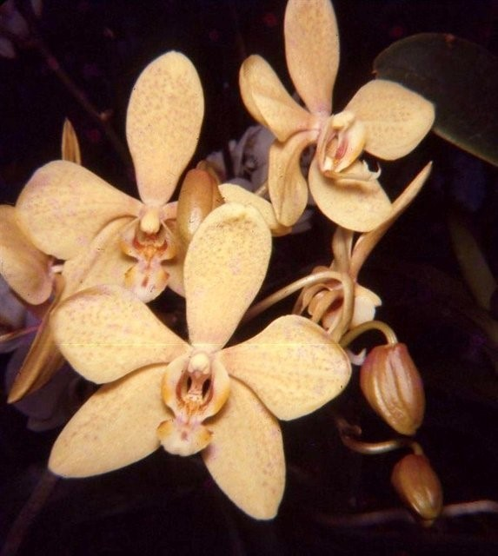
This relatively old hybrid, registered in 1958, is the highest awarded of P. mannii offspring with 17 AOS awards. It is a F-1 cross with Phal Chieftain, a large white standard. It went on to produce 12 progeny.

Phalaenopsis Mambo AM/AOS

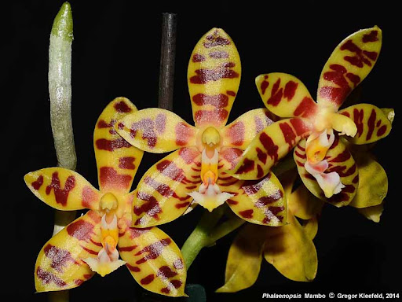
This primary with P. amboinensis is another older hybrid registered in 1965. It is a good breeder with 113 F-1’s and 477 total progeny in 7 generations. It has 13 AOS awards.

References:

Aldridge, Peggy. 2008. An Illustrated Dictionary of Orchid Genera. Selby Botanical Garden Press.
¹Christenson, Eric A. 2001. Phalaenopsis- A Monograph.Timber Press.
² Cribb, CJ. 2014. Epidendroidae. In: Pridgeon AM, Cribb PJ, Chase MW, Rasmussen F, eds. Genera Orchidacearum, Vol. 6. Oxford: Oxford University Press, 344-349.

³Jay Pfahl's IOSPE at www.orchidspecies.com
⁴OrchidWiz.Database X7.1
http://apps.kew.org/wcsp/qsearch.do

https://secure.aos.org/aqplus/SearchAwards.aspx

