Phalaenopsis Walnut Valley Itty Bitty AM/AOS 86 Points
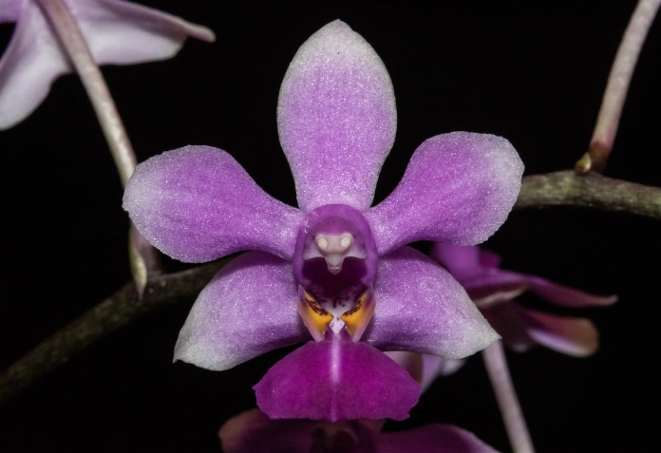
Fifteen flowers and three buds on three, 12 cm inflorescences; sepals and petals pale pink, blushed fuchsia, apices white; lip mid lobe violet, side lobes golden yellow, striped fuchsia; column pink, anther cap white; substance firm; texture crystalline.

Phalaenopsis honghenensis CCM/AOS 86 Points
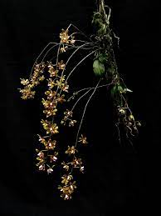
Seventy two flowers on five branched pendent inflorescences on a 4 leafed plant grown on a branch; sepals and petals lavender, striped purple medially; lip purple; column and anther cap pale lavender; substance firm; texture matte.

Phalaenopsis gibbosa HCC/AOS 75 Points
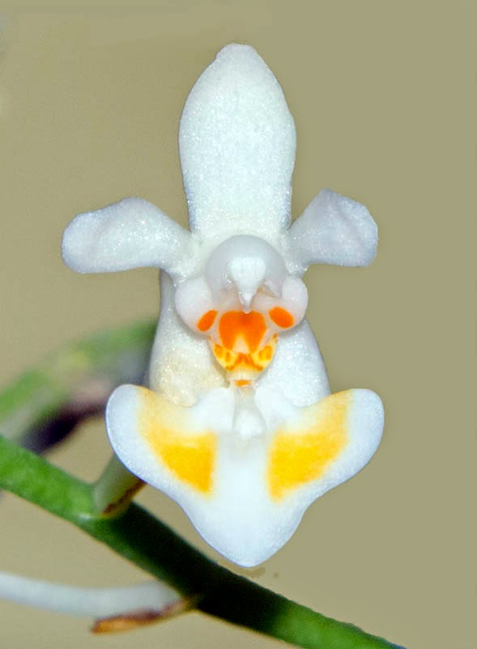
Seven flowers and two buds on two well shingled inflorescences; sepals and petals hinged, white; lip white, side lobes overlaid orange-yellow; column white, base spotted bright orange; substance firm; texture crystalline.

Phalaenopsis Liu’s Star Dusts AM/AOS 81 Points
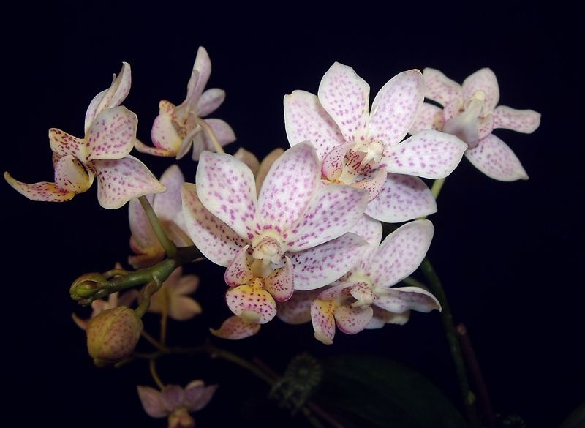
Eleven flowers and five buds on two branched 14 cm inflorescences; flowers white finely and evenly spotted pink, ring of magenta spots basally; lip white, overlaid yellow centrally, spotted magenta; substance firm; texture crystalline.

Phalaenopsis Memoria Herman Sweet HCC/AOS 76 Points
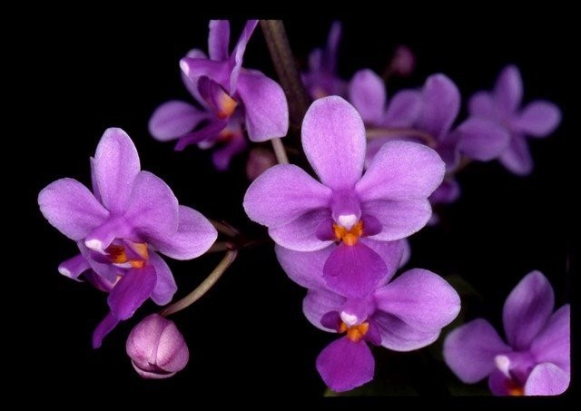
Twenty seven flat flowers and two buds on one branched inflorescence; sepals and petals violet, lighter at the margins; lip purple, callus red-orange; anther cap white; substance firm; texture diamond dust,.

