Phalaenopsis- Section Aphyllae Species

SPECIES PROGENY AWARDS AWARD TYPE RANGE TEMP/LHT BLOOM TIME
F-1/Total AOS Peak
honghenensis | 27/29 | 6 | 1 AM, 2 CCM, 1 CHM, 2 HCC | China | Cool/Lo | Feb-Apr
stobartiana | 21/21 | 6 | 2 CBR, 1 CCM, 3 HCC | China | Cool/Lo | June
taenialis | 15/21 | 4 | 3 AM, 1 CHM, 1 CBR, 1 CCM, 3 HCC | NW Himalayan Region | Cool/Lo | April
wilsonii | 30/30 | 10 | 3 AM, 1 CBR, 1 CHM, 2 HCC | China, Tibet | Cool/Lo | April

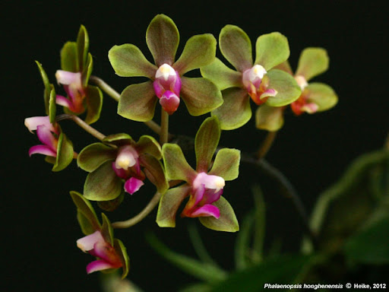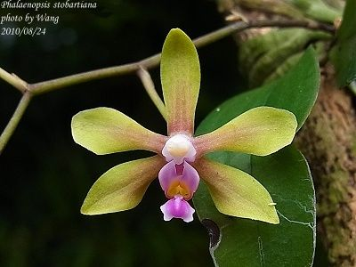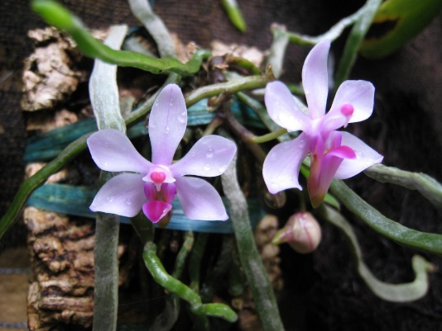

Phal honghenensis Phal stobartiana Phal taenialis

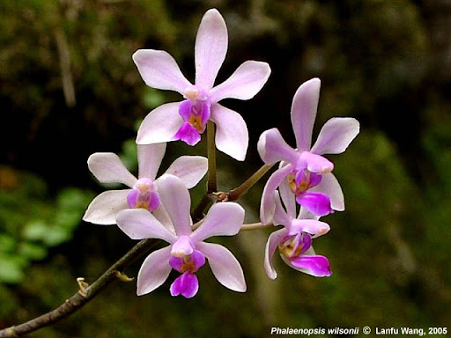

Phal wilsonii

