Phalaenopsis- Section Parishianae Species

SPECIES PROGENY AWARDS AWARD TYPE RANGE TEMP/LHT BLOOM TIME
F-1/Total AOS Peak
appendiculata | 13/13 | 3 | 1 AM, 1 CHM, 1 HCC | Malaya | Hot/Lo | Oct
gibbosa | 5/6 | 5 | 3 AM, 2 HCC | Laos, Vietnam | Warm/Lo | Feb
lobbii | 68/130 | 28 | 12 AM, 1 CHM, 1 CBM, 2 CCE, 6 CCM, 4 HCC, 2 JC | Eastern Himalayas | Warm/Lo | Mar
parishii | 39/83 | 20 | 3 AM, 1 CBM, 1 CCE, 9 CCM, 3 CHM, 3 HCC | India, Burma, Thailand | Warm/Lo | Mar

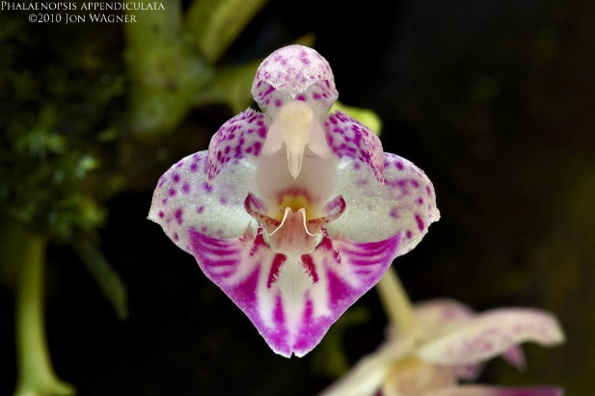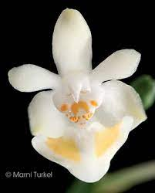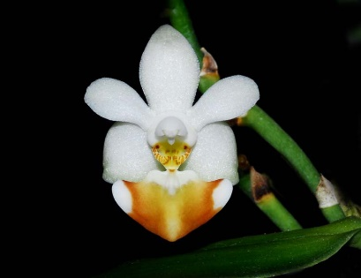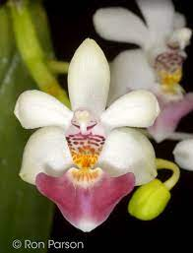

Phal appendiculata Phal gibbosa Phal lobbii Phal parishii

