Phalaenopsis- Section Proboscidioides Species

SPECIES PROGENY AWARDS AWARD TYPE RANGE TEMP/LHT BLOOM TIME
F-1/Total AOS Peak
lowii | 14/21 | 5 | 1 AM, 1 CCM, 1 CHM, 2 HCC | Burma and Thailand | Warm/Lo | Sept

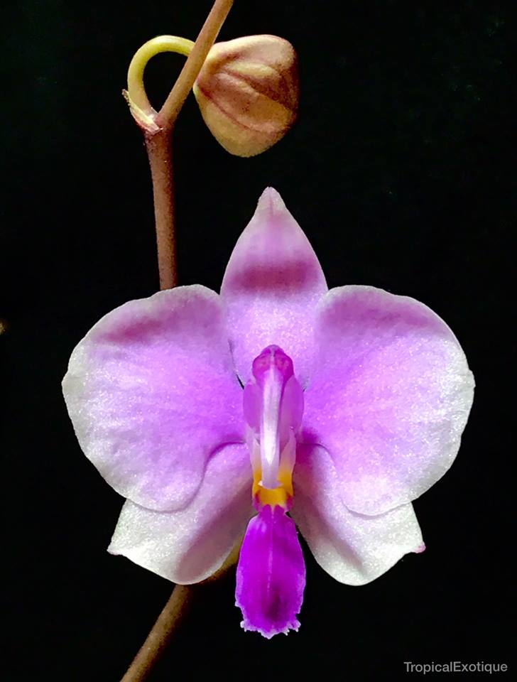

Phal lowii

