Species Report

Phalaenopsis honghenensis F. Y. Liu 1991
SUBGENUS Parishinae SECTION Aphyllae Sweet ₃

Description:

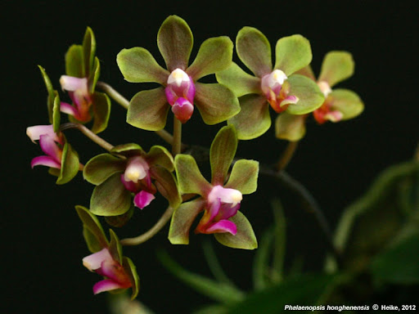
A miniature sized, cool to cold growing epiphyte with warty roots giving rise to a stem carrying 1 to 2, obliquely elliptic, acute, persistent sheathing base leaves that blooms in the spring on a racemose, 3" [7.7cm] long, simple, few [3 to 6] flowered inflorescence with ovate floral bracts and carrying strongly fragrant flowers. ³
Miniature epiphytes with minutely warty roots forming flattened mats against the substrate. Stems short, to 1 cm long. Leaves one or two, obliquely elliptic, acute, 5-7 x 1.5-2.5 cm, the sheathing bases persistent, spotted purple-red, ca. 0.5 cm long. Inflorescences short pedunculate racemes to 7.7 cm long including the 3.5-4.5 cm long rachis, the peduncular bracts broadly ovate, the floral bracts ovate, to 0.6 cm long. Flowers three to six, to 2.9 cm across, the sepals and petals ranging from rose-pink to pale green, the lip purple. Dorsal sepal oblong-elliptic, obtuse, to 1.3 x 0.6 cm, the lateral sepals obliquely elliptic-ovate, obtuse, to 1.3 x 0.6 cm. Petals spatulate, obtuse, to 1.1 x 0.6 cm. Lip three-lobed, minutely spurred, the lateral lobes oblong, obliquely truncate, to 0.7 x 0.2 cm, the midlobe oblong, obtuse, tapered at both ends, to 0.8 x 0.2 cm, the spur short, nipple-like, to 1.5 mm long, the callus biseriate, the posterior callus fleshy, bifid, terminating at the base of the midlobe, the anterior callus plate-like, bifid, extending be-yond the base of the midlobe. Column stout, conspicuously dilated to either side of the stigma, to 0.9 cm long. Pedicel and ovary 1.6-2.2 cm long.
Discussion:
Liu contrasted P honghenensis with his earlier P minor (see P wilsonii) thus: "Species nova proxima P minore F. Y. Liu sed floribus minoribus purpureo-rubris, sepalis et petalis 10-13 mm longis [,] labelli lobo medio ligula [t] o, polliniis orbiculatis distincta" [translation: New species near P minor F. Y. Liu but distinguished by the smaller, purple-red flowers, the sepals and petals 10-13 mm long, the labellum midlobe ligulate, and the pollinia orbiculate] . Despite Liu's straightforward original description and type illustration, P honghenensis has caused considerable confusion, in part because the original publication was obscure, largely unknown and unavailable to the horticultural community. Phalaenopsis honghenensis is distinguished by having short, few-flowered inflorescences, a short, nipple-like spur, and an oblong lip mid-lobe that is slightly tapered at both ends. Liu described the lip apex as emarginate but this is an illusion caused by the subapical lateral mar-gins being strongly deflexed-revolute. The resulting apical tube results in an apex that casually appears to be emarginate but is actually obtuse when flattened. Liu also described the inflorescences as simple or branched, but I have yet to document a branched inflorescence among several hundred flowering plants seen in cultivation. Flower color is somewhat variable in P honghenensis. Most clones are a pale rose-pink with a darker lip. Not infrequently one sees this same color infused with varying amounts of pale green. The pastel green seen in this species is unlike the dark greens seen in P braceana and P stobartiana and is unlikely to be a source of confusion. Phalaenopsis honghenensis has been exported from China in rather astonishing quantities. Nearly all these exportations have been mis-labeled P wilsonii, which has added to the confusion surrounding these species in cultivation. Many provisional AOS awards for P wilsonii have been rejected as mislabeled plants of P honghenensis. Clones of P honghenensis have also been mislabeled as other species in this sub-genus, including plants awarded as P hainanensis `Memoria Herman Sweet', CSR/AOS (see Awards Quarterly 24 (1) :74. 1993) and P stobartiana `Limrick', CBR/AOS (see Awards Quarterly 25 (4) :199. 1994).
Synonyms:

Doritis honghenensis (F.Y.Liu) T.Yukawa & K.Kita 2005 ³
Distribution/Habitat:

China. Found near Honghe in Yunnan Province at about 6550 ft. (2000 m).-- Source: Charles Baker). ⁴
Awards:

Origin | HCC | AM | CHM | CBM | CCE | CCM | Total
 | 2 | 1 | 1 |  |  | 2 | 6
Years | 1998-1999 | 2014 | 2018 |  |  | 2004- 2009

Hybrids: F-1

Pre 1940 | 1940-1949 | 1950-1959 | 1960-1969 | 1970-1979 | 1980-1989 | 1990-1999 | 2000-2009 | 2010-2019 | 2020-2029 | Total
 |  |  |  |  |  |  | 4 | 21 | 2 | 27

Hybrids: Progeny

Pre 1940 | 1940-1949 | 1950-1959 | 1960-1969 | 1970-1979 | 1980-1989 | 1990-1999 | 2000-2009 | 2010-2019 | 2020-2029 | Total
 |  |  |  |  |  |  | 4 | 23 | 2 | 29

Significant Progeny

n/a

References:

Aldridge, Peggy. 2008. An Illustrated Dictionary of Orchid Genera. Selby Botanical Garden Press.
¹Christenson, Eric A. 2001. Phalaenopsis- A Monograph.Timber Press.
² Cribb, CJ. 2014. Epidendroidae. In: Pridgeon AM, Cribb PJ, Chase MW, Rasmussen F, eds. Genera Orchidacearum, Vol. 6. Oxford: Oxford University Press, 344-349.

³Jay Pfahl's IOSPE at www.orchidspecies.com
⁴OrchidWiz.Database X7.1
http://apps.kew.org/wcsp/qsearch.do

https://secure.aos.org/aqplus/SearchAwards.aspx

