Species Report
Phalaenopsis lowii Rchb.f. 1862
SUBGENUS Parishinae SECTION Aphyllae Sweet ₃

Description:

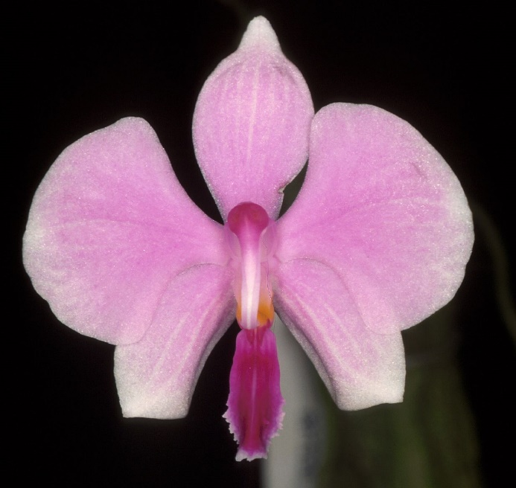
A miniature sized, hot to warm growing epiphyte or sometimes lithophyte with deciduous leaves with an erect or ascending stem enveloped by imbricating leaf bases carrying elliptic, obovate or oblong-elliptic, fleshy, acute or obtuse leaves that blooms in the summer and early fall on a lateral, arcuate to pendant, 10 to 15" [25 to 37.5 cm] long, racemose or rarely paniculate, laxly many flowered inflorescence with small triangular bracts and fragrant, fleshy, long-lived flowers that have an extremely long, beak-like rostellum. ³
Miniature lithophytes and epiphytes. Roots numerous, flattened, appressed to thr substrate, exposed to the air without any associated accumulated organic matter, very long. Leaves one to five, ovate-lanceolate to oblong-lanceolate. Inflorescences arching to pendent. Flowers showy, membranous, white with variable degrees of pink suffusion, the lateral lobes of the lip white with bright yellow-orange teeth, the mid-lobe purple with a narrow white border and five diffuse longitudinal white stripes including the dorsal keel, the column and rostellum white except for purple suffusion over the pollinia. Dorsal sepal oblong-elliptic to ovate-elliptic, obtuse (broadly subacuminate), 15-20 x 9-12 mm, the lateral sepals subequal, obliquely ovate to ovate-elliptic, acute or subobtuse, with revolute margins. Petals flabellate-reniform, cuneate, broadly rounded, 17-22 x 18-24 mm. Lip three-lobed, 15 mm long, 10 mm wide across the expanded lateral lobes, the lateral lobes erect, parallel, in the form of acute retrorse hooks, with a tooth terminating along the leading edge, the midlobe fleshy, obovate, convex, bluntly acute, with an irregular-subdenticulate margin, the upper surface with a longitudinal keel for its length, the callus biseriate, with a small, fleshy bilobed callus at the base, a larger bilobed callus between the lat-eral lobes. Column arching, subtriangular in cross-section, ca. 8 mm long, with a long narrowly bifid rostellum at right angle to and sube-qual to the column. Pedicel and ovary to 4 cm long. Distribution: Myanmar and adjacent western Thailand. Etymology: Named for Hugh Low, whose nursery first flowered this species in England. Illustrations: Bot. Mag. 88: t. 5351. 1862; Fitch 1996:808, 809; Gruss and Mike 1992b:153, 154, 155; Gruss and Wolff 1995:69; Lindenia 6: t. 272. 1890; Orchids 65 (7):803; Sweet 1969:239, 1980:43, 44; Xenia Orch. 2:151. 1868. The range of variation in this species is little known. Plants cultivated in the 19th century, such as those figured in Lindenia, bore white to pale pink sepals and petals with a darker blush pink center. An extremely dark pink clone was figured in Xenia Orchidacea, but this may have been an error in printing where the white ground color was re-placed with medium pink. Recent collections from Thailand have white sepals and petals with minimal pink blush. Whether this is an artifact of geography or a bias of small sample size is unknown at this time. Similarly, the floral and vegetative potential of P lowii is unknown.
Historic illustrations (as well as the type specimens and recent collections) show plants with unbranched racemes that bear only two to four flowers. Orchid collector E. S. Berkeley, however, reported seeing plants in Moulmein with inflorescences three feet long bearing many side branches and "at least a hundred flowers out at a time." There is no reason to doubt Berkeley's observation; no other orchid in Myanmar could be confused with P lowii. The extreme seasonal drought of its native habitat, which leads to the shedding of the plants' leaves, may account for the species' limited ability to produce large numbers of flowers in nature (as well as on recently imported plants). In cultivation, where supplemental watering is provided, the plants are not stressed and may be able to produce larger branched inflorescences. This is certainly the case with such other Aeridinae as Aerides crassifolia Burb.; populations of this species, dwarfed by seasonally arid conditions, produce only few-flowered short racemes in nature but rebound in cultivation, producing massive, branched panicles bearing many flowers on larger, non-stunted plants. Plants of P lowii collected in Thailand as lithophytes (Fitch 1996) bore a solitary leaf, as did the type collection. Plants growing nearby as epiphytes were not subjected to the same degree of drying and retained more leaves. Like other deciduous species, P lowii should not be dried out in cultivation to the point of causing leaf drop. Under optimal cultivation the plants should retain three to five leaves year-round. Fitch also reported finding this species at an elevation of ca. 800 m. This suggests that plants of P lowii should be grown at intermediate temperatures and not the warmer conditions that are optimal for most other species and hybrids in the genus. No hybrids are known to have been made with P lowii in the 19th and early 20th century during the species' first round of cultivation (1862 until at least 1904) and nothing is known of its genetic affinities. The flowers of P lowii superficially resemble those of P amabilis and its allies on the basis of the white ground color and very broad petals. On the basis of the species biogeography, four separate pollinia, and deciduous habit, however, P lowii is only distantly related to the P amabilis group and is probably most closely related to species of sub-genus Parishianae.¹
Synonyms:

Doritis lowii (Rchb.f.) T.Yukawa & K.Kita 2005; Phalaenopsis lowii f. alba O.Gruss 2001; Phalaenopsis proboscidioides Parish ex Rchb.f 1868; Polychilos lowii (Rchb. f.) Shim 1982 ³
Distribution/Habitat:

Myanmar (Burma) and adjacent areas in western Thailand. Plants were originally found near Moulmein, Myanmar (Burma) in the hills of the Tenasserim region and in the deltas of the Gyne, Salween, and Ataran Rivers, which are seasonally flooded. Recent collections in Thailand were made at 2600 ft. (800 m). Phalaenopsis lowii usually grows on bare limestone rocks where it receives full morning sun but is shaded in the afternoon. It also grows on the branches of small bushes which have rooted in rock crevices. Tuberous begonias also grow in this moist warm area. -- Source: Charles Baker.⁴ Found in Myanmar, Thailand and Borneo in conjunction with limestone rocks at elevations around sea level to 500 meters near rivers. This species experiences a long drought in nature which causes it to shed its leaves especially when growing as a lithophyte, in pot cultivation it is best to grow it wetter and keep 3 to 5 leaves for optimum growing. ³
Awards:

Origin | HCC | AM | CHM | CBM | CCE | CCM | Total
 | 2 | 1 | 1 |  |  | 1 | 5
Years | 2001-2010 | 2015 | 1998 |  |  | 2011

Hybrids: F-1

Pre 1940 | 1940-1949 | 1950-1959 | 1960-1969 | 1970-1979 | 1980-1989 | 1990-1999 | 2000-2009 | 2010-2019 | 2020-2029 | Total
 |  |  |  |  |  | 1 | 2 | 9 | 2 | 14

Hybrids: Progeny

Pre 1940 | 1940-1949 | 1950-1959 | 1960-1969 | 1970-1979 | 1980-1989 | 1990-1999 | 2000-2009 | 2010-2019 | 2020-2029 | Total
 |  |  |  |  |  | 1 | 7 | 11 | 2 | 21

Significant Progeny

Phalaenopsis Siam Treasure AM/AOS

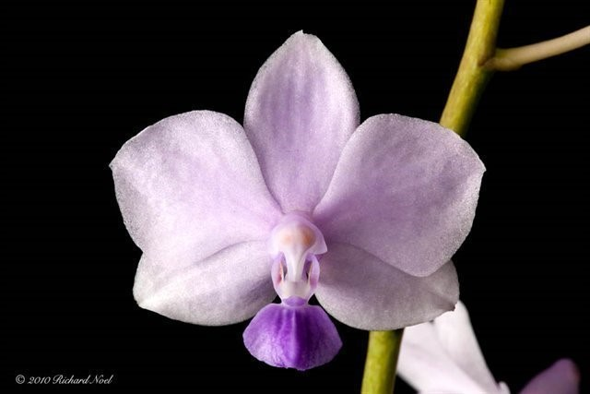
This is a well awarded primary hybrid from 1997. It has 9 AOS awards including a thirteen plant AQ, two AM and six HCC, the most recent in 2014. The cross has been used in breeding 7 times with one progeny, Phal Peter Blue Sky receiving an AM in 2012.

References:

Aldridge, Peggy. 2008. An Illustrated Dictionary of Orchid Genera. Selby Botanical Garden Press.
¹Christenson, Eric A. 2001. Phalaenopsis- A Monograph.Timber Press.
² Cribb, CJ. 2014. Epidendroidae. In: Pridgeon AM, Cribb PJ, Chase MW, Rasmussen F, eds. Genera Orchidacearum, Vol. 6. Oxford: Oxford University Press, 344-349.

³Jay Pfahl's IOSPE at www.orchidspecies.com
⁴OrchidWiz.Database X7.1
http://apps.kew.org/wcsp/qsearch.do

https://secure.aos.org/aqplus/SearchAwards.aspx

