Species Report
Phalaenopsis taenialis (Lindl.) E. A. Christ & Pradham 1986
SUBGENUS Parishinae SECTION Aphyllae E. A. Christensen 2001 ₃

Description:

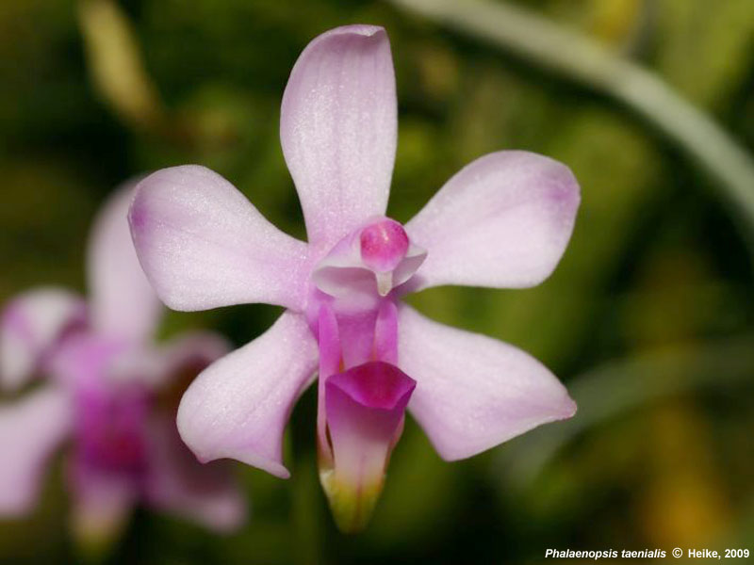
A miniature sized, cool to cold growing monopodial epiphyte with long, flat roots, a short stem carrying 1 to 2, oblong-elliptic, narrow pendant leaves that blooms in nature in the spring on a pedunculate, raceme to 4" [10 cm] long, with lanceolate floral bracts giving rise to 6 to 8, strongly fragrant flowers. ³

Miniature epiphytes with numerous flattened roots. Stems very short, concealed by small scarious bracts and leaf sheaths. Leaves one or two, obliquely lanceolate, acute, dark green, to 10 x 2 cm, usually about half that size. Inflorescences pedunculate racemes to 10 cm long, the floral bracts lanceolate, to 0.3 cm long. Flowers six to eight, to 2 cm across, the sepals and petals pale pink, the lip and anther rose-purple. Dorsal sepal oblong, obtuse, to 0.8 x 0.3 cm, the lateral sepals obliquely elliptic-ovate, obtuse, to 0.8 x 0.4 cm. Petals elliptic-obovate, obtuse, to 0.8 x 0.3 cm. Lip three-lobed, spurred, to 0.8 cm long from the base of the spur to the midlobe apex, the lateral lobes erect, oblong, obtuse, to 6 x 1.5 mm, the midlobe oblong-elliptic, obtuse, arching, to 6 mm long, the callus biseriate, the posterior callus fleshy, bidentate, on the backwall of the spur, the anterior callus ligulate, deeply bifid, attached to the frontwall at the base of the midlobe. Column stout, strongly di-lated at the middle to either side of the stigma, to 0.4 cm long. Pedicel and ovary to 1.6 cm long. Phalaenopsis taenialis has always been the best known of the species in this subgenus. It is abundant in nature, and numerous herbarium specimens have

been available for study and critical comparison. Until recent restrictions on the export of wild-collected plants by India and their importation into the United States by the enactment of CITES legislation, P taenialis was frequently exported from northeast India for horticulture. It is easily recognized by its pale pink flowers with a conspicuous spur. Only P braceana has a similar spur and that species has significantly larger green to greenish bronze flowers. Garay (pers. comm.) suggests that Aerides carnosa may represent a separate species as the spur appears to be shorter and more broadly rounded than in P taenialis. The paucity of material from Bhutan makes the significance of this difference hard to judge. Further study of this question is left to the botanists preparing the Orchidaceae for the Flora of Bhutan at the Royal Botanic Garden, Edinburgh. Spur length in P taenialis may represent a dine, or perhaps the recognition of a distinct subspecies is warranted. ¹
Synonyms:

Aerides carnosa Griff. 1851; Aerides taeniale Lindl. 1830-40; Biermannia naviculare Tang & Wang 1997; Biermannia taenialis (Lindl.) T. Tang & F.T. Wang 1951; Doritis braceana Hook. f. 1890; Doritis taenialis Benth. & Hook. f. 1890; Kingidium braceanum (Hook. f.) Seidenf. 1988; Kingidium naviculare Tsi ex Hashim 1984; Kingidium taeniale (Lindl.) P.F. Hunt 1970; Kingiella taenialis (Lindl.) Rolfe 1917; Polychilos taenialis (Lindl.) Shim 1982. ³
Distribution/Habitat:

The northwest Himalayan Region. Plants are known from central and eastern Nepal, northeast India in the Khasia near Shillong as well as in Manipur, near Darjeeling in Sikkim, Bhutan, Myanmar (Burma) and Thailand. Plants are found at 3300-8200 ft, (1000-2500 m). Although reported as occurring in Thailand, Seidenfaden (1988) stated that this species had not been recorded in Thailand. -- Source: Charles Baker. ¹ Found in the western Himalayas, eastern Himalayas, Assam India, Nepal, Bhutan, Sikkim, southern China and Myanmar in forests on tree trunks at elevations of 1000 to 2500 meters. ³

Awards:

Origin | HCC | AM | CHM | CBM | CBR | CCM | Total
 | 3 | 3 | 1 | 1 | 1 | 1 | 10
Years | 1010-2012 | 2012-2017 | 2002 | 1974 | 2002 | 2012

Hybrids: F-1

Pre 1940 | 1940-1949 | 1950-1959 | 1960-1969 | 1970-1979 | 1980-1989 | 1990-1999 | 2000-2009 | 2010-2019 | 2020-2029 | Total
 |  |  | 2 |  |  |  | 1 | 12 |  | 15

Hybrids: Progeny

Pre 1940 | 1940-1949 | 1950-1959 | 1960-1969 | 1970-1979 | 1980-1989 | 1990-1999 | 2000-2009 | 2010-2019 | 2020-2029 | Total
 |  |  | 2 | 2 |  |  | 1 | 16 |  | 21

Significant Progeny

There are no significant progeny. Only one was awarded in Germany, Phal Wossner Little Star. There is no photo available.

References:

Aldridge, Peggy. 2008. An Illustrated Dictionary of Orchid Genera. Selby Botanical Garden Press.
¹Christenson, Eric A. 2001. Phalaenopsis- A Monograph.Timber Press.
² Cribb, CJ. 2014. Epidendroidae. In: Pridgeon AM, Cribb PJ, Chase MW, Rasmussen F, eds. Genera Orchidacearum, Vol. 6. Oxford: Oxford University Press, 344-349.

³Jay Pfahl's IOSPE at www.orchidspecies.com
⁴OrchidWiz.Database X7.1
http://apps.kew.org/wcsp/qsearch.do

https://secure.aos.org/aqplus/SearchAwards.aspx

