Phalaenopsis Red Hot Imp HCC/AOS 76 Points
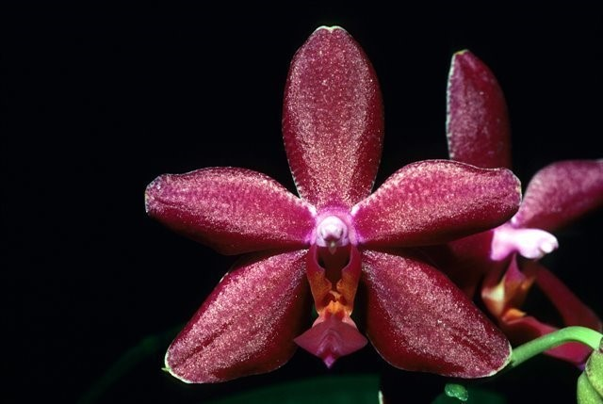
Three stellate flowers and two buds on one 20 cm inflorescence; sepals and petals slightly ribbed, garnet red; lip darker garnet, callus gold; column magenta; substance heavy; texture satiny.

Phalaenopsis Riverbend’s Pink Pearl AM/AOS 82 Points
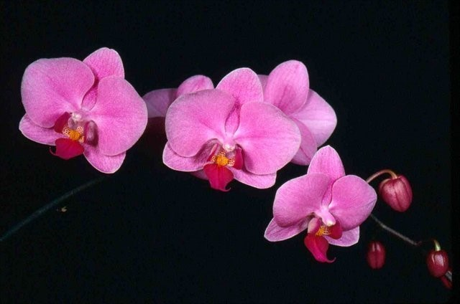
Six flowers and three buds on one arching, 27 cm inflorescence; sepals and petals dark rose-pink; lip white, overlais deep magents, base spotted magenta, callus yellow; substance firm; texture diamond dust.

Phalaenopsis Cassandra CCM/AOS 81 Points
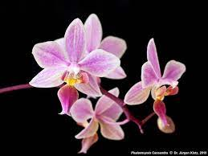
Two hundred fifteen flowers and twenty seven buds in six branched inflorescences to 80 cm tall on a blemish free 34 by 29 cm plant grown in a 30 cm ceramic pot; sepals and petals white, blushed pink; lip lavender; substance medium firm; texture matte.

Phalaenopsis Silbergrube HCC/AOS 77 Points
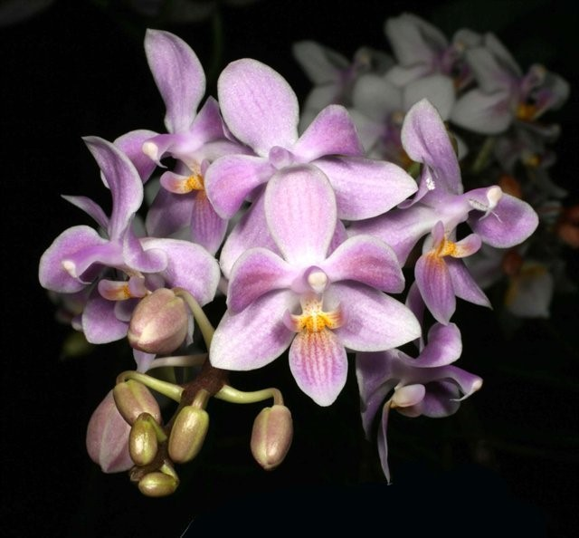
Twenty three flowers and seven buds on one branched inflorescence; sepals and petals white, blushed pink, slightly veined darker pink; lip pink, veined magenta, callus golden; substance firm; texture crystalline.

Phalaenopsis Jungle Warrior AM/AOS 81 Points
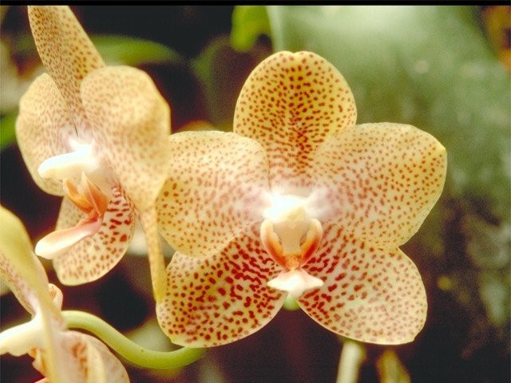
Eleven very flat flowers and three buds on one 37 cm branched inflorescence; sepals and petals orange-yellow, evenly spotted brick red; lip lemon yellow, side lobes blushed brick red; substance firm; texture waxy.

