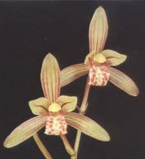
Species Data Sheet
Cymbidium ensifolium
Cymbidium ensifolium (Linne) Swartz., Nova Acta Regiae Soc. Sci. Upsal. 6: 77 (1799) (sim-BID-ee-em en-si-FOH-li-um)
“If longevity is a criterion for value, surely Cymbidium ensifolium must be the most valued of all orchids. Known to civilized culture since before the time of Confucius (500 B.C.) …” and introduced to Europe around the turn of the eighteenth century.
These plants can easily be grown in 6-inch pots in either a cool or intermediate to even warm temperatures as long as there are high light conditions. A terrestrial orchid that is native to China, Taiwan, Ryuku Islands, and the Philippines at elevations ranging from 250 to 3000 meters (~800 to 9800 ft). The pseudobulb is 3.0 - 1.5 cm, ovoid, often inconspicuous, 2-5 leaves that are 29-55 by 0.8-1.6 cm. The erect spike is 15-67 cm long from the base of the pseudobulb with 3-9 very fragrant flowers on the upper third appearing in July – September but will bloom throughout the year. The 3-5 cm wide flowers, sepals and petals straw-yellow to green with 5-7 more or less obvious longitudinal red or red-brown veins, the petals often with a stronger central strip and red-brown spots and blotches towards the base. The lip is pale yellow or green, occasionally white, side-lobes streaked red, with a red margin, mid-lobe with red blotches or transverse spots, column pale yellow, with red dashes beneath, anther-cap cream.
Species in the subgenus Jensoa (Cym. ensifolium plus roughly 8 other species) are characterized by a distinctive callus structure where the two callus ridges converge towards the apex, forming a short tube at the base of the mid-lobe of the lip (see photo on subsequent page). Other additional characteristics are; the micromorphology of the abaxial leaf surface, long thread-like seed shape, erect seed pods, the seedling is rhizomatous rather than forming a spherical protocorm.
As one would expect for any orchid that has been in continuous ‘civilized culture’ for over 2000 years there is considerable variation. There are varieties with variegated leaves, flower shape, and MANY color forms, examples (nowhere exhaustive) of some of the varieties are on the next page.
Awards:
 | Progeny | AOS Awards
Name | F1/Remain | FCC | AM | HCC | JC | AD | AQ | CCE | CCM | CHM | CBR | Total
Cymbidium ensifolium | 73/1109 |  |  | 9 | 2 |  |  |  | 4 | 2 |  | 17
Hybrids: Total of 1109 registered, to the 6th generation
 | Progeny | Grexes |  |  |  |  |  | Awards
Name | F1/Remain | F1 | F2 | F3 | F4 | F5 | F6 | F1 | F2 | F3 | F4 | F5 | F6 | Total
Cymbidium ensifolium | 73/1109 | 73 | 316 | 407 | 239 | 68 | 6 | 41 | 119 | 21 | 12 | 3 | 0 | 327

 | 1950-59 | 1960-69 | 1970-79 | 1980-89 | 1990-99 | 2000-09 | 2010- | Total
All Progeny | 2 | 16 | 11 | 118 | 276 | 292 | 394 | 1109
F1-1st Gen | 2 | 14 | 5 | 15 | 13 | 17 | 7 | 73
F2-2nd Gen | 0 | 2 | 6 | 83 | 112 | 58 | 55 | 316
F3-3rd Gen | 0 | 0 | 0 | 20 | 129 | 122 | 136 | 407
The first register cross, Cym. Peter Pan (Cym. ensifolium x Cym. Miretta), in 1957 was an instant success (considered the Cym. Alexanderi of miniature cymbidiums), starting miniature warm growing cymbidiums. As a parent, Cym. ensifolium is dominant for upright spike, fragrance, small number of flowers, flowering throughout the year, heat tolerance, tendency of green progeny, and compact growth habit. Unfortunately, it also tends to impart a short flower life, need for high light, and poor keeping quality as a cut flower.
References:
www.orchidspecies.com
http://apps.kew.org/wcsp/qsearch.do
https://secure.aos.org/aqplus/SearchAwards.aspx
OrchidWiz.Database 13.1
Du Puy, D. & Cribb, P., 1988, The Genus Cymbidium
Du Puy, D. & Cribb, P., 2007, The Genus Cymbidium (Botanical Magazine Monograph)
Nash, N. 1996, Culture Column: Flavor of the Month Cymbidium ensifolium, Orchids, 65(9), 972-974
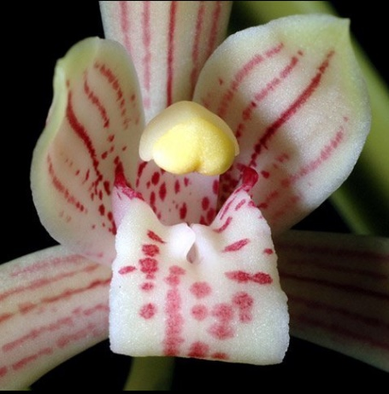
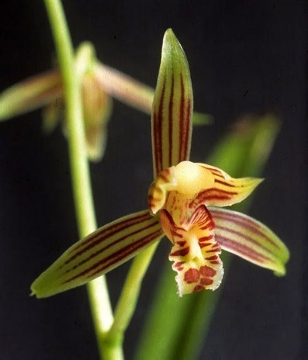
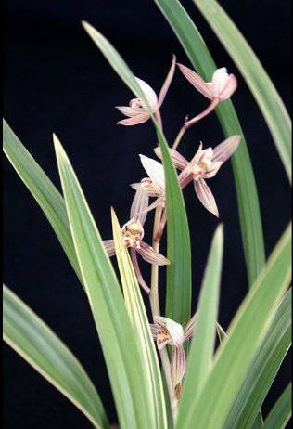
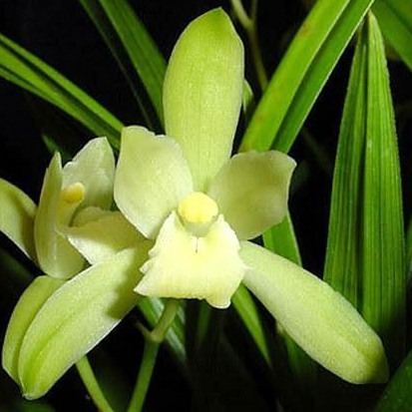
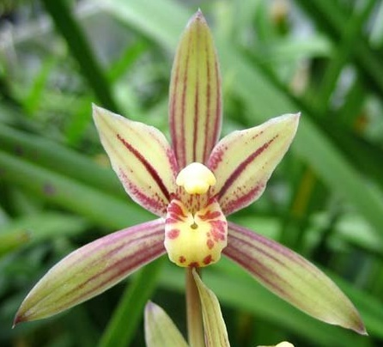
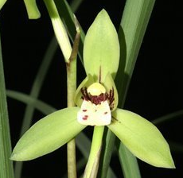
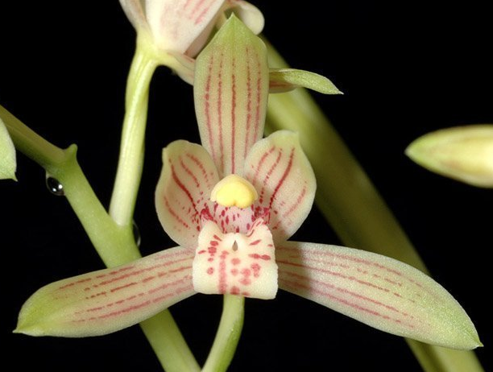
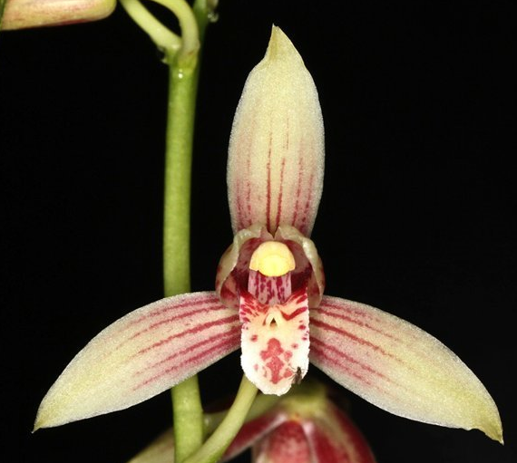
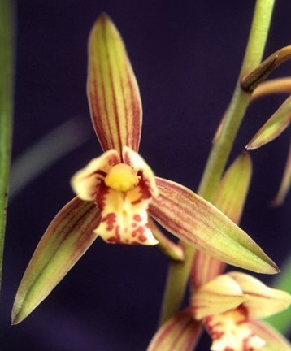
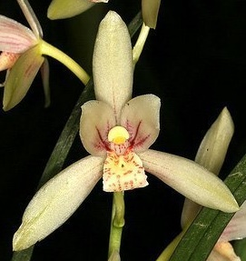
Various Cymbidium ensifolium pictures, varieties identified when provided
Two callus ridges converge, forming a short tube
ssp. ensifolium
ssp. haematodes
Now Cym. haematodes
Variegated leaves
Name |  |  |  |  | Parent | Parent | Year | F1 Offspr | Total Offspr | Originator | % eryth
Peter Pan |  |  |  |  | ensifolium | Miretta | 1957 | 152 | 825 | Dos Pueblos | 50.0%
 | Sue |  |  |  | Showgirl | Peter Pan | 1980 | 31 | 85 | Santa Barbara | 25.0%
 |  | Kiwi Magic |  |  | Sue | Coraki | 1988 | 10 | 20 | A. Easton | 12.8%
 | Rolling Stone |  |  |  | Peter Pan | Doris Aurea | 1986 | 25 | 183 | Geyserland | 25.0%
 |  | Kusuda Shining |  |  | Rolling Stone | Golden Elf | 1994 | 47 | 139 | Geyserland | 38.0%
 |  |  | Enzan Shining |  | Coraki | Kusuda Shining | 1999 | 18 | 20 | Mukoyama | 18.8%
 |  |  | Blanche Ames |  | One Tree Hill | Kusuda Shining | 2001 | 14 | 15 | A. Easton | 18.8%
 |  |  | Kusuda Bay |  | Terama | Kusuda Shining | 2003 | 8 | 18 | Mukoyama | 18.6%
 |  |  | Donovan |  | Kusuda Shining | Sleeping Ransom | 2004 | 7 | 12 | New Horizon Orchids | 19.0%
 |  |  | Pretty Shine |  | Kusuda Shining | Pretty Dawn | 2010 | 4 | 13 | Mukoyama | 30.7%
 |  | Strawberry Village |  |  | Rolling Stone | Olymilum | 1993 | 8 | 14 | Geyserland | 12.9%
 |  | Enzan Stone |  |  | Rolling Stone | Lovely Angel | 1997 | 3 | 12 | Mukoyama | 13.0%
 | Valerie Absolonova |  |  |  | Golden Elf | Peter Pan | 1989 | 24 | 24 | Everglades | 50.0%
 | Summer Pearl |  |  |  | Peter Pan | Trigo Royale | 1984 | 20 | 37 | Geyserland | 25.0%
 | Green Santa |  |  |  | Hazel Tyers | Peter Pan | 2005 | 15 | 27 | A. Easton | 25.0%
 | Pink Peach |  |  |  | Rincon | Peter Pan | 1982 | 14 | 56 | Featherhill | 25.0%
 |  | Cherry Cola |  |  | Pink Peach | Beaconfire | 1993 | 18 | 22 | Geyserland | 12.9%
 | Everglades |  |  |  | sanderae | Peter Pan | 1981 | 13 | 24 | Everglades | 25.0%
 | Wild Colonial Boy |  |  |  | Coraki | Peter Pan | 1989 | 13 | 27 | Geyserland | 25.0%
 | Sunbreeze* |  |  |  | Cariga | Peter Pan | 1989 | 10 | 94 | Geyserland | 25.0%
 |  | Michael Herbert |  |  | Sunbreeze | Golden Elf | 1997 | 13 | 58 | Geyserland | 37.6%
 |  |  | Sundaani Autumn |  | Michael Herbert | Harvest Queen | 2006 | 33 | 44 | P. Zbierski | 31.0%
 | Peter Pilot |  |  |  | Peter Pan | Fred Stewart | 1983 | 9 | 23 | Geyserland | 25.0%
 | Prettipink |  |  |  | Alison Shaw | Peter Pan | 1986 | 9 | 44 | Geyserland | 25.0%
 |  | Pretty Dawn |  |  | Runaway | Prettipink | 1993 | 1 | 14 | Geyserland | 25.0%
 |  |  | Pretty Shine |  | See Pretty Shine in Rolling Stone above
 | Runaway |  |  |  | Radiant Harry | Peter Pan | 1989 | 9 | 24 | Geyserland | 25.0%
 |  | Prettipink |  |  | See Prettipink above
 | Maureen Grapes |  |  |  | Sussex Moor | Peter Pan | 1984 | 8 | 16 | Geyserland | 25.0%
Golden Elf |  |  |  |  | ensifolium | Enid Haupt | 1978 | 99 | 391 | P. Gripp | 50.0%
 | Rolling Stone |  |  |  | See Rolling Stone above
 | Valerie Absolonova |  |  |  | See Valerie Absolonova above
 | Sunbreeze* |  |  |  | See Sunbreeze above
Korintji |  |  |  |  | ensifolium | Rangoon | 1963 | 17 | 70 | Stewart Inc. | 50.0%
 | Harvest Queen |  |  |  | Korintji | floribundum | 1970 | 1 | 45 | Thomdel Coll. | 25.0%
 |  | Michael Herbert |  |  | See Michael Herbert above

There are three major lines; Peter Pan, Golden Elf, and Korintji. Of these Peter Pan has the most progeny, the significant progeny of Cym Golden Elf are in the Cym. Peter Pan progeny, and the progeny of Cym Korintji is dominated by two breeders with very few awards.
Cymbidium Peter Pan
[Cym. ensifolium x Cym. Miretta]
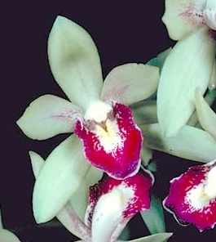
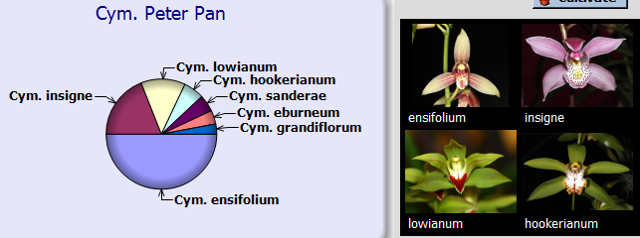
The grex Peter Pan was registered in 1957 by Dos Pueblos. The cross was an instant success (considered the Cym. Alexanderi ‘Wentonburt’ of miniature cymbidiums), starting a new cymbidium class ‘miniature’ which has the added benefit of being able to be grown under warm growing conditions. The key progeny are listed on the prior page and some of the highest award winners are pictured below.
Cymbidium Peter Pan
'Pirate Ship' AM/AOS,
July 1979, NS 6.0cm
 | Progeny | AOS Awards
Name | F1/Total | FCC | AM | HCC | JC | AD | AQ | CCE | CCM | CHM | CBR | Total
Cym. Peter Pan | 152/825 |  | 1 | 5 |  |  |  |  | 1 |  |  | 7
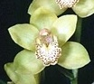
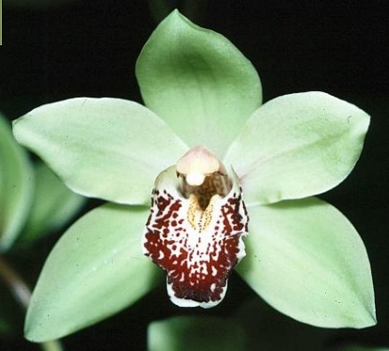
Cym. Autumn Green
‘Santa Barbara' HCC/AOS,
(Peter Pan x Peetie)
Oct. 1999, NS 7.4cm
1 F1 progeny
4 HCC/AOS
Cym. Wild Colonial Boy
‘Wolfgang' HCC/AOS,
(Coraki x Peter Pan)
Mar. 1990, NS 7.0cm
13 F1, 27 total progeny
2 HCC/AOS
Cym. Valentine’s Love
‘Heavens Scent' HCC/AOS,
(Peter Pan x Ora Lee)
Jan. 1986, NS 8.0cm
No progeny
12 HCC/AOS
Cym. Fatal Beauty
‘Marlow Orchids' HCC/AOS,
(Wild Colonial Boy x devonianum)
Feb. 2009, NS 4.8cm
No progeny
2 HCC/AOS

Cymbidium Golden Elf
[Cym. ensifolium x Cym. Enid Haupt]
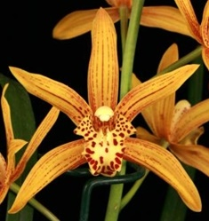
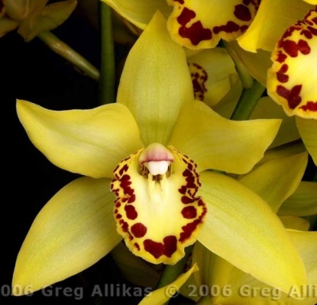
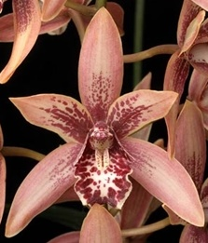
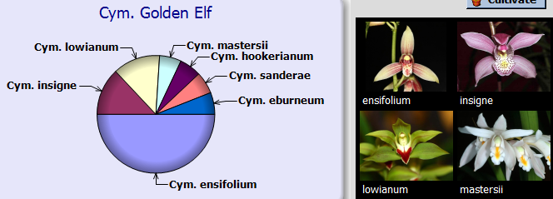
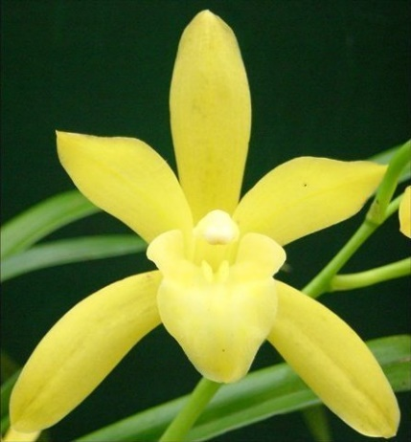
The grex Golden Elf was registered in 1978 by P. Gripp. The key progeny are listed in a table on an earlier page, key breeding lines have been into the Peter Pan line, and some of the highest award winners are pictured below. Again breeding plants have very few (if any) awards????
Cymbidium Golden Elf
Sundust' HCC/AOS,
Oct. 1983, NS 7.6cm
 | Progeny | AOS Awards
Name | F1/Total | FCC | AM | HCC | JC | AD | AQ | CCE | CCM | CHM | CBR | Total
Cym. Golden Elf | 99/391 |  |  | 2 |  |  |  |  | 1 |  |  | 3
Cym. Neil Pagano
‘New Horizon' AM/AOS
(Canterbury x Golden Elf)
Jan. 2007, NS 7.4cm
No progeny
1 AM, 1 HCC
Cym. Chen’s Ruby
‘Maluna' AM/AOS,
(iridioides x Golden Elf)
Sep. 2010, NS 10.0cm
1 progeny
2 AMs, 1 HCC, 1 CCM
Cym. Milton Carpenter
‘Everglades Gold' AM/AOS,
(Golden Elf x Via Ambarino)
Oct. 2006, NS 9.5cm
4 F1, 4 total progeny
1 AM, 1 JC
Cym. Cooper Point
‘Full Moon' HCC/AOS,
(Golden Elf x erythrostylum)
Sep. 2009, NS 6.7cm
3 F1, 3 total progeny
2 HCC/AOS

Cymbidium Korintji
[Cym. ensifolium x Cym. Rangoon]
 | Progeny | AOS Awards
Name | F1/Total | FCC | AM | HCC | JC | AD | AQ | CCE | CCM | CHM | CBR | Total
Cym. Korintji | 17/70 |  |  | 1 |  |  |  |  |  |  |  | 1
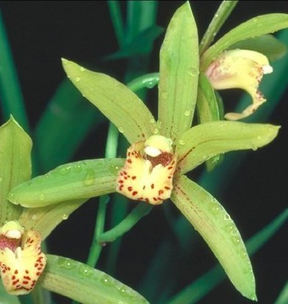
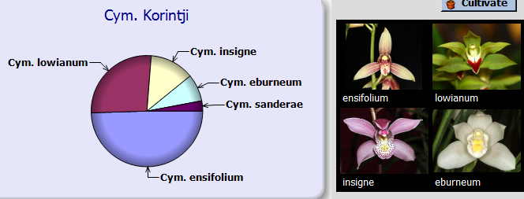
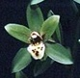
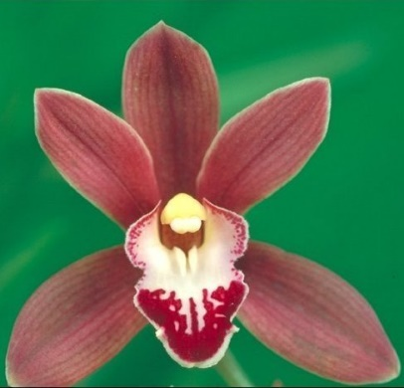
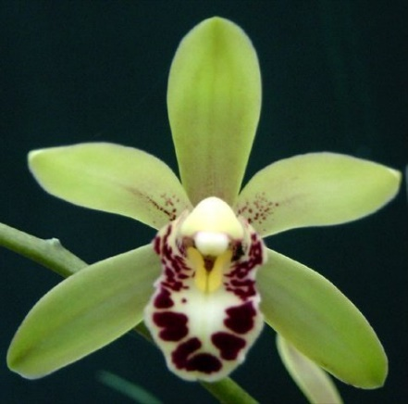
The grex Korintji was registered in 1963 by Stewart Inc. The key progeny are listed in a table on an earlier page. All of the progeny of this cross have received a total of 3 awards, two of which are pictured below (other does not have a picture) along with two of cross that I found interesting.
Cymbidium Korintji
‘Golden Showers'
Cym. Promised Land

(Nancy Carpenter x Peter Pan)

1 progeny

Cym. Nancy Carpenter
‘My Love' AM/AOS,
(Korintji x chloranthum)
Feb. 1979, NS 5.8cm
1F1 and 2 total progeny
1 AM/AOS
Cym. Giselle
‘Ballerina' HCC/AOS,
(Korintji x madidum)
Dec. 1994, NS 4.6cm
1 progeny
1 HCC/AOS
Cym. Cabrintji

(Korintji x Cabernet)

1 progeny

