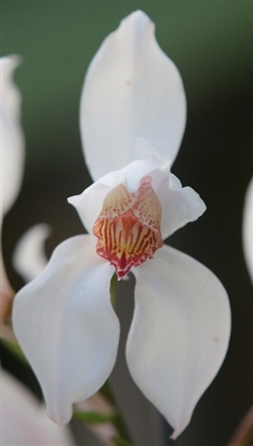**Species Data Sheet**

**Cymbidium erythrostylum** Rolfe, Gard. Chron., ser. 3, 38: 427 (1905)

(sim-BID-ee-em err-ih-‘ROS-tie-lum’)

Found as an epiphyte, lithophytic, or terrestrial at 4900 ft. (1500 m) in Vietnam with 6-cm long, 2-cm in diameter narrowly ovoid, bilaterally flattened pseudobulbs with 6-8 45-cm by 1.5-cm long leaves. Inflorescense are 15-35 cm long, from the axils of the lower leaves of immuture growths, peduncle suberect, arching with three to twelve 6-cm flowers. Sepals and Petals are white, petals pale pink along mid-vein in the basal half, sometimes spotted pink at the base, glistening as though covered in frost and rather thin in texture. The tri-lobed lip is yellow-white, darker yellow on the mid-lobe, stronly veined with deep red, the veins becoming broken and spotted towards the margins of the side-lobes, and broader blotched near the apexof the mid-lobe; callus cream, strongly pink-mottled. The flowers occur in the early summer, May – July, in the wild, in the fall, October – December, in cultivation.

Cymbidium erythrostylum

'Miwako’s Dream' HCC/AOS

Nov. 2015, N.S. 6.3cm

The distinctive features are the shape of the lip, and especially the short, triangular mid-lobe.

**Awards:**

|  |  |  |  |  |  |  |  |  |  |  |  |  |
| --- | --- | --- | --- | --- | --- | --- | --- | --- | --- | --- | --- | --- |
|  | **Progeny** | **AOS Awards** | | | | | | | | | |  |
| **Name** | F1/Remain | FCC | AM | HCC | JC | AD | AQ | CCE | CCM | CHM | CBM | Total |
| Cym. erythrostylum | 79/7390 |  |  | 2 |  |  |  |  | 1 |  | 1 | 4 |

**Hybrids: Total of 7390 registered, to the 10th generation**

Hybridization and award Information by progenys’ generation

|  |  |  |  |  |  |  |  |  |  |  |  |  |  |  |  |  |  |  |  |  |  |  |
| --- | --- | --- | --- | --- | --- | --- | --- | --- | --- | --- | --- | --- | --- | --- | --- | --- | --- | --- | --- | --- | --- | --- |
|  | **Progeny** | **Grexes** | | | | | | | | | | **Awards** | | | | | | | | | |  |
| **Name** | F1/Remain | F1 | F2 | F3 | F4 | F5 | F6 | F7 | F8 | F9 | F10 | F1 | F2 | F3 | F4 | F5 | F6 | F7 | F8 | F9 | F10 | Total |
| Cym. erythrostylum | 47/26 | 79 | 333 | 1183 | 2051 | 1767 | 1274 | 554 | 128 | 20 | 1 | 20 | 48 | 741 | 531 | 260 | 226 | 111 | 25 |  |  | 51 |

Hybrid registration versus time (in decades)

|  |  |  |  |  |  |  |  |  |  |  |  |
| --- | --- | --- | --- | --- | --- | --- | --- | --- | --- | --- | --- |
|  | **to 1919** | **1920-29** | **1930-39** | **1940-40** | **1950-59** | **1960-69** | **1970-79** | **1980-89** | **1990-99** | **2000-09** | **2010-** |
| **All Progeny** | 7 | 15 | 53 | 64 | 122 | 221 | 320 | 853 | 1960 | 2080 | 1695 |
|  |  |  |  |  |  |  |  |  |  |  |  |
| **F1-1st Gen** | 7 | 9 | 8 | 7 | 5 | 8 | 3 | 3 | 14 | 8 | 7 |
| **F2-2nd Gen** | 0 | 6 | 37 | 33 | 51 | 72 | 31 | 20 | 27 | 42 | 14 |
| **F3-3rd Gen** | 0 | 0 | 8 | 23 | 47 | 84 | 181 | 317 | 369 | 119 | 35 |

There appears to be a constant interest in using Cym. erythrostylum as a primary hybrid with peaks in the 1960’s, 1990’s and afterward. There also appears to be a peak in third generation registration in the 1980’s and 1990’s, will need to look for a 2nd generation hybrid(s) that was heavily used during this time frame.

Dominate traits are early flowering period and long lasting flowers.

**References:**

[www.orchidspecies.com](http://www.orchidspecies.com)

<http://apps.kew.org/wcsp/qsearch.do>

[https://secure.aos.org/aqplus/SearchAwards.aspx](https://secure.aos.org/aqplus/SearchAwards.aspx%20)

OrchidWiz.Database 13.1

Du Puy, D. & Cribb, P., 1988, *The Genus Cymbidium*

Du Puy, D. & Cribb, P., 2007, *The Genus Cymbidium (Botanical Magazine Monograph)*

**Cym. erythrostylum breeding lines -** Cym. erythrostylum has been heavily used in hybridization since it was discovered. The table below provides some of the historical breeding lines and key hybrids at the end of the breeding line.

The are six Cym. erythrostylum breeding lines with approximatly 1000 or more progeny in each. The six are: Albanense (2018 progeny), Charm (827 progeny), Early Bird (3325 progeny), Atlantes (1865 progeny), Parsifal (1136 progeny), and Windsor (2161 progeny). A brief picture and significant crosses in the later half of the twentith century follows.

**Cym. Albanense** (erythrostylum x insigne), 1915, Sanders [St. Albans], 44 F1 and 2018 total progeny, 4 AOS awards, 2 HCCs, 1 CCM, and 1 CBM (in addition FCC/RHS), avg. NS 6.1 cm. There are five key crosses;

1. Cym. Palace Court (Fred Stewart x Palomar), 1977, R. Vandyke, 46 F1 and 190 total progeny, 1 AOS award an HCC, N.S. 10.2 cm.
2. 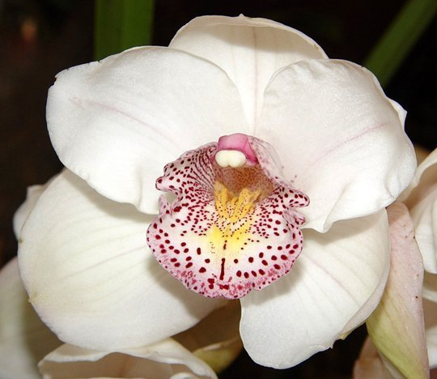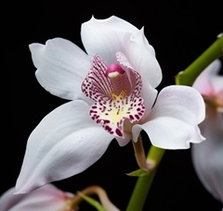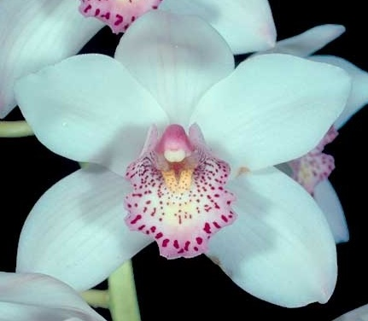Cym. Lovely Angel (Winter Paradise x Gardalvin), 1991, A. R. Bryant, 45 F1 and 124 total progeny, no AOS awards.

Cymbidium Lovely Angel

'Bubbles' AM/AOC

Jul.. 1997, N.S. 10.2cm

Cymbidium Palace Court

'Snow White' HCC/AOS

Jul.. 1979, N.S. 10.2cm

Cymbidium Albanense

'Geyserland' HCC/AOS

Jan.. 2014, N.S. 7.5cm

1. 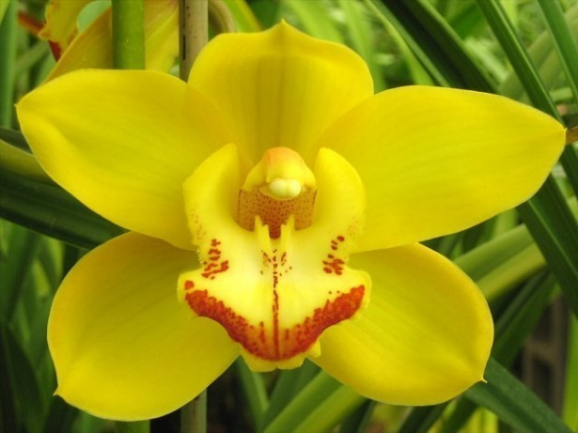Tracey Reddaway (Trigo Royale x Coraki) 1989, Geyserland, 69 F1 and 177 total progeny, no awards
2. Valley Angel (Lunagrad x Angelica0 1982, Valley Orchids, 20 F1 and 136 total progeny, no awards
3. Christmas Angel (Lucy Moor x Angelica) 1982, McBean’s, 14 F1 and 126 total progeny, no awards.

**Cym. Charm** (Ceres x erythrostylum) 1930, Sanders [St. Albans], 44 F1 and 827 total progeny, 1 AOS award an HCC, there is one key cross:

1. 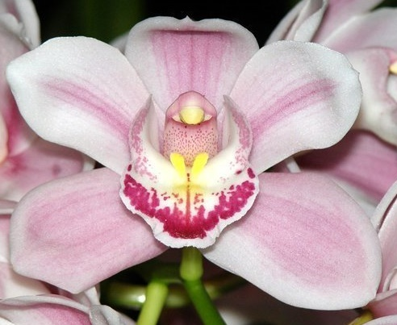Cym. Lucky Rainbow (Newmate x Valley Flower), 1985, Kawano Mericlone, 35 F1 and 226 total progeny, no AOS awards.

Cymbidium Tracey Reddaway Geyserland’

Cymbidium Lucky Rainbow

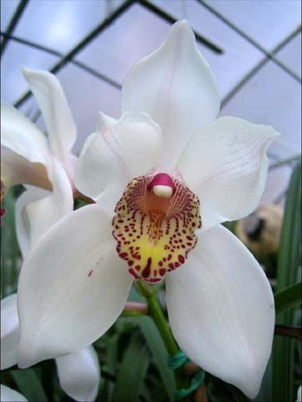**Cym. Early Bird** (Edward Marshall x erythrostylum), 1946, Sanders [St. Albans], 33 F1 and 3325 total progeny. The Early Bird breeding line is the largest associated with Cym. erythrostylum (even though it is the youngest cross of the Cym. erythrostylum group) and there are nine key crosses / breeding lines:

1. Cym. Winter Wonder (Winter Fair x Fanfare), 1980, Stewart Inc., 96 F1 and 408 total progeny, 1 AOS award, an HCC.
2. Cym. Winter Paradise (Winter Fair x Valley Paradise), 1985, A. R. Bryant, 24 F1 and 191 total progeny, no awards.
3. Cym. Gardalvin (Palaker x Winter Fair), 1985, A. R. Bryant, 12 F1 and 211 total progeny, no awards.
4. Cleo’s Melody (Arcadian Melody x Cleo Sherman), 1974, Y. Meredith, 37 F1 and 176 total progeny, 1 AOS award an AM.

Cymbidium Early Bird

'Pacific' JC/AOS

Nov. 1998, N.S. 7.9cm

1. 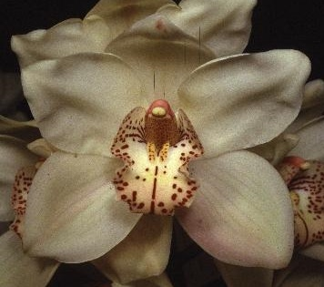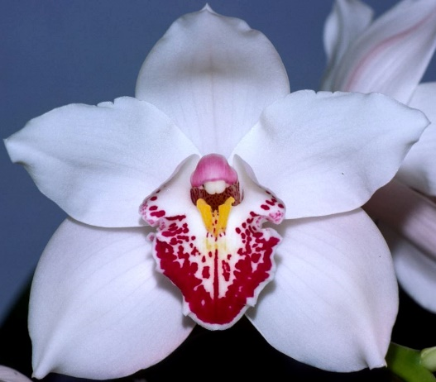Cym. Great Flower (Great Waltz x Valley Flower), 1985, Kawano Mericlone, 39 F1 and 125 total progeny, No awards

Cymbidium Great Flower

Cymbidium Winter Wonder

'Bonanza' HCC/AOS

Feb. 1987, N.S. 11.0cm

Cymbidium Cleo’s Melody

'Eldorado' AM/AOS

Aug. 1977, N.S. 12.6cm

1. 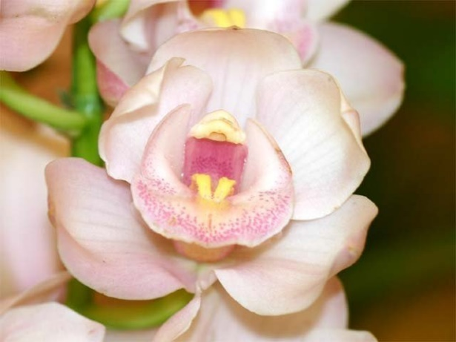Cym. Winter Fair (Fred Stewart x Stanley Fouraker), 1971, Stewart Inc., 91 F1 and 900 total progeny, 1 AOS award an HCC
2. Cym. Palace Court [See Cym. Palace Court above in the Albanense line]
3. Cym. Sylvan Star (Sylvania x Baltic) 1981, A. R. Bryant, 48 F1 and 221 total progeny,
4. Cym. Winter Paradise [See Cym. Winter Paradise above in the Albanense line]

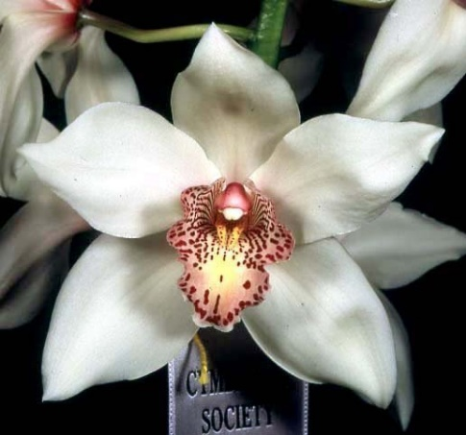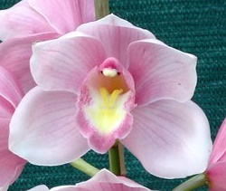

Cymbidium Winter Fair

'Zita' SM/CSS

Feb. 1972, N.S. 15.2cm

Cymbidium Sylvan Star

'Tia'

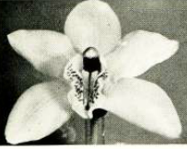**Cym. Atlantes** (Alexanderi x erythrostylum), 1927, Hanbury, 32 F1 and 1865 total progeny, 1 AOS award AM **(Note: Judges comment in award description ”Plant unusual in showing little erythrostylum influence and judges expressed some doublt as to correct labelling”)**

1. Solana Beach (Rincon x Atlantes) 1969, Cobbs’, 142 F1 and 551 total progeny, 1 AOS award AM.
2. 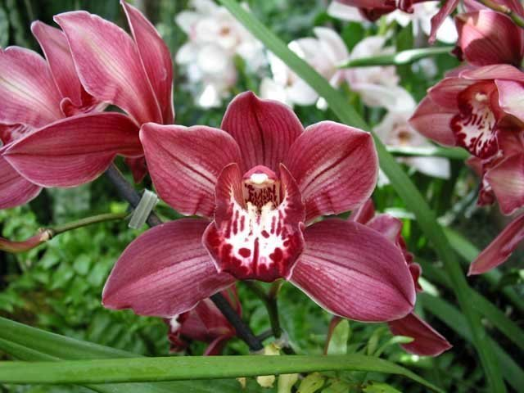Red Beauty (Vanguard x Tapestry) 1979, H. Winter, 275 F1 and 875 total progeny, 4 AOS awards, 3 HCCs, 1 CCM

Cymbidium Atlantes ??

‘Priceless’, AM/AOS

Cymbidium Red Beauty

‘Carmen’, HCC/AOS

Jan. 1986, NS 12.5 cm

Cymbidium Solana Beach

‘Saint Francis’, AM/AOS

Feb. 1986, NS 12.7 cm

Cymbidium Atlantes

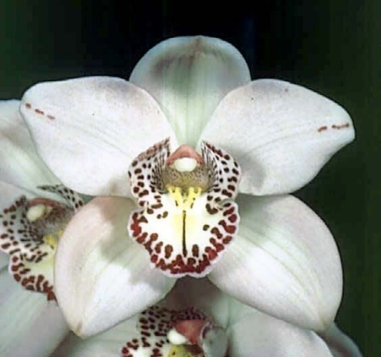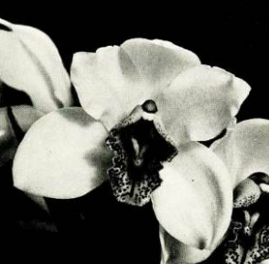**Cym. Parsifal** (erythrostylum x Redshank) 1930, Alexander, 12 F1 and 1136 total progeny, no awards. There are four key crosses in this line;

1. Cym. Tethys (Suva x Khyber Pass) 1969, Stewart Inc., 131 F1 and 389 total progeny, 3 AOS awards, 3 JCs
2. Cym. Rose Armstrong (Sleeping Beauty x Melinga) 1983, A. R. Bryant, 52 F1 and 155 total progeny, 1AOS award and HCC
3. Cym. Culpaulin (Melinga x Sussex Dawn) 1978, Wondabah, 51 F1 and 163 total progeny, no awards
4. 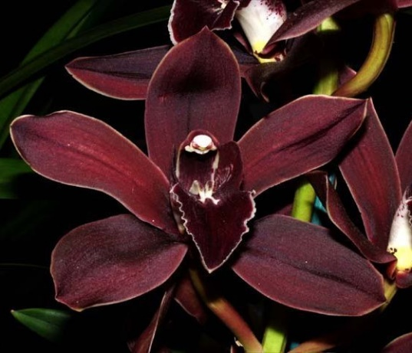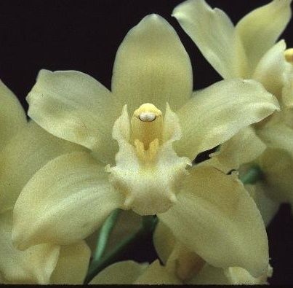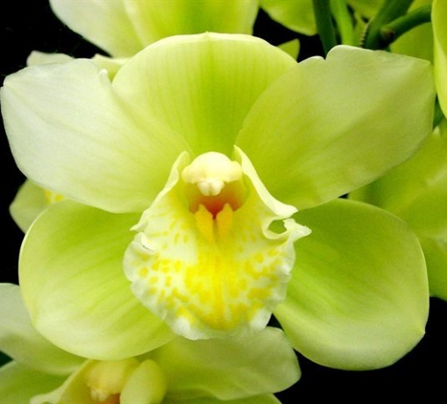Cym Caringal (Melinga x Coraki) 1983, Wondabah, 11 F1 and 123 total progeny, no awards

Cymbidium Tethys

‘Brenda Starr’, JC/AOS

Mar. 1972

Cymbidium Rose Armstrong

‘Sunray’, HCC/AOS

Feb. 1989, NS 10.6 cm

Cymbidium Culpaulin

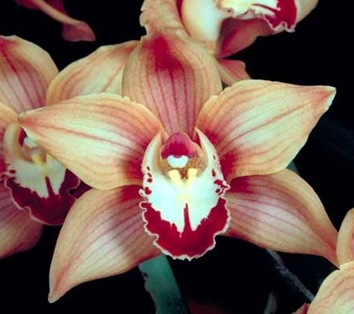**Cym. Windsor** (erythrostylum x Louis Sander) 1940, Royal Gardens Windsor, 4 F1 and 2161 total progeny, no awards. There are two key crosses.

1. Cym. Solana Beach [See Cym. Solana Beach above in the Atlantes line]
2. Cym. Claude Pepper (Rincon x Doris Aurea) 1968, Dos Pueblos, 114 F1 and 580 total progeny, 6 AOS awards, 3 AMs, 3 HCCs.

Cymbidium Claude Pepper

‘Yoko’, AM/AOS

Mar. 1983, NS 8.6 cm

**Recent Cym. erythrostylum Hybrids – High Number Awards**

1. 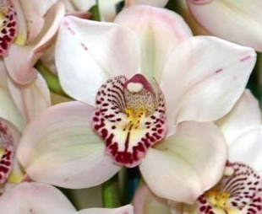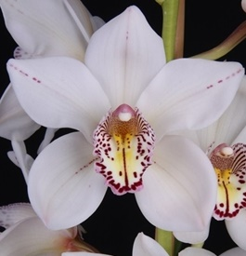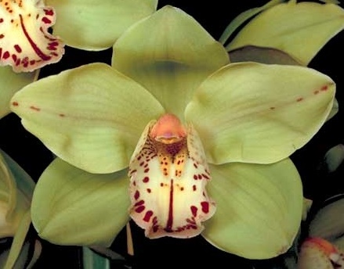Cym. Featherhill Fanfare (Fanfare x Solana Beach), Windsor breeding line, 1982, Featherhill, 27 F1 and 34 total progeny, 13 AOS Awards, 3 AMs, 10 HCCs, Avg. NS 12.05 cm.

Cymbidium Featherhill Fanfare

‘Rose Jade’, AM/AOS

Mar. 1990, NS 10.4 cm

Cymbidium Featherhill Fanfare

‘Bright Day’, HCC/AOS

Mar. 2012, NS 12.1 cm

Cymbidium Featherhill Fanfare

‘Solana Envy’, HCC/AOS

Jan. 1987, NS 11.8 cm

1. Cym. Alegria (Balkis x Rincon), Windsor breeding line, 1962, Greenoaks, 25 F1 and 66 total progeny, 12 AOS awards, 3 AMs, 9 HCCs, Avg. NS 11.95 cm
2. Cym. Via Nogales (Solana Beach x Sussex Dawn) Windsor breeding line, 1973, Gallup & Stribling, 2 F1 progeny, 11 AOS awards, 1 FCC, 4 AMs, 6 HCCs, Avg. NS 11.86 cm
3. 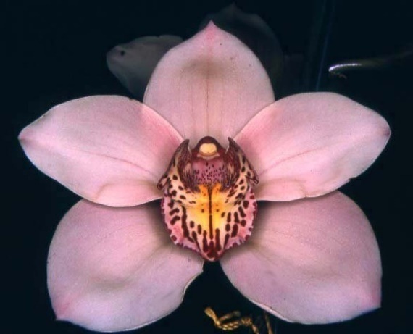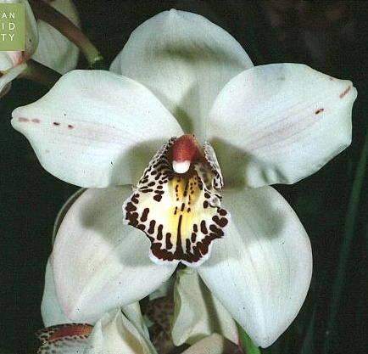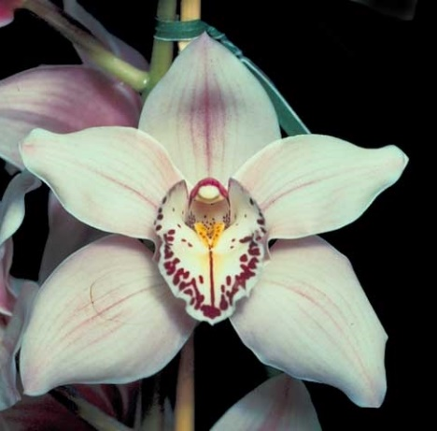Cym. Fancy Free (Rincon x Snow Sprite) Windsor breeding line, 1982, Featherhill, 34 F1 and 97 total progeny, 11 AOS awards, 10 HCCs, 1 CCM, Avg NS 11.43 cm

Cymbidium Alegria

‘St. Lita’, AM/AOS

Mar. 1983, NS 13.0 cm

Cymbidium Via Nogales

‘Lori Jo’, FCC/AOS

Mar. 1983, NS 13.3 cm

Cymbidium Fancy Free

‘Pink Lace’, HCC/AOS

Feb. 1993, NS 11.9 cm

**Comment: It appears that in this line that the breeding plants are NOT necessarily award winning plants.**