Species Data Sheet
Cymbidium sanderae (Rolfe) P.J.Cribb & Du Puy, Genus Cymbidium: 131 (1988)
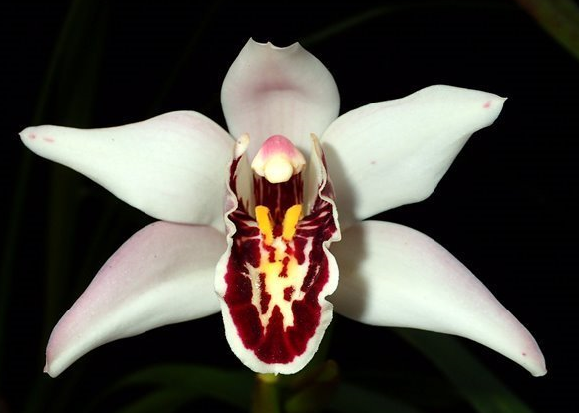
[sim-BID-ee-em SAN-der-ay]
Found as an epiphyte at 4500-4900 ft. (1400-1500 m) on the Lang Bian Plateau of Vietnam in 1904 with 6-cm long, 4-cm in diameter ovoid, lightly bilaterally flattened pseudobulbs with about ten 50-cm by 2.5-cm long leaves. Inflorescense are suberect with three to fifteen 8-cm flowers. Sepals and Petals are cream/white, usually with a flushed pink(a few purple spots at the base are not ususal). The tri-lobed lip is cream, usually heavily marked with maroon, the center and base are yellow and there is a 2-mm wide white petticoat. The flowers occur in the spring, March through May.
In 1967 Milton Carpenter of Evergreen Orchids, located in Belle Glade which is in South Florida just south of Lake Okeechobee, started an investigation / hybridization progrom to identify Cymbidiums that would bloom in both cold and hot temperature (temperature range in Belle Glade are highs of 105°F and night time temperatures in the high 70s to 80°F) tolerance. As a result of this program he states that Cymbidium sanderae “is the major breakthrough in my goal of termperature tolerant cymbidiums of a size and quality to equal the best standard cymbidiums…”
Cymbidium sanderae
Its was also mentioned that Cymbidium sanderae is intermediate in plant size. What does intermediate plant size mean. The table below provides data for two key items that relate to physical size for represenative species for each group:

 | Full size  (Cymbidium insigne) | Intermediate size  (Cymbidium sanderae) | Miniture size  (Cymbidium floribundum)
Pseudobulbs | 8-cm long by 5-cm diameter | 6-cm long by 4-cm diameter | 3.3-cm long by 2.2-cm diameter
Leaves | 100-cm long, 0.7-1.8-cm wide | 50-cm long, 2.5-cm wide | 20-55 cm long, 0.8-2-cm wide

“Cym. sanderae is very uncommon in cultivation, and was believed to have been lost until , in 1961, Mrs. E. D. Menninger uncovered a single specimen in the nursery of Armacost and Royston, California. This plant was flowered in 1963. The named cultivar ‘Emma Menninger’ is a tetraploid plant converted from the diploid by Dr. D. Wimber. “
A detail that is confusing is the relationship between Cym. sanderae and Cym. parishii. The flowers are similar and the parentage of some crosses as reported by the hybridizer are listed in the references differently (I will make an attempt to correct), details follow.
Per du Puy and Cribb reference, I have generated the following table:

 | Cym. parishii | Cym. sanderae
Flower | 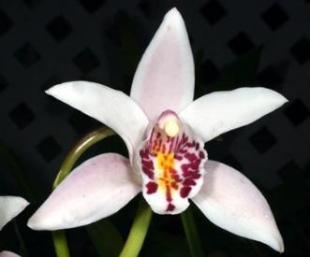 | 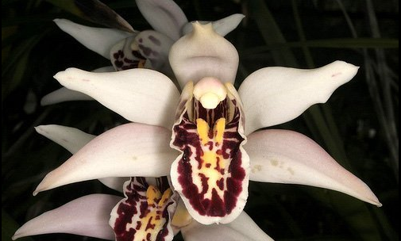  ‘Emma Menninger’
Habitat | ~5500 ft (1650 m), Myanmar near Thialand border in montane forests | 4500-4900 ft. (1400-1500 m), Lang Bian Plateau, Vietnam. Associated with Polyodium Ferns
Pseudobulbs | Fusiform psuedobulbs which grow and flower several seasons before producing new growths | Ovoid, well-developed pseudobulbs which are produced annually
Leaves | Unequally bilobed or forked at the apex | Acute (forms a point) at the apex
Flower spike | Originates from the leaf axials towards the center or apex of the pseudobulb | Originates from the base of the pseudobulb
Number of Flowers | 2-3 | Up to 15
Flowering | June – July | January – March (May)
Another point of confusion in the progeny data to follow is pointed out by the 1987 article “Temperature Tolerant Cymbidiums” by Milton Carpenter of Evergreen Orchids. Of the Cym. parishii ‘sanderae’ crosses mentioned in the article, Cym. Tropical Christmas and Cym. Everglades are listed by OrchidWiz with Cym. parsihii as the parent instead of Cym. sanderae parent. I strongly believe that all of the post 1963 hybrids by Evergreen Orchids and by Andy Easton (A. Easton, Featherhill, and Geyserland) were made with Cym. sanderae (AKA Cym. parishii ‘sanderae’ and Cym. parishii ‘Emma Menninger 4N’) not Cym. parishii and I am sure there are more.
Synonyms:
Cymbidium parishii var. sanderae
Cymbidium parishii ‘sanderae’
Cymbidium parishii ‘Emma Menninger 4N’
Awards:
 | Progeny | AOS Awards
Name | F1/Remain | FCC | AM | HCC | JC | AD | AQ | CCE | CCM | CHM | CBR | Total
Cymbidium sanderae | 78/12033
Note: As noted above there has been confusion with Cym. parishii and the Cym. sanderae ‘Emma Menninger 4N’ was awarded an HCC/AOS in 1979 as Cym. parsihii.

Hybrids: Total of 12033 registered, to the 11th generation
Hybridization Information
 | Progeny
Name / Grexes | F1/Remain | F1 | F2 | F3 | F4 | F5 | F6 | F7 | F8 | F9 | F10 | F11 | Total
Cymbidium sanderae | 78/12033 | 78 | 278 | 312 | 689 | 1924 | 3587 | 3510 | 1408 | 233 | 13 | 1 | 12033
Name / Awards | F1/Remain | F1 | F2 | F3 | F4 | F5 | F6 | F7 | F8 | F9 | F10 | F11 | Total
Cymbidium sanderae | 78/12033 | 47 | 64 | 50 | 795 | 1624 | 1682 | 1074 | 274 | 81 | 1 |  | 5692
The following table is registered hybrids versus time (by decades), both all progeny and then the first three generations as independent populations.
 | to 1919 | 1920-29 | 1930-39 | 1940-40 | 1950-59 | 1960-69 | 1970-79 | 1980-89 | 1990-99 | 2000-09 | 2010-
All Progeny | 9 | 44 | 176 | 175 | 337 | 925 | 753 | 1817 | 2762 | 2891 | 2144
F1-1st Gen | 7 | 3 | 0 | 0 | 0 | 0 | 4 | 13 | 30 | 17 | 4
F2-2nd Gen | 0 | 30 | 35 | 16 | 8 | 8 | 2 | 7 | 41 | 71 | 60
F3-3rd Gen | 0 | 11 | 68 | 48 | 42 | 36 | 20 | 19 | 12 | 28 | 28
The line associated with ‘All Progeny’ indicates a continued interest in hybrids associated with Cym. sanderae. The first generation crosses points out the importance of the finding of Cym. sanderae at Armacost and Royston, California; the subsequent conversion to a tetrapoid named cultivar ‘Emma Menninger’ in the 1960’s; the finding that Cym. sanderae is more temperature tolerant than the other large Cymbidiums; and the interest generated by Milton Carpenter in his temperature tolerant Cymbidium hybridization program.
Dominate trait’s
- Temperature tolerance
- Better / full shape of flower
- Red lip
- An autumn and heavier spring blooming
- Sweet violet-like fragrance
- Upright panicle with many smallish flowers
Historical Hybrids:
Cym. sanderae has been heavily used in hybridization since it was discovered and has the fifth most progeny among Cymbidium species (and is NOT in the parentage of the workhorse Cym. Alexanderi cross). The table below provides some of the historical hybrids with the most progeny (criteria to be included in the table are more than ~2500 progeny and line started prior to 1950):

Name |  |  | Parent | Parent | Year | F1 Offspr | Total Offspr | Originator | Percent Sanderae
Dryad |  |  | sanderae | insigne | 1914 | 32 | 10168 | Sir G. Holford | 50.0%
 | Redstart |  | Dryad | Pauwelsii | 1920 | 21 | 2716 | Sir G. Holford | 25.0%
 | Merlin |  | Dryad | Alexanderi | 1920 | 13 | 5001 | Sir G. Holford | 25.0%
 |  | Flamingo | Merlin | Alexanderi | 1925 | 62 | 3606 | Sir G. Holford | 12.5%
 |  | Mirabel | Flamingo | Petrel | 1933 | 8 | 3240 | Alexander | 19.0%
 |  | Miretta | Claudette | Mirabel | 1946 | 117 | 2851 | McBean's | 8.9%
 | Landrall |  | Dryad | lowianum | 1920 | 12 | 3672 | Sir G. Holford | 25.0%
 |  | Sussex | Landrall | Profusion | 1940 | 50 | 3579 | McBean's | 12.9%
 |  | Sussex Dawn | Sussex | Ramboda | 1955 | 108 | 2620 | McBean's | 6.0%
 | Kittiwake |  | Dryad | Gottianum | 1920 | 10 | 4291 | Sir G. Holford | 25.0%
 |  | Rosanna | Alexanderi | Kittiwake | 1927 | 127 | 4035 | Alexander | 12.5%
 |  | Balkis | Alexanderi | Rosanna | 1934 | 308 | 2980 | L. de Rothschild | 6.0%
Garnet |  |  | sanderae | lowianum | 1915 | 22 | 7141 | Sir G. Holford | 50.0%
 | Petrel |  | Garnet | Pauwelsii | 1922 | 15 | 3807 | Sir G. Holford | 25.0%
 |  | Mirabel | See Merlin-Miretta line in Dryad above
 | Bustard |  | Lowio-grandiflorum | Garnet | 1922 | 6 | 4812 | Sir G. Holford | 25.0%
 |  | Chiron | Bustard | President Wilson | 1935 | 12 | 4767 | Armstrong / Brown | 12.9%
 |  | Doris Aurea | Chiron | Lysander | 1942 | 74 | 3616 | Black & Flory | 5.9%
Elfin |  |  | sanderae | Pauwelsii | 1918 | 15 | 3136 | Sanders [St. Albans] | 50.0%
 | Cremona |  | J. Davis | Elfin | 1933 | 15 | 3108 | McBean's | 25.0%
 |  | Carisona | Carisbrook | Cremona | 1947 | 47 | 2689 | McBean's | 12.5%
 |  | Khyber Pass | Profita | Carisona | 1956 | 76 | 2314 | Stewart Inc. | 6.3%
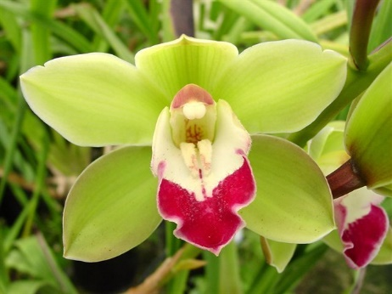
From this table, you can see that there are three major primary crosses: Cym. Dryad (sanderae x insigne), Cym. Garnet (sanderae x lowianum), and Cym. Elfin (sanderae x Pauwelsii). All of these crosses were made prior to 1920. Cym. Dryad has the most progeny and there are four key lines and the main progeny used after 1950 are:
- Cym. Redstart (Dryad x Pauwelsii) – Most notable 1950’s cross is Cym. Alnwick Castle (Reginald x Corinth) with 1,262 progeny. Percentage of Cym. sanderae is roughly 3%, I assume very little influence going forward.
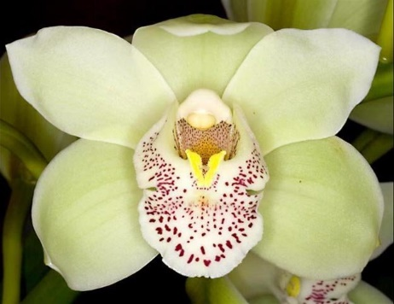
- Cym. Merlin (Dryad x Alexanderi) – Most notable 1950’s cross is Cym. Miretta (Claudette x Mirabel) with 2,851 progeny. Notable traits of this cross are green color, vivid banded lip, lobed sepals and petals, and large flowers.
Cym. Miretta
‘Mem. A. A. McBean’ FCC/RHS
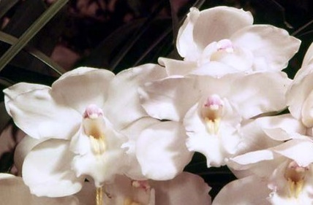
- Cym. Landrall (Dryad x lowianum) – Most notable 1950’s cross is Cym. Sussex Dawn (Sussex x Ramboda) with 2620 progeny. Notable traits of this cross are a good white flower and long inflorescence of twenty-five to thirty flowers.
Cym. Sussex Dawn ‘Concolor’ AM/AOS
- Cym. Kittiwake (Dryad x Gottianum) – Most notable1950’s cross is Cym. Balkis (Alexanderi x Rosanna) with 2980 progeny. M. Carpenter in his program to develop temperature tolerant Cymbidiums had seven different clones of Cym. Balkis in his initial collection of over 200 standard Cymbidiums, the clone ‘Nevada’ was the only one cultivar that he was successfully able to bloom regularly in Florida (out of this initial collection only four standard size cymbidiums were select).
Cym. Balkis ‘Nevada’ HCC/AOS
The second Cym. sanderae breeding line is Cym. Garnet (sanderae x lowianum) with two key breeding lines:
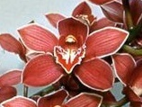
- Cym. Petrel (Garnet x Pauwelsii) – Most notable 1950’s cross was Cym. Mirabel (Flamingo x Petrel) which is in the Cym. Dryad / Merlin line above.
- Cym. Bustard (Lowio-grandiflorum x Garnet) – Most notable 1950’s cross was Cym. Doris Aurea (Chiron x Lysander) with 3616 progeny. Cym. Doris Aurea flower shape is like Cym. eburneum (parentage is 12.87% eburneum) with forward petals and broad, somewhat sagging petals. The flower is golden bronze with a deep ox-blood banded lip. It is an early-bloomer. Breeding strengths are massiveness and fullness of form and enhancement of the other parent flower color.
The third Cym. sanderae breeding line is Cym. Elfin (sanderae x Pauwelsii) – Most notable 1950’s cross was Cym. Khyber Pass (Profita x Carisona) with 2314 progeny. Breeding strength is the plant color and the red banded lip.
Cym. Khyber Pass
‘Treva’ AD/CSA
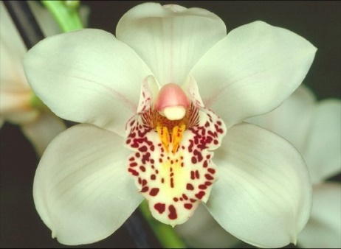
Recent primary hybrids with Cym. sanderae (Temperature Tolerant Hybrids?) after 1966:
- Cym. Rod Stewart (Cym. sanderae x Cym. Fred Stewart, Featherhill, 1982), no awards, 27 F1 and 58 total progeny. A tetraploid white with excellent form. Key progeny are Cym Anna Szabo (Cym. Rod Stewart x Cym. Hazel Tyers), Geyserland, 1993, white with a dark red banded lip, 6 awards, 1 HCC/AOS, 12 F1 and 22 total progeny and Cym. Hungarian Rhapsody (Cym. Music Box Dancer x Cym. Anna Szabo), Geyserland, 1997, white with broad pink petticoat lip, no awards, 7 F1 progeny.
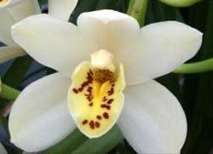
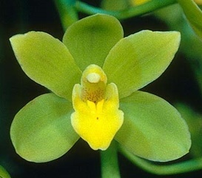
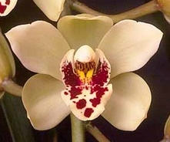
- Cym. Gladys Whitesell (Cym. Fifi x Cym. sanderae) Geyserland, 1983, 26 awards, 3 AMs, 10 HCCs, 1 CCM, and the remaining are non AOS awards, avg. NS 6.7cm, 21 F1 and 27 total progeny. White to pale green with red markings in the lip. Key progeny are Cym. Memoria Andy Warhol (Cym. Gladys Whitesell x Cym. Bill Quinn), Geyserland, 1996, 4 awards, 1 HCC/AOS the other awards are CSA awards, 4 F1 progeny.
Cym. Gladys Whitesell
‘The Charmer’ AM/AOS
Cym. Gladys Whitesell
‘Rebel’ HCC/AOS
Cym. Rod Stewart
‘The Wedding Party’
Cym. Gladys Whitesell
‘New Horizon’ AM/AOS
- Cym. Everglades (Cym. parishii [per Feb. 87 AOS Bulletin article Cym. sanderae, aka Cym. parishii ‘sanderae’] x Cym. Peter Pan) Everglades, 1981, 4 awards, 1 AM, 1 HCC, the other two are CAS awards, avg. NS 6.9 cm, 13 F1 and 24 total progeny. Limited information available of progeny.
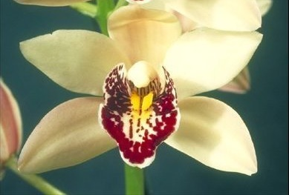
Cym. Everglades
‘Hot Lips’
Cym. Everglades
‘Diamond Jubilee’ AM/AOS
Cym. Everglades
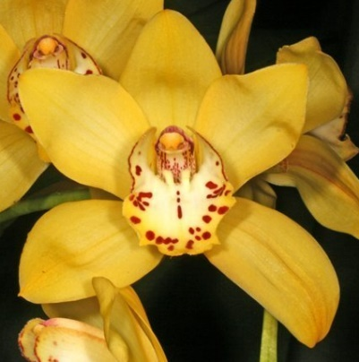
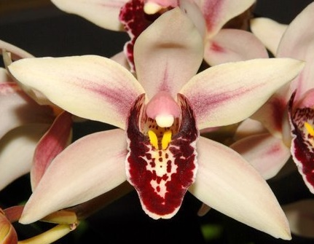
References:
www.orchidspecies.com
http://apps.kew.org/wcsp/qsearch.do
https://secure.aos.org/aqplus/SearchAwards.aspx
OrchidWiz.Database 13.1
Du Puy, D. & Cribb, P., 1988, The Genus Cymbidium
Du Puy, D. & Cribb, P., 2007, The Genus Cymbidium (Botanical Magazine Monograph)
Carpenter, M. O., 1987, Temperature Tolerant Cymbidiums, Amer. Orchid Soc. Bull. 56(2): 123-129
Gripp, P., 1967, Ten Proven Diploid Cymbidiums Good for Future Use, Amer. Orchid Soc. Bull. 36(7): 582-58

