The Genus Catasetum (Rich. ex Kunth 1822)
Type: Ctsm. macrocarpum [kat-a-SEE-tum mack-row-KAR-pum]
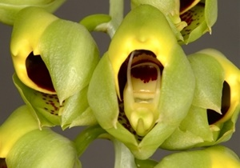
There are 186 species and 35 (35 Kew Monocat list [Dec. 2016) natural hybrids ranging from Mexico to Argentina and the West Indies (with a concentration in Brazil) of this deciduous leaved genus that has two forms of flowers, both male and female. The fleshy pseudobulbs can carry eight to twelve leaves. The inflorescence starts at the base of the pseudobulbs and may be erect or pendulous and carry male, female, or both types of flowers (technically referred to as ‘sexual dimorphism’). Female flowers are achieved by giving a mature plant high direct light, males will be produced by shading them some. The male flowers are characterized with the ability to eject their pollina up to eight feet from the plant. Male flowers are showy, highly fragrant, short-lived (five to ten days), and have a pollen-ejecting trigger below the column. Female flowers are helmet-shaped, generally green, lightly fragrant, generally long-lasting (four to six weeks), and the column has a narrow slot to allow access to the stigmatic surface. Breeding in the genus Catasetum has been focused on the showy male flowers. Breeding of Catasetums can be challenging since both male and female flowers are required and it is not unusual for plants to go several years without producing female flowers [seems to imply that more than light conditions are required for female flowers]. Catasetum fragrances are reminiscent of a mixture of pine, eucalyptus, mint, and cinnamon and is used to attract male euglossine bees.
Ctsm. macrocarpum
OW George Carr, HCC/AOS
Nov 2011, NS 3.8
Catasetums are divided into three sections with one section further divided into three subsections:
SUBGENUS Catasetum SECTION Catasetum- has crossed asymmetrical antennae
SUBGENUS Catasetum SECTION Isoceras - has symmetrical antennae
SUBGENUS Catasetum SECTION Isoceras SUBSECTION Isoceras- has symmetrical antennae that are parallel to each other
SUBGENUS Catasetum SECTION Isoceras SUBSECTION Divaricatae - has symmetrical antennae that go away from each other
SUBGENUS Catasetum SECTION Isoceras SUBSECTION Convergentes - has symmetrical antennae that come towards each other
SUBGENUS Pseudocatasetum - has antennae that are short and not well developed
This genus consists primarily of tropical and subtropical epiphytic (lithophytic occasionally) plants growing in open, lowland forested areas at elevations up to 1,500 meters (5,000 feet) preferring warmer temperatures and a distinct dry season. Water heavily from mid-May to mid-November with a distinct dry season (NO water, any water at all will entice root rot) from mid-December to mid-April. The plants are found on trees (trunk, branches, crooks where they receive bright dappled light most of the day and a constant breeze. Pseudobulbs are ovoid, conical, or fusiform with large plicate, narrow in basal part deciduous leaves. Each pseudobulb can have up to four erect or arching to pendulant inflorescences in one flowering season from the base is unbranched and may be erect, arching, or pendulous. Flowers few to many. [Note: Common name / meaning refers to the 2 long bristles at the base of the column on the male flowers that trigger the pollina.]
Point Scale using the general point scale or the Miltonia scale depending on the lip.

Species marked with a * are used the most in hybridization |  |  |  |  |  | Progeny | AOS Awards
Kew Name | Section | Subsection | Habitat, Country | Temp | Season | F1/  Remain | FCC | AM | HCC | JC | AD | AQ | CCE | CCM | CHM | CBR | Total
Catasetum barbatum | Isoceras | Isoceras | Trinidad to Tropical South America | Warm | Nov. to Apr., primarily Dec. | 25/30 |  | 1 | 2 | 1 |  |  |  |  | 1 | 1 | 6
Catasetum denticulatum | Isoceras | Convergentes | Brazil | Warm | June to October | 31/40 |  | 2 |  |  |  |  |  |  | 1 |  | 3
Catasetum discolor | Pseudo-catasetum |  | Tropical South America | Warm | Year round, peak Oct to March | 4/4 |  |  |  |  |  |  |  |  |  | 1 | 1
Catasetum expansum* | Catasetum |  | Ecuador | Warm | Year round, peak in fall | 41/243 |  | 10 | 5 | 5 |  |  |  |  |  | 2 | 22
Catasetum fimbriatum | Isoceras | Convergentes | Tropical South America | Warm | Year round, peak Aug to Dec | 38/70 |  | 4 | 1 |  |  |  |  | 5 | 1 |  | 11
Catasetum lanciferum | Isoceras | ?? | Brazil | Warm | January | 15/19 |  |  |  |  |  |  |  |  |  | 1 | 1
Catasetum macrocarpum | Catasetum |  | Trinidad to Nothern Argentina | Warm | Year round, peak in October | 18/24 |  | 1 | 1 |  |  |  |  | 1 |  |  | 3
Catasetum pileatum* | Catasetum |  | Trinidad to Ecuador | Hot | Year round, peak in August to November | 69/278 | 1 | 27 | 9 |  |  |  |  | 4 |  | 1 | 42
Catasetum saccatum | Catasetum |  | Tropical South America | Warm | Year round, peak in October | 17/42 | 1 | 6 | 4 | 1 |  |  |  | 2 |  | 2 | 16
Catasetum spitzii | Isoceras | Divaricatae | Brazil | Warm | February | 11/13 | 1 |  |  |  |  |  |  |  | 1 |  | 2
Catasetum tenebrosum | Isoceras | Convergentes | Ecuador, Peru, Brazil | Warm | Mar. to Nov., primarily Apr.-Jun. | 25/85 |  | 23 | 6 | 3 |  |  |  | 3 |  | 3 | 38
Catasetum vinaceum | Isoceras | Convergentes | Brazil | Warm | January | 15/16 |  |  | 1 |  |  |  |  |  | 2 |  | 3
Table of Top 10 species used in hybridization plus at least one species from each Section / Sub-section
Key: Warm: Warm to Hot (66F to 85F at night)
Hot: Hot (75F to 87F at night)

There are two species, Catasetum expansum and Catasetum pileatum, that are used the most in hybridization (Species report for both to follow).
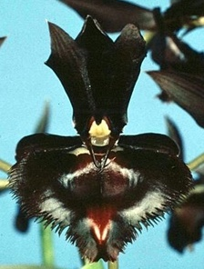
Catasetum tenebrosum has the most AOS awards. Three species (Catasetum pileatum, Catasetum saccatum, and Catasetum spitzii) have received FCCs.
‘Significant’ Hybrids (without Ctsm. pileatum or Ctsm. expansum in their background):
Ctsm. Francis Nelson (socco x fimbriatum), 1974, Beall, No progeny, 8 AOS awards (4 AMs and 4 HCCs)
Ctsm. Dragon’s Teeth (fimbriatum x saccatum), 1991, JEM, 6 F1 and 7 total progeny, 5 AOS awards (4 AMs and 1 HCC). Significant progeny; Ctsm. Ten Dragons (Dragon’s Teeth x tenebrosum), 2003, F. Clarke, No progeny, 3 AOS awards (2 AMs and 1 HCC)
Catasetum Francis Nelson
‘Memoria Phyllis Roberts’, AM/AOS
Sep 1997, NS 6.5 cm
Catasetum Dragon’s Teeth
‘Sunset Valley Orchids’, AM/AOS
Sep 2003, NS 8.0 cm
Ctsm. Jumbo Ego (atgratum x tenebrosum), 2003, Jumbo Orchids, 1 F1 progeny, 2 AOS awards (1 AM and 1 HCC)
Ctsm. Brent Baker (rectangulare x callosum), 2010, B. Baker, No progeny, 2 AOS awards (1 AM and 1 HCC)
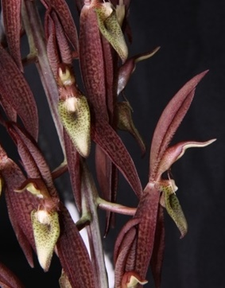
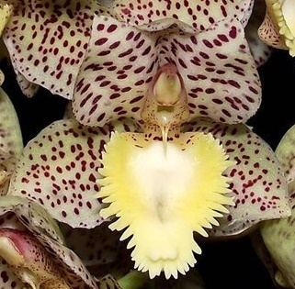
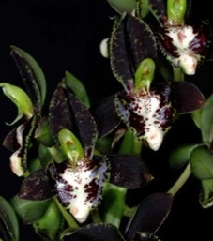
Ctsm. Dentigrianum (denticulatum x tigrinum), 2012, Toninho, No progeny, 3 HCC/AOS awards
Catasetum Jumbo Ego
‘David Bird’, AM/AOS
Apr 2008, NS 5.5 cm
Catasetum Brent Baker
‘Priscilla’, AM/AOS
Sep 2011, NS 2.0 cm
Catasetum Dentigrianum
‘B-C’, HCC/AOS
Oct 2015, NS 3.0 cm

Potential new breeding line, Mini Catasetums: An important line of breeding was started in 2000 with the introduction into cultivation of Ctsm. denticulatum, a specie with a compact growing habit, short pseudobulbs (six inches tall), yet has 25 or more flowers several times a season. This is the Catasetum that modern hobbyist (limit bench space) have been looking for. It has been used successfully in many crosses and the progeny have been well received. Just a few of the over 40 crosses are below and the future appears to be VERY bright for this breeding line:
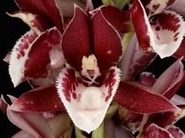
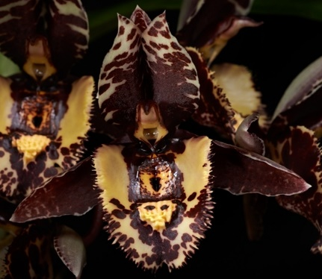
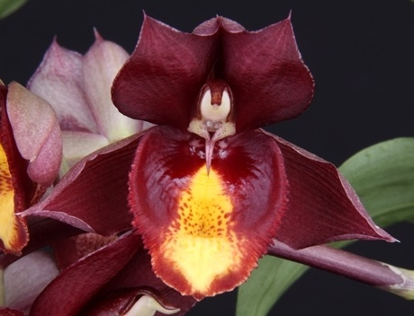
Catasetum Chuck Taylor
‘SVO Sun Spot’, AM/AOS
(Portagee Star x denticulatum)
Jun 2013, NS 5.7 cm
Catasetum Melana Davison
‘Bombshell’, AM/AOS
(denticulatum x Penang)
Oct 2014, NS 6.5 cm
Catasetum Karen Armstrong
‘Owen’, HCC/AOS
(Susan Fuchs x denticulatum)
Sep 2013, NS 7.2 cm

References:
www.orchidspecies.com
http://apps.kew.org/wcsp/qsearch.do
https://secure.aos.org/aqplus/SearchAwards.aspx
Holst, A.W., The World of Catasetums, 1999
Bechtel, H.; Cribb, P.; Launert, E.; The Manual of Cultivated Orchid Species, 1992
OrchidWiz.Database x3.2, update: March 2017
Orchid Digest, Oct., Nov., Dec., 2016, 80(4), all four articles but mainly The State of Affairs in Breeding Catasetinae, Clarke, F., pp. 174-234
Interesting Tidbits

The Table below list the names of the existing intergeneric cross made with Catasetum and the number of cross that exist: 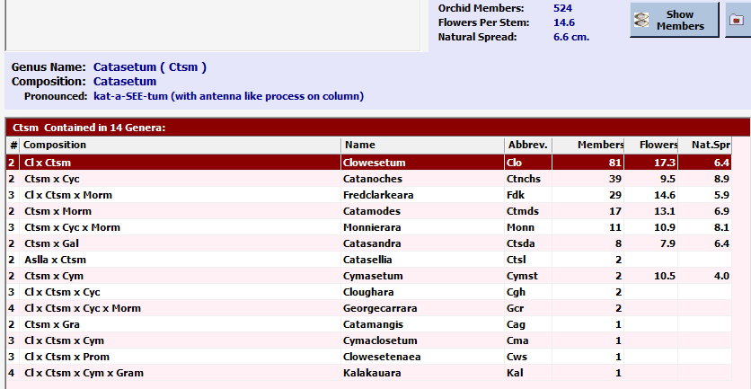

Since there are 186 species, and from above 524 members of the Catasetum family, that means there are 338 hybrids.

The intergeneric cross with the most progeny is Clowesetum (Clowesia x Catasetum) with more than twice as many members as the next intergeneric cross Catanoches (Catasetum x Cycnoches).

Since Catasetum, Cycnoches, Mormodes, and Clowesia are well mixed in terms of intergeneric breeding, they will be handled together.

A brief review of some of the species indicates that distribution of male and female flowers is not consist within the species. While some species may have male and female flowers on the same inflorescences other species have separate inflorescences for male and female flowers (and the number of flowers per inflorescences is not the same for the two, male / female).

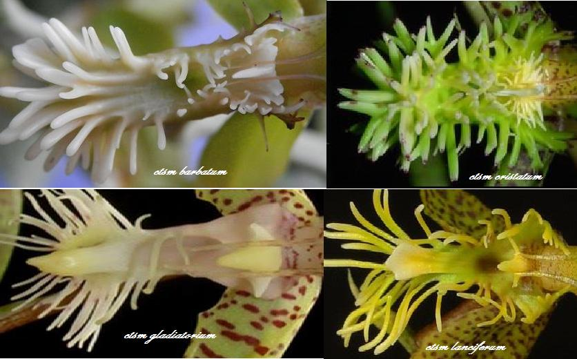
Picture of labellum detail of four Catasetum species (http://www.orchidboard.com/community/catasetum-and-stanhopea-alliance/69406-catasetum-gladiatorium.html):
Species Data Sheet/Building Block Report
Catasetum pileatum Rchb.f., Gard. Chron., n.s., 17: 492 (1882)
Catasetum expansum Rchb.f., Otia Bot. Hamburg.: 9 (1878)
Catasetum Orchidglade (Ctsm. pileatum x Ctsm. expansum)
The above three plants (two species and the cross between the two species) account for the vast majority of crosses / awards associated with Catasetum, consequently I have decided to report on the three together.
Catasetum pileatum, [kat-a-SEE-tum pee-lee-AY-tum]
Catasetum pileatum has the largest flower (more than 4 in [10 cm]) in the genus with inflorescences that carry up to 13 blossoms and lips as big as the palm of your hand. It is a large sized, hot growing epiphytic species comes from Venezuela, Colombia, Trinidad, Brazil, and Ecuador occurring in lowland forest at elevations around 100 to 200 meters under tropical conditions with a long-wet period and a short dry season. The 15-25 cm long clustered pseudobulbs are fusiform-ovoid, several noded that are enveloped by several leaves bearing sheaths carrying distichous, lanceolate, suberect, plicate 20-35 cm leaves and blooms in the spring through fall on a basal, erect to pendant, 12-16" [30-40 cm] long racemose inflorescence carrying fragrant flowers that open very flat and arise on a mature pseudobulb. Flower size, number of flowers, and characteristic lip make Ctsm. pileatum an important parent in breeding. The flowers are typically pale green, but white, yellow, and red clones (var. imperial) exist. Flower life is usually six to ten days, and well-grown plants can produce two to four inflorescences from a newly matured pseudobulb.
Catasetum pileatum
‘Snow White’, FCC/AOS
Aug 2014, NS 9.0 cm
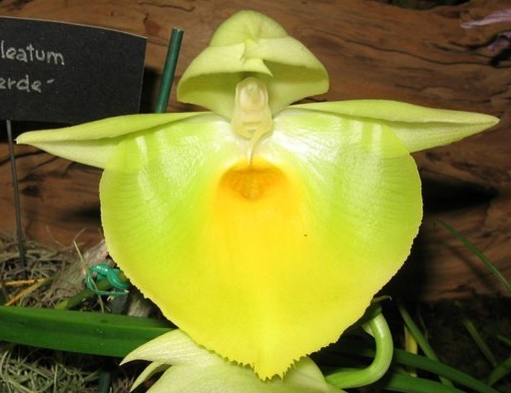
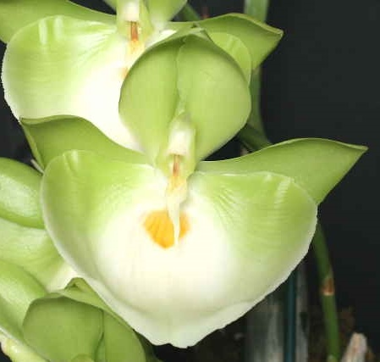
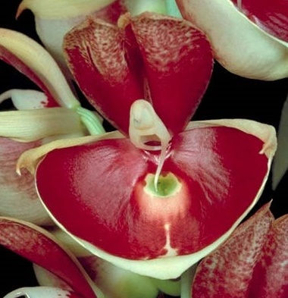
This was the national flower of Venezuela until 1921 when it was changed to Cattlaya mossiae var wagnerii.
Catasetum pileatum
‘Oro Verde’, HCC/AOS
Dec 1968

Catasetum pileatum
‘Imperial’, AM/AOS
Jul 1984, NS 8.5 cm

Catasetum pileatum
‘Jumbo Green Gold’, HCC/AOS
Oct 2008, NS 9.0 cm

Varieties:
Catasetum pileatum var. album (Linden & Rodigas) Hoehne, Fl. Brasílica 12(6): 90 (1942)
Catasetum pileatum var. imperiale (L.Linden & Cogn.) Cogn. ex Hoehne, Fl. Brasílica 12(6): 90 (1942)
Catasetum pileatum var. lindenii (Gower) Hoehne, Fl. Brasílica 12(6): 90 (1942)
Catasetum pileatum var. regale (Gower) Hoehne, Fl. Brasílica 12(6): 90 (1942)

Awards:
 | HCC | AM | FCC | JC | CCM | CBM | CHM | TOTAL
AOS | 9 | 27 | 1 |  | 4 | 1 |  | 42
Year(s) Awarded | 1971-2012 | 1964-2009 | 2014 |  | 1974-1985 | 1975

Breeding Characteristics:
Flower size, number of flowers, and characteristic lip make Ctsm. pileatum an important parent in breeding.
Per the article on the color variation of Catasetum pileatum, Study on the Morphology and Pigmentation of Catasetum pileatum Rchb.f, and its Natural Hybrids by Pierre Couret in the March 1977 issue of AOS Bulletin provides the following natural occurring distribution in a region of Venezuela:
50% White
20% Red
14% Green
3% Golden / Yellow
13% White with red spots or markings

‘Major’ Catasetum Hybrids (without Ctsm. Orchidglade):
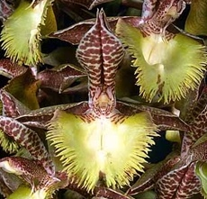
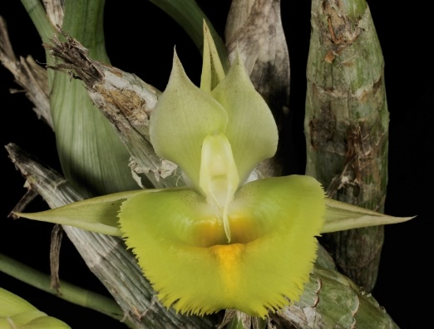
Ctsm. Doris’s Choice (fimbriatum x pileatum), 1989, JEM, 4 F1 and 12 total progeny, 3 AOS awards (1 AM and 2 HCCs). Major progeny is Ctsm. Frilly Doris (Doris’s Choice x Dona Marie), 2002, F. Clarke, 8 F1 progeny, 2 AOS awards (1 AM and 1 HCC).
Catasetum Frilly Doris
‘Sunset Valley Orchids’ HCC/AOS, Aug 2002, NS 9.3 cm
Aug 2014, NS 9.2 cm
Catasetum Doris’s Choice
‘Mark’s Green Gold’, HCC/AOS
Aug 2014, NS 9.2 cm
Ctsm. Portagee Star (pileatum x Black Knight), 2002, F. Dishman, 6 F1 and 11 total progeny, 4 AOS awards (1 AM, 2 HCCs, 1 CCM). Major progeny is Ctsm. Chuck Taylor (Portagee Star x denticulatum), 2011, F. Clarke, 4 F1 progeny, 4 AOS awards (3 AMs, 1 HCC)
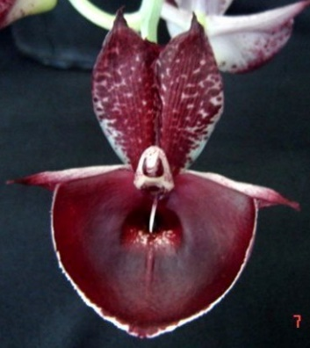
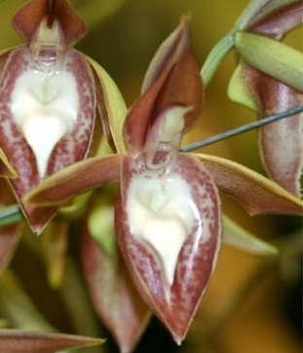
Ctsm. Alexis Pardo (pileatum x tabulare), 1996, 5 F1, no awards
Ctsm. Mary Spencer (socco x pileatum), 1974, R. W. Spencer, 4 F1 and 21 total progeny, no AOS awards
Catasetum Mary Spencer
AV1/CAOB
Catasetum Alexis
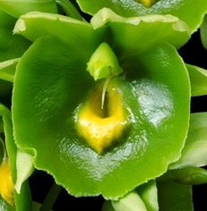
Catasetum expansum, [kat-a-SEE-tum eks-PAN-sum]
Catasetum expansum gets its name from the flat expanded lip, which is somewhat square in most clones. It is a large sized, showy, hot to cool growing epiphytic from Northeastern Ecuador occurring in dry forest at elevations around 20 to 1500 meters with a long-wet period and a short dry season. The pseudobulbs are spindle shaped several leaves carrying several deciduous, plicate, lanceolate leaves that can bloom from May until December on a basal, 12" [30 cm] long, several [6] flowered arching raceme arising on a newly forming pseudobulb carrying either male or female flowers. Flower size, number of flowers, and characteristic lip make Ctsm. expansum an important parent in breeding. The flowers are typically 7.5 cm [3 in] across and are green to yellow, either with or without spots, but there is always a raised (usually darker or different color) callus in the center of the lip. Flower life is usually six to ten days, and mature plants have been known to produce five inflorescences a season carrying up to 18 flowers each.
Catasetum expansum
‘SVO Midori’, AM/AOS
Dec 2014, NS 7.6 cm

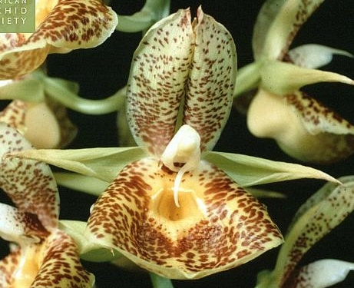
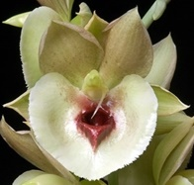
Catasetum expansum
‘Como Conservatory’, AM/AOS
Jan 2000, NS 9.4 cm
Catasetum expansum
‘Clown Alley’, HCC/AOS
Sep 2007, NS 9.6 cm
Catasetum expansum
‘Mary Motes’, AM/AOS
Aug 2015, NS 8.7 cm
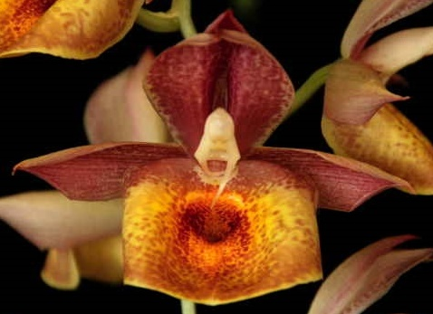
Varieties:
None
Awards:
 | HCC | AM | FCC | JC | CCM | CBM | CHM | TOTAL
AOS | 5 | 8 |  | 3 |  | 1 |  | 17
Year(s) Awarded | 1977-2008 | 1981-2015 |  | 1981-2002 |  | 1974

Breeding Characteristics:
Flower size, number of flowers, and characteristic lip make Ctsm. pileatum an important parent in breeding.

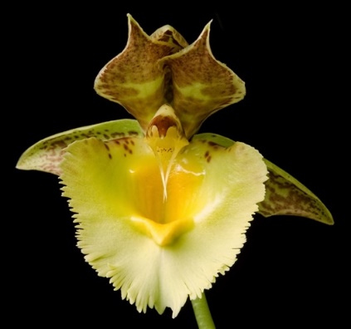
‘Major’ Catasetum Hybrids (without Ctsm. Orchidglade):
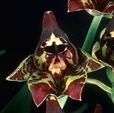
Ctsm. FanFair (expansum x saccatum), 1982, Jones & Scully, no progeny, 8 AOS awards (7 HCCs, 1 CCM)
Catasetum FanFair
‘Mark’s Surprise’, HCC/AOS
Jun 2014, NS 7.2 cm
Ctsm. Jumbo Eagle (sanguineum x expansum), 2000, Jumbo Orchids, no progeny, 5 AOS awards (4 HCCs, 1 JC)
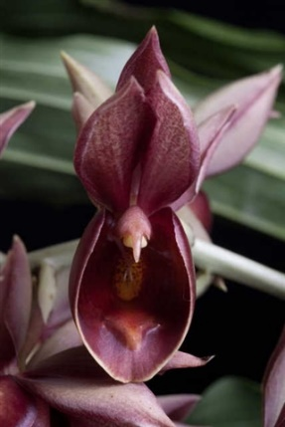
Ctsm. Thinger Dinger (expansum x fuchsia), 1988, C. Pearson, 6 F1 and 8 total progeny, 1 AM/AOS award. Major progeny: Ctsm. Jacqueline Perez (barbatum x Thinger Dinger), 2009, M. Margolis, no progeny, 3 AOS awards (1 AM, 2 HCCs).
Catasetum Thinger Dinger
‘Pretty Birdie’, AM/AOS
Aug 2011, NS 6.8 cm
Catasetum Jacqueline Perez
‘Caroline Loves Nini’, AM/AOS
Aug 2009, NS 9.6 cm
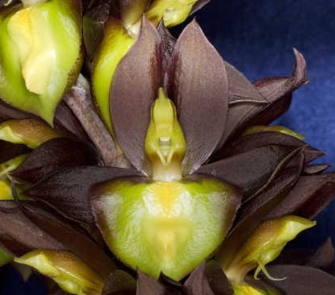
Ctsm. Black Knight (expansum x tenebrosum), 1996, W. Neptune, 3 F1 and 15 total progeny, 1 AM/AOS award
Catasetum Black Knight
‘Jardin botanique de Montréal'
AM/AOS, Apr 2007, NS 7.7 cm
Catasetum Jumbo Eagle
‘Lake Archer’, HCC/AOS
Sep 2003, NS 6.7 cm
Aug 2014, NS 9.2 cm
Ctsm. Marge Soule (fimbriatum x expansum), 1985, L. Soule, no progeny, 5 awards
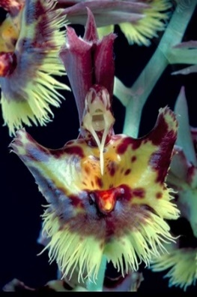
Catasetum Marge Soule
‘Orchid Art’, HCC/AOS
Aug 2011, NS 6.8 cm
Catasetum Orchidglade (Ctsm. pileatum x Ctsm. expansum)
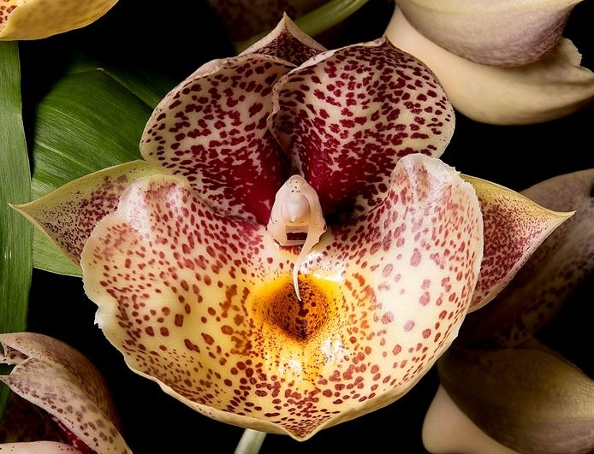
Catasetum Orchidglade is a cross between Catasetum pileatum and Catasetum expansum that was made in 1974 by Jones & Scully. It has been an extremely successful hybrid with the third most Catasetum hybrids behind the parent species (Ctsm. Orchidglade is a parent in 59% of all Catasetum hybrids) along with 43 F1 progeny. The flowers range from green to yellow to red, with and without spots, examples are provided with some of the awarded cross shown below. The cross has received 19 AOS awards (14 AMs, 4 HCCs, and 1 CCM).
Catasetum Orchidglade
‘Krull Smith’, AM/AOS
Oct 2014, NS 10.5 cm
The cross has appeared on the cover of AOS Bulletin / Orchids magazine three times (Aug. 1975, Oct. 1996, and Jan. 2004). I would not be surprised if this is not near the most if not the most for any hybrid.
In the article Catasetum Orchidglade – A Colorful New Hybrid by Robert M. Scully, Jr. the follow story is extracted in regards to the history of this cross.
“… Dr. Calaway Dodson, a prominent botanist at the University of Miami, … in the mid-60’s … encountered a relatively limited population of Catasetum species confined to a river’s edge near the Colombian border. This was later determined to be Catasetum expansum … all of those previously seen were either white, pale green or yellow … the plants that Dr. Dodson had found were unique in that most all of the clones showed red spotting or blotching on the flower parts … In November, 1968, Dr. Dodson arrived at Orchidglade on one of his frequent visits and gave Tony Bos pollen of a special clone, Ctsm. expansum ‘Rio Blanco’, suggesting that some breeding be attempted to produce red Catasetums with large open flowers. Since Ctsm. pileatum var. aureum ‘Orchidglade’, AM/AOS was open at the time with female flowers, Tony Bos made the cross which has now been named Catasetum Orchidglade.”

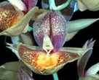
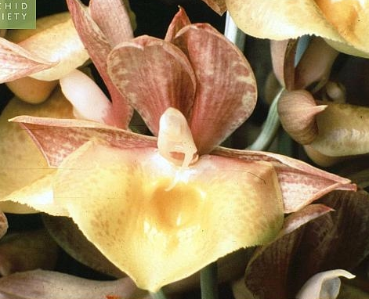
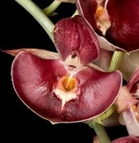
Awards
Catasetum Orchidglade
‘Orchidglade II’, AM/AOS
Oct 1983, NS 9.5 cm
Catasetum Orchidglade
‘Green Apple’, AM/AOS
Jul 2004, NS 10.9 cm
Catasetum Orchidglade
‘Doris’, AM/AOS
Nov 1995, NS 9.7 cm
Catasetum Orchidglade
‘Nicola’, HCC/AOS
May 2016, NS 10.0 cm
 | HCC | AM | FCC | JC | CCM | CBM | CHM | TOTAL
AOS | 4 | 14 |  |  | 1 |  |  | 19
Year(s) Awarded | 1974-2016 | 1979-2014 |  |  | 1995

Hybridization, Ctsm. Orchidglade Catasetum Hybrids:
 | 1970-1979 | 1980-1989 | 1990-1999 | 2000-2009 | 2010- | TOTAL
Registrations | 1 | 7 | 17 | 40 | 40 | 105
Associated Awards | 4 | 27 | 26 | 40 | 38 | 135
Flower size, number of flowers, characteristic lip, color range, and hybrid cultural strength make Ctsm. Orchidglade an important parent in breeding.
Major Ctsm. Orchidglade Hybrids and reason they are considered outstanding:
Ctsm. Susan Fuchs (expansum x Orchidglade), 1992, R. F. Orchids, 40 F1 and 106 total progeny, 7 AOS awards (1 FCC, 4 AMs, 1 HCC, 1 JC). Along with Ctsm. Orchidglade this is a workhorse of Catasetum breeding with all of the strengths of Ctsm. Orchiglade.
Ctsm. Louise Clarke (Susan Fuchs x Donna Wise), 2009, F. Clarke, 5 F1 progeny, 8 AOS awards (4 AMs, 4 HCCs)
Ctsm. Penang (Susan Fuchs x pileatum), 1989, Ooi Leng Sun, 15 F1 and 26 total progeny, no awards
Ctsm. Melana Davison (denticulatum x Penang), 2012, F. Clarke, No progeny, 8 AM/AOS awards (See end of Catasetum section for picture)
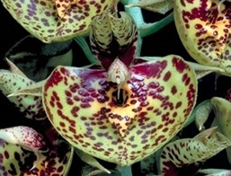
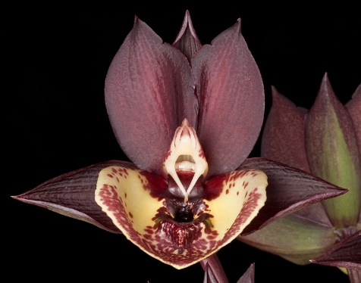
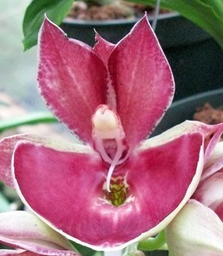
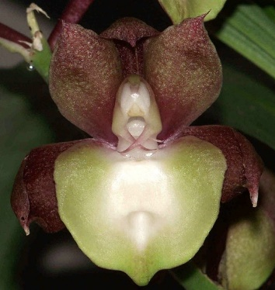
Ctsm. Jumbo Pearl (Penang x tenebrosum), 2000, Jumbo Orchids, 9 F1 and 10 total progeny, no awards
Catasetum Susan Fuchs
‘Burgundy Chips’, FCC/AOS
May 1994, NS 10.2 cm
Catasetum Penang
‘Sweetheart’
Catasetum Louise Clarke
‘Sally’, AM/AOS
Oct. 2013, NS 8.0 cm
Catasetum Jumbo Pearl

Ctsm. Donna Wise (tenebrosum x Orchidglade), 1995, E.Wise, 11 F1 and 28 total progeny, 9 AOS awards (4 AMs, 5 HCCs)
Ctsm. Spotted Dragon (fimbriatum x Orchidglade), 1983, JEM, 2 F1 progeny, 9 AOS awards (6 AMs, 3 HCCs)
Ctsm. Bound for Glory (pileatum x Orchidglade), 1978, Jones & Scully, 11 F1 and 12 total progeny, 2 HCC/AOS awards
Ctsm. Marsh Hollow (fuchsii x Orchidglade), 1992, Laurel Orchids, 5 F1 progeny, 2 HCC/AOS awards
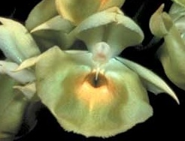
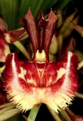
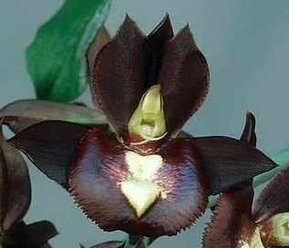
Catasetum Donna Wise
‘Susan’, AM/AOS
Jun 2006, NS 8.0 cm
Catasetum Spotted Dragon
‘Springhill’, AM/AOS
Sep 2010, NS 4.0 cm
Catasetum Bound for Glory
‘Jessica’, HCC/AOS
Jan 1990, NS 12.0 cm
Catasetum Marsh Hollow
‘Clair’s Delight’, HCC/AOS
Jan 1995, NS 5.6 cm
The Genus Cycnoches (Lindley 1832)
Type: Cyc. loddigesii [SIK-no-keez lod-IJ-es-ee-eye]

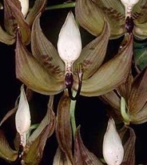
Cycnoches is a genus with 32 species (Kew Monocat list March 2017, 33 F. Clarke, 35 OrchidWiz 3.2 [Update March 2017]) spread throughout most of tropical America. Cycnoches flowers are non-resupinate with the lip above the column. As in Catasetums, cycnoches have sexually dimorphic flowers. The Cycnoches genus is divided into two sections: the Cycnoches section has male (staminate) and female (pistillate) flowers closely resemble each other, and the Heteranthae section, the male and female flowers are distinctly different in lip and flower form. Cycnoches are lowland epiphytes found from sea level to 600m in humid to moist forests or terrestrials on fallen rotten logs. They like warm conditions, heavy fertilizer and water after the new lead is 2-3 inches tall through flowering in the fall, then no water or fertilizer until the lead shows again in the spring. The pseudobulbs are elongated, fusiform-cylindrical and are 10 - 30 cm long with 2 to 7 thin, veined deciduous leaves on each pseudobulbs. The pendent inflorescence forms from the upper apical nodes of the pseudobulb, can reach almost a meter in length, and have as many as seven to thirty flowers in some species.
Cyc. Loddigesii
‘Thanks Eric’, AM/AOS
Aug 2004, NS 11.4 cm

Each plant of Catasetum and Cycnoches can produce female or male flowers, but what triggers the flower’s sex? It appears that the quality of the environment in which they grow is the determining factor. Female flowers are often produced under optimal growing conditions, with suitable light levels, and ample moisture and nutrients. These conditions produce large, robust plants that are capable of carrying seed capsules through the dry winter dormant period when weaker plants could perish. Male flowers are typically produced when growing conditions are not quite optimal. When plants are young, receive too much light or not enough, are stressed from lack of moisture or nutrients and other factors, the result is a plant suitable for pollen production but not the task of supporting a developing capsule.

Common Name or Meaning Swan-necked Orchid - refers to the swan-like curved column of the male flowers

Point Scale using the general point scale.

Species marked with a * are used the most in hybridization |  |  |  |  | Progeny | AOS Awards
Kew Name | Section | Habitat, Country | Temperature | Season | F1/Remain | FCC | AM | HCC | JC | AD | AQ | CCE | CCM | CHM | CBR | Total
Cycnoches barthiorum | Heteranthae | Columbia | Hot, 75 to 85F at night | Winter to Spring | 11/19 |  | 11 | 5 |  |  |  |  | 1 | 1 |  | 18
Cycnoches chlorochilon* | Cycnoches | Panama to Tropical South America | Hot, 75 to 85F at night | Fall to Winter | 27/83 |  | 7 | 5 | 1 |  |  |  | 8 |  |  | 21
Cycnoches cooperi | Heteranthae | Brazil to Peru | Hot, 75 to 85F at night | Year round, Winter | 8/13 | 1 | 16 | 5 | 1 |  |  | 1 |  | 1 |  | 25
Cycnoches egertonianum | Heteranthae | South Mexico to Columbia | Hot, 75 to 85F at night | Summer to Fall | 5/19 |  | 2 |  | 1 |  |  |  | 1 |  | 1 | 5
Cycnoches haagii | Cycnoches | Tropical South America | Hot, 75 to 85F at night | Summer to Fall | 17/19 |  |  | 1 | 2 |  |  |  | 1 |  | 1 | 5
Cycnoches herrenhusanum | Heteranthae | Columbia to Ecuador | Hot, 75 to 85F at night | Fall | 11/16 |  | 2 | 2 |  |  |  |  | 1 | 1 |  | 6
Cycnoches lehmannii | Cycnoches | Ecuador to Peru | Warm to Hot, 66 to 85F at night | Fall to Winter | 8/16 |  |  |  | 1 |  |  |  | 1 |  | 1 | 3
Cycnoches loddigesii | Cycnoches | Tropical South America | Warm to Hot, 66 to 85F at night | Fall to Winter | 9/55 |  | 1 | 2 |  |  |  |  | 2 |  | 1 | 6
Cycnoches pentadactylon* | Heteranthae | Peru to Brazil | Warm to Hot, 66 to 85F at night | Year round | 24/69 |  | 2 | 1 |  |  |  |  | 2 | 1 |  | 6
Cycnoches warszewiczii* | Cycnoches | Nicaragua to Panama | Warm to Hot, 66 to 85F at night | Fall | 45/0 |  |  |  |  |  |  |  |  |  |  | 0

There are three species to consider in regards to most use in hybridization: Cyc. chlorochilon, Cyc. pentadactylon, Cyc. warszewiczii. Cyc. chlorochilon and Cyc. warszewiczii are both members of the Cycnoches section, are very similar in appearance resulting in considerable confusion between these two species, consequently I will report on both in a single section. Cyc. pentadactylon is a member of the Heteranthae section, other Heteranthae members (Cyc. herrenhusanum, Cyc. barthiorum, and Cyc. cooperi) have started to be used in hybridization but have not obtained the number of Cyc. pentadactylon hybrids.
Cycnoches pentadactylon
'Dennis Quardt', AM/AOS
Oct 2004, NS 5.8 cm

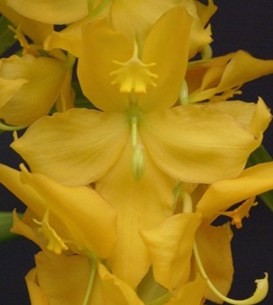
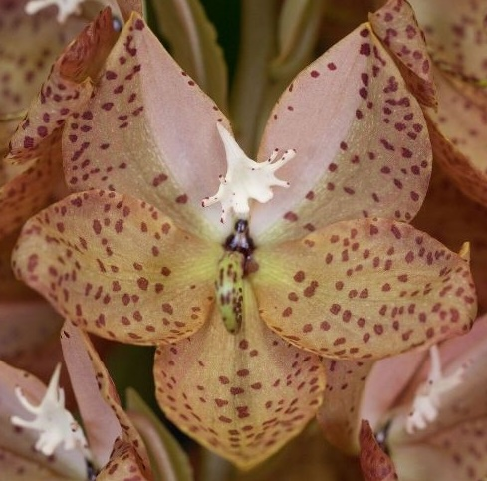
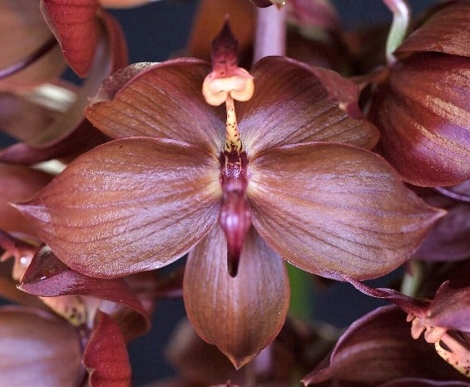
Cycnoches herrenhusanum
'Peggy's Delight', AM/AOS
Aug 2015, NS 5.3 cm
Cycnoches barthiorum
'Elektra', AM/AOS
Sep 2016, NS 5.7 cm
Cycnoches cooperi
'Elektra', AM/AOS
Sep 2016, NS 7.3 cm
References:
www.orchidspecies.com
http://apps.kew.org/wcsp/qsearch.do
https://secure.aos.org/aqplus/SearchAwards.aspx
Bechtel, H.; Cribb, P.; Launert, E.; The Manual of Cultivated Orchid Species, 1992
OrchidWiz.Database x3.2, update: March 2017
Orchid Digest, Oct., Nov., Dec., 2016, 80(4), all four articles but mainly The State of Affairs in Breeding Catasetinae, Clarke, F., pp. 174-234
Orchids, Supplement to, Oct. 2012 Cycnoches Species and Hybrids, Carr, G. F., Jr., pp 2-35
Interesting Tidbits

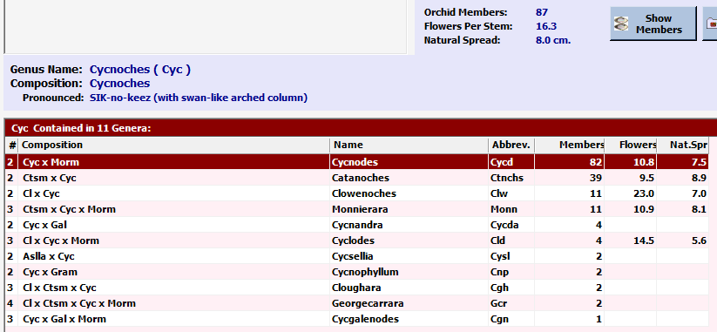
The Table below list the names of the existing intergeneric cross made with Cycnoches and the number of cross that exist:
Since OrchidWiz list 35 Cycnoches species and that there are a total of 87 Cycnoches that yields 52 hybrid cycnochoes.

The intergeneric cross with the most progeny is Cycnodes (Cycnoches x Mormodes) with more than twice as many members as the next intergeneric cross Catanoches (Catasetum x Cycnoches).

Since Catasetum, Cycnoches, Mormodes, and Clowesia are well mixed in terms of intergeneric breeding, they will be handled together.

Species Data Sheet/Building Block Report
Cycnoches warszewiczii Rchb.f., Gard. Chron., n.s., 17: 492 (1882)
Cycnoches chlorochilon Rchb.f., Otia Bot. Hamburg.: 9 (1878)
These two plants are very similar in appearance and account for the majority of Cycnoches crosses and awards, consequently, this report will a combined on the two.
Cycnoches warszewiczii, [SIK-no-keez var-sheh-VICH-ee-eye]
This plant is found in central Costa Rica to Colombia and is an epiphytic, deciduous, medium sized, warm growing orchid found on trees and rotten logs and occasionally as a terrestrial beside rotten logs at elevatiions of 700 to 1000 meters. Heavily scented 4" flowers (largest Cycnoches flowers) are arranged in a pendant, racemose, several flowered inflorescence arising from the leaf nodes at the apex of the newest, mature, leafless pseudobulb. Flower shape is a dominant breeding trait and has the most cycnoches progeny.
Cycnoches chlorochilon, [SIK-no-keez klo-ro-KYE-lon]
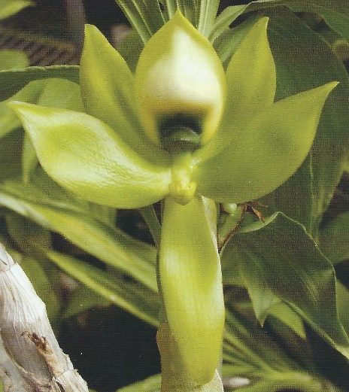
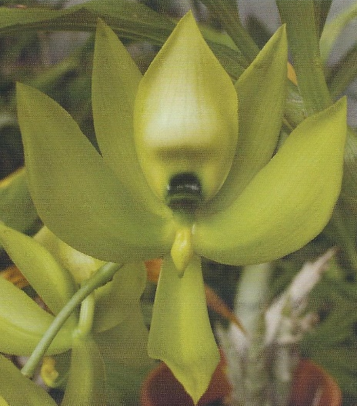
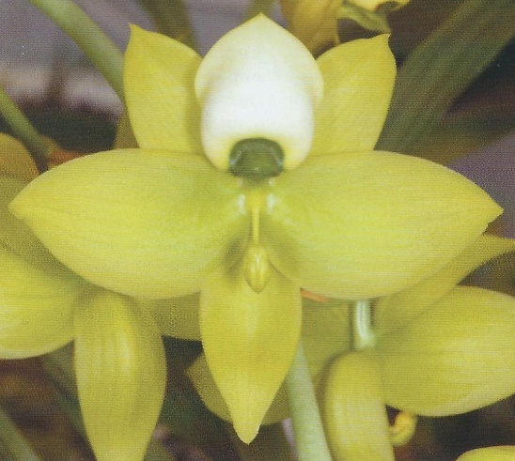
This medium sized, epiphytic, hot to warm growing species is found from southeastern Panama, Colombia and Venezuela in semi-dense wet forests at elevations around 400 to 850 meters with fusiform pseudobulbs enveloped by non-foliaceous sheaths and carrying 4 to 7, plicate, elliptic-lanceolate leaves that blooms in the late summer and fall on an axillary, pendant, 3" [7.5 cm] long, racemose, few to several flowered inflorescence arising from the leaf nodes just below the apex of the newest, mature, large, fusiform to conical pseudobulb.
Female Flowers

‘SVO’
Cycnoches chlorochilon
‘Giant Swan’
Cycnoches warscewiczii
Male Flowers
Plant habits between the two species are indistinguishable, and the most notable difference between the two is the upswept petal stance and larger lip in Cyc. Chlorochilon.
Awards
 | AOS Awards
Kew Name | FCC | AM | HCC | JC | AD | AQ | CCE | CCM | CHM | CBR | Total
Cycnoches chlorochilon |  | 2 | 3 |  |  |  |  |  |  |  | 5
Cycnoches warszewiczii |  | 11 | 4 | 1 |  |  |  | 9 |  | 1 | 26
The above award count, from AOS Orchid Plus does NOT agree with that reported by OrchidWiz (Cyc. chlorochilon 21 AOS awards and Cyc. warszewiczii no awards), but I consider it to be more accurate in this specific case.
Hybridization
Flower shape is a dominant breeding trait
Significant Cycnoches Hybrids, Progeny:
There are NOT many hybrids in the Cycnoches family, consequently below are the most hybridized of the entire family, those hybrids with either Cyc. chlorochilon or Cyc. warszewiczii will be bolded and underlined.
Cyc. Jumbo Dragon (Cyc. Chloroge x Cyc. pentadactylon), 1996, Jumbo Orchids, 30 F1 and 32 total progeny, 1 AD/AOS award. Major progeny: Cyc. Jumbo Canary (Jumbo Dragon x haagii), 1999, Jumbo Orchids, no progeny, 2 AOS awards (1 AM, 1 CCM) and Cyc. Tawny Dragon (Cyc. Tawny x Cyc. Jumbo Dragon), 2006, W. E. Brown, 1 F1 progeny, no AOS awards.
Cyc. Chloroge (Cyc. chlorochilon x Cyc. loddigesii), 1970, Polk, 10 F1 and 45 total progeny, 3 AOS awards (1 AM, 1 HCC, 1 JC). Major progeny is Cyc. Jumbo Dragon above.
Cyc. Rocky Clough (Cyc. pentadactylon x Cyc. egertonianum), 1995, G. Carr, 10 F1 progeny, 2 HCC/AOS awards
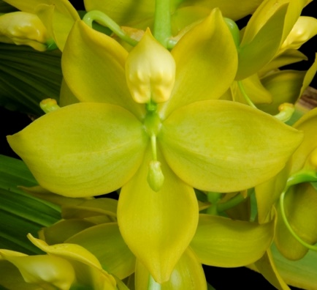
Cyc. Kevin Clarke (Cyc. warscewiczii x Cyc. herrenhusanum), 2004, F. Clarke, 3 F1 progeny, 2 AOS awards (1 FCC, 1 HCC)
Cyc. Jumbo Dragon
AD/AOS
Oct 1997, NS 9.1 cm
Cyc. Chloroge
“Live Oak”, AM/AOS
Nov 2001, NS 13.5 cm
Cyc. Rocky Clough
“Bryon”, HCC/AOS
Sep 2000, NS 4.6 cm
Cyc. Kevin Clarke
“Sunset Valley Orchids”, FCC/AOS
Dec 2012, NS 10.0 cm
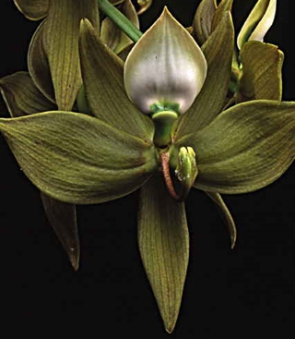
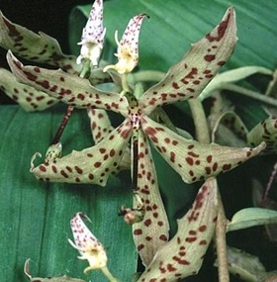
Significant Cycnoches Hybrids, Awards:
Cyc. Jean E. Monnier (Cyc. barthiorum x Cyc. cooperi), 2003, G. Monnier, 2 F1 and 6 total progeny, 27 AOS awards (1 FCC, 16 AMs, 9 HCCs, 1 CCE). Major progeny: Cyc. Swan Cascade see below, Cyc. Richard Brandon (Cyc. warscewiczii x Cyc. Jean E. Monnier), 2011, F. Clarke, 3 F1 progeny, 2 AOS awards (1 AM, 1 HCC).
Cyc. Swan Cascade (Cyc. cooperi x Cyc. Jean E. Monnier), 2011, F. Clarke, 2 F1 progeny, 3 AOS awards (1 FCC, 1 AM, 1 HCC)
Cyc. William Clarke (Cyc. herrenhusanum x Cyc. cooperi), 2004, F. Clarke, No progeny, 8 AOS awards (5 AMs, 2 HCCs, 1 CCM)
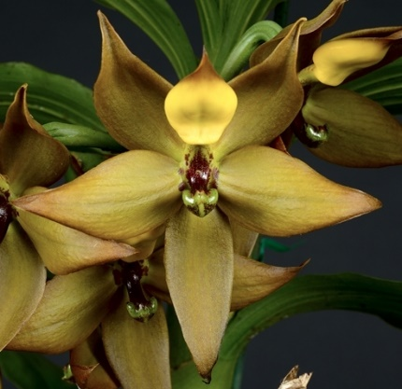
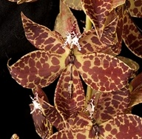
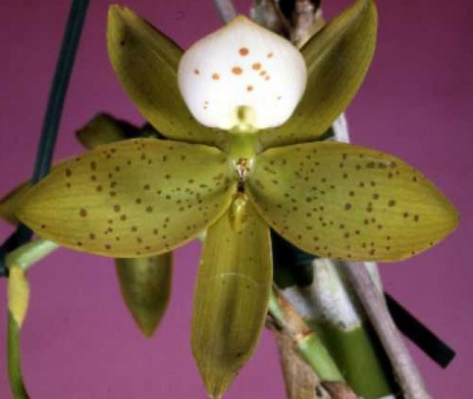
Cyc. Robert Dickow (Cyc. haagii x Cyc. warscewiczii), 2004, F. Clarke, No progeny, 4 AOS awards (3 AMs, 1 CCM)
Cyc. Swan Cascade
“Max Thompson”, FCC/AOS
Aug 2013, NS 10.0 cm
Cyc. Jean E. Monnier
“Elektra”, FCC/AOS
Nov 2012, NS 10.0 cm
Cyc. William Clarke
“Maluna”, AM/AOS
Sep 2009, NS 6.1 cm
Cyc. Robert Dickow
“De Etta”, AM/AOS
Dec 2006, NS 10.4 cm

The Genus Mormodes (Lindley 1836)
Type: Morm. atropurpurea [mor-moe-DEEZ a-tro-pur-PUR-ee-a]
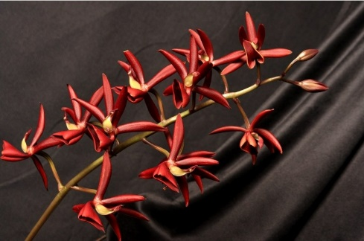
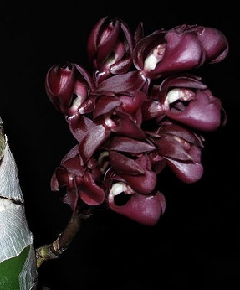
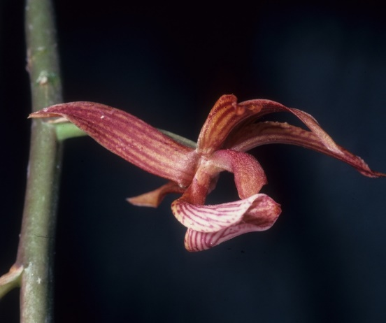
Mormodes atropurpurea
‘Taqui’, CHM/AOS
Apr 2010, NS 7.7 cm
This genus of 92 species is found from Mexico to Bolivia and Brazil and are epiphytes found in lower tropical forests. The fleshy pseudobulbs have heavily veined deciduous leaves and the inflorescence is produced from the middle of the pseudobulb a major distinguishing factor with the plant out of flower between this genus and the genus Catasetum which has a basal inflorescence. These plants are related to the Catasetum, but have perfect flowers (with pollinia and stigmatic surfaces present in each flower), and can be crossed with them producing extremely bizarre flowers. The flowers are large, highly fragrant, brightly colored (often with complex patterning), have saddle-shaped lips, and twisted columns with similar sepals and petals, with the dorsal sepal arching over the column while lateral sepals flex back, the lip arises from the base of the apodal column which has reflexed lateral edges, two large side lobes and an acute apex. The erect column is twisted to the side allowing the anther and an elongate stigma to be exposed. There are two pollina with an elastic stipe and they are ejected by means of a sensitive mechanism. A very interesting aspect of the reproductive strategy in Mormodes is that removing the pollinia causes the twisted column to straighten significantly increasing the area of the stigmatic surface. This adaptation should reduce the likelihood of self-pollination and improve the chances of flower pollination after the pollinia have been removed. Flower longevity is generally three to four weeks. Hot to cool conditions suit these plants well and they like to be wet when the growth is happening but once maturity is attained in the fall all water and fertilizer should be withheld until the new growth arises in the spring.
Mormodes atropurpurea

The Mormodes genus is divided into sections, but no information was found about these sections but this information is included in the species summary table.

Mormodes species have proven challenging to cultivate. They are native to tropical forests and as Catasetums require a definite rest period during which they shed their leaves but they cannot stand the severe drying out which Catasetums seem to require and which the latter survive without shriveling of the pseudobulbs. Bulbs shrivel badly when allowed to dry out completely and if this happens, they are unable to recover. On the other hand, the slightest over-watering, while the plants are at rest, results in rotting. They also appear to need more shade than Catasetums.

Common Name or Meaning Ghost-like orchids and are commonly known as goblin orchids because of their twisted asymmetric flower form.

There are presently 29 registered Mormodes hybrids. Mormodes hybrids have some real benefits, including hybrid vigor that makes them much easier to cultivate compared to the species. Greater ease of cultivation means that hobbyists are more successful and more likely to present plants for judging. Some of the most successful hybrids have increased flower size, amazing color, and beautiful patterning.

Due to this low number of registered hybrids, I will NOT have a species report but will conclude this paper with summary information on four species and at least that number of hybrids.

Point Scale using the general point scale.
The Table below is based on information in OrchidWiz and includes species with the most progeny and awards.
Species marked with a * are used the most in hybridization |  |  |  |  | Progeny | AOS Awards
Kew Name | Section | Habitat, Country | Temperature | Season | F1/Remain | FCC | AM | HCC | JC | AD | AQ | CCE | CCM | CHM | CBR | Total
Mormodes badia | Mormodes | Mexico | Warm | Fall to Winter | 21/39 |  |  |  |  |  |  |  |  | 1 |  | 1
Mormodes buccinator | Mormodes | Mexico to Nothern South America | Warm to Hot | Fall to Winter, low in Summer | 9/22 |  | 3 | 1 |  |  |  |  |  | 1 | 1 | 6
Mormodes colossus | Mormodes | Costa Rica and Panama | Warm to Hot | Winter to Spring | 1/1 |  | 7 | 2 |  |  |  |  |  |  | 1 | 10
Mormodes elegans | Klotzschia | Bolivia and Brazil | Hot | Winter | 4/5 |  | 1 |  |  |  |  |  | 1 |  |  | 2
Mormodes frymirei | Mormodes | Ecuador | Warm to Hot | Winter | 5/10 |  |  |  |  |  |  |  | 1 | 1 |  | 2
Mormodes horichii | Klotzschia | Nicaragua and Costa Rica | Warm to Hot | Winter | 4/5 | 1 | 4 | 2 |  |  |  |  |  |  | 1 | 8
Mormodes ignea | Mormodes | Costa Rica, Panama, and Columbia | Warm to Hot | Winter to Spring | 7/12 |  | 2 | 2 |  |  |  |  |  | 1 |  | 5
Mormodes maculata | Coryodes | Mexico | Cool to warm | Year round, peak in summer | 12/27 |  |  | 1 |  |  |  |  |  |  | 2 | 3
Mormodes rolfeana | Mormodes | Ecuador and Peru | Warm | Fall to Spring | 5/8 |  | 3 |  | 1 |  |  |  |  | 1 | 1 | 6
Mormodes sinuata* | Mormodes | Brazil and Venezuela | Warm | Fall to Winter | 20/75 |  | 5 | 2 |  |  |  |  | 1 |  | 1 | 9
Mormodes tuxtlensis |  | Mexico | Warm | Fall | 5/11 |  | 1 | 1 |  |  |  |  |  | 1 | 1 | 4
Mormodes uncia | Coelodes | Mexico | Warm to Hot | Spring to Summer | 5/12 |  |  |  |  |  |  |  |  |  | 1 | 1
Mormodes variabilis | Mormodes | Ecuador | Warm | Spring to Summer | 0/0 |  | 3 |  |  |  |  |  | 1 | 2 | 2 | 8
Mormodes warszewiczii | Coryodes | Peru | Warm | Fall | 9/16 |  | 3 | 2 |  |  |  |  | 1 | 1 | 2 | 9
Key: Cool – Cool to warm, 58 to 75F at night; Warm – 66 to 75F at night; Warm to Hot – 66 to 85F at night; Hot – 75 to 85F at night

Awards, Top Two Species used for Hybridization Plus Top Two Awarded Species
 | AOS Awards
Kew Name | FCC | AM | HCC | JC | AD | AQ | CCE | CCM | CHM | CBR | Total
Mormodes badia |  |  |  |  |  |  |  |  | 1 |  | 1
Mormodes colossus |  | 7 | 2 |  |  |  |  |  |  | 1 | 10
Mormodes sinuata |  | 5 | 2 |  |  |  |  | 1 |  | 1 | 9
Mormodes warszewiczii |  | 3 | 2 |  |  |  |  | 1 | 1 | 2 | 9
The above award list does not include the one Mormodes specie that has received an FCC, Mormodes horichii.
Hybridization
Bright intense flower colors is a dominant breeding trait

Significant Mormodes Species, Progeny:
Morm. badia, 21 F1 and 39 total progeny, 1 CHM/AOS Award
Morm. sinuata, 20 F1 and 75 total progeny, 9 AOS Awards (5 AM, 2 HCC, 1 CCM, 1 CBM)
Morm. maculata, 12 F1 and 27 total progeny, 3 AOS Awards (1 HCC, 2 CBM)
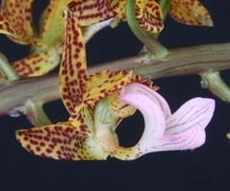
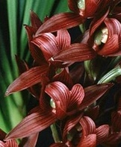
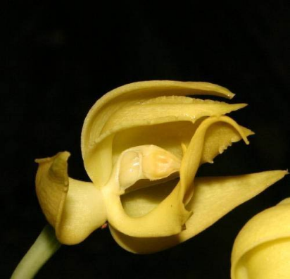
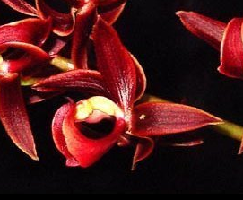
Morm. warszewiczii (syn. Morm. revolute), 9 F1 and 16 total progeny, 9 AOS Awards (3 AM, 2 HCC, 1 CCM, 1 CHM, 2 CBR)
Mormodes maculata
Mormodes badia
Mormodes sinuata
‘Sunset Valley Orchids”, AM/AOS
Nov 1999, NS 6.5 cm
Mormodes warszewiczii
‘Baker's Mini Butterfly’, AM/AOS
Feb 2014, NS 1.7 cm

Significant Mormodes Species, Awards:
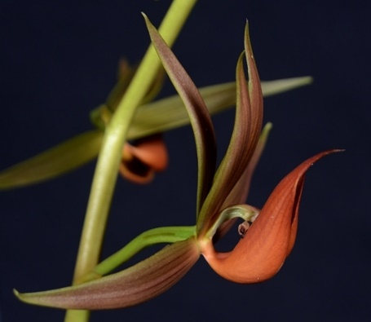
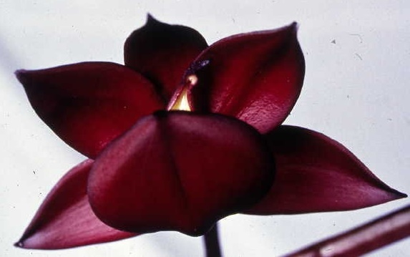
Morm. horichii, 4 F1 and 5 total progeny, 8 AOS Awards (1 FCC, 4 AMs, 2 HCCs, 1 CBR)
Morm. colossus, 1 F1 progeny, 10 AOS Awards (7 AMs, 2 HCCs, 1 CBM)
Morm. rofeana, 5 F1 and 8 total progeny, 6 AOS Awards (3 AMs, 1 JC, 1 CHM, 1 CBM)
Morm. variabilis, No progeny, 8 AOS Awards (3 AMs, 2 CHMs, 1 CCM, 2 CBRs)
Morm. buccinator, 9 F1 and 22 total progeny, 6 AOS Awards (3 AMs, 1 HCC, 1 CHM, 1 CBM)
Mormodes colossus
‘Hazel Marisol’, AM/AOS
Feb 2016, NS 15.2 cm
Mormodes horichii
‘Edwin Bolanos’, FCC/AOS
Mar 2000, NS 8.4 cm
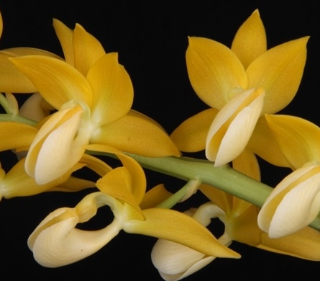
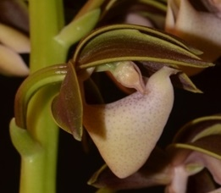
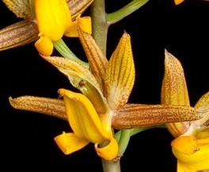
Morm. lineata, No progeny, 7 AOS Awards (2 AMs, 1 HCC, 1 CHM, 1 CCM, 1 CBR, 1 CBM)
Mormodes rolfeana
‘Baker's Peruvian Sunrise’, AM/AOS
Jul 2013, NS 4.3 cm
Mormodes variabilis
‘Malcolm’, AM/AOS
Jun 2014, NS 5.5 cm
Mormodes buccinator
‘Orquivalle’, AM/AOS
Sep 2011, NS 6.0 cm
Mormodes lineata
‘Maria Rubia’, AM/AOS
Jul 2013, NS 6.4 cm
Significant Mormodes Hybrids, Progeny:
Morm. Midnight (Morm. buccinator x Morm. sinuate), 1999, F. Clarke, 6 F1 progeny, No Awards
Morm. Jumbo Bacia (Morm. badia x Morm. uncia), 1999, Jumbo Orchids, 5 F1 and 6 total progeny, 3 AOS Awards (1 AM, 2 HCCs), NOTE: Picture clearly shows twisted the column along with other pictures once you know what you are looking for.
Morm. Jumbo Volcano (Morm. buccinator x Morm badia), 1999, Jumbo Orchids, 4 F1 progeny, No AOS Awards
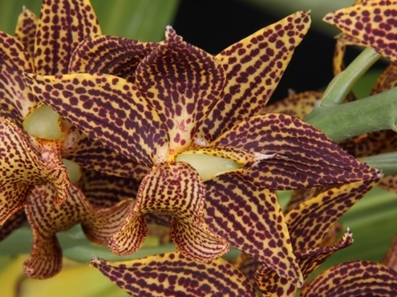
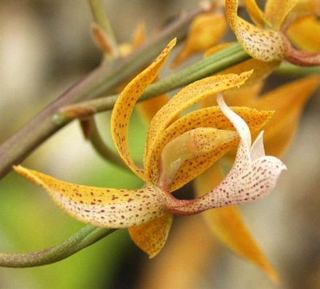
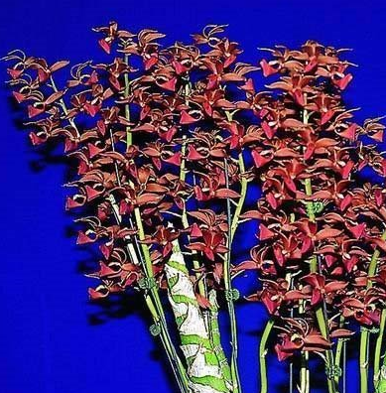
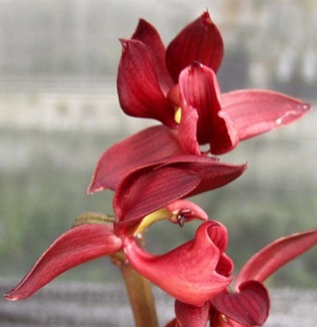
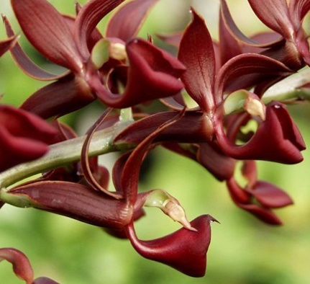
Morm. Jumbo Poseidon (Morm. revolute x Morm. maculata) 2001, Jumbo Orchids, 4 F1 progeny, No Awards
Mormodes Jumbo Poseidon
‘Sunset Valley Orchids Purple & Gold
Mormodes Jumbo Volcano
Mormodes Jumbo Bacia
‘Sunset Valley Orchids’, AM/AOS
Dec 2011, NS 3.6 cm
Mormodes Midnight
‘SVO’
Significant Mormodes Hybrids, Awards:
Morm. Exotic Treat (Morm. sinuata x Morm. tuxtlensis), 2004, Exotic Orchids, 3 F1 and 5 total progeny, 5 AOS Awards (4 AMs, 1 HCC)
Morm. Mark Mills (Morm. Jumbo Bacia x Morm. Virgen del Valle), 2013, F. Clarke, 1 F1 progeny, 3 AM/AOS Awards
Morm. Nitty-Gritty (Morm. Exotic Treat x Morm. rolfeana), 2012, F. Clarke, 2 F1 progeny, 2 AOS Awards (1 HCC, 1 JC)
Morm. Jumbo Candy (Morm. ignea x Morm. buccinator), 1999, Jumbo Orchids, 1 F1 progeny, No AOS Awards
Mormodes Exotic Treat
‘Sunset Valley Orchids’, AM/AOS
Oct 2012, NS 7.0 cm
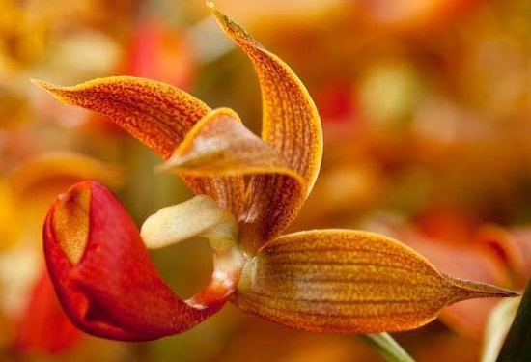
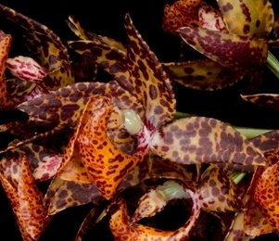
Mormodes Nitty-Gritty
‘Sunset Valley Orchids’, HCC/AOS
Jan 2013, NS 5.8 cm
Mormodes Exotic Treat
Mormodes Mark Mills
‘B-C’, AM/AOS
Nov 2014, NS 2.5 cm
References:
www.orchidspecies.com
http://apps.kew.org/wcsp/qsearch.do
https://secure.aos.org/aqplus/SearchAwards.aspx
Bechtel, H.; Cribb, P.; Launert, E.; The Manual of Cultivated Orchid Species, 1992
OrchidWiz.Database x3.2, update: March 2017
Orchid Digest, Oct., Nov., Dec., 2016, 80(4), all four articles but mainly The State of Affairs in Breeding Catasetinae, Clarke, F., pp. 174-234
AOS Bulletin, 1961, 30(8), Four little-known Species of the Genus Mormodes, Teuscher, H., pp. 648-655
Interesting Tidbits

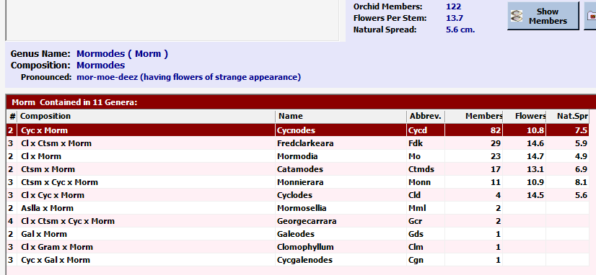
The Table below list the names of the existing intergeneric cross made with Mormodes and the number of cross that exist:

There are presently 29 registered Mormodes hybrids.

The intergeneric cross with the most progeny is Cycnodes (Cycnoches x Mormodes) with more than twice as many members as the next intergeneric cross Fredclarkeara (Clowesia x Catasetum x Mormodes).

Since Catasetum, Cycnoches, Mormodes, and Clowesia are well mixed in terms of intergeneric breeding, they will be handled together.

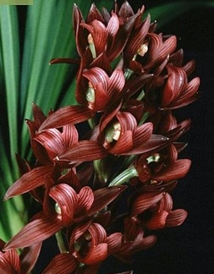
Building Block Data
Mormodes sinuata [1881]
(mor-moe-deez sin-YEW-AH-ta)

Mormodes sinuata is native to Brazil and Venezuela on plains and savannas at 1650-3300 ft. (500-1000 m). It is a medium to large, 18 in. (45 cm) sympodial hot growing epiphyte, with 8 in. (20 cm) long by 1.6 in. (4 cm) wide clustered, fusiform pseudobulbs holding at the apex several 10 in. (25 cm) long by 1.6 in. (4 cm) wide, thin, sharply pointed, erect to arching leaves. The one to two approximately 6 in. (16 cm) long arching to nearly horizontal inflorescences emerge from the lower half of mature pseudobulbs. The 1.3 in (3.3 cm) yellow to wine red flowers are carried in a closely spaced raceme on the upper two-thirds of the inflorescence. The 8 to 15 flowers on one inflorescences have a slight fragrance and occur in the spring. The strongly 3-lobed lip is rolled into a tube around the column. The midlobe, which is only about 0.3 in. (0.75 cm) wide, has a small, sharply pointed extension in the center of the otherwise rounded apical margin.
Mormodes sinuate
‘Sunset Valley Orchids’, HCC/AOS
Nov 1999, NS 6.5 cm

Varieties:
None that are recognized

Synonyms
Mormodes sinuatum

Awards:
 | AOS Awards
Kew Name | FCC | AM | HCC | JC | AD | AQ | CCE | CCM | CHM | CBR | Total
Mormodes sinuata |  | 5 | 2 |  |  |  |  | 1 |  | 1 | 9
Timetable for awards: 1975 to 1999

Hybrids: Total of 75 registered, to the 4th generation
Before 1979 | 1980-89 | 1990-99 | 2000-10 | After 2010
0 | 4 | 9 | 29 | 33
Only 13 of the crosses are NOT intergeneric.

Used to intensify / darken color.

Outstanding progeny and reason they are considered outstanding:
Since the intergeneric crosses are in a separate report and there are so few Mormodes crosses the following report will concentrate on those crosses that are NOT reported on in other reports. Below is a screen capture of the top 10 award winners and the top 10 progeny.

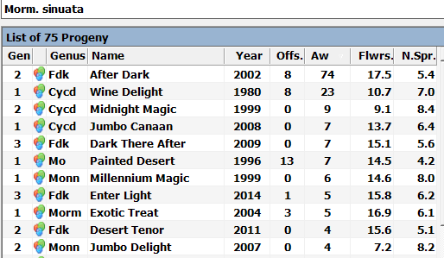
Mormodes sinuata progeny sorted by awards (OrchidWiz database)
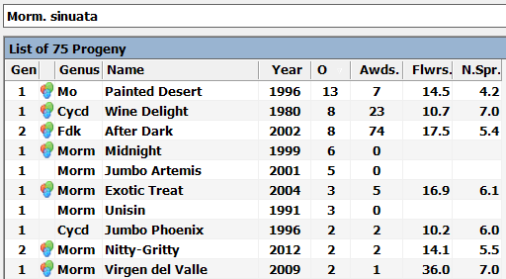
Mormodes sinuata progeny sorted by number of progeny (OrchidWiz database)

Cycnodes [Cycd.] Jumbo Canaan (Cyc. pentadactylon x Morm. sinuata), 2008, Jumbo Orchids, no progeny, 7 AOS awards (6 AMs and 1 HCC)
Mormodia [Mo.] Painted Desert (Cl. Rebecca Northen x Morm. sinuata), 1996, JEM, 13 F1 and 23 total progeny, 7 AOS Awards (4 AMs and 3 HCCs)
Monnierara [Monn.] Millennium Magic (Ctnchs. Midnight Jem x Morm. sinuata), 1999, G. Monnier, no progeny, 4 AOS awards (2 FCCs, 1 AM, and 1 CCE)
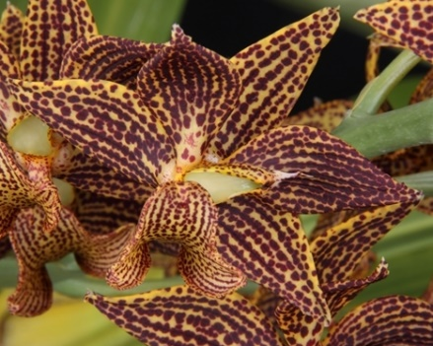
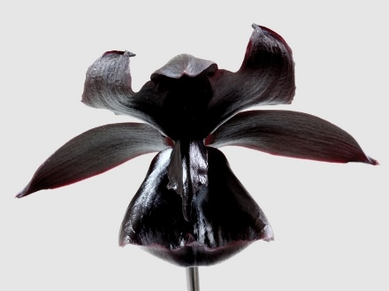
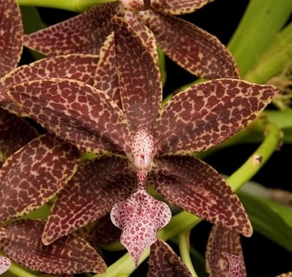
Mormodes Exotic Treat (Morm. sinuata x Morm. tuxtlensis), 2004, Exotic Orchids, 3 F1 and 5 total progeny, 5 AOS awards (4 AMs, 1 HCC)
Monnierara Millennium Magic
‘Witchcraft’, FCC/AOS
Dec 2015, NS 9.6 cm
Cycnodes Jumbo Canaan
‘Que Linda’, AM/AOS
Oct 2011, NS 6.4 cm
Mormodia Painted Desert
‘Cranberry Delight’, AM/AOS
Jan 2003, NS 4.2 cm
Mormodes Exotic Treat
‘Sunset Valley Orchids’, AM/AOS
Oct 2012, NS 7.0 cm

Monnierara [Monn.] Jumbo Delight (Cycd. Wine Delight x Ctsm. Orchidglade), 2007, Jumbo Orchids, no progeny, 1 AM/AOS award
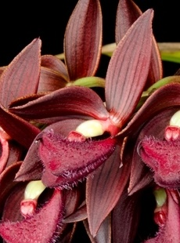
Morm. Midnight (Morm. buccinator x Morm. sinuata), 1999, F. Clarke, 6 F1 progeny, no awards
Morm. Nitty-Gritty (Exotic Treat x Morm. rolfeana), 2012, F. Clarke, 2 F1 progeny, 2 AOS awards (1 HCC, 1 JC)
Morm. Virgen del Valle (Morm. sinuata x Morm. hookeri), 2009, F. Clarke, 2 F1 and 3 total progeny, 1 AM/AOS award
Mormodes Virgen del Valle
‘SVO Dark Horse’, AM/AOS
Dec 2014, NS 7.0 cm
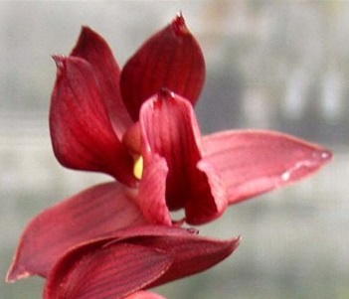
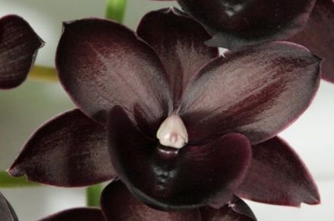
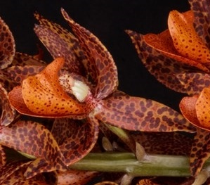
Mormodes Midnight
‘Sunset Valley Orchids’
Cycnodes Jumbo Delight
‘Helyna Lawson-Park XOXO’
AM/AOS, Oct 2013, NS 8.4 cm
Mormodes Nitty-Gritty
‘SVO Ripper’, JC/AOS
Dec 2014, NS 5.2 cm

The Genus Clowesia (Swartz 1799)
Type: Cl. rosea [KLO-wes-ee-ah ROH-zee-ah]
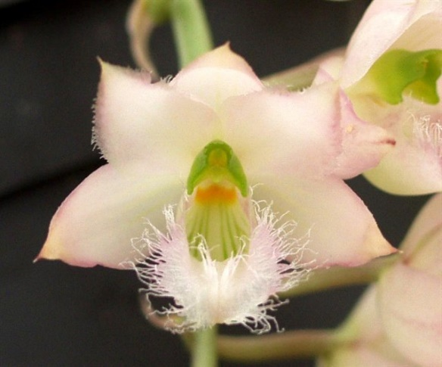
There are seven species in the Clowesia genus (per Kew Monocat list [Dec. 2016]. OrchidWiz has eight, the eighth species is list as Clowesia scurra, and the Kew Monocat list does not have Clowesia scurra as a synonym for any of the recognized Clowesia species. Doing a search in OrchidWiz finds a Catasetum scurra which is a synonym for Clowesia warscewiczii. The entry in OrchidWiz appears to be related to an Australian awarded plant, no pictures and a very limit description. Will discount this species.) The epiphytic genus ranges from Mexico to Ecuador in moist or dry forest at elevations from 200 to 1,500 meters. They are vegetatively similar (shorter pseudobulbs) to Catasetum yet the flowers are perfect flowers (contain both sexes), and generally fragrant flowers with a short column (as broad as it is long). The fleshy pseudobulbs can carry eight to twelve heavily veined, deciduous leaves. The pendulous inflorescence starts at the base of the pseudobulbs. The membranous flower has a free saccate lip.
Clowesia rosea ‘Sunset Valley Orchids’
I was not able to find any additional information on the following division within the genus but the source I consider reliable (F. Clarke).
Name | Flowering time | Inflorescences | Flower shape | Flower color
Clowesia thylaciochila | Early spring with new developing growth | Long, 20-40 flowers | Poorly formed | Green to green striped
Clowesia dodsoniana | Summer when in full leaf | Long, 20-40 flowers | Poorly formed | Green to green striped
Clowesia glaucoglosa | Summer when in full leaf | Long, 20-40 flowers | Poorly formed | Green to green striped
Clowesia russelliana | Summer when in full leaf | Long, 20-40 flowers | Poorly formed | Green to green striped
Clowesia amazonica | Late fall and winter when deciduous | 8-12 inch long, 15-20 flowers | Well formed | Light green and pink
Clowesia rosea | Late fall and winter when deciduous | 8-12 inch long, 15-20 flowers | Well formed | Light green and pink
Clowesia warczewitzii | Late fall and winter when deciduous | 8-12 inch long, 15-20 flowers | Well formed | Light green and pink

Common Name or Meaning: Named for the Rev. J. Clowes An English orchid aficionado 1800's

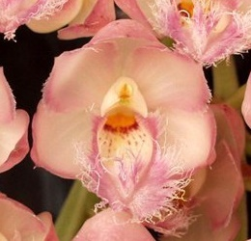
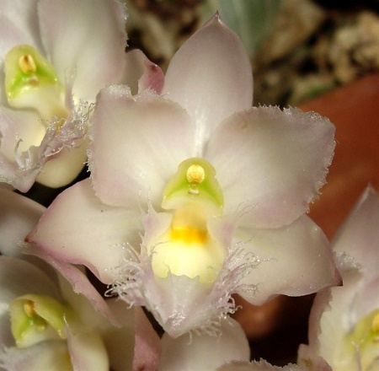
Surprisingly, there are just eight registered Clowesia hybrids. The two most popular are Cl. Grace Dunn (rosea x warczewitzii) [Regr. 1959, W. W. G. Moir, 19 F1 and 107 total progeny, 4 AOS awards (1 AM, 1 HCC, 2 CCMs)] and Cl. Rebecca Northern (Grace Dunn x rosea) [Regr. 1971, W. W. G. Moir, 31 F1 and 85 total progeny, 4 AOS awards (1 AM, 2 HCCs, 1 CCM)]. The flower qualities and name recognition of Cl. Rebecca Northern have made it the most sought-after Clowesia cross. They flower reliably with two to four pendulous inflorescences carrying ten to fifteen soft pink flowers with delicate, frilly lips, and a fragrance reminiscent of Lemons.
Clowesia Rebecca Northen
‘Grapefruit Pink’, CCM/AOS
Mar 1987, NS 2.4 cm
Clowesia Grace Dunn
‘Chadds Ford’, AM/AOS
Feb 1970, NS 3.5 cm

Point Scale using the general point scale.
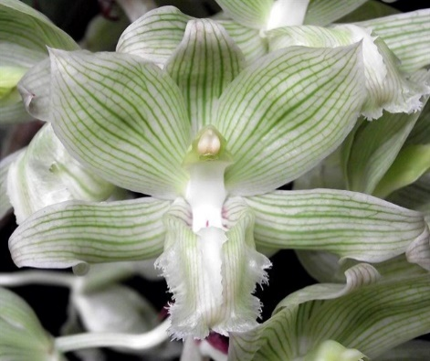
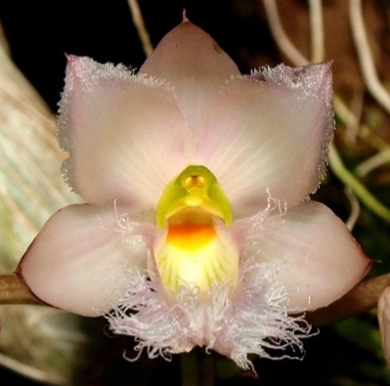
Clowesia Species Key Information Table:
Species marked with a * are used the most in hybridization |  |  |  | Progeny | AOS Awards
Kew Name | Habitat, Country | Temperature | Season | F1/Remain | FCC | AM | HCC | JC | AD | AQ | CCE | CCM | CHM | CBR | Total
Clowesia amazonica | Venezuela, Ecuador and Brazil | Warm to hot, 66 to 85F at night | Fall to Winter | 0/0 |  |  |  |  |  |  |  |  |  |  | 0
Clowesia dodsoniana | Mexico | Hot, 75 to 85F at night | June to Oct | 5/6 |  | 1 |  |  |  |  |  |  | 1 |  | 2
Clowesia glaucoglosa | Mexico | Warm to hot, 66 to 85F at night | Summer | 2/3 |  |  |  |  |  |  |  |  |  | 2 | 2
Clowesia rosea | Mexico | Warm to hot, 66 to 85F at night | Fall to Winter | 7/113 |  |  |  |  |  |  |  | 6 |  | 1 | 7
Clowesia russelliana | Mexico to Nicaragua, Venezuela | Warm to hot, 66 to 85F at night | Summer to Fall | 19/27 |  |  | 2 | 2 |  |  |  | 6 |  | 1 | 11
Clowesia thylaciochila | Mexico | Warm to hot, 66 to 85F at night | Summer | 0/0 |  |  |  |  |  |  |  |  |  |  | 0
Clowesia warczewitzii* | Costa Rica to Ecuador | Warm to hot, 66 to 85F at night | Year round | 22/127 |  |  | 1 |  |  |  |  | 4 |  |  | 5
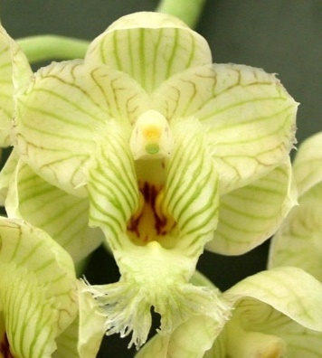
Clowesia russelliana
Clowesia dodsoniana
‘Nadia Tavarez’, AM/AOS
Jun 2001, NS 3.4 cm
Clowesia rosea
‘Pink’
Clowesia warczewitzii
‘Sunset Valley Orchids’

References:
www.orchidspecies.com
http://apps.kew.org/wcsp/qsearch.do
https://secure.aos.org/aqplus/SearchAwards.aspx
Bechtel, H.; Cribb, P.; Launert, E.; The Manual of Cultivated Orchid Species, 1992
OrchidWiz.Database x3.2, update: March 2017
Orchid Digest, Oct., Nov., Dec., 2016, 80(4), all four articles but mainly The State of Affairs in Breeding Catasetinae, Clarke, F., pp. 174-234

Building Block Data
Clowesia warczewitzii [1975]
(KLO-wes-ee-ah war-chew-IT-see-eye??)

Clowesia warczewitzii is native from Costa Rica to Guyana / Ecuador in tropical, moist forest at altitudes around 70 to500 meters. It is a medium sized, warm to hot growing epiphyte with narrowly ovoid to oblong, sulcate with age pseudobulbs carrying 4 to 6 apical, elliptic-lanceolate, deciduous leaves. The pendant inflorescences appear in the fall to mid-winter, up to 15 inches [30 cm] long, several [15 to 20] to many flowered, racemose arising from the base of a mature pseudobulb without leaves. The flowers have a lemony fragrance, fleshy 1.5 in [6.25 cm] green flowers of good form with darker green veining, the fimbriate lip has a deep gullet with a spot of red at tits base and a green column.
Clowesia warczewitzii
‘Severinii’, HCC/AOS
Feb 1972, NS 2.5 cm

Varieties:
None that are recognized

Synonyms
Clowesia warscewiczii
Catasetum warczewitzii
Myanthus warczewitzii
Catasetum scurra

Awards:
 | AOS Awards
Kew Name | FCC | AM | HCC | JC | AD | AQ | CCE | CCM | CHM | CBR | Total
Clowesia warczewitzii |  |  | 1 |  |  |  |  | 4 |  |  | 5
Timetable for awards: 1964 to 1999

Hybrids: Total of 127 registered, to the 6th generation
Before 1959 | 1960-1969 | 1970-1979 | 1980-89 | 1990-99 | 2000-10 | After 2010
1 | 4 | 1 | 7 | 21 | 41 | 52
Only 7 of the crosses are NOT intergeneric.

Used to increase flower longevity with individual blooms lasting four to five weeks in most cases.

Outstanding progeny and reason they are considered outstanding:
Since the intergeneric crosses are in a separate report and there are so few Clowesia crosses the following report will concentrate on those crosses that are NOT reported on in other reports. Below is a screen capture of the top 10 award winners and the top 10 progeny.
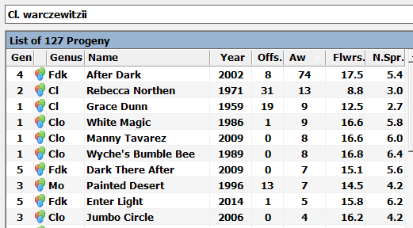
Clowesia warczewitzii progeny sorted by awards (OrchidWiz database)

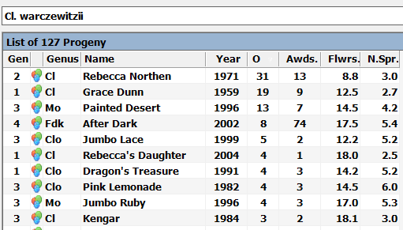
Clowesia warczewitzii progeny sorted by number of progeny (OrchidWiz database)

Clowesetum [Clo.] Jumbo Circle (Cl. Jumbo Grace x Ctsm. cirrhaeoides), 2006, Jumbo Orchids, No progeny, 3 AM/AOS awards.
Mormodia [Mo.] Jumbo Ruby (Cl. Rebecca Northen x Morm. ignea), 1996, Jumbo Orchids, 4 F1 progeny, 3 AOS awards (1 AM, 2 HCCs)
Clowesia Kengar (Cl. rosea x Cl. Rebecca Northen), 1984, Richella, 3 F1 progeny, 2 AOS awards (1 HCC, 1 CCM)
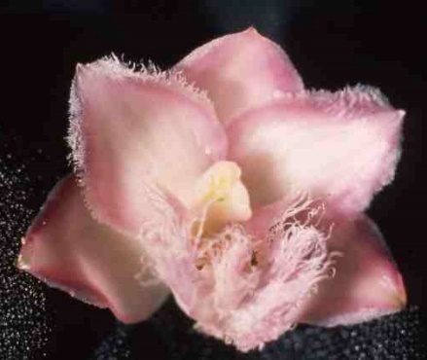
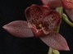
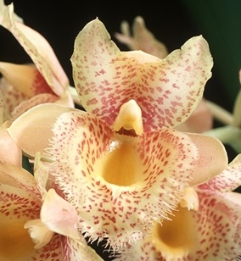
Clowesetum [Clo.] Jumbo Glory (Cl. Rebecca Northen x Ctsm. Bound for Glory), 1999, Jumbo Orchids, No progeny, 3 AOS awards (1 AM, 2 HCCs)
Interesting Tidbits
Clowesetum Jumbo Circle
‘Claire’, AM/AOS
Feb 2015, NS 4.0 cm
Mormodia Jumbo Ruby
‘Karen Meyer’, AM/AOS
Jan 2016, NS 5.3 cm
Clowesetum Jumbo Circle
‘Claire’, AM/AOS
Feb 2015, NS 4.0 cm
Clowesetum Jumbo Glory
‘Jumbo Orchids’, HCC/AOS
Oct 2006, NS 5.2 cm

The Table below list the names of the existing intergeneric cross made with Clowesia and the number of cross that exist:

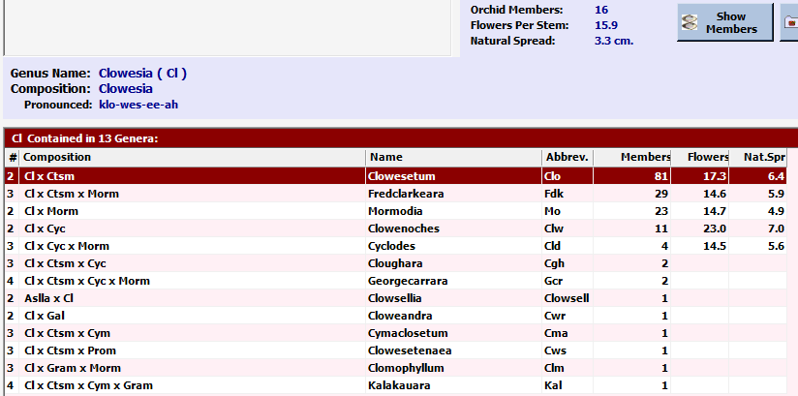

There are presently 8 registered Clowesia hybrids.

The intergeneric cross with the most progeny is Clowesetum (Clowesia x Catasetum) with more than twice as many members as the next intergeneric cross Fredclarkeara (Clowesia x Catasetum x Mormodes).

Since Catasetum, Cycnoches, Mormodes, and Clowesia are well mixed in terms of intergeneric breeding, they will be handled together.

Intergeneric Crosses between Catasetum, Cycnoches, Mormodes, Clowesia

“The Intergeneric Catasetinae hybrids are where much of the current excitement in breeding originates. The rate of development for new flower colors, shape, floriferousness, and bloom longevity is remarkable and has contributed to their skyrocketing popularity. There is still a lot to learn about intergeneric hybrids. One of the most interesting observations in this breeding is that many of what are considered to be the best floral qualities are also dominant breeding traits, and the less desirable qualities are recessive traits. How fortunate is that for hybridizing?! Understanding these dominant and recessive traits is very important and, when used properly, can result in superior progeny.”

In reviewing the intergeneric crosses of the above genera, two intergeneric crosses for each genus that had the most hybrids in the table along with number of members in parentheses and the last column has the genera that constitutes the cross:

Catasetum | Clowesetum (81)  Catanoches (39) | Clowesia x Catasetum  Catasetum x Cycnoches
Cycnoches | Cycnodes (82)  Catanoches (39) | Cycnoches x Mormodes  Catasetum x Cycnoches
Mormodes | Cycnodes (82)  Fredclarkeara (29) | Cycnoches x Mormodes  Clowesia x Catasetum x Mormodes
Clowesia | Clowesetum (81)  Fredclarkeara (29) | Clowesia x Catasetum  Clowesia x Catasetum x Mormodes

There are four different intergeneric crosses, the table below summarizes these crosses:

Intergeneric Cross | Year Regr | Members | Sum, top ten progeny | Sum, top ten awards
Catanoches | 1967 | 39 | 1 | 4
Clowesetum | 1978 | 81 | 24 | 110
Cycnodes | 1961 | 82 | 23 | 117
Fredclarkeara | 2003 | 29 | 10 | 106

Following will be s report for Clowesetum, Cycnodes, and Fredclarkeara (Catanoches was not included due to small number of progeny and awards even though breeding down this line started in 1967). All of the breeding information is obtained from the F. Clarke article in Orchid Digest, Oct., Nov., Dec., 2016.

References:
www.orchidspecies.com
http://apps.kew.org/wcsp/qsearch.do
https://secure.aos.org/aqplus/SearchAwards.aspx
Bechtel, H.; Cribb, P.; Launert, E.; The Manual of Cultivated Orchid Species, 1992
OrchidWiz.Database x3.2, update: March 2017
Orchid Digest, Oct., Nov., Dec., 2016, 80(4), all four articles but mainly The State of Affairs in Breeding Catasetinae, Clarke, F., pp. 174-234
Orchids, Supplement to, Oct. 2012 Cycnoches Species and Hybrids, Carr, G. F., Jr., pp 2-35

The Genus Clowesetum [Clo.]

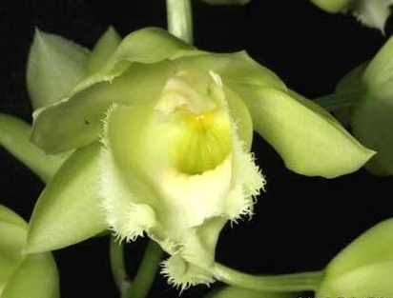
There are 45 hybrids in the Clowesetum genus and 36 additional intergeneric crosses. The initial Clowesetum cross was Clo. Billy Whiskers (Clowesia warczewitzii x Catasetum barbatum) registered in 1967 by W. W. G. Moir, it was not a successful cross with no progeny or awards. The second registered hybrid was in 1973, Clo. Delightful (Clowesia rosea x Catasetum pileatum) by J. Furrow it had one progeny and 2 AOS awards.
The combination of Clowesia and Catasetum brings several important characteristics into play. Catasetums have sexual dimorphism, with different male and female flowers, while clowesias produce perfect flowers like most orchids. Sexual dimorphism of flowers is a recessive trait, so the cross between a catasetum and clowesia blooms with perfect flowers. Thus, plants in the resulting hybrid genus Clowesetum do not have different-looking male or female flowers. All flowers are perfect and lack pollen ejecting triggers. Clowesias are known to have four- to five-week flower longevity, and this also is a dominant trait; clowesetum flowers typically last four to five weeks. Catasetums have a wide range of bloom sizes and colors. Careful selection of appropriate Catasetums can lend bloom size or color to the resulting Clowesetum progeny.
Clowesetum Delightful
‘Cimarron Valley’, AM/AOS
Oct. 1973, NS 7.0 cm
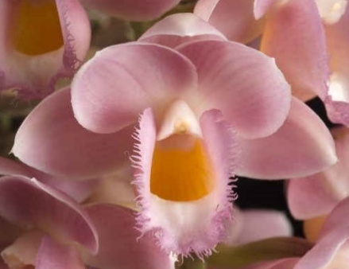
Hybrids with the most progeny
Clo. Jumbo Lace (Cl. Rebecca Northen x Ctsm. fimbriatum), 1999, Jumbo Orchids, 5 F1 progeny, 2 HCC/AOS awards. Major crosses: Clo. Sandi Uhlig (Clo. Jumbo Lace x Ctsm. Frilly Doris), 2011, F. Clarke, no progeny, HCC/AOS award; Clo. Upper Echelon (Clo. Jumbo Lace x Ctsm. Orchidgladed), 2012, F. Clarke, no progeny, AM/AOS.
Clo. Raymond Lerner (Cl. russelliana x Ctsm. pileatum), 1983, P. Lerner, 4 F1 and 5 total progeny, 18 AOS awards (13 AMs, 3 HCCs, 2 CCMs).
Clo. Pink Lemonade (Rebecca Northern x Ctsm. fuchsia), 1982, JEM, 4 F1 and 8 total progeny, 3 AOS awards (1 AM, 2 HCCs). Major cross: Clo. Dragon’s Treasure (Cl. warczewitzii x Clo. Pink Lemonade), 1991, JEM, 4 F1 progeny, 3 AM/AOS awards.
Clowesetum Dragon’s Treasure
‘Miss Anita’, AM/AOS
Dec. 2008, NS 5.2 cm
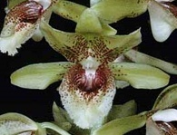
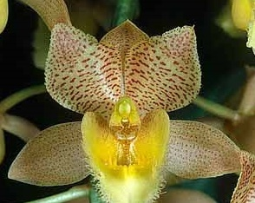
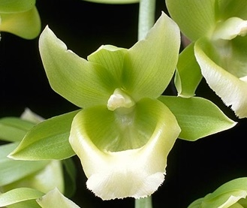
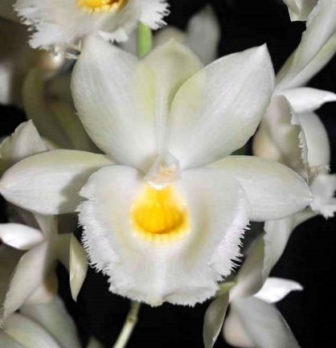
Clo. Black Jade (Cl. russelliana x Ctsm. expansum), 1991, JEM, 2 F1 progeny, 8 AOS awards (3 AMs, 4 HCCs, 1 JC)
Hybrids with the most awards
Clowesetum Black Jade
‘Woodland’s Jewel’, AM/AOS
Aug. 2003, NS 10.0 cm
Clowesetum Jumbo Lace
‘Monclair’, HCC/AOS
Nov. 2003, NS 6.2 cm
Clowesetum Raymond Lerner
‘Lucinda Lee’, AM/AOS
Feb. 2004, NS 9.0 cm
Clowesetum Pink Lemonade
‘JEM’, AM/AOS
Aug. 1994, NS 6.1 cm
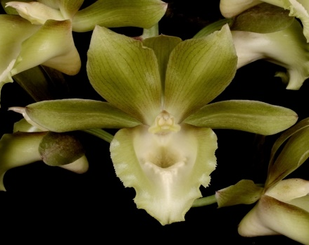
Clo. Sandy Kasner (Cl. dodsoniana x Ctsm. Alexis Pardo) 2008, E. Goldberg, no progeny, 15 AOS awards (11 AMs, 4 HCCs)
Clo. Brown’s Delight (Clo. Delightful x Ctsm. Orchidglade), 2002, W. E. Brown, no progeny, no AOS awards
Clo. White Magic (Cl. warczewitzii x Ctsm. Orchidglade), 1986, JEM, 1 F1 progeny, 5 AOS awards (3 AMs, 2 HCCs)
Clo. Manny Tavarez (Ctsm. expansum x Cl. warczewitzii), 2009, M. Margolis, no progeny, 8 AOS awards (3 AMs, 5 HCCs)
Clo. Mark Margolis (Ctsm. Durval Ferreira x Cl. dodsoniana), 2009, M. Margolis, no progeny, 8 AOS awards (6 AMs, 2 HCCs)
Clowesetum Brown’s Delight
‘Rose’, AM/OSNSW
Jun 2014, NS 10.2 cm
Clowesetum Sandy Kasner
‘Benttree’, AM/AOS
Jun 2016, NS 9.5 cm
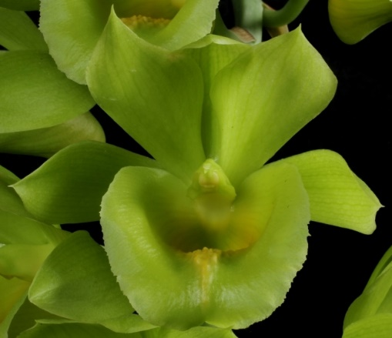
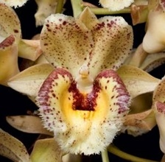
Clo. Wyche’s Bumble Bee (Cl. warczewitzii x Ctsm. Susan Fuchs), 1989, L. Poole, no progeny, 5 AM/AOS awards
Clowesetum Manny Tavarez
‘June’s Orchid Estate’, AM/AOS
Jan 2011, NS 7.0 cm
Clowesetum Wyche’s Bumble Bee
‘Jumbo Orchids’, AM/AOS
Mar 2010, NS 6.0 cm
Clowesetum Mark Margolis
‘Mark’s Lemon-Lime’, AM/AOS
May 2015, NS 6.5 cm
Clowesetum White Magic
‘Mark’s Lemon Lime’, AM/AOS
Oct 2015, NS 5.0 cm

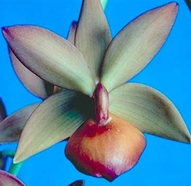
The Genus Cycnodes [Cycd.]

There are 81 hybrids in the Cycnodes genus and 18 additional intergeneric crosses. The initial Cycnodes cross was Cycd. L. Sherman Adams (Cycnoches chlorochilon x Mormodes wendlandii) registered in 1961 by Jones & Scully, receiving an AD/AOS award, no pictures were found. The second registered hybrid was in 1966, Cycd. Ginger Snap (Cycnodes chlorochilon x Mormodes colossa) by Alberts & Merkel, receiving 2 AOS awards (1 AM, 1 HCC).
This hybrid genus is quite remarkable. The bright flower colors of Mormodes are strongly dominant, and the twisted, asymmetrical flower form is recessive. The large, well-formed flowers of cycnoches are dominant, and their color is recessive. Thus, the best qualities of each genus dominate and the poor qualities are not passed to the offspring. Very high flower quality results from this breeding, as evidenced by the many awards. The over 80 registered hybrids have received 99 AOS awards, including four highly coveted First Class Certificates.
Cycnodes Ginger Snap
‘Discovery’, HCC/AOS
Jan. 1985, NS 9.2 cm
Hybrids with the most progeny
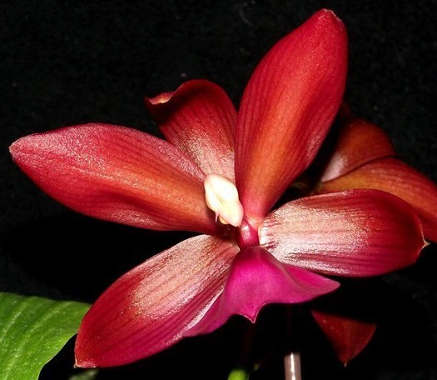
Cycd. Wine Delight (Cyc. lehmannii x Morm. sinuata), 1980, R. Coffman, 8 F1 progeny, 10 AOS awards (1 FCC, 6AMs, 3 CCMs). Wine delight ‘J.E.M.’ has been cloned and tens of thousands of plants have been distributed around the world making it the most popular and recognized cycnodes. Major cross: Monnierara Jumbo Delight (Cycd. Wine Delight x Ctsm. Orchidglade), 2007, Jumbo Orchids, no progeny, 4 awards
Cycd. Stephen Moffitt (Morm. maculata x Cyc. chlorochilon), 1999, Michael L. Levin, 4 F1 progeny, 2 HCC/AOS awards
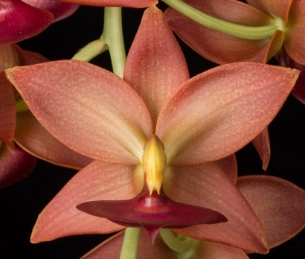
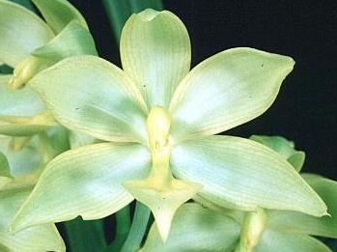
Cycd. Taiwan Gold (Cyc. chlorochilon x Morm. badia), 2004, Orchis Flor., 3 F1 progeny, 7 AOS awards (4 AMs, 2 HCCs, 1 CCM)
Cycnodes Jumbo Phoenix
‘JEM’, AM/AOS
Oct 1999, NS 7.8 cm
Cycnodes Stephen Moffitt
‘Sunset Valley Orchids’, HCC/AOS
Oct. 1999, NS 8.0 cm
Cycnodes Taiwan Gold
‘Rainbow Bay Joni’, AM/AOS
Dec 2014, NS 7.8 cm
Cycd. Jumbo Phoenix (Cyc. chloroge x Morm. sinuata), 1996, Jumbo Orchids, 2 F1 progeny, 2 awards
Cycnodes Wine Delight
‘J.E.M.’, FCC/AOS
Oct. 1984, NS 7.0 cm
Cycd. Taiwan Gold - Misregistration?? – should be Cycd. Jumbo Puff??
(Excerpt below copied from G. F. Carr article, pg. 28)
“I want to discuss involves what is apparently a clear case of misregistration of a hybrid. Cycnodes Jumbo Puff was registered on April 9, 2001 by Jumbo Orchids from Taiwan as the cross of (Cyc. warscewiczii x Morm. badia). It has been a highly successful hybrid that has received six AMs, one HCC, one Certificate of Cultural Excellence (CCE), and one Certificate of Cultural Merit (CCM) from the American Orchid Society. All of the awarded plants, along with other clones I have seen, have shown the clear yellow and flat lip of a good Cycnodes.
On May 17, 2004, Orchis Floricultural, Inc., from Taiwan, registered Cycnodes Taiwan Gold as the cross of (Cyc. chlorochilon x Cycd. Jumbo Jewel). There is a third award granted under the clonal name ‘Orchis’, HCC/AOS, but no photograph in the AQ Plus system. Then at the 20th World Orchid Conference in Singapore in 2011, the Judges chose Cycd. Taiwan Gold with the clonal name ‘Orchis’ as the Grand Champion plant. The plant belonged to the Council of Agriculture, Taiwan Orchid Growers Association, which is commonly referred to under the short name, Orchis. A protest was filed by Jumbo Orchids that said that Orchis had purchased a flask of Cycd. Jumbo Puff from them and when plants from that flask bloomed they registered them as Cycd. Taiwan Gold with the parentage (Cyc. chlorochilon x Cycd. Jumbo Puff). The Grand Champion and the awarded clones listed above all are the same color and form as Cycd. Jumbo Puff as you will note from the photographs (figures not included in this text, but comparable figures are below). At the 19th World Orchid Conference held in Miami, Florida in 2008, I had purchased plants with both names and I saw that Orchis, in their sales area, had labeled blooming plants of Cyc. warscewiczii as Cyc. chlorochilon. I told them they should correct their labels. I think this is a good indicator that the Cyc. chlorochilon listed as the capsule parent was Cyc. warscewiczii, the same as the capsule parent of Cycd. Jumbo Puff.
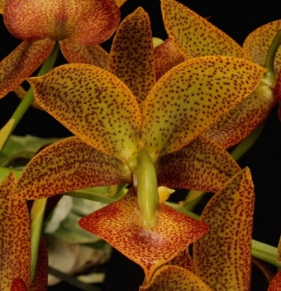
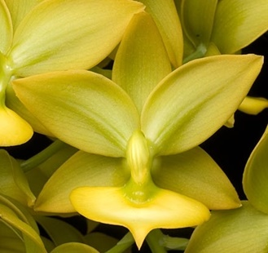
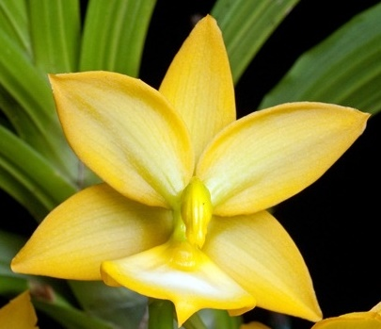
Jumbo Orchids of Taiwan registered the hybrid Cycnodes Jumbo Jewel on June 15, 1999, as the cross of (Morm. badia x Cyc. haagii). Jumbo Orchids maintained that all the plants of Cycd. Jumbo Jewel were spotted and, therefore, the Cycd. Taiwan Gold should also be spotted. Cycnodes Jumbo Jewel has received two Bronze Medals from the Taiwan Orchid Growers Association. The flowers of both of the clones show the spotting that Jumbo Orchids said were a mark of the hybrid. There are three awards by the American Orchid Society to Cycd. Jumbo Jewel, two of which have no photographs in AQ Plus (‘Everglades’, AM/AOS, and ‘Great Crystal Star’, AM/AOS). The descriptions of both of these clones state that they are overlaid with tiny mahogany spots. The third flower awarded under the name of Cycd. Jumbo Jewel ‘Sunset Valley Orchids’, AM/AOS, is the clear greenish gold of Cycd. Jumbo Puff. I think this plant is mislabeled and clearly not a true Cycd. Jumbo Jewel. Jumbo Orchids obtained samples of the Cycd. Taiwan Gold and submitted them for analysis together with samples from plants of Cycd. Jumbo Puff. According to Jumbo Orchids, the DNA results prove that Cycd. Taiwan is in fact Cycd. Jumbo Puff. The information has been submitted to the 20th World Orchid Conference committee for their decision. So far as I am aware, the committee has taken no action. The orchid registrar has, however, noted in the hybrid lists the result that Cycd. Taiwan Gold is Cycd. Jumbo Puff. An interesting side note to this situation is that all hybrid registrations depend on the registrant to submit correct information for parentage. This may not be the only mislabeled plant in the system.”
… sepals and petals pale green, edged mustard, heavily overlaid with fine oxblood spots, spotting denser on lower edge of lateral sepals; lip mustard, very heavily overlaid with oxblood spots peripherally…
… sepals and petals golden yellow, lime green centrally; lip light yellow…
Cycnodes Taiwan Gold
‘Memoria Nicolasa Tavarez’, AM/AOS
Nov 2014, NS 7.1 cm
… sepals and petals light green overlaid butter yellow, dark gold marginally, green basally and at midline; lip lemon yellow, lighter centrally …
Cycnodes Jumbo Jewel
‘Inge Ruecker’, HCC/AOS
Nov 2014, NS 5.0 cm
… sepals and petals broadly lanceolate; base color chartreuse, heavily stippled light cordovan; lip extremely flat, porrect, broadly cordate, apiculate, apex pointed downward, oxblood centrally overlaid iridescent purple …
Cycnodes Jumbo Puff
‘Nicola’, AM/AOS
Nov 2011, NS 7.0 cm
Cycnodes Taiwan Gold
‘Rainbow Bay Joni’, AM/AOS
Dec 2014, NS 7.8 cm
Updated Award Information
Since the article was written (assuming mid 2012) four AOS awards have been made to Cycd. Taiwan Gold, two of the yellow form and two of a reddish-brown form and two awards to Cycd. Jumbo Puff, clear yellow to yellow green, pictures and descriptions shown. I suspect that only the reddish-brown forms are correctly identified as Cycd. Taiwan Gold.

Hybrids with the most awards
Cycd. Jumbo Puff (Cyc. warscewiczii x Morm. badia) 2001, Jumbo Orchids, 2 F1 progeny, 12 AOS awards (8 AMs, 2 HCCs, 1 CCE, 1 CCM)
Cycd. Jumbo Erebus (Cyc. warscewiczii x Morm. Jumbo Volcano), 2001, Jumbo Orchids, no progeny, 1 AM/AOS award
Cycd. Midnight Magic (Morm. Midnight x Cyc. chlorochilon), 1999, F. Clarke, no progeny, 9 AOS awards (4 AMs, 2 HCCs, 2 JCs, 1 AQ)
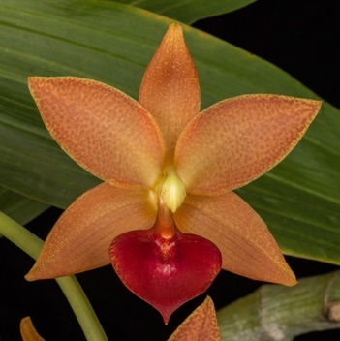
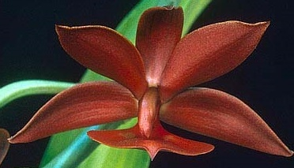
Cycd. Jumbo Micky (Cyc. Jumbo Dragon x Morm. badia), 2000, Jumbo Orchids, 1 F1 progeny, 6 AOS awards (3 AMs, 3 HCCs)
Cycnodes Jumbo Micky
‘Jumbo Orchids’, AM/AOS
Sep 2014, NS 7.8 cm
Cycnodes Midnight Magic
‘Mahogany Bird’, AM/AOS
Dec 2006, NS 9.0 cm
Cycnodes Jumbo Erebus
‘Nicola’, AM/AOS
Dec 2013, NS 8.4 cm
Cycnodes Jumbo Puff
‘Nicola’, AM/AOS
Nov 2011, NS 7.0 cm
The Genus Fredclarkeara [Fdk.]

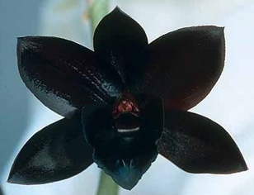
There are 29 members of the Fredclarkeara genus (from OrchidWiz X3.2, Update: Mar. 2017, RHS Registered Orchid Hybrids Oct.-Dec. 2016, per F. Clarke article in Oct.-Dec. 2016 Orchid Digest he states there are 41 registered hybrids). The initial cross was Fdk. After Dark (Mormodia Painted Desert x Catasetum Donna Wise) registered by F. Clarke in 2002. It became an instant success with 8 F1 and 10 total progeny with 48 AOS awards (27 March 2017). I suspect that this is the most awarded plant in AOS history (based on the length of time, if not total) and has definitely been an extremely successful cross in regards to awards (1 AD, 9 FCCs, 26 AMs, 5 HCCs, 6 CCEs, 1 CCM). The next page will include information on all nine FCC/AOS cultivars. This grex produced the first flower color widely recognized as black (or as close to black as possible). There were only 35 plants from the original cross. Of these, 16 received AOS awards, including eight FCC/AOS. The color and fragrance of the flowers inspired the development of a perfume called “Tom Ford Black Orchid.”
Fredclarkeara After Dark
‘SVO Black Diamond’, FCC/AOS
Jan 2006, NS 6.5 cm
The hybrid genus Fredclarkeara incorporates the best breeding qualities from the three genera in its make-up. Mormodes is dominant for color and a strong inflorescence; Clowesia is dominant for shape, multiple inflorescences, and flower longevity; and Catasetum is dominant for flower size and lip shape and is known to complement or intensify bloom color. This hybrid genus has set a new standard for quality in Catasetinae breeding. Fredclarkearas have beautiful colored flowers (initial predominant breeding was for ‘black’ or dark red orchids), full-shaped blooms, an amazing fragrance, high flower count, ease of growth, and amazing flower longevity that can exceed seven weeks, far longer than any other Catasetinae species or hybrids. These superior qualities have helped to establish a strong interest in the Catasetinae.
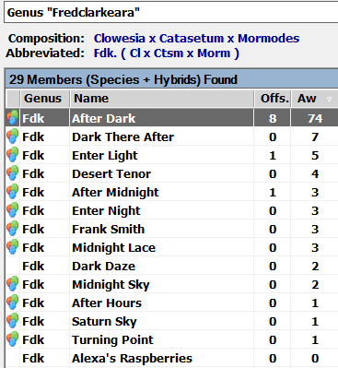
Hybridization and Awards:
From OrchidWiz x3.2 (March 2017 update)
Only 13 crosses of the 29 members have received awards or have progeny (awards in OrchidWiz appear to be about 6 months behind, that is awards from Oct. 2016 do not appear to be listed).

The report on significant members will include award winners.
Information on the nine Fredclarkeara After Dark cultivars receiving an FCC/AOS award.
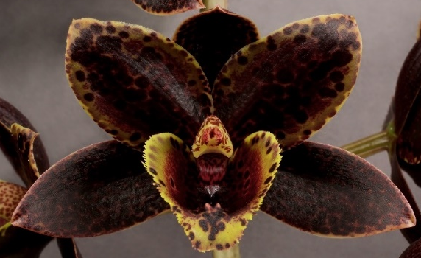
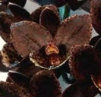
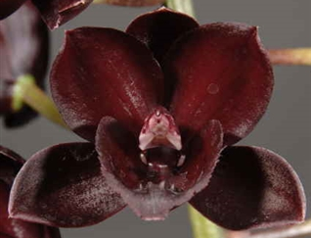
(Chronological Order)
‘Red Hawk’, FCC/AOS
Dec 2015, NS 7.2 cm
‘Ursa Spots’, FCC/AOS
Nov 2008, NS 5.0 cm
‘SVO Black Knight’, FCC/AOS
Dec 2007, NS 5.8 cm
‘SVO Black Diamond’, FCC/AOS
Jan 2006, NS 6.5 cm
‘SVO Black Cherry’, FCC/AOS
Jan 2007, NS 7.8 cm
‘Ursa Negra’, FCC/AOS
Nov 2007, NS 5.3 cm
‘SVO Black Pearl’, FCC/AOS
Jan 2005, NS 4.7 cm
‘Sunset Valley Orchids’, FCC/AOS
Nov 2005, NS 5.3 cm
‘Juliana Marie’, FCC/AOS
Nov 2004, NS 4.8 cm

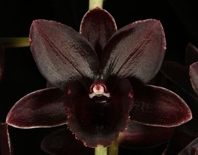
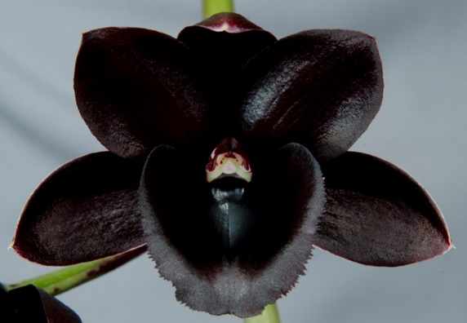
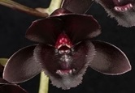
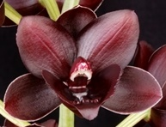
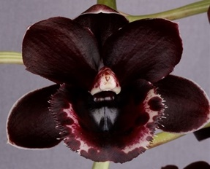
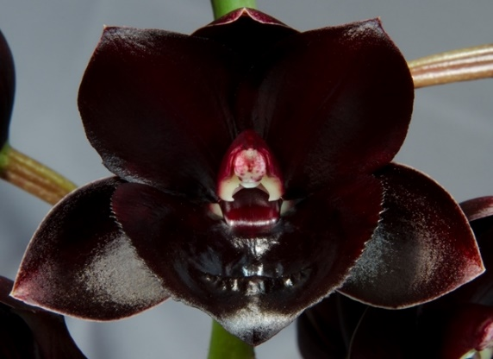
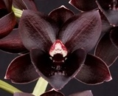
Other Fredclarkeara FCC/AOS awardees: (alphabetical order)
Fdk. Frank Smith
‘Nicola’, FCC/AOS
Dec 2015, NS 6.0 cm
Regr F. Clarke, 2012
Fdk. Enter Light
‘SVO Dark Beauty’, FCC/AOS
Dec 2015, NS 7.9 cm
Regr F. Clarke, 2014
Fdk. Desert Tenor
‘Sunset Valley Orchids’, FCC/AOS
Dec 2011, NS 4.3 cm
Regr F. Clarke, 2011
Fdk. Dark There After
‘SVO Winter’s Night’, FCC/AOS
Jan 2015, NS 5.2 cm
Regr F. Clarke, 2009
Fdk. After Midnight
‘SVO Dark Beauty’, FCC/AOS
Dec 2013, NS 6.5 cm
Regr F. Clarke, 2009
Fdk. After Hours
‘SVO Heaven Scent’, FCC/AOS
Nov 2015, NS 6.5 cm
Regr F. Clarke, 2011
Fdk. Frank Smith
‘Sunset Valley Orchids’, FCC/AOS
Jan 2015, NS 5.0 cm
Regr F. Clarke, 2012
Fdk. L'amour de vie de Sue
'The Dark Side', FCC/AOS
Dec 2016, NS 6.0 cm
Regr F. Clarke, 2015
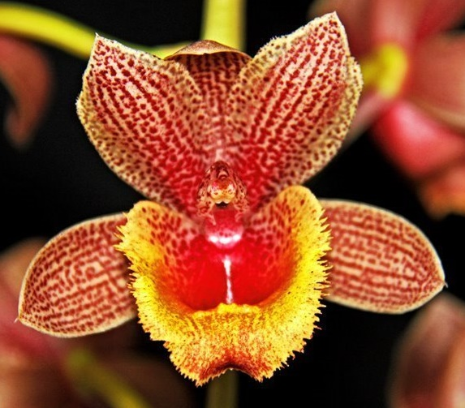
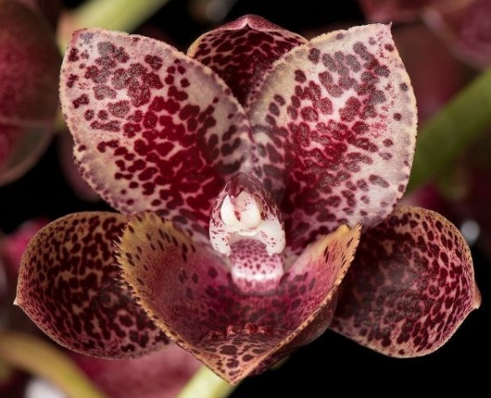
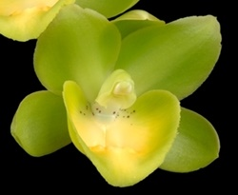
Other Fredclarkeara AOS awardees, NOT solid black or dark red: (alphabetical order)
Fdk. Turning Point
‘Louisiana’, AM/AOS
Dec 2016, NS 6.2 cm
Fdk. Enter Night
‘Nicola’, HCC/AOS
Nov 2015, NS 5.6 cm
Fdk. Saturn Sky
'Tamara Meikar's Passion', HCC/AOS
Oct 2013, NS 6.5 cm
Fdk. After Dark
‘Krull-Smith’, AM/AOS
Oct 2012, NS 8.2 cm
Fdk. Dark There After
‘Sunset Valley Orchids’, AM/AOS
Nov 2012, NS 6.3 cm
Fdk. Enter Light
‘SVO Grasshopper’, AM/AOS
Feb 2016, NS 6.2 cm
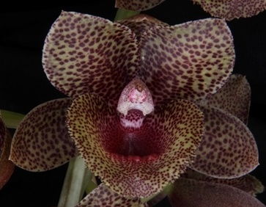
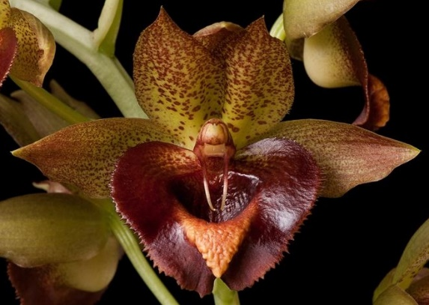
References:
www.orchidspecies.com
http://apps.kew.org/wcsp/qsearch.do
https://secure.aos.org/aqplus/SearchAwards.aspx
Bechtel, H.; Cribb, P.; Launert, E.; The Manual of Cultivated Orchid Species, 1992
OrchidWiz.Database x3.2, update: March 2017
Orchid Digest, Oct., Nov., Dec., 2016, 80(4), all four articles but mainly The State of Affairs in Breeding Catasetinae, Clarke, F., pp. 174-234

Award Descriptions
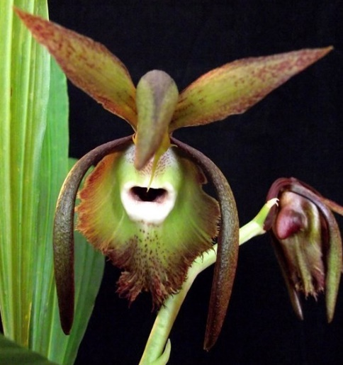
Catasetum [Ctsm.] incurvum – Quality Award Description
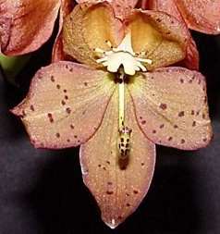
Three flowers on one inflorescences; flower with green base color; dorsal sepal over hangs column, lateral sepals frame lip, overlaid with small dark maroon blotches in some areas tending to lines, apical denser; petals, erect, flat, overlaid with small dark maroon blotches, apically denser, area in lower third without overlay; saccata fimbrilate lip base color green with a broad red-brown picotee band, band transitions to a broader area of spots and increased fibrillation apically, maroon spots basally, saccata opening dark maroon internally, halo white externally; column yellow; substance firm; texture matte.

Cycnoches [Cyc.] Martha Clarke – Quality Award Description
(Cyc. herenhusanum x Cyc. barthiorum)
Twenty flowers on one inflorescences; flower with yellow base color overlaid with maroon blush, basal ten percent no overlay; dorsal sepal and petals randomly maroon spotted apically two-thirds; lateral sepals golden maroon overlay; lip white, denticulate; column creamy yellow with apical half spotted maroon; substance medium; texture matte.

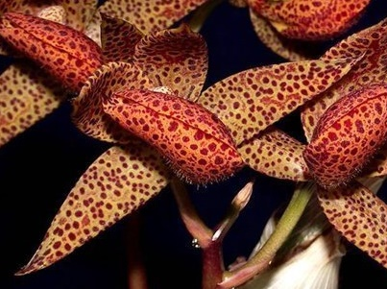
Mormodes [Morm.] Mini – Quality Award Description
(Morm. lawrenceana x Morm. ignea)
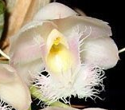
Four flowers and one bud on two inflorescences; flower with a light brown base color; sepals and petals spotted and blotched dark maroon; lip saddle shaped, edges overlap over 50% of the range, rosy red overlay, spotted and blotched dark maroon; column white with small lavender spots, heavier basally and apically; substance firm; texture waxy.

Clowesia [Cl.] Kengar – Quality Award Description
(Cl. rosea x Cl. Rebecca Northen)
Seven flowers and four buds on one inflorescences; flower with a white base color; sepals and petals cupped, pink blush; lip heavily fibrillated apically on main and side lobes, side lobes distally pink blush, yellow basalily, with a few pink spots; column white, anther cap yellow; substance medium; texture matte.
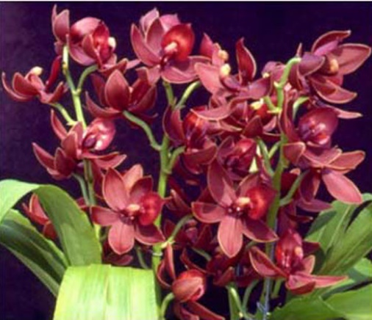
Cycnodes Jumbo Phoenix – CCM Description
(Cyc. Chloroge x Morm. sinuate)
Fifty-two flowers on 4 erect inflorescences; plant is in excellent condition grown in a 10 in pot of sphagnum moss; sepals and petals stellate, slightly cupped, maroon; lip triangular, red; column maroon, anther cap creamy yellow; substance sepals and petals heavy, lip leathery; texture waxy.

