Five Sample Descriptions for Lycaste, Anguloa, and Zygopetalum

- Lycaste virginalis AM/AOS, 82 points

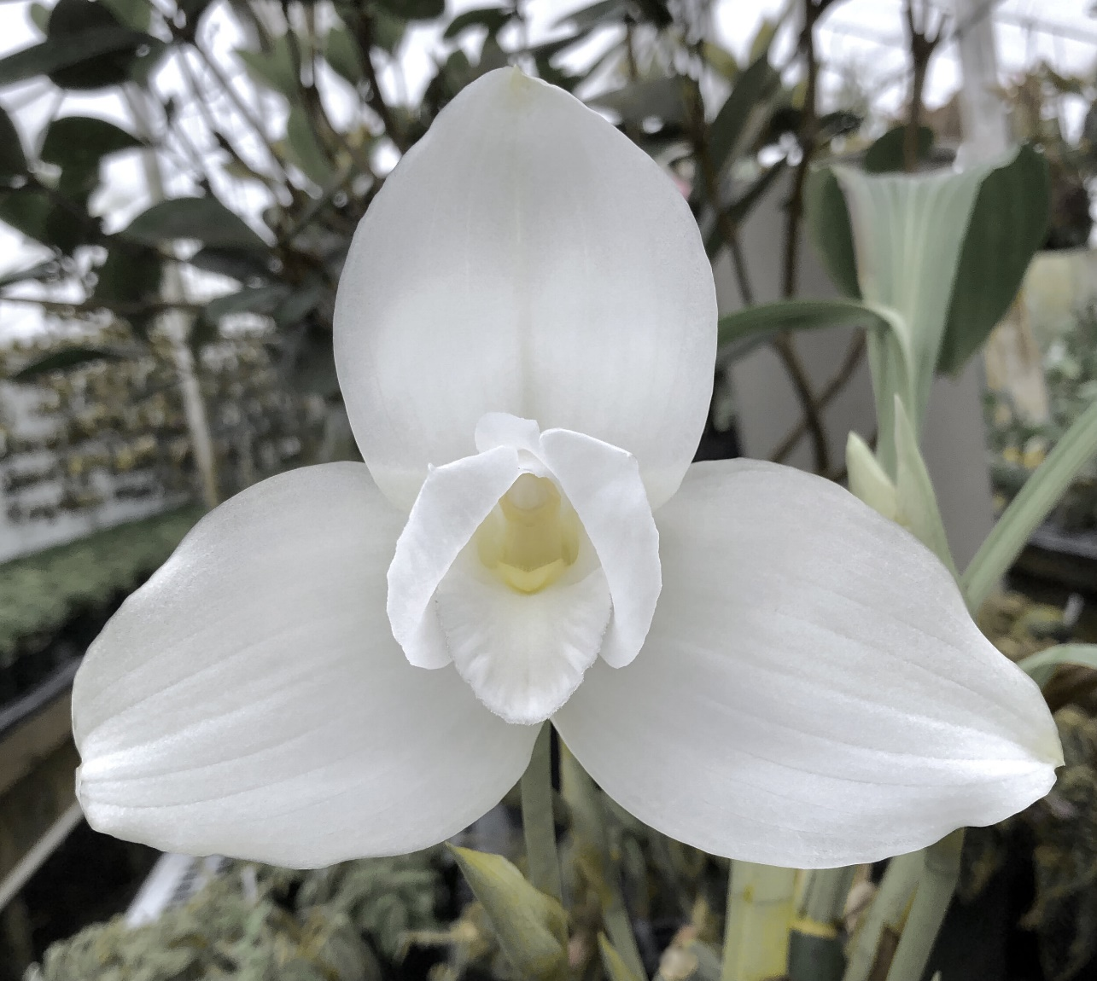

Description
Two flowers on two inflorescences up to x cm in length; sepals white; petals porrect, white; lip white, callus white overlaid yellow, column flushed yellow, anther cap white; substance firm; texture waxy.

- Lycaste Shonan Beat AM/AOS, 81 points

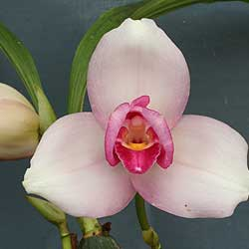

Description
Two flowers on two inflorescences to x cm; sepals white, blushed fuchsia peripherally basally, apical margins recurved; petals porrect, white, blushed darker fuchsia; lip fuchsia, white picotee, callus yellow, column white flushed fuchsia, anther cap white; substance hard, texture matte.

- Anguloa brevilabris CCE/AOS, 95 points

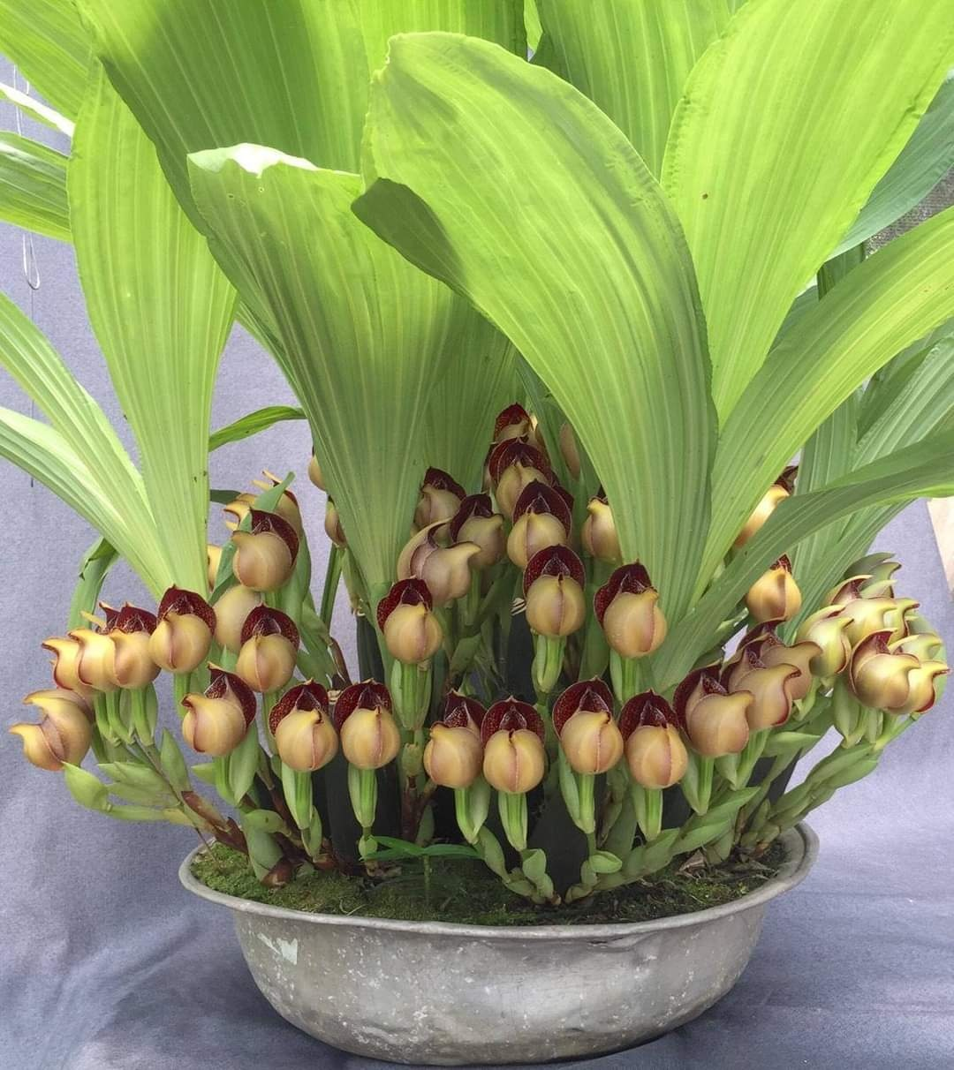

Description
One hundred twenty-four flowers and fourteen buds on one hundred thirty-eight inflorescences; sepals and petals cream; sepals heavily spotted burgundy; petals heavily spotted burgundy; lip cream spotted burgundy; substance firm; texture matte; commended for floriferousness.

- Zygopetalum Blue Bank AM/AOS, 82 points

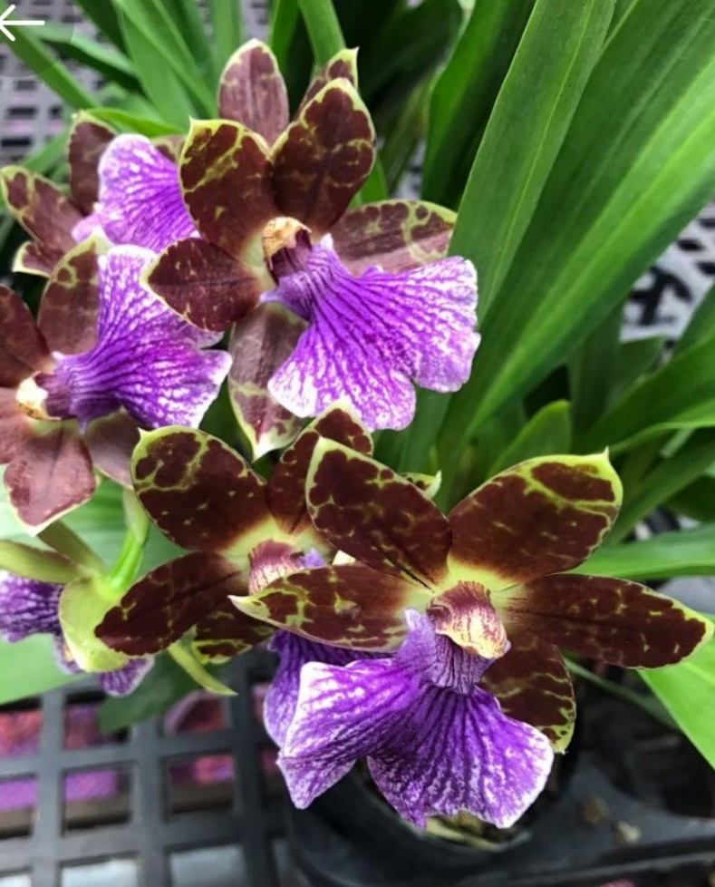

Description
Seven flowers on one inflorescence, x cm long; sepals and petals chartreuse, heavily blotched chestnut; lip white, heavily overlaid violet; substance heavy; texture matte.

- Zygopetalum Kiwi Beach AM/AOS, 84 points

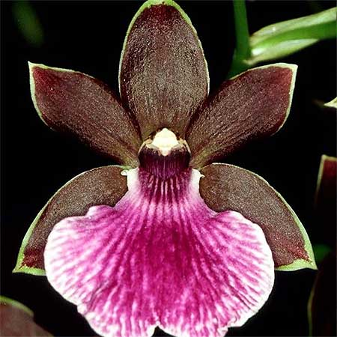

Description
Nine flowers on one inflorescence, x cm long; sepals and petals chartreuse, heavily overlaid deep brown, chartreuse picotee; lip white, heavily overlaid fuchsia, white picotee; substance heavy; texture matte.

