BUILDING BLOCK REPORT

Lycaste cruenta John Lindley 1843
[kroo-EN-ta] (Blood colored)

General Information
LIGHT: 1500-2500 fc. Plants need diffused or dappled light and protection from direct midday sun. Strong air movement should be provided at all times.

TEMPERATURES: Summer days average 73-74F (23C), and nights average 56F (13C), with a diurnal range of 17-18F (10C). The warmest days and greatest diurnal range of the year occur in spring at the end of the winter dry season. Temperatures in the preceding table reflect conditions in the higher elevations of the habitat and, therefore, represent about the coolest conditions under which this species should be grown. Because of the range in habitat elevations, Lycaste cruenta should adapt to temperatures up to 10F (6C) warmer than indicated. If an evaporative cooler is used in the growing area, it should respond well if placed in the cool, moist airflow near its outlet.

HUMIDITY: 80-85% in summer and early autumn, dropping to 70-75% in winter and spring. WATER: Rainfall is moderate to heavy from late spring into autumn. Monthly averages then drop abruptly into a very dry 5- to 6-month dry season that extends into the following spring. Cultivated plants should be watered often while actively growing; but their roots must dry rapidly after watering. Conditions around the roots should never be stale or soggy. Water should be gradually reduced after new growths mature in autumn.

FERTILIZER: 1/4–1/2 recommended strength, applied weekly when plants are actively growing. Many growers use a high-nitrogen fertilizer from spring to midsummer, then switch to one high in phosphates in late summer and autumn.

REST PERIOD: Winter days average 68-71F (20-22C), and nights average 49-51F (9-11C), with a diurnal range of 17-21F (9-12C). Growers are reminded that because of the range in habitat elevation, these plants should adapt to conditions as much as 10F (6C) warmer than indicated. Rainfall is very low in winter, but the amounts in the habitat may be somewhat greater than is indicated by the averages from the lower-elevation weather station. In addition, moisture not reflected by the rainfall averages is usually available from heavy dew and mist. Cultivated plants need less water in winter and should dry out between waterings, but not stay dry for long periods. Occasional early morning misting between infrequent light waterings should provide sufficient moisture in most growing areas. Fertilizer should be eliminated until new growth starts and heavier watering is resumed in spring. New growths are particularly susceptible to infection and are easily lost to disease and rot, so care should be taken to keep water out of the conelike new growths before the leaves open. If plants are watered automatically, growers might consider putting a little fungicide in the expanding cone to help prevent disease.

GROWING MEDIA: Plants usually are grown in pots or baskets filled with an open, fast draining medium that retains moisture without becoming stale or soggy. Growers recommend undersized, rather shallow containers with room for only 1–2 year's growth are best because the medium in larger pots stays wet for too long after watering so the roots cannot dry fast enough and easily develop root rot. Hawkes (1965) reported that most Lycaste species grow best when potted in straight shredded tree-fern fiber. More recently, however, some growers use fine-grade fir bark mixed with perlite and charcoal, while others prefer a mixture of equal volumes of shredded or chopped sphagnum, sedge peat, and perlite. These plants may also be grown mounted on tree-fern or cork slabs, but humidity must be high and plants need at least daily watering during the growing season. Mounted plants may need several waterings a day during extremely hot, dry weather. Providing enough summer moisture for mounted plants is difficult for some growers, so plants are usually grown in pots or baskets. Repotting or dividing should be done before the medium breaks down or when the plant starts to overgrow its container. In most instances, this occurs about every 2 years. Plants should be repotted after a new growth starts and roots are starting to grow. This is when the plant is best able to become reestablished in the shortest possible time with the least amount of stress.

ORIGIN/HABITAT: Mexico, Guatemala, and El Salvador. In Mexico, this orchid is found in several locations in the State of Chiapas. Plants were found about 50 mi. (80 km) southwest of Comitán at 3000 ft. (910 m), 15 mi. (24 km) southeast of San Cristobal de las Casas at 5500 ft. (1700 m), and near Teopisca at 6050 ft. (1850 m). In Guatemala, collections are reported from numerous locations in the Departments of Huehuetenango, Jalapa, Sacatepéquez, Santa Rosa, Suchitepequez, and Zacapa. Plants grow on forest trees below 7200 ft. (2200 m). In El Salvador, plants are found in the mountains in the western part of the country at 2150-3300 ft. (650-1000 m).

Distribution of Lycaste cruenta from Royal Botanic Gardens Kew

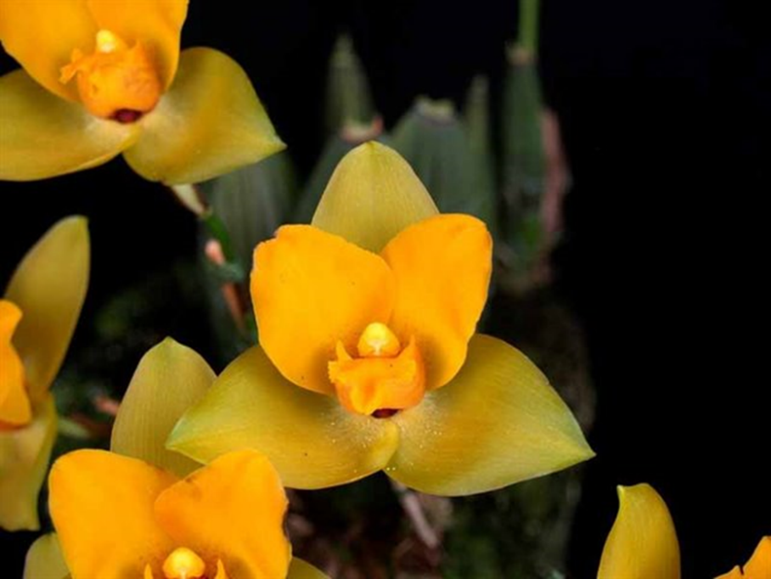
Lycaste cruenta ‘Erendira’ AM/AOS, 82 points, 2017
Photography by George Carlos

Synonyms, Subspecies, Varieties, Forms and Other Names Found
Lycaste cruenta var. concolor - Oakeley in Lycaste, Ida, Anguloa: 68 (2008)
Lycaste cruenta var. longibracteata - Oakeley in Lycaste, Ida, Anguloa: 70 (2008)
Lycaste cruenta subvar. longibracteata - Oakeley in Lycaste, Ida, Anguloa: 72 (2008)
Lycaste cruenta var. sulphurea - (Rchb.f.) Oakeley in Orchid Digest 71: 199 (2007)

Synonyms/Forms:
Lycaste balsamea - A.Rich. in Portef. Hort. 1: 250 (1847)
Lycaste chrysoptera - C.Morren in Ann. Soc. Roy. Agric. Gand 5: 7 (1849)
Lycaste rossiana - Rolfe in Orchid Rev. 1: 239 (1893)
Lycaste saccata - A.Rich. in Portef. Hort. 1: 249 (1847)
Lycaste sulphurea - Rchb.f. in Gard. Chron., n.s., 17: 218 (1882)
Lycaste sulfurea

Maxillaria balsamea - (A.Rich.) Beer in Prakt. Stud. Orchid.: 264 (1854)
Maxillaria chrysoptera - (C.Morren) Beer in Prakt. Stud. Orchid.: 264 (1854)
Maxillaria skinner -i Lindl. in Edwards's Bot. Reg. 26(Misc.): 48 (1840)
Maxillaria cruenta - Lindl.

Selbvana cruenta - (Lindl.) Archila

Awards:
Lycaste cruenta has been awarded by the AOS 21 times over the period of 1953 to 2017 (AM – 7; HCC – 3; CBM – 1; CCM – 5; CHM – 4; and JC – 1).

Hybrids
The use of Lycaste cruenta in hybridizing is considered important because of its color and cold tolerance.

Lycaste cruenta has a total of 37 first generation offspring and a total progeny of 765. In the first generation of the 37 offspring, it was the seed parent 17 times and the pollen parent 20 times.

9 Generations of Progeny
Generation | Grexes | Awarded | % Awarded | Awards
1 | 37 | 12 | 32.4% | 35
2 | 72 | 12 | 23.6% | 45
3 | 116 | 36 | 31.0% | 184
4 | 203 | 57 | 28.1% | 263
5 | 160 | 38 | 23.8% | 152
6 | 120 | 37 | 30.8% | 101
7 | 47 | 14 | 29.8% | 43
8 | 6 | 0 | 0% | 0
9 | 4 | 0 | 0% | 0

Lycaste Concentration is the (Lycaste cruenta x Lycaste Aubrun). This Lycaste cruenta offspring is the hybrid with the largest number of awarded grexes, having eight.

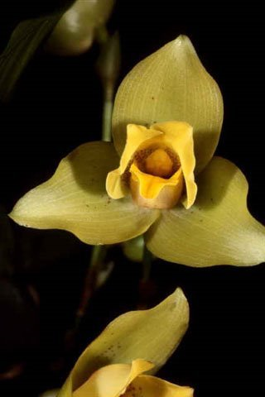
Lycaste Concentration ‘Jeffrey’ HCC/AOS, 77 points, 1987
Photography by OWZ Lib

Of the complex progeny of Lycaste cruenta, the Intrageneric cross of Angluocaste Olympus (Angcst. Apollo x Lyc. Sunrise) registered in 1959 has the largest number of awards with forty-eight. Angcst. Olympus was registered in 1959 by Wyld Court and originated by Wyld Court. Angcst Olympus has 12 first generation offspring and a total of 40 progeny. The hybrid has been awarded by the AOS 33 times (AM -11; FCC – 3; HCC – 6; and CCM – 13).

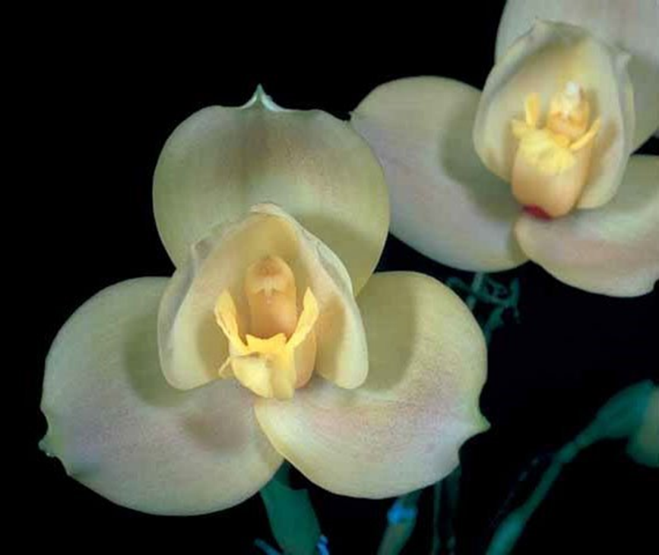
Angluocaste Olympus ‘Honey’ AM/AOS, 79.7 points, 2016
photography by OWZ Lib

The progeny with the second largest number of awards (45) Lyc. Koolena, which was registered in 1968. Lycaste Koolena is a cross of (Lyc. Auburn x Lyc. virginalis). Lycaste Koolena was registered in 1967 Wondabah and originated by Wondabah. Lycaste Koolena has 56 first generation offspring and a total of 368 progeny. This hybrid has been awarded by the AOS 26 times (AM – 14; HCC – 9; and CCM – 3).

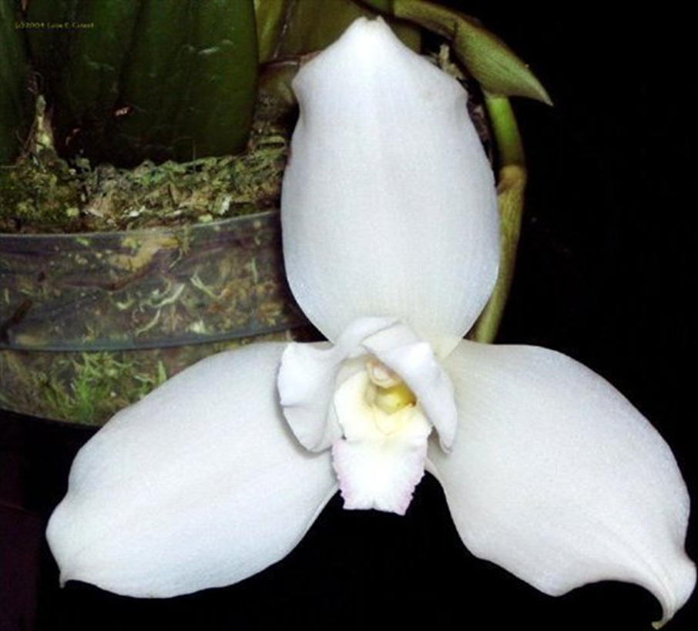
Lycaste Koolena ‘White Starlight’ AM/AOS, 80 points, 2004
photography by Lois Cinert

References
American Orchid Society. 2023. Lycaste culture sheet, American Orchid Society, 25/05/2023, On-line: https://www.aos.org/orchids/culture-sheets/lycaste.aspx .

Ames, O. & D. Correll. 1985. Orchids of Guatemala and Belize. Dover Publications, New York. Originally in Fieldiana 26(1 and 2) and 31(7).

Bechtel, P. 1998. Judging lycastes. Awards Quarterly, volume 29, number 3.

Bechtel, H., Cribb, P., & Launert, E. 1980. Manual of cultivated orchid species. MIT Press, Cambridge, Mass.

Fowlie, J. 1970. The genus lycaste: Its speciation, distribution, literature, and
cultivation--a monographic revision. Day Printing, Pomona, California.

Fowlie, J. 1970. The genus Lycaste. J. A. Fowlie, M. D., 1739 Foothill Blvd., La Canada, Calif. 91011.

Govaerts, R. 2003. World checklist of monocotyledons - Database in ACCESS: 1-71827. The Board of Trustees of the Royal Botanic Gardens, Kew.

Gripp, P. 1972. Looking at, learning about, and liking Lycastes. American Orchid Society Bulletin 41(5): 393-399.

Gripp, P. & D. Killeen. 1982. Succeeding with Lycastes. American Orchid Society Bulletin 51(7): 728-732.

Hamer, F. 1964. Orchids of El Salvador, vol. 2. The Marie Selby Botanical Gardens, 811 South Palm Avenue, Sarasota, FL 33577.

Hamilton, R. 1988. When does it flower? 2nd ed. Robert M. Hamilton, 9211 Beckwith Road, Richmond, B. C., Canada V6X 1V7.

Hawkes, A. 1987. Encyclopaedia of cultivated orchids. Faber and Faber, London.

Odion, D. 1984. Lycaste hybrids old and new. American Orchid Society Bulletin 53(4): 376-389.

Oakeley, H. 2007. A new infrageneric classification of lycaste (Lindl.) and a checklist of species for the genus Lycaste. Orchid Digest 71: 196-208.

Oakeley, H. 2008. Lycaste, ida and anguloa. The essential guide: 1-445. Published by the author.

OrchidsPlus. 1.4

OrchidWiz X9.1
Pridgeon, A. 1992. The illustrated encyclopedia of orchids. Timber Press, Portland, OR
Pridgeon, A., Cribb, P., Chase, M., & Rasmussen, F. 2009. Epidendroideae (Part two). Genera Orchidacearum 5: 1-585. Oxford University Press, New York, Oxford.

Royal Botanic Gardens Kew. 2023. Lycaste. Royal Botanic Gardens Kew: Plants of the World Online, 25/05/2023, On-line: https://powo.science.kew.org/taxon/urn:lsid:ipni.org:names:30000072-2 .

Slaughter, S. 1992. Observations on judging lycastes and other single-flowered genera. Awards Quarterly, volume 23, number 2.
Tinschert, O. 1983. Lycastes of Guatemala—some natural hybrids, some species, and many questions. American Orchid Society Bulletin 52(9): 908-916.

Vanini, J., Lycaste virginalis: From wet nurse to white nun. Exotica Esoterica. 29/05/2023. On-line: Guatemalan national flower in nature and cultivation. Jay Vannini on Lycaste virginalis flower forms — Exotica Esoterica .

