BUILDING BLOCK REPORT

Lycaste lasioglossa
[lay-zee-o-GLOSS-a] (wooly tounged, with a hairy lip)

General Information

PLANT SIZE AND TYPE: A large epiphyte with growths usually 12-18 in. (30-45 cm) tall. Plants to 24 in. (60 cm) tall have been reported, however. Hairy, terete roots to 0.08 in. (0.2 cm) in diameter are produced at the base of the pseudobulb.

PSEUDOBULB/STEM: 2.0-3.3 in. (5.0-8.5 cm) long by 1.0-2.5 in. (2.6-5.5 cm) in diameter. The intermediate to dark green, egg-shaped to elliptic pseudobulb is somewhat compressed laterally, has several rather blunt longitudinal ribs or ridges, and is partially enclosed at the base by close-fitting, short-lived, leaf-bearing bracts that weather away quickly. The pseudobulb does not have spines at the top after the leaves have fallen.

LEAVES: Usually 16-20 in. (40-50 cm) long by 4-5 in. (10-12 cm) wide but leaves to 28 in. (70 cm) long and 6 in. (16 cm) wide have been noted. Two or three elliptic to lanceolate leaves with sharply pointed tips, longitudinal fanlike folds, and a long, narrow, longitudinally folded petiole at the base are carried at the apex of the pseudobulb. The leaves normally remain on the pseudobulb for more than a season, but plants have been observed to lose its leaves after flowering before initiating a new growth.

INFLORESCENCE: 2.8-3.5 in. (7-9 cm) long. Two to six more or less erect inflorescences are produced from the base of a recently matured pseudobulb after a brief rest but before the leaves have fallen. A single blossom is carried at the apex of each inflorescence on a pedicellate ovary that is about 1 in. (2.5 cm) long and is subtended by a floral bract that is broadly egg-shaped, sharply pointed, and about 0.8-1.1 in. (2.0-2.7 cm) long by 0.5 in. (1.3 cm) wide.

FLOWERS: 1 per inflorescence, but 2-6 inflorescences per flowering growth usually are produced, and as many as 12 have been noted. The showy, non-fragrant blossoms are about 5 in. (13 cm) wide across the lateral sepals and have tan-brown to chocolate-brown sepals with yellow margins, while the petals and the lip are yellow, with the lip sometimes blotched with red and is covered with long, soft hairs. The sepals are oblong-elliptic, somewhat channeled along the midvein, and taper to sharply pointed tips. The erect dorsal sepal is 1,8-2.0 in. (4.6-5.2 cm) long by 0.6-0.7 in. (1.6-1.8 cm) wide and is somewhat reflexed toward the apex. The horizontally spreading lateral sepals joined at the base to form a sharp mentum and are 2.0-2.8 in. (5-7 cm) long by 0.6-0.7 in. (1.6-1.9 cm) wide. The narrowly lanceolate or elliptic petals are 1.4-1.7 in. (3.5-4.2 cm) long by 0.6-0.8 in. (1.6-2.0 cm) wide, have sharply pointed tips, are held in forward-pointing or arching to hooded positions over the column for most of their length but flare outward near their tips. The prominently 3-lobed lip, which is hinged to the column foot, is egg-shaped in outline if expanded, and measures 1.3-1.4 in. (3.2-3.5 cm) long by 1.1 in. (2.8 cm) wide across the lateral lobes if they are expanded. In their natural position, however, the conspicuous lateral lobes have rounded margins that curl strongly upward to embrace the column, are difficult to spread, and are 0.3 in. (0.8 cm) long by 0.3 in. (0.7 cm) wide. The midlobe bends gently downward toward its base, is 0.5 in. (1.2 cm) long by 0.3 in. (0.7 cm) wide, is bluntly rounded at the apex, and is entirely covered by long, soft hairs on the upper surface. The disc has an egg-shaped to triangular callus that is directed forward and is minutely notched at the tip. The rather straight column is 1.1-1.2 in. (2.8-3.0 cm) long and is gently recurved toward its tip. It is 0.3 in. (0.7 cm) wide at the base, tapering to about 0.2 in. (0.5 cm) wide at the tip.

ORIGIN/HABITAT: Mexico, Guatemala, El Salvador, and Honduras. The location of the habitat of this rather rare orchid in Guatemala is uncertain, but plants were earlier said to come from the Baja Verapaz region, while later collections were reported from near sea level in the vicinity of Lake Izabal. The species is thought to now be extinct in Mexico, but in previous times, plants were found in Chiapas near the border with Guatemala. Hágsater & Soto (2003) stated, "There is no information about the habitat of this species in Mexico. However, it seems to be native of cloud forests about 1400-1800 m, like the habitat recorded in Guatemala and El Salvador." Because of uncertainty as to actual habitat elevation, the following climate table and cultural suggestions should be used somewhat cautiously.

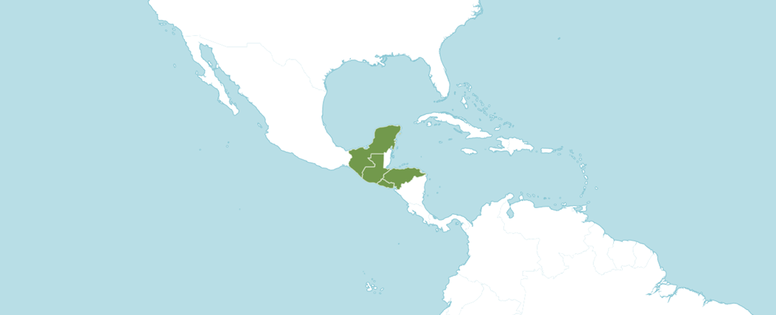
Distribution of Lycaste lasioglossa from Royal Botanic Gardens Kew

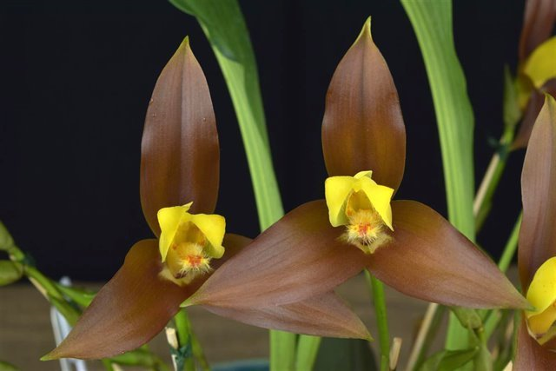
Lycaste lasioglossa ‘Melissa Archilla’ AM/AOS, 83 points, 2018
Photography by Jorge Carlos

Synonyms, Subspecies, Varieties, Forms and Other Names Found

Lycaste lasioglossa var. flava - Tinschert ex Oakeley in Lycaste, Ida, Anguloa: 105 (2008)
Lycaste lasioglossa var. melanacra - Cogn. in Chron. Orchid. 2: 10 (1904)
Lycaste lasioglossa var. minor - Oakeley in Lycaste, Ida, Anguloa: 106 (2008)

Synonyms/Forms:

Lycaste macropogon Rchb.f. in Gard. Chron., ser. 3, 3: 200 (1888)

Awards:

Lycaste lasioglossa has been awarded 11 times during the period of 1962 to 2018 (AM – 4; HCC – 4; CCM – 2; and JC – 1).

Hybrids
Lycaste lasioglossa has 28 first generation offspring and total progeny of 402. In the first generation of 28 offspring, it was the seed parent 16 times and pollen parent 12 times.

7 Generations of Progeny
Generation | Grexes | Awarded | % Awarded | Awards
1 | 28 | 8 | 28.6% | 22
2 | 61 | 16 | 26.2% | 30
3 | 98 | 32 | 32.7% | 144
4 | 102 | 32 | 31.4% | 120
5 | 83 | 28 | 33.7% | 75
6 | 28 | 3 | 10.7% | 10
7 | 2 | 0 | 0% | 0

Of the progeny of Lycaste lasioglossa, the cross of Lycaste Lucianii (Lyc. lasioglossa x Lyc. virginalis) registered in 1972 has the largest number of awards with 6 awards. Lycaste Lucianii was registered by G. Sparrow and originated by G. Sparrow. Lycaste Lucianii as 16 first generation offspring and a total of 297 progeny. The hybrid has been awarded by the AOS 6 times (AM -1; HCC – 3; CBM – 1 and CCE – 1).

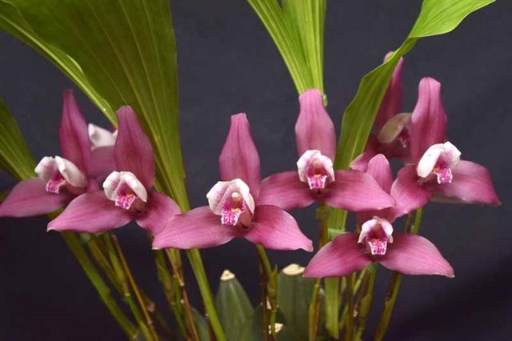
Lycaste Lucianii ‘Memoria Chaly’ CCE/AOS, 91 points, 2017
photography by Jorge Carlos

References
American Orchid Society. 2023. Lycaste culture sheet, American Orchid Society, 25/05/2023, On-line: https://www.aos.org/orchids/culture-sheets/lycaste.aspx .
Bechtel, P. 1998. Judging lycastes. Awards Quarterly, volume 29, number 3.

Fowlie, J. 1970. The genus lycaste: Its speciation, distribution, literature, and
cultivation--a monographic revision. Day Printing, Pomona, California.

Govaerts, R. 2003. World checklist of monocotyledons - Database in ACCESS: 1-71827. The Board of Trustees of the Royal Botanic Gardens, Kew.

Oakeley, H. 2007. A new infrageneric classification of lycaste (Lindl.) and a checklist of species for the genus Lycaste. Orchid Digest 71: 196-208.

Oakeley, H. 2008. Lycaste, ida and anguloa. The essential guide: 1-445. Published by the author.

OrchidsPlus. 1.4

OrchidWiz X9.1
Pridgeon, A.M., Cribb, P.J., Chase, M.C. & Rasmussen, F.N. (2009). Epidendroideae (Part two). Genera Orchidacearum 5: 1-585. Oxford University Press, New York, Oxford.

Royal Botanic Gardens Kew. 2023. Lycaste. Royal Botanic Gardens Kew: Plants of the World Online, 25/05/2023, On-line: https://powo.science.kew.org/taxon/urn:lsid:ipni.org:names:30000072-2 .

Slaughter, S. 1992. Observations on judging lycastes and other single-flowered genera. Awards Quarterly, volume 23, number 2.

Vanini, J., Lycaste virginalis: From wet nurse to white nun. Exotica Esoterica. 29/05/2023. On-line: Guatemalan national flower in nature and cultivation. Jay Vannini on Lycaste virginalis flower forms — Exotica Esoterica .

