GENUS SUMMARY
Anguloa Lindl. 1844
[an-gyew-LOH-a]

Anguloa Ruiz & Pavon 1794 known as the “Tulip Orchid”

The plants in this genus are quite large. Pseudobulbs can be over 9 inches tall and the plicate leaves on a well-grown plant can be over 4 feet long. This easily grown genus is terrestrial and the plant losses its leaves at the start of each season’s new growth. There are two basic groups of anguloas, white and yellow/red. White anguloas can produce up to six inflorescences per pseudobulb and the yellow/red up to twelve in late spring and early summer. There is usually one cupped flower per inflorescence. The flowers of all species are strongly fragrant.

Number of species:
With reference to Dr. Henry F. Oakley’s work, the genus is composed of nine distinct species and four natural hybrids. The species are breviaries, cliftonii, clowesii, dubia, eburnea, hohenlohii, tognettiae, uniflora, and virginalis. The four natural hybrids are x acostae, x rolfei, x ruckeri, and x speciosa. Currently, the Kew World Checklist of Selected Plant Families recognizes a total of 9 species, 4 varieties, and 4 natural hybrids (8/2012).

Distribution
Andean regions of Columbia, Venezuela, Ecuador, and Peru.

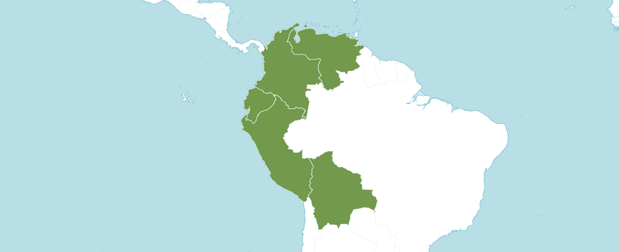
Distribution of genus Anguloa from Royal Botanic Gardens Kew

--- C U L T U R E ---
Mostly high elevation plants, they are best suited to cooler temperatures and vigorous air movement like odontoglossums, though an intermediate temperature does not appear to be detrimental to most of the species.
Almost direct sun in summer and as much sun as you can give it in winter, remembering that they need cooler temperatures.
Regular watering during the season, when the plant is producing new growth, and a dry winter rest will encourage flower production. Water just enough to keep bulbs from shriveling during rest and then heavily when the new growth appears in the spring.
The plants should be fertilized at full strength at each watering when the new growths are forming so that the new pseudobulbs will become large and mature as soon as possible in the fall.
Anguloas are terrestrials and a finer mix such as that used for cymbidiums works very well.
Lycaste, Ida and Anguloa by Dr Henry F. Oakeley (2008).
Encyclopedia of Cultivated Orchids edited by Alex D Hawkes (1965).
The Illustrated Encyclopedia of Orchids edited by Alec Pridgeon (1992).
Dennis S. Dayan
Dennisdayan@comcast.net

According to the American Orchid Society, orchid plants that belong in this specific genus are noticeably large, with fleshy pseudobulbs growing taller 9 inches in height and with leaves going beyond 4 feet in length. Jay’s Internet Orchid Species explicitly described its leaves as large, plicate, imbricate, and deciduous.

They are mostly terrestrial in nature but with some occasional epiphytes. Anguloa orchids are closely related to Lycaste orchid genus. The blooming season for these orchid plants takes place late spring to early summer months.
Anguloa orchids have a signature cup-shaped flower with the petals huddled inward, and only one flower per stem. It bears a strong resemblance to the popular tulips. They can bloom in white, yellow, and red, which come with differences. The white Anguloa orchids produce up to 6 inflorescences only, while the red and yellow ones are more impressive, making up to 12 inflorescences.
Another distinct characteristic of Anguloa orchids is that their flowers have a pleasant scent, which others say can be likened to menthol, wintergreen, and cinnamon. Many say this wonderful fragrance is more noticeable during the daytime. This same scent that humans love is what attracts the male Euglossine bees to come near the Anguloa orchids and pollinate them.

The AOS cited the extensive work of Dr. Henry F. Oakeley’s, which revealed that Anguloa orchid genus is made of 9 unique orchid species and 4 natural hybrids. We have listed them accordingly below along with their countries of distribution.

ANGULOA ORCHID SPECIES

Anguloa brevilabris Rolfe - Colombia, Peru

Anguloa cliftonii J. G. Fowler - Colombia

Anguloa clowesii Lindl. - Venezuela and Colombia

Anguloa dubia Rchb.f. - Colombia and possibly Venezuela

Anguloa eburnea Linden ex B.S. Williams - Colombia, Peru, Ecuador

Anguloa hohenlohii C. Morren - Colombia

Anguloa tognettiae Oakeley - Venezuela and Colombia

Anguloa uniflora Ruiz & Pav. - Peru

Anguloa virginalis Linden ex B.S. Williams - Venezuela, Colombia, Ecuador, Peru, Bolivia

NATURAL ANGULOA ORCHID HYBRIDS

Anguloa × acostae Oakeley (A. eburnea × A. hohenlohii) - Colombia

Anguloa × rolfei Sander ex Rolfe (A. brevilabris × A. cliftonii)- Colombia

Anguloa × ruckeri Lindl. (A. clowesii × A. hohenlohii) - Colombia, Venezuela, Peru

Anguloa × speciosa Linden (A. tognettiae × A. virginalis) - Venezuela, Colombia

References

American Orchid Society. (2023). Anguloa culture sheet, American Orchid Society, 28/05/2023, On-line: https://www.aos.org/orchids/additional-resources/anguloa-culture.aspx .

Bechtel, H., Cribb, P., & Launert, E. 1980. Manual of cultivated orchid species. MIT Press, Cambridge, Mass. Escobar, R. ed. 1990.

Escobar, R. 1994. Native Colombian orchids, vol. 5: Supplement Aa-Lepanthes. Colombian Orchid Society C/O "Hola" Colina Ltda., P. O. Box 3674, Medellin, Colombia.

Govaerts, R. 1995. World checklist of seed plants 1(1, 2): 1-483, 1-529. MIM, Deurne.

Govaerts, R. 2003. World checklist of monocotyledons database in ACCESS: 1-71827. The Board of Trustees of the Royal Botanic Gardens, Kew.

Hamilton, R. 1988. When does it flower? 2nd ed. Robert M. Hamilton, 9211 Beckwith Road, Richmond, B. C., Canada V6X 1V7. Hawkes, A. (1965) 1987.

Hawkes, A. 1987. Encyclopedia of cultivated orchids. Faber and Faber, London. Kew Data Base. 2007. http.//apps.kew.org/wcsp/home.do.

Hokche, O., Berry, P. & Huber, O. 2008. Nuevo catálogo de la flora vascular de Venezuela: 1-859. Fundación Instituto Botánico de Venezuela.

Kraus, L. 1987. Tulips by quite another name. AOS Bulletin, vol. 56, Number 1.

Native Colombian Orchids, vol. 1: Acacallis—dryadella. Colombian Orchid Society C/O "Hola" Colina Ltda., P. O. Box 3674, Medellin, Colombia. Escobar, R. ed. 1994.

Native Colombian Orchids, vol. 5: Supplement aa-lepanthes. Colombian Orchid Society C/O "Hola" Colina Ltda., P. O. Box 3674, Medellin, Colombia.
Ouch. Rev. 1915, xxiii. 292.

Oakeley, H. 2008. Lycaste, Ida and Anguloa. The essential guide: 1-445. Published by the author.

OrchidWiz X9.0.

Pridgeon, A. 1992. The illustrated encyclopedia of orchids. Timber Press, Portland, OR.

Royal Botanic Gardens Kew. Plants of the world online. Online: https://powo.science.kew.org/taxon/urn:lsid:ipni.org:names:616502-1

Valdivisieso, P., Martinez, A., & Urreta. G. 1982. Ornamental orchids of Colombia. Carlos Valencia, Bogota, Colombia.

