GENUS SUMMARY
Lycaste Lindl. 1843
[Lye-CAST-ee]

In the Manual of Cultivated Orchid Species Lycaste is noted as epiphytic, terrestrial or lithophytic herbs with shore, thick pseudobulbs. Leaves are plicate, several at apex of each pseudobulb, large, deciduous. Inflorescence lateral, several borne from the base of a pseudobulb, erect or erect spreading, 1 flowered in most species. Flowers large, showy, often fragrant. Sepals subequal, spreading; lateral sepals forming with the column-foot a distinct saccate mentum. Petals are like sepals but often distinctly colored. Lip 3-lobed, +/- pubescent; disc +/- pubescent, with a variously shaped callus Column long, wingless to narrowly 2-winged above, produced into a foot at base; pollinia 4 or 2 and sulcate, with 2 noticeably short or elongate stipites.

Distribution About 25 species, widely distributed from Mexico south to Peru and Bolivia and in the W. Indies.

Derivation of Name. Lycaste was the beautiful daughter of King Priam of Troy.

Taxonomy John Lindley described Lycaste in 1843 in the Botanical Register (misc. p. 14). Most of the species of Lycaste have been placed in Maxillaria at one time or another but they are readily distinguished from that genus by their plicate leaves. Lycaste is also allied to Xylobium, but the species of that genus have few- to many- flowered inflorescences. The genus has recently been monographed by J. A Fowlie in The Genus Lycaste (1970). The genus may be conveniently divided into those species such as L. barringtoniae (J. E. Smith) Lindl. In which the mid-lobe of the lip is fimbriate and the callus is bifid; and the species such as L cruenta (Lindl.) Lindl., L. deppei (Lodd.) Lindl. And L. skinneri (Batem. Ex Lindl.) Lindl. where the lip mid-lobe is not fimbriate and the callus is entire and finger-like.

Culture Compost A. Temp. Winter min. 12*C. While the hard pseudobulbs ae leafless, Lycaste species require a cool, dry rest with only a little water given from time to time. When the new shoots appear, the plants should be given conditions of moderate shade and humidity but very little water until the roots are seen to be growing. When in full growth, water may be freely given until the new pseudobulbs are finally formed.

Kew notes Lycaste are native to: Belize, Bolivia, Brazil North, Brazil West-Central, Colombia, Costa Rica, Ecuador, El Salvador, French Guiana, Guatemala, Guyana, Honduras, Mexico Central, Mexico Gulf, Mexico Northeast, Mexico Southeast, Mexico Southwest, Nicaragua, Panamá, Peru, Suriname, Venezuela.
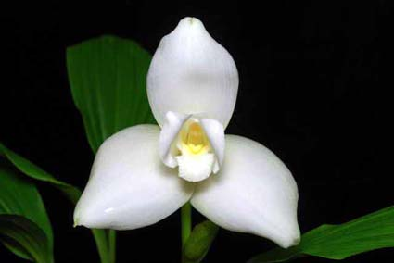
Lycaste skinneri f. alba ‘Golden Gate’ HCC/AOS, 77 points, 2008
Photography Eric Hunt

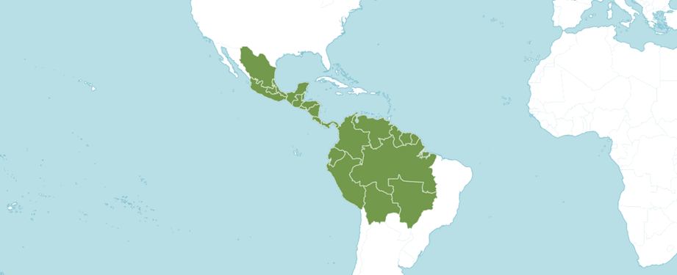
Distribution of genus Lycaste from Royal Botanic Gardens Kew
Kew notes the genus Lycaste was formerly divided into four sections: Fimbriatae, Deciduosae, Lycaste and Longisepalae. The species of section Fimbriatae - Lycaste barringtoniae, Lycaste ciliata, Lycaste cinnabarina, Lycaste costata, Lycaste dyeriana Lycaste fragrans, Lycaste fulvescens Lycaste gigantea, Lycaste lanipes Lycaste linguella, Lycaste locusta and Lycaste reichenbachii - have spineless pseudobulbs, persistent leaves, typically green sepals, and petals, and a fimbriate lip. Results of DNA analysis provide strong support for the separation of Lycaste section Fimbriatae from the rest of the genus. These species appear to be much more closely related to Anguloa than to the remaining three sections of Lycaste. Recently, these species have been transferred to a newly created genus, Ida.

Number of species. As of 2007, The World Checklist of Monocotyledon recognizes the genus Lycaste to be comprised of 31 species and 3 natural hybrids.

The American Orchid Society denotes Lycastes are deciduous in various degrees, from the strongly deciduous, yellow-flowered species like Lycaste aromatica that flowers from leafless pseudobulbs to the evergreen types like Lycaste skinneri with pseudobulbs that retain their leaves at flowering. This genus produces large, long-lasting, showy, triangular flowers that are waxy. The plants are distinctive for their roundish pseudobulbs and broad, plicate (pleated) leaves. Culture for the hybrid genus Angulocaste (Lycaste Anguloa) follows the culture for the Lycaste parent.
Light requirements vary. Deciduous species require light conditions as for cattleyas — 2,000 to 4,000 foot-candles or 50 to 70 percent shade. More light is usually provided as new growths form pseudobulbs. Evergreen species grow best with less light — 1,500 to 2,000 foot-candles or 60 to 80 percent shade.
Temperatures for the evergreen species should be constant and never hot. Nights of 60 F and days of 75 to 80 F are desirable. The deciduous species of Lycaste can tolerate a wider range, up to 95 F during the day and down to 50 F at night when dormant in the winter.
Water should be applied freely during active growth (usually summer). The potting medium should begin to dry out between waterings. Deciduous species should be kept almost completely dry when leafless; evergreen species should be kept only slightly drier than normal after pseudobulbs form. Water should be kept off the leaves, and especially out of the new growths, to prevent rot or leaf spotting, which disfigure otherwise handsome plants.
Humidity should be maintained at 40 to 70 percent. Deciduous species need less humidity when dormant. Brisk air circulation will help prevent damage to leaves by leafspot fungi.
Fertilize regularly and heavily when plants are actively growing. A higher nitrogen formulation (such as 30-10-10) is recommended during active growth (usually summer); some growers spread blood meal on the top of the potting medium as new pseudobulbs form, though in inexperienced hands this can be dangerous to the plant. In autumn, or as growths mature and pseudobulbs are produced, fertilizer is reduced or switched to a high-phosphorus (such as 10-30-20) formulation to stimulate flower production.
Potting is best when new growth starts, usually in spring. A fine-grade potting medium is often used; fir bark and perlite (3:1) is a common, fast-draining mix. When repotting, split plants into no less than two pseudobulbs per pot and choose a container to allow for two years of growth. The plant should be positioned in the vessel so that the newest growths are farthest away from the edge of the pot, allowing the maximum number of new growths without crowding the pot. Spread the roots over a cone of potting medium and fill in around the roots with potting medium to the junction of the roots and the pseudobulbs. Push the medium firmly around the roots. Keep humidity high and the potting medium on the dry side until new roots form.
C U L T U R E ---
Temperature: | Winter night 50-60F, Winter day 65-70F, maximum summer day temperature should be below 85F when growing and vary according to the altitude of the species.
Light: | Bright shade appears to work for most of the Sections. Many can take more sun, particularly during the winter months, as long as the temperature is under control.
Water-Humidity: | Water heavily; making sure that the mix becomes barely moist before watering again. Humidity should be very high at night, falling to around 50% during the day.
Fertilizer: | Use an even formula and apply more frequently when the plants are making up their bulbs.
Potting: | Repot every year, leaving room for only one year’s growth. Use clay pots to help keep the temperature lower with a fast-draining finer mix. Many growers have used sphagnum moss successfully.
References: | 1. Orchids, April 2001, Lycaste Species, The Essential Guide by Dr. Henry F. Oakeley. 2. Encyclopedia of Cultivated Orchids by Alex D. Hawkes 3. The Illustrated Encyclopedia of Orchids edited by Alec Pridgeon.
Author: | Dennis Dayan
E-mail: | dennisdayan@comcast.net

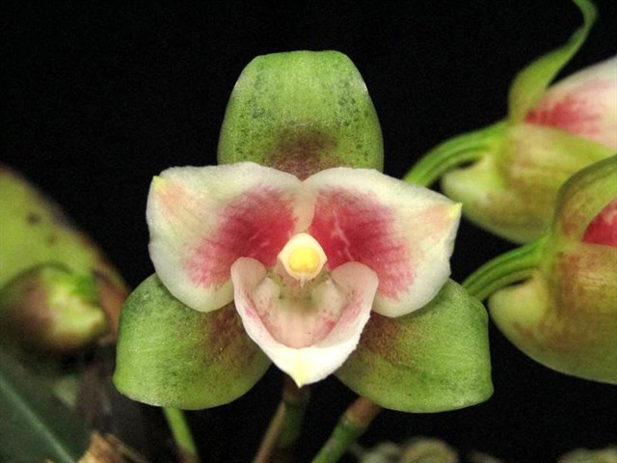
Lycaste angelae, no award
photography by Kresly Pineda
Reference
American Orchid Society. 2023. Lycaste culture sheet, American Orchid Society, 25/05/2023, On-line: https://www.aos.org/orchids/culture-sheets/lycaste.aspx .

Bechtel, P. 1998. Judging lycastes. Awards Quarterly, volume 29, number 3.

Fowlie, J. 1970. The genus lycaste: Its speciation, distribution, literature, and
cultivation--a monographic revision. Day Printing, Pomona, California.

Govaerts, R. 2003. World checklist of monocotyledons - Database in ACCESS: 1-71827. The Board of Trustees of the Royal Botanic Gardens, Kew.

Oakeley, H. 2007. A new infrageneric classification of lycaste (Lindl.) and a checklist of species for the genus Lycaste. Orchid Digest 71: 196-208.

Oakeley, H. 2008. Lycaste, ida and anguloa. The essential guide: 1-445. Published by the author.

OrchidWiz X9.0.

Pridgeon, A., Cribb, P., Chase, M. & Rasmussen, F. (2009). Epidendroideae (Part two). Genera Orchidacearum 5: 1-585. Oxford University Press, New York, Oxford.

Royal Botanic Gardens Kew. 2023. Lycaste. Royal Botanic Gardens Kew: Plants of the World Online, 25/05/2023, On-line: https://powo.science.kew.org/taxon/urn:lsid:ipni.org:names:30000072-2 .

Slaughter, S. 1992. Observations on judging lycastes and other single-flowered genera. Awards Quarterly, volume 23, number 2.

Vanini, J., Lycaste virginalis: From wet nurse to white nun. Exotica Esoterica. 29/05/2023. On-line: Guatemalan national flower in nature and cultivation. Jay Vannini on Lycaste virginalis flower forms — Exotica Esoterica .

