Species Data Sheet

Anguloa cliftonii
[an-gyew-LOH-ah]

Anguloa cliftonii J. G. Fowler 1910 (named for J.T. Clifton British Orchidist).

General Information

ORIGIN/HABITAT: Colombia. This terrestrial orchid is found in the Andes of northwestern Colombia. Specific habitat location and elevation is not available, but Escobar (1994) reported that the plant has been grown at Colomborquideas, a nursery near Medellin, and indicated that plants are found in warm locations at 3300-5900 ft. (1000-1800 m). Armed with this wealth of information, the following climate table and cultural suggestions are based on an estimated elevation and should be used with caution until more specific information is available. -- Source: Charles Baker

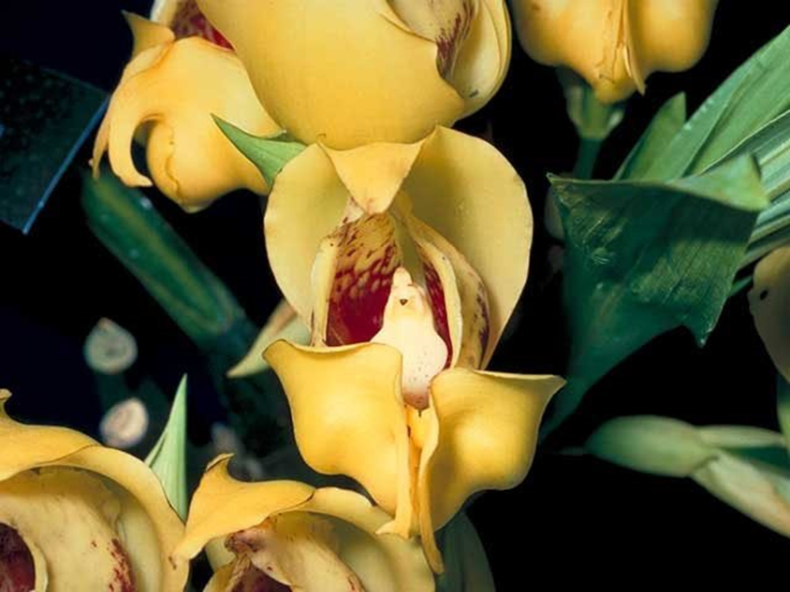
Anguloa cliftonii ‘Ligia’ AM/AOS, 82 points, 1987
photography by OWZ Lib

PLANT SIZE AND TYPE: A large terrestrial plant that grows to 12-16 in. (30-40 cm) tall.

PSEUDOBULB/STEM: 4-6 in. (11-15 cm) long by 1.8-2.6 in. (4.5-6.5 cm) in diameter. The clustered pseudobulbs are egg-shaped to oblong.

LEAVES: 6-12 in (15-30 cm) long by 2.8-3.5 in. (7-9 cm) wide. Two or three elliptic-oblong leaves are carried at the apex of the pseudobulb. They taper to sharply pointed tips, are somewhat undulated, taper to a narrow base, and have fanlike longitudinal folds.

INFLORESCENCE: 8-10 in (20-26 cm) long. The erect inflorescences emerge from the base of a new growth before the leaves are fully developed and are completely covered with overlapping sheaths. The blossom has a floral bract that is elliptic-lanceolate, sharply pointed, and 2.0-2.4 in. (5-6 cm) long.

FLOWERS: 1 per inflorescence. The somewhat globelike flowers, which are the largest in the genus, are usually more open than those of the other species. They are very large, waxy, strongly fragrant, and measure up to 3.5 in. (9 cm) long and wide and are pale yellow or lemon-yellow, with the petals flecked with small maroon spots. At the base of the sepaline cup, the flowers shade to a very dark butter yellow. The brownish yellow lip is spotted with brown on the front lobe. The dorsal sepal is elliptic oblong, somewhat bluntly pointed, and about 4 in. (10 cm) long by 2 in. (5 cm) wide. The orbicular-elliptic lateral sepals are sickle-shaped, are strongly reflexed at their rather bluntly pointed tips, and measure 3 in. (7.5 cm) long by 1.6 in. (4 cm) wide. The orbicular to egg-shaped petals are somewhat bluntly pointed and measure 3 in. (7.5 cm) long by 1.6-2.0 in. (4-5 cm) wide. The erect lip, which has a 0.4 in. (1 cm) long claw at the base, is 1.6 in. (4 cm) long. The blade of the lip is 3-lobed and is saccate at the base. The lateral lobes are sickle-shaped to incurved, bluntly pointed, and 0.3 in. (0.8 cm) long. The triangular midlobe is clawed at the base, tapers to a pointed apex, is pubescent, and has a 2-lobed or obcordate callus at the base. The fleshy column is 1.4 in. (3.5 cm) long.

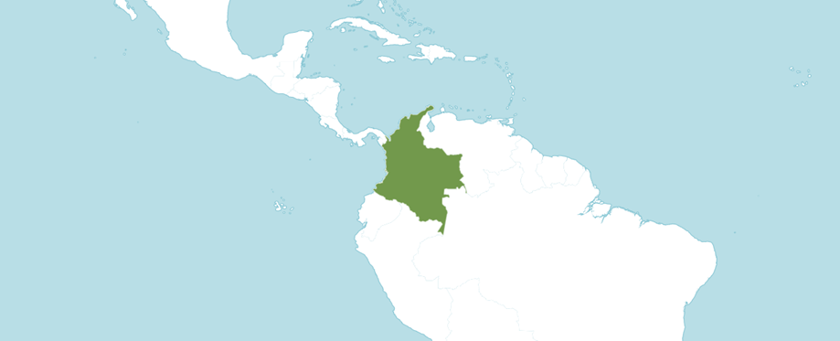
Distribution of Anguloa cliftonii from Royal Botanic Gardens Kew
Botanical Varieties (if any)

Anguloa cliftonii var. alba Oakeley in Orquideologia 21: 189 (1999)

Anguloa cliftonii var. concolor Oakeley in Orchids (Tokyo) 38: 32 (1999)
Synonyms
None

Awards
Anguloa cliftonii has been awarded 13 times during the period of 1966 to 2019 (AM – 6; HCC – 2; and CCM – 5).

Hybrids
Anguloa cliftonii has 18 first generation offspring and a total progeny of 37. In the first generation of 18 offspring, it was the seed parent 13 times and pollen parent 5 times.

Of the progeny of Anguloa cliftonii, the primary hybrid of Anguloa Nathalie Dublineau (Ang. cliftonii x Ang. virginalis) registered in 2010. Anguloa Nathalie Dublineau has the largest number of awards of Anguloa cliftonii highbred holding 3 awards. Anguloa Nathalie Dublineau was registered by P. Bertaux and originated by P. Bertaux. Anguloa Nathalie Dublineau as 1 first generation offspring and a total of 1 progeny. The hybrid has been awarded by the AOS 1 time (AM -1) in 2014.

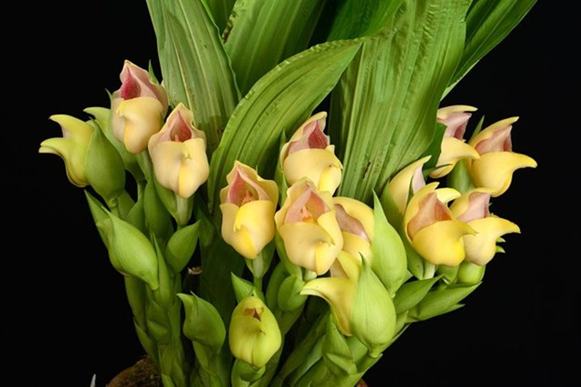
Anguloa Nathalie Dublineau ‘ De Angulo’ AM/AOS, 85 points, 2014
photography by Nicolas Gomez Rios

Building Blocks
Anguloa aurantiaca has 27 first generation offspring and a total of 223 progeny. In the first generation of 27 offspring, it was the seed parent 11 times and the pollen parent 16 times. From 1981 to 2019 Anguloa aurantiaca has 7 AOS awards (HCC – 2; CBR – 1; CCM – 3; and CHM – 1). Anguloa aurantiaca’s synonym is Lycaste macrobulbon. Photographs in OrchidWiz X9.0 do not resemble a Anguloa, instead resemble a Lycaste. This appears to be a mistake in OrchidWiz X9.0.

Anguloa clowesii has 32 first generation offspring and a total of 163 progeny. In the first generation of 32 offspring, it was the seed parent 22 times and the pollen parent 10 times. From 1968 to 2021 Anguloa clowesii has 12 AOS awards (AM – 6; CCE – 1; and CCM – 5).

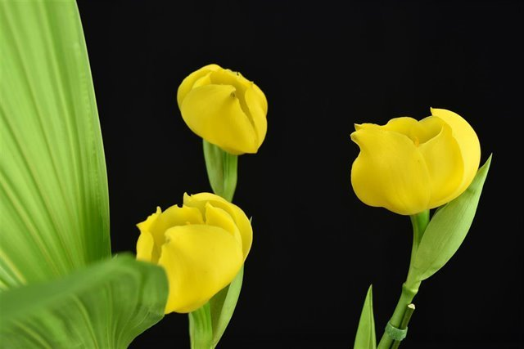
Anguloa clowesii ‘Tulipa’ AM/AOS, 87 points, 1972
Photography by Jorge Carlos

References
American Orchid Society. 2023. Anguloa culture sheet, American Orchid Society, 28/05/2023, On-line: https://www.aos.org/orchids/additional-resources/anguloa-culture.aspx .

Bechtel, H., Cribb, P., & Launert, E. 1980. Manual of cultivated orchid species. MIT Press, Cambridge, Mass. Escobar, R. ed. 1990.

Escobar, R. 1994. Native Colombian orchids, vol. 5: Supplement Aa-Lepanthes. Colombian Orchid Society C/O "Hola" Colina Ltda., P. O. Box 3674, Medellin, Colombia.

Hamilton, R. 1988. When does it flower? 2nd ed. Robert M. Hamilton, 9211 Beckwith Road, Richmond, B. C., Canada V6X 1V7. Hawkes, A. (1965) 1987.

Hawkes, A. 1987. Encyclopedia of cultivated orchids. Faber and Faber, London. Kew Data Base. 2007. http.//apps.kew.org/wcsp/home.do.

Kraus, L. 1987. Tulips by quite another name. AOS Bulletin, vol. 56, Number 1.

Native Colombian Orchids, vol. 1: Acacallis—dryadella. Colombian Orchid Society C/O "Hola" Colina Ltda., P. O. Box 3674, Medellin, Colombia. Escobar, R. ed. 1994.

Native Colombian Orchids, vol. 5: Supplement aa-lepanthes. Colombian Orchid Society C/O "Hola" Colina Ltda., P. O. Box 3674, Medellin, Colombia.
Ouch. Rev. 1915, xxiii. 292.

OrchidPro

OrchidWiz X9.0.

Pridgeon, A. 1992. The illustrated encyclopedia of orchids. Timber Press, Portland, OR.

Royal Botanic Gardens Kew. Plants of the world online. Online: https://powo.science.kew.org/taxon/urn:lsid:ipni.org:names:616502-1

Valdivisieso, P., Martinez, A., & Urreta, G. 1982. Ornamental orchids of Colombia. Carlos Valencia, Bogota, Colombia.

