Bulbophyllum amplebracteatum, Johannes Elias Teijsmann & Simon Binnendijk., 1862

Nickname: The extended bract Bulbophyllum

Origin / Habitat: Philippines. This orchid was described from a plant grown in cultivation with no details given as to habitat location or elevation. Cootes (1999) reported other clones of this species have "recently bloomed in Australia and the United States from recent importations from Sulawesi (Celebes)." Habitat details for these collections were, unfortunately, also not given. Regrettably, we have insufficient information available to select representative climate data or make reasonable cultural suggestions. Source: Charles Baker

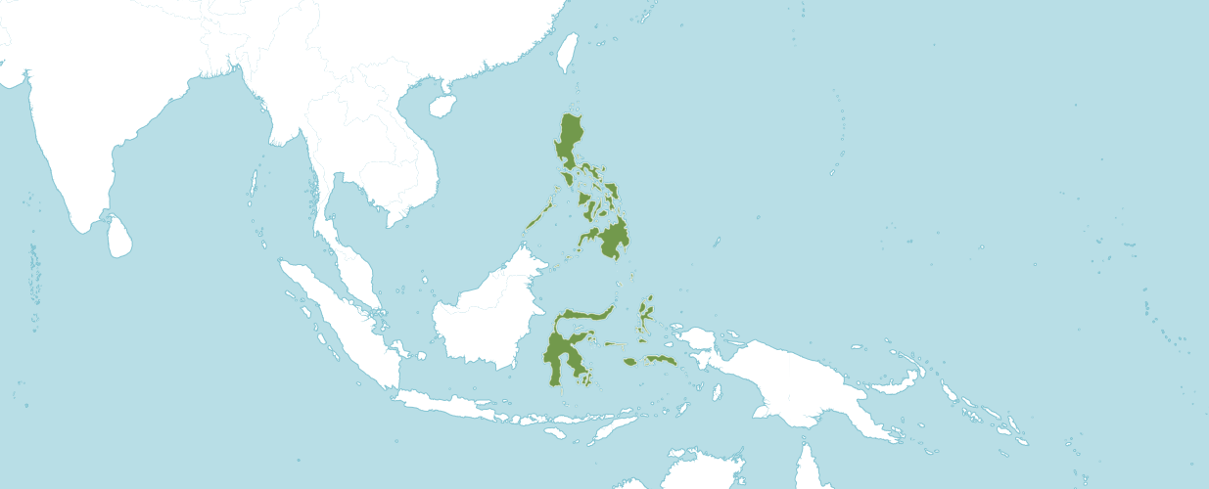
Natural Habitat by Kew

Native to: Maluku, Philippines, Sulawesi

Bulbophyllum amplebracteatum subsp. amplebracteatum

Bulbophyllum amplebracteatum subsp. carunculatum (Garay, Hamer & Siegerist) J.J.Verm. & P.O'Byrne

Bulbophyllum amplebracteatum subsp. orthoglossum (H.Wendl. & Kraenzl.) J.J.Verm. & P.O'Byrne

Plant Size and Type: A large, upright sympodial epiphyte with growths up to 18 in (45 cm) tall separated on a short rhizome.

Pseudobulb / Stem: Up to 2.4 in. (6 cm) long. The pseudobulbs are egg-shaped.

Leaves: The leaf blade is up to 14 in. (36 cm) long by 2.8 in. (7 cm) wide. A single elliptic, bluntly pointed leaf is carried at the apex of the pseudobulb. Each leaf has a narrow petiole at the base that is up to 2 in. (5 cm) long.

Inflorescence: Up to 18 in. (45 cm) long. The upright flower spike has several tubular bracts that are up to 2 in. (5 cm) long. Numerous flowers are produced in succession on each inflorescence.

Flowers: Up to 12 per inflorescence. The flowers are golden yellow with a lip that is dark purple, sometimes appearing to be almost black. The dorsal sepal is egg-shaped to oblong, sharply pointed, and up to 1.6 in. (4 cm) long by 0.6 in. (1.5 cm) wide. The sickle-shaped lateral sepals are up to 2 in. (5 cm) long by 0.6 in. (1.5 cm) wide. Petals are egg-shaped, sharply pointed, and about 1 in. (2.5 cm) long by 0.5 in. (1.2 cm) wide. The lip is fleshy with a wart-like texture. It is about 1 in. (2.5 cm) long and is 3-lobed with short, toothed lateral lobes. The erect column is about 0.2 in. (0.7 cm) long with a pair of forward-pointing arms.

This information is quoted from a Charles Baker culture sheet. For more details, please consult www.orchidculture.com.

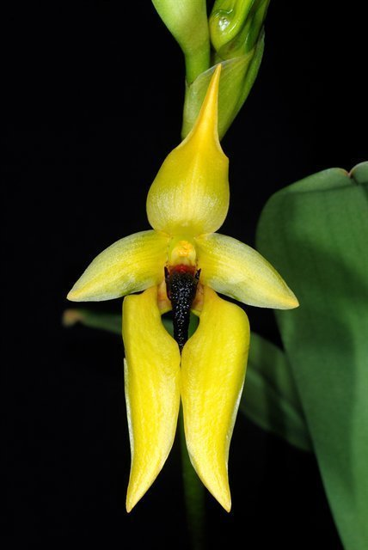
Bulbophyllum carunculatum ~ amplebracteatum ‘Windy Hill” AM/AOS, 81 points, 2008
Photography Craig Plahn

AOS Awards:

Bulbophyllum amplebracteatum
 | FCC | AM | HCC | AQ | JC | CCM | CCE | CHM | CBM | CBR | TOTAL
AOS | - | 5 | 7 | - | 1 | 4 | - | 3 | - | 2 | 22
Years Awarded |  | 1999  -  2011 | 2002  -  2018 |  | 2002 | 2003  -  2013 |  | 2000  -  2010 |  | 1982  1995

Hybrids
Of the thirty-eight Bulbophyllum amplebracteatum hybrids registered in the F1 generation one was registered in 1999 and the rest after 2000.

The Bulbophyllum amplebracteatum hybrid that appears to have the most significance is Bulbophyllum Frank Smith (amplebracteatum x lobbii). Bulbophyllum Frank Smith was registered in 1999 by B. Thomas and was originated by B. Thomas. Bulbophyllum Frank Smith has twelve AOS awards (CCE - 2; HCC – 5, and AM - 5 ).

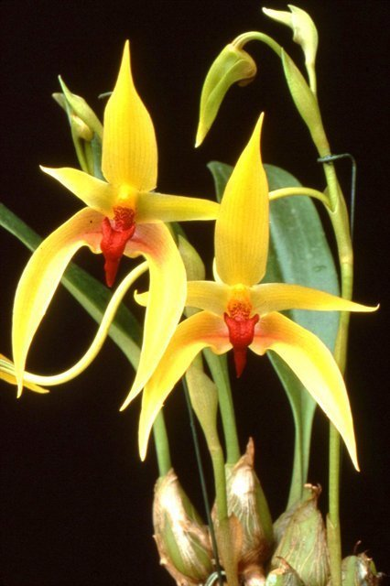

Bulbophyllum Frank Smith ‘Windy’s Hill Starburst’ AM/AOS, 81 points, 2000
Photography by Dr. C. Plahn

References

Govaerts, R. (2003). World Checklist of Monocotyledons Database in ACCESS: 1-71827. The Board of Trustees of the Royal Botanic Gardens, Kew.

Govaerts, R. (1996). World Checklist of Seed Plants 2(1, 2): 1-492. MIM, Deurne.

OrchidWiz 9X.0.

Vermeulen, J. & O'Byrne, P. (2011). Bulbophyllum of Sulawesi: 1-247. Natural history publications (Borneo), Kota Kinabalu, Malaysia.

