Bulbophyllum grandiflorum, Blume, 1849
[gran- di-FLOE-rum]

Nickname: The large-flowered Bulbophyllum

Jay Pfahl’s Internet Orchid Species Encyclopedia notes Origin/Habitat: Found in New Guinea on trees in lower montane forests at elevations of 200 to 500 meters.

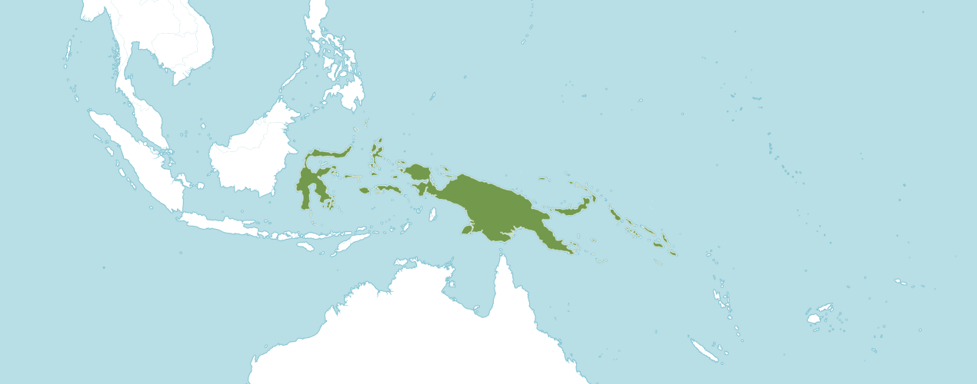
Bulbophyllum grandiflorum Habitat

Kew notes Bulbophyllum grandiflorum is native to Bismarck Archipelago, Maluku, New Guinea, Solomon Is., Sulawesi

OrchidWiz notes Origin / Habitat: New Guinea and the Solomon Islands. This species is distributed widely in both Papua New Guinea and Irian Jaya (Indonesian or western New Guinea). In Papua, Schlechter found these plants in the Minjem Valley at about 1650 ft. (500 m) and near Jaduna on the Waria River at about 1000 ft. (300 m). This species reportedly also occurs in Sumatra, the Celebes, and the Moluccas, but details of habitat locations and elevations were not given. The plant that is now considered a synonym, Bulbophyllum cominsii, is widespread in the Solomon Islands, growing in coastal forests, mangrove swamps, and coconut plantations from near sea level to about 150 ft. (50 m). -- Source: Charles Baker

Description: Jay Pfahl describes this orchid species as "Hot growing epiphyte with 2.8 to 4.8 [7 to 12 cm] between each, cylindrical pseudobulb carrying a single, oblong, obtuse, glabrous, narrowly subpetiolate base leaf that blooms in the fall on a short to .6 [1.5 cm] long, single flowered inflorescence." Please see Sources in the bottom right box for quoted references.

Homotypic Synonyms
Hyalosema grandiflorum (Blume) Rolfe in Orchid Rev. 27: 130 (1919)
Phyllorkis grandiflora (Blume) Kuntze in Revis. Gen. Pl. 2: 677 (1891)
Sarcopodium grandiflorum (Blume) Lindl. in Fol. Orchid. 2: 3 (1853)

Heterotypic Synonyms
Bulbophyllum burfordense Anon. in Garden (London, 1871-1927) 47: 225 (1895)
Bulbophyllum cominsii Rolfe in Bull. Misc. Inform. Kew 1895: 138 (1895)
Bulbophyllum micholitzii Rolfe in Orchid Rev. 9: 272 (1901)
Ephippium grandiflorum Blume in Rumphia 4: 42 (1849)
Hyalosema burfordiense (Anon.) Rysy in J. Orchideenfr. 9: 328 (2002)
Hyalosema cominsii (Rolfe) Rolfe in Orchid Rev. 27: 131 (1919)
Hyalosema micholitzii (Rolfe) Rolfe in Orchid Rev. 27: 131 (1919)

Flower size: 3.2 inches [8 cm]

This information is quoted from Jay Pfahl's Internet Orchid Species Encyclopedia (IOSPE). For more details, please consult www.orchidspecies.com.

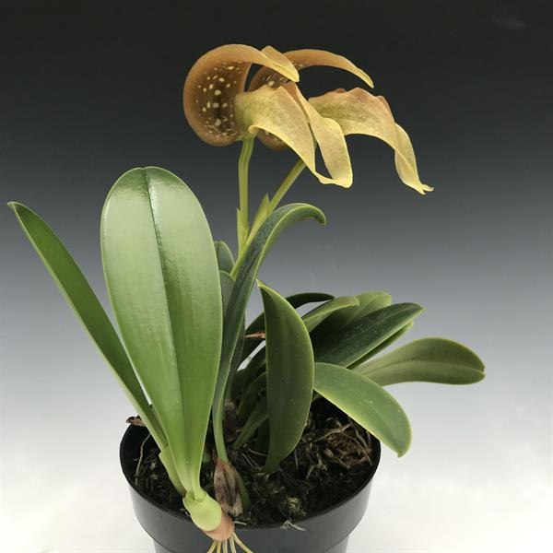
Bulbophyllum grandiflorum
Photography by Andy’s Orchids

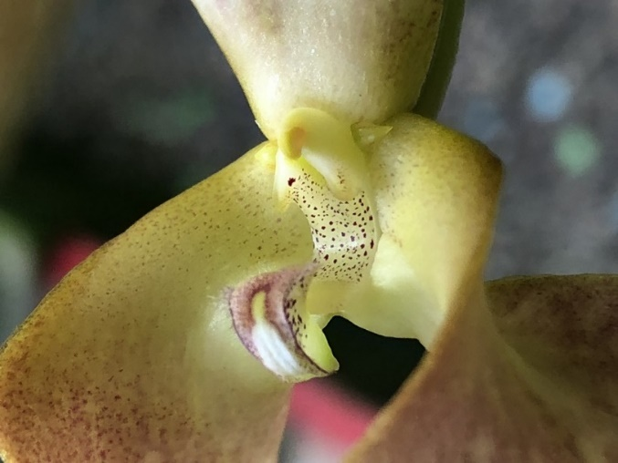
Bulbophyllum grandiflorum
Photography by Andy’s Orchids
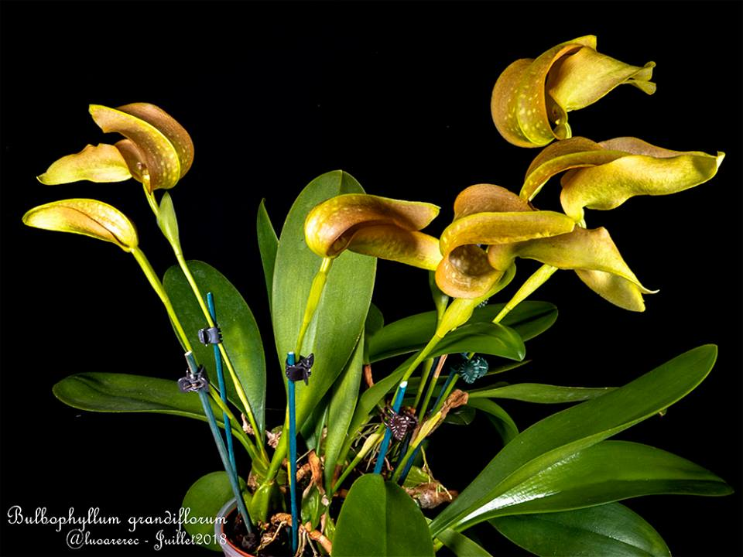
Bulbophyllum grandiflorum
Photography by Julie12018

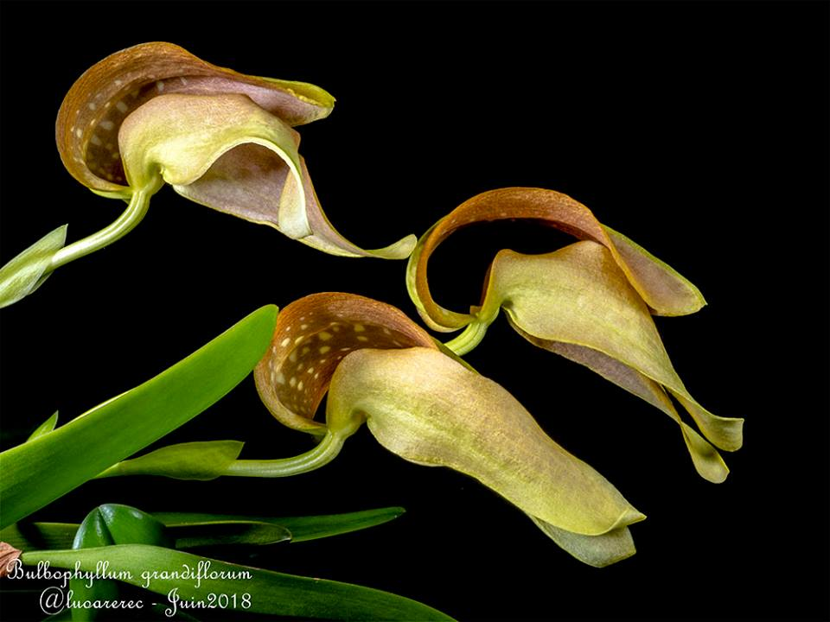
Bulbophyllum grandiflorum
Photography by Julie12018

AOS Awards

Bulbophyllum grandiflorum
 | FCC | AM | HCC | AQ | JC | CCM | CCE | CHM | CBM | TOTAL
AOS | 2 | 10 | 6 | - | - | 10 | 3 | 2 | 1 | 34
Years Awarded | 2014  2019 | 1990 –  2019 | 2001  -  2020 |  |  | 1987  -  2019 | 2007  -  2021 | 1994  2004 | 1974

Hybrids
Of the six Bulbophyllum grandiflorum hybrids registered, all were made since 2000. Of the six Bulbophyllum grandiflorum hybrids only five of the offspring have received an AOS award.

The Bulbophyllum grandiflorum hybrid that appears to have the most significance is Bulbophyllum Hsinying Grand-arfa (grandiflorum x arfakianum). Bulbophyllum Hsinying Grand-arfa was registered in 2008 by Ching Hua and was originated by Ching Hua. Bulbophyllum Hsinying Grand-arfa has one AOS awards (CCE - 1).

References

Get references from OrchidWiz

Govaerts, R. (2003). World Checklist of Monocotyledons Database in ACCESS: 1-71827. The Board of Trustees of the Royal Botanic Gardens, Kew.

Govaerts, R. (1996). World Checklist of Seed Plants 2(1, 2): 1-492. MIM, Deurne.

Hamilton, R. (1972). Index to plant illustrations. 1932-1971, volumes. 1-40 of the American Orchid Society Bulletin. Hamilton, Richmond, B.C., Canada.

Hawkes, A. (1987). Encyclopedia of cultivated orchids. Faber and Faber, London.

Lewis, B., and Cribb, P. (1991). Orchids of the Solomon Islands and Bougainville. Royal Botanic Gardens, Kew, England.

Millar, A. (1978). Orchids of Papua, New Guinea: an introduction. University of Washington Press, Seattle, Washington.

OrchidWiz 9X.0

Ormerod, P. (2017). Checklist of Papuasian Orchids: 1-494. Nature & Travel Books, Australia.

Schlechter, R. (1982). The Orchidaceae of German New Guinea. Translated by D. Blaxell, H. Katz, and J. Simmons. Australian Orchid Foundation, Melbourne, Australia.

Vermeulen, J. & O'Byrne, P. (2011). Bulbophyllum of Sulawesi: 1-247. Natural history publications (Borneo), Kota Kinabalu, Malaysia.

Royal Bontanic Gardens Kew Plants of the World Online. https://powo.science.kew.org/taxon/urn:lsid:ipni.org:names:619056-1

