Bulbophyllum medusae, (Lindl.) Rchb.f., 1861

Charles Baker notes Origin/Habitat: Widespread in S.E. Asia. Peninsular Thailand, Malaya, Malasia, Borneo, the Indonesian islands of Sumatra and Bangka, and the Lesser Sunda Islands. They grow in lowland forests, sometimes high in trees under a closed canopy, and at other times lower on the trees in more open locations.

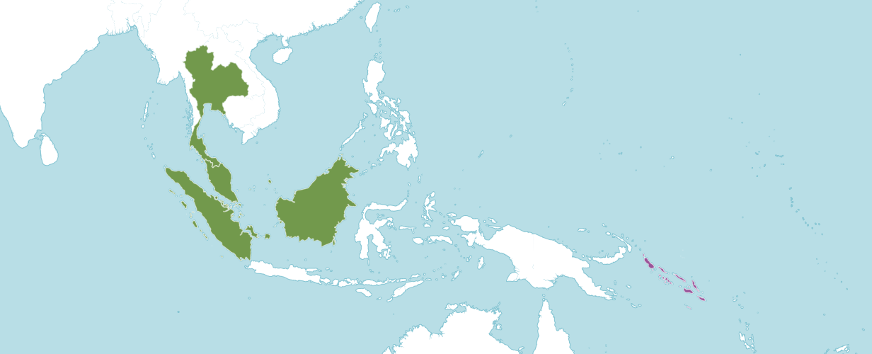
Native Habitat, Kew

Native to:
Borneo, Malaya, Sumatera, Thailand

Introduced into:
Solomon Islands

Plant Size and Type: A relatively small, 6–10 in. (15–25 cm), epiphyte.

Pseudobulb and Stem: 0.8–2.0 in. (2–5 cm) long. The ovoid-conical to pear-shaped pseudobulbs are often curved. They are ribbed, angled, and may be yellowish in color. Pseudobulbs are spaced rather far apart on a stout rhizome.

Leaves: 5–8 in. (12–20 cm) long. A single, rigid, leathery leaf is carried at the top of each pseudobulb. The leaf, which is about 2 in. (5 cm) wide, is short stalked at the base and has a blunt, slightly cleft tip.

Inflorescence: 8 in. (20 cm) long. The stout, erect to arching peduncle emerges from the base of the pseudobulb. It is protected by several loose sheathing bracts and has a mop-like, almost globular head of many long-tailed flowers.

Flowers: Many. Blossoms have long, threadlike tails at the tips of the lateral sepals. The yellow to white or cream-white blossoms are marked with a varying number of red or pink spots. The lip is usually yellowish. Flowers, which are rather strongly scented with a musty odor, are up to 6 in. (15 cm) long. Lateral sepals are each about 5 in. (12 cm) long. The length of the basal blade is less than 0.5 in. (1.2 cm), and the remainder is a very slender, thread-like tail that hangs in a weeping manner from the tip of each. The somewhat erect dorsal sepal is about 1 in. (2.5 cm) long by 0.1 in. (0.3 cm) wide. It tapers to a slender point and extends into an upright to arching tail that is shorter than the ones on the lateral sepals. The triangular petals are only about 0.2 in. (0.5 cm) long and have slender points. The nearly straight, egg-shaped lip is only about 0.1 in. (0.2 cm) long. The column is about 0.1 in. (0.3 cm) long.

This information is quoted from a Charles Baker culture sheet. For more details, please consult www.orchidculture.com.

Homotypic Synonyms
Cirrhopetalum medusae Lindl. in Edwards's Bot. Reg. 28: t. 12 (1842)
Phyllorkis medusae (Lindl.) Kuntze in Revis. Gen. Pl. 2: 677 (1891)

Heterotypic Synonyms
Cirrhopetalum medusae var. album Rolfe in Orchid Rev. 31: 131 (1923)

AOS Awards:
Bulbophyllum medusae
 | FCC | AM | HCC | AQ | JC | CCM | CCE | CHM | CBM | TOTAL
AOS |  | 3 |  |  | 1 | 5 | 1
Years Awarded |  | 2006  2009  2009 |  |  | 2000 | 1962 - 2013 | 2019

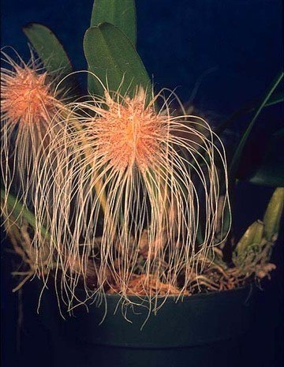
Bulbophyllum medusae ‘A-doribil’ AM/AOS, 82 points, 2006
Photography by J. Clarkson
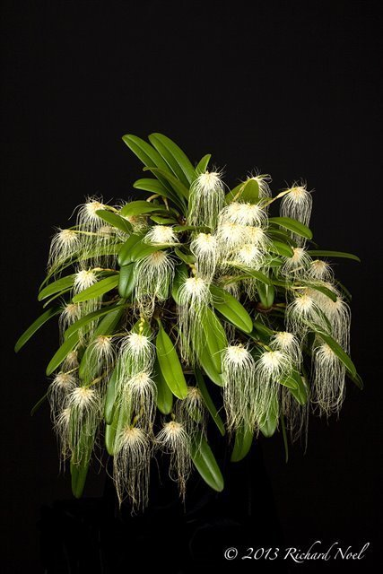
Bulbophyllum medusae ‘Windswept Whimsical’ CCM/AOS, 83 points, 2013
Photography by R. Noel

Hybrids
Of the 15 hybrids registered in the F1 generation. All were made since 1995.

The Bulbophyllum medusae hybrid that appears to have the most significance is Bulbophyllum Lion King (medusae x mastersianum). Bulbophyllum Lion King was registered in 19995 by Supachadiwong and was originated by Supachadiwong. Bulbophyllum Lion King has one AOS award, a JC/AOS given in 2002. Bulbophyllum has five registered hybrids. None of the offspring are awarded.

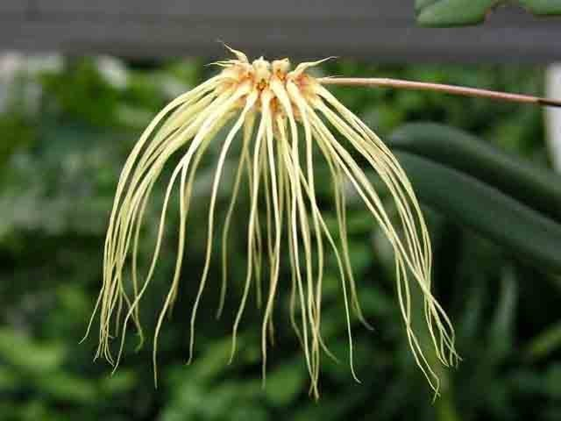
Bulbophyllum Lion King
Photography by Jean Wilson
References

Bechtel, H., Cribb, P., and Launert, E. (1980). Manual of cultivated orchid species. MIT Press, Cambridge, Mass.

Govaerts, R. (2003). World Checklist of Monocotyledons Database in ACCESS: 1-71827. The Board of Trustees of the Royal Botanic Gardens, Kew.

Govaerts, R. (1996). World Checklist of Seed Plants 2(1, 2): 1-492. MIM, Deurne.

Hamilton, R. (1988). When does it flower? 2nd ed. Hamilton, Richmond, B. C., Canada.

Hawkes, A. (1987). Encyclopedia of cultivated orchids. Faber and Faber, London.

Holttum, R. (1964). A revised flora of Malaya. vol. 1, Orchids. Government Printing Office, Singapore.

Linder, A. (1987). Growing Bulbophyllums (Including Cirrhopetalums). American Orchid Society Bulletin 56(12):1261.

OrchiWiz X9.0

Pridgeon, A. (1992). The illustrated encyclopedia of orchids. Timber Press, Portland, OR.

Seidenfaden, G. (1975). Notes on Cirrhopetalum Lindl. Dansk Botanisk Arkiv Bind 29—Nr. 1. copy.

Seidenfaden, G. (1979). Orchid genera in Thailand VIII. Bulbophyllum Thou. Dansk Botanisk Arkiv Bind 33—Nr. 3.

Seidenfaden, G., and Wood, J. (1992). The orchids of peninsular Malaysia and Singapore. Published in association with The Royal Botanic Gardens, Kew and Botanic Gardens, Singapore.

Siegerist, E. (1988). The genus Bulbophyllum in the broad sense. American Orchid Society Bulletin 57(7):719.

Sittisujjatham, S. (2006). Wild Orchid of Thailand 1: 1-495. Amarin.

Wood, J., and Cribb, P. (1994). A checklist of the orchids of Borneo. Royal Botanic Gardens, Kew.

Vermeulen, J., O'Byrne, P. and Lamb, A. (2015). Bulbophyllum of Borneo. Natural History Publications (Borneo), Kota Kinabalu.

