Bulbophyllum Five Sample Descriptions

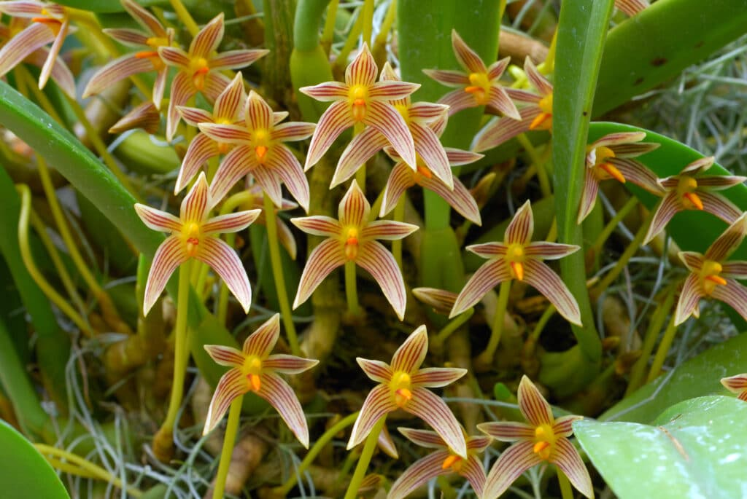

Bulbophyllum affine
Photography by Orchid Digest

Seventy-two flowers and six buds on 78 inflorescences, on a well-grown plant grown in a 25.4 cm green pot, growing medium mixture of bark, charcoal, and perlite; flowers star-shaped, cream-colored; sepals and petals burgundy stripe; lip golden yellow, burgundy side lobes; column butter yellow; substance firm; texture waxy.

Award: CCM, 83 points.

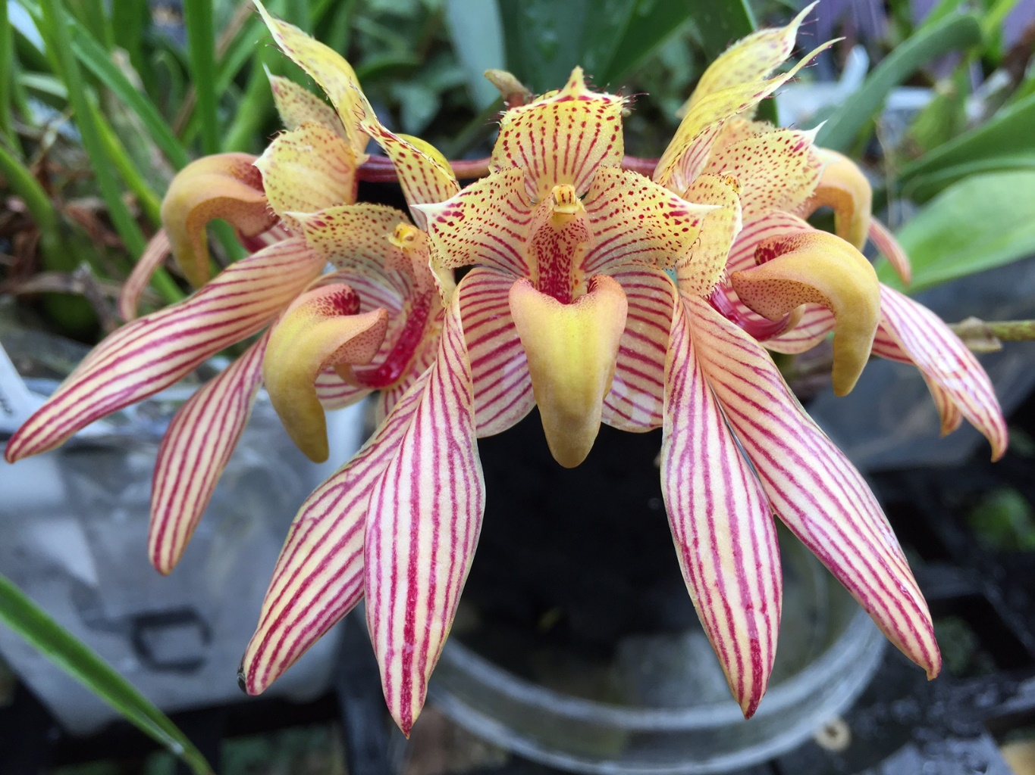

Bulbophyllum bicolor
Photography by New World Orchids

Five cupped flowers; dorsal sepal apically pointed, yellow, overlaid red dotted lines; lateral sepals rolled inward on distal two-thirds presenting reverse, white, overlaid red lines; petals yellow overlaid bright red lines; lip hinged, curved auriculate, yellow, overlay chartreuse; column finely spotted red, anther cap yellow; substance firm; texture waxy.

Award: HCC/AOS, 75 points

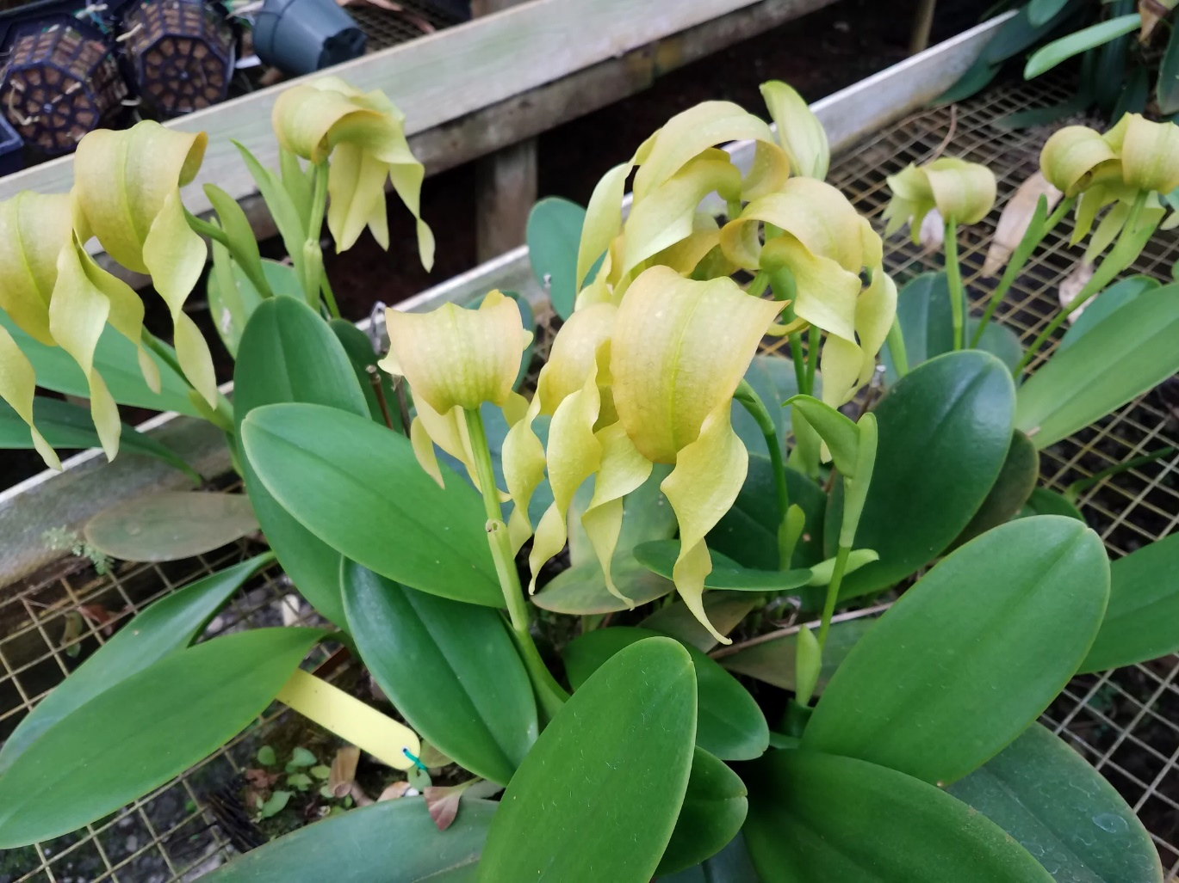

Bulbophyllum grandiflorum var album
Photography by unknown

Eleven flowers on 11 inflorescences held above foliage; flower color yellow, midline ride overlaid green; dorsal sepal curved forward; lateral sepals porrect, twisting medially; lip hinged; column light green, anther cap yellow; ovary bright green; substance medium, texture waxy.

Award: AM/AOS, 80 points.
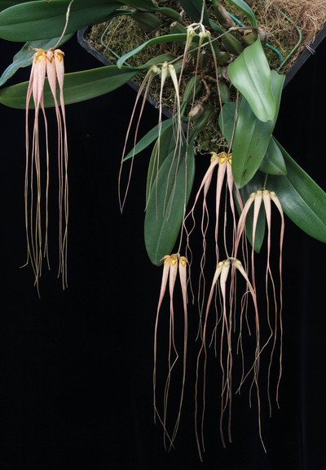

Bulbophyllum longissimum

Twenty flowers and eight immature flowers seven inflorescences; dorsal sepal hooded, porrect, yellow, overlaid burgundy stripes; lateral sepals slightly curved, fused laterally below lip revealing reverse, separating about midway, base color cream, overlaid burgundy vertical striations; petals lanceolate, margins ciliate, base color cream, burgundy stripes; lip hinged, central groove, bright yellow; substance firm; texture crystalline.

Award: AM/AOS, 82 points
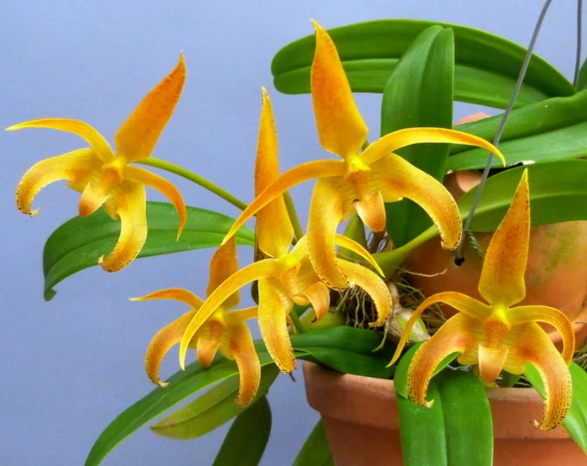

Bulbophyllum lobbii
Photography by unknown

Five flowers on five inflorescences; flowers yellow, distally overlaid orange; dorsal sepal finely spotted mahogany on upper margins; lateral sepals finely spotted mahogany on lower margins, apices slightly reflexed; petals recurved; lip hinged, finely spotted mahogany at margin; substance firm; texture matte.

Award: HCC/AOS, 80 points.

