Bulbophyllum lasiochilum, C.S.P.Parish & Rchb.f., 1874

Nickname: the shaggy lipped Bulbophyllum

Origin/Habitat: Thailand, Burma (Myanmar), and Malaya. In Thailand, plants are found throughout the country, and the habitat varies from the mountains in the north to peninsular Thailand in the south. In the north, collections have been reported at 3950-4900 ft. (1200-1500 m). Habitat elevation was not reported for other collections around the country, however. This orchid has been found in the Tenasserim region of Burma (Myanmar). In Malaya, it is known only from the type specimen for Bulbophyllum breviscapum which was sent from Perak to Dublin in 1908. No additional details of habitat location, type, or elevation were given.

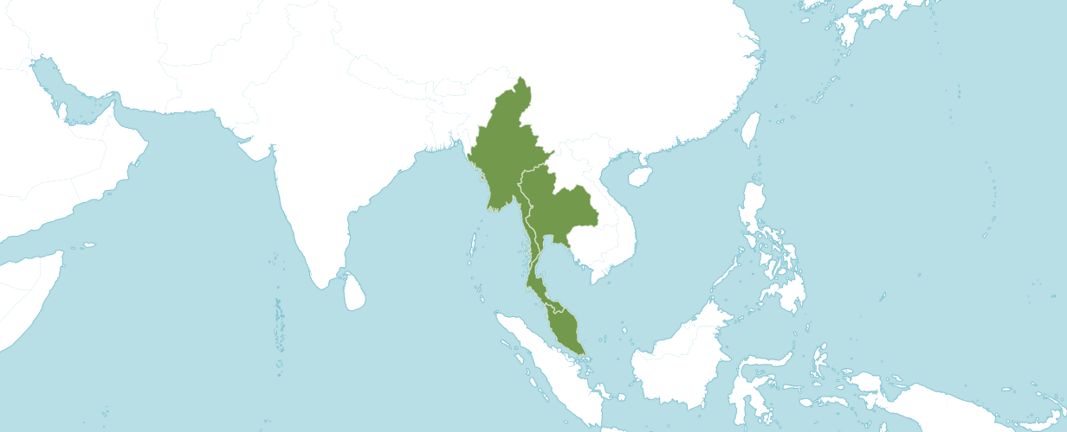
Natural Habitat from Kew

Native to:
Malaya, Myanmar, Thailand

Plant Size and Type: A small, 4 in. (10 cm) sympodial epiphyte.

Pseudobulb: 0.8-1.2 in. (2-3 cm) tall by 0.6-0.8 in. (1.5-2.0 cm) wide. The egg-shaped pseudobulbs, which are 4-ridged, are spaced about 1.2 in. (3 cm) apart on a creeping rhizome.

Leaves: 1.6-2.8 in. (4-7 cm) long by 0.8 in. (2 cm) wide. A single erect, fleshy, leathery, oblong-elliptic leaf is carried at the apex of each pseudobulb. The leaf is bluntly tipped, minutely bilobed apex, and narrowed base.

Inflorescence: Up to 2.8 in. (7 cm) long. The slender, arching, purple-spotted flower spike emerges from at the base of a recently matured pseudobulb.

Flowers: 1. A solitary blossom is carried at the apex of each inflorescence. Flowers are about 1.7 in. (4.3 cm) long from the tip of the dorsal sepal to the tips of the lateral sepals. The dorsal sepal, petals, lip, and column are dark maroon, and the lateral sepals are creamy white with maroon spots. The linear-lanceolate dorsal sepal is about 0.7 in. (1.8 cm) long by 0.2 in. (0.6 cm) wide. It curves forward and the edges curl up and roll inward. A distinguishing characteristic is that the dorsal sepal is not hairy. The widely spread, sickle-shaped petals are narrowly linear-oblanceolate, 0.5 in. (1.2 cm) long by 0.1 in. (0.3 cm) wide, and rather bluntly tipped. The somewhat sickle-shaped lateral sepals are about 1 in. (2.5 cm) and converge near their apices so that the tips often touch. The margins or each lateral sepal are rolled inward and almost meet above the center. The slightly curved, 3-lobed lip is about 0.4 in. (1 cm) long with a broad, deeply cleft base, a blunt tip, slightly down-curved lateral lobes, and a fleshy midlobe, with long purple hairs on the edges. The stout column is about 0.2 in. (0.4 cm) long.

This information is quoted from a Charles Baker culture sheet. For more details, please consult www.orchidculture.com.

Homotypic Synonyms
Phyllorkis lasiochila (C.S.P.Parish & Rchb.f.) Kuntze in Revis. Gen. Pl. 2: 677 (1891)

Heterotypic Synonyms
Bulbophyllum breviscapum (Rolfe) Ridl. in Mat. Fl. Malay. Penins. 1: 78 (1907)
Cirrhopetalum breviscapum Rolfe in Bot. Mag. 131: t. 8033 (1905)
Cirrhopetalum lasiochilum C.S.P.Parish & Rchb.f. in Trans. Linn. Soc. London 30: 153 (1874)

AOS Awards:
Bulbophyllum lasiochilum
 | FCC | AM | HCC | AQ | JC | CCM | CCE | CHM | CBM | TOTAL
AOS | - | 2 | 1 | - | - | 7 | - | 2 | 1
Years Awarded |  | 2018  2020 | 1977 |  |  | 1962 - 2020 |  | 2000  -  2017 | 1977

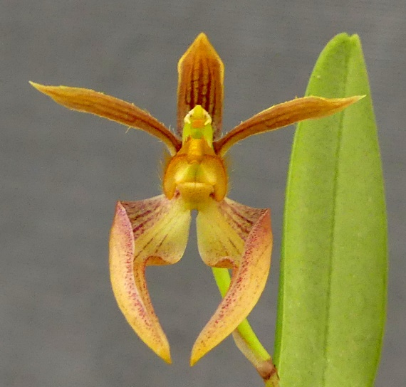
Bulbophyllum lasiochilum
Photographer unknown

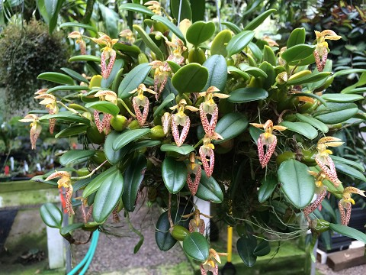
Bulbophyllum lasiochilum
Photography by Andy’s Orchids

Hybrids
Of the 26 hybrids registered in the F1 generation all were made since 1989.

The Bulbophyllum lasiochilum hybrid that appears to have the most significance is Bulbophyllum Emily Siegerist (lasiochilum x Elizabeth Ann). Bulbophyllum Emily Siegerist was registered in 1989 by Suphachadiwon and was originated by Suphachadiwon. Bulbophyllum Emily Siegerist has seven AOS awards (CCE - 2; CCM - 3; HCC - 1 and AM - 1). Bulbophyllum Emily Siegerist has five offspring.

References

Bechtel, H., Cribb, P., and Launert, E. (1980). Manual of cultivated orchid species. MIT Press, Cambridge, Mass.
Hamilton, R. (1988). When does it flower? 2nd ed. Hamilton, Richmond, B. C, Canada V6X 1V7.

Govaerts, R. (2003). World Checklist of Monocotyledons Database in ACCESS: 1-71827. The Board of Trustees of the Royal Botanic Gardens, Kew.

Govaerts, R. (1996). World Checklist of Seed Plants 2(1, 2): 1-492. MIM, Deurne.

Holttum, R. (1964). A revised flora of Malaya. vol. 1, Orchids. Government Printing Office, Singapore.

OrchidWiz 9X.0.

Ormerod, P., Kurzweil, H. & Watthana, S. (2021). Annotated List of Orchidaceae for Myanmar. Phytotaxa 481: 1-262.

Pridgeon, A. ed. (1992). The illustrated encyclopedia of orchids. Timber Press, Portland, OR.

Seidenfaden, G. (1975). Notes on Cirrhopetalum Lindl. Dansk Botanisk Arkiv Bind 29—Nr. 1. copy

Seidenfaden, G. (1979). Orchid genera in Thailand VIII. Bulbophyllum Thou. Dansk Botanisk Arkiv Bind 33—Nr. 3.

Seidenfaden, G., and Wood, J. (1992). The orchids of peninsular Malaysia and Singapore. Published in association with The Royal Botanic Gardens, Kew and Botanic Gardens, Singapore.

