Yellow Cymbidium

This careful retrospective review of Cymbidium species holding a probability of producing progeny with yellow flower expression will include Cymbidium aloifolium, synonym erectum; Cymbidium chloranthum, synonym pulchellum; Cymbidium elegans, synonym densiflorum; Cymbidium ensifolium, synonym Cymbidium koran; Cymbidium suave, synonym Cymbidium gomphocarpum; Cymbidium madidum; Cymbidium sanderae; Cymbidium sichuanicum; Cymbidium tigrinum; and Cymbidium tortisepalum, synonym longibracteatum.

Cymbidium aloifolium, synonym Cymbidium erectum has 40 offspring and 83 progeny. Cymbidium aloifolium has six awards, (1 HCC; 1 AM; 2 CCM; and 2 CHM).

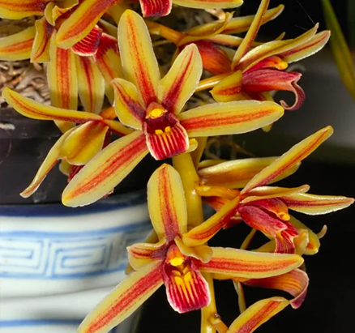
Cymbidium aloifolium, no clonal name, unawarded
Photography by unknown

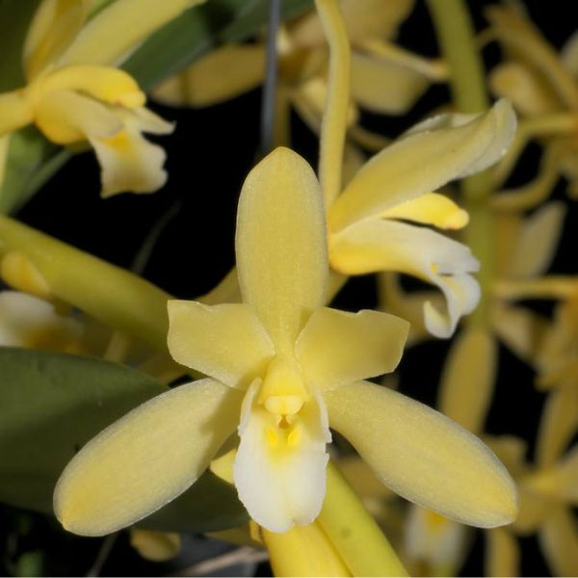
Cymbidium aloifolium var. flava, no clonal name, unawarded
Photography by unknown

Hybridizing with Cymbidium aloifolium can produce offspring that bloom yellow. Cymbidium Pratabong (Cymbidium aloifolium x Cymbidium Golden Elf) is an example. Cymbidium Pratagong originated by Pakkret Flor. and was registered by Pakkret Flor. in 2005. Cymbidium Pratabong has no offspring registered and no awards. Hybridizing with Cymbidium Pratabong has a probability of producing Cymbidium plants with yellow flowers
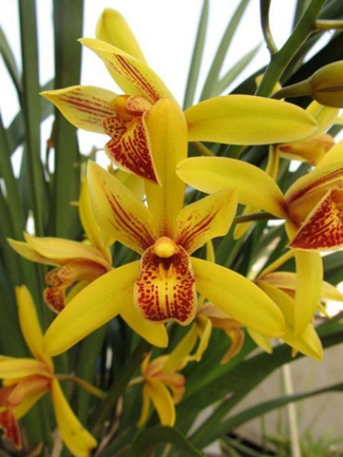
Cymbidium Pratabong, no clonal name, unawarded
Photography by Andy Easton

Cymbidium chloranthum, synonym Cymbidium pulchellum is presently noted to have seven offspring and 28 progeny. OrchidWiz records one AOS award for clone ‘Everglades,’ CHM/AOS, 83 points, received in 1979. The AOS award photograph of the clone ‘Everglades’ coloration appears on the chartreuse side of yellow; however, other photographs of Cymbidium chloranthum depict flowers of more yellow hues. Further hybridizing with Cymbidium chloranthum looks promising to produce offspring with yellow flower expression.

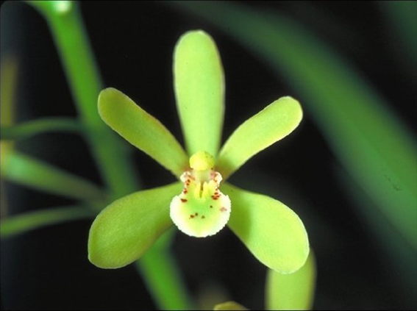
Cymbidium chloranthum ‘Everglades’ CHM/AOS, 83 points, 1979
Photography by E. Carpenter

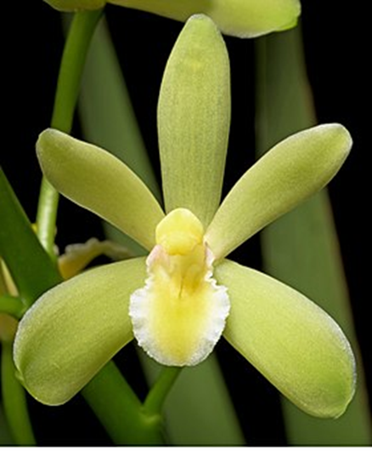
Cymbidium chloranthum, no clonal name, unawarded
Photography by unknown
The only awarded offspring of Cymbidium chloranthum is Cymbidium Nancy Carpenter (Cymbidium chloranthum x Cymbidium Korintji) originated by Everglades Orchids and registered by Everglades Orchids in 1974. The awarded clone of Cymbidium Gladio ‘My Love’ appears green with a yellow lip in the AOS award photography, which may be a result of old photography or lighting. Cymbidium Nancy Carpenter gives the impression it is a promising parent to produce further yellow offspring, i.e., Cymbidium Promised Land.

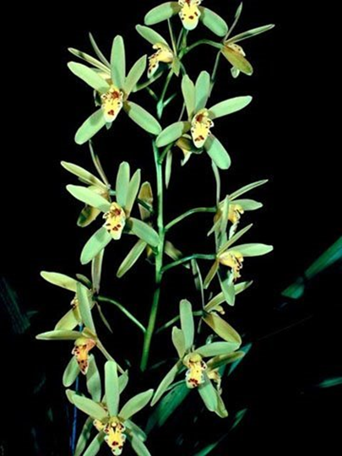
Cymbidium Nancy Carpenter ‘My Love’ AM/AOS, 81 points, 1979
Photography by OWZ Lib

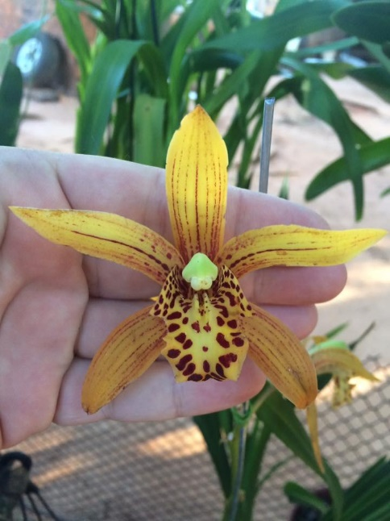
Cymbidium Promised Land, no clonal name, unawarded
Photography by Jose Maria Paredes Benitez
Cymbidium elegans, synonym Cymbidium densiflorum has four AOS awards (1 HCC; 2 CCM and 1 CHM). Cymbidium elegans has 26 offspring and 64 progeny. Cymbidium Gladio (Cymbidium elegans x Cymbidium Esmerelda) is the only progeny of Cymbidium elegans that has been awarded. Cymbidium Gladio received a CCM/AOS of 81 points in 1981. Cymbidium Gladio was originated by L. DeGarmo and registered by Mrs. H. Whitesell in 1980. The awarded clone of Cymbidium Gladio ‘Largo’ does not produce yellow flowers; however, other clones of Cymbidium Gladio produce yellow flowers, i.e., see photograph below.

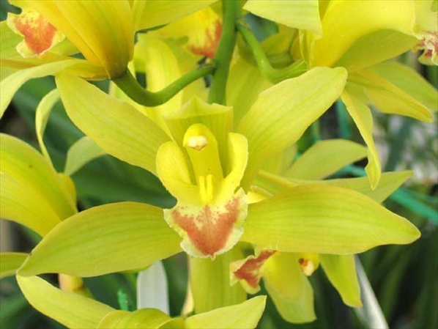
Cymbidium Gladio, no clonal name, unawarded
Photography by Dr. Elliot Atstupenas

Cymbidium ensifolium has 88 first generation offspring and a total of 1,405 progeny. Cymbidium ensifolium has 24 AOS awards (10 HCC; 5 AM; 2 JC; 2 CHM; and 5 CCM.)

Progeny of Cymbidium ensifolium have expressed yellow coloration. Cymbidium Peter Pan (Cymbidium ensifolium x Cymbidium Miretta) originated by Dos Pueblos and registered by Dos Pueblos in 1957 has 162 offspring and 1,006 progeny. Cymbidium Peter Pan has received eight AOS awards (1 AM; 5 HCC; 1 CCE; and 1 CCM). Most Cymbidium Peter Pan clones are chartreuse/yellow to yellow with an orange overlay.

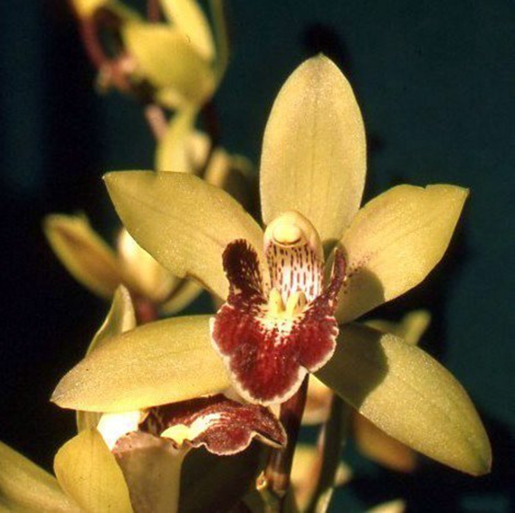
Cymbidium Peter Pan ‘Greensleeves’ HCC/AOS, 75 points, 1960
Photography by M. Baird

Five Generations of Cymbidium Peter Pan Progeny
Generation | Grexes | Awdd. | Percent Awarded | Awarded
1 | 162 | 30 | 18.5% | 87
2 | 327 | 13 | 4.0% | 19
3 | 300 | 14 | 4.7% | 16
4 | 177 | 4 | 2.3% | 7
5 | 40 | 1 | 2.5% | 1

Cymbidium Peter Pan has produced offspring and progeny with yellow flowers. Examples of Cymbidium Peter Pan progeny with yellow flowers include: Cymbidium Kiwi Magic, and Cymbidium Maureen Grapes. An example of the third-generation Cymbidium Peter Pan progeny with yellow flowers is Cymbidium Donovan.

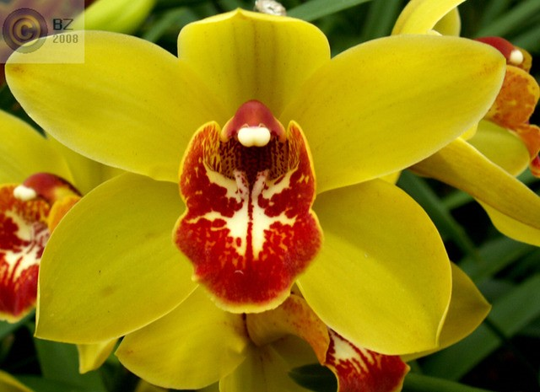
Cymbidium Kiwi Tracey (Kiwi Magic x Tracey Reddaway) ‘Stirling,’ unawarded
Photography by unknown
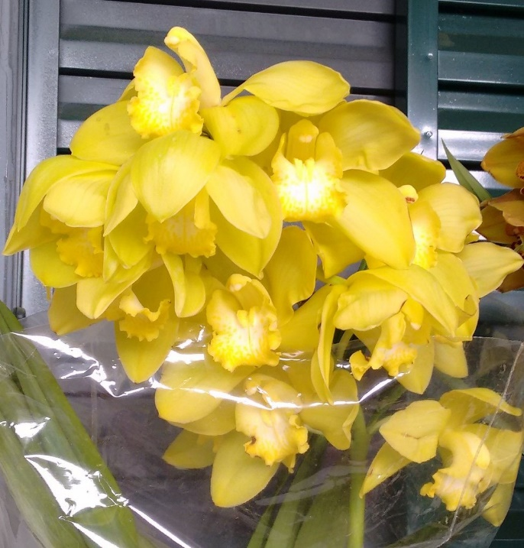
Cymbidium Donovan, no clonal name, unawarded
Photography by unknown

Another Cymbidium ensifolium hybrid with yellow flower expression is Cymbidium Golden Elf (Cymbidium ensifolium x Cymbidium Enid Haupt). The originator of Cymbidium Golden Elf is P. Gripp. Cymbidium Golden Elf was registered in 1978 by Rod McLellan Company. Cymbidium Golden Elf has106 offspring and 530 progeny. Cymbidium Golden Elf holds five AOS awards (2 HCC; 1 AM; and 2 CCM).

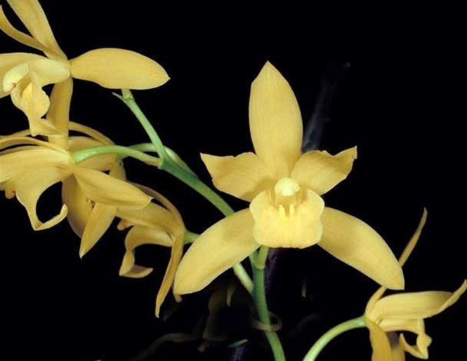
Cymbidium Golden Elf ‘Sundust’ HCC/AOS, 76 points, 1983
Photography by OWZ Lib.

Cymbidium Golden Elf has produced offspring and progeny that have yellow flower expression. Cymbidium Golden Elf has three first generation offspring that produce yellow flowers: Cymbidium Pixie Dust, Cymbidium Golden Vanguard, and Cymbidium Armstrong. Further hybridizing with Cymbidium Golden Elf to produce offspring with yellow flowers is promising.

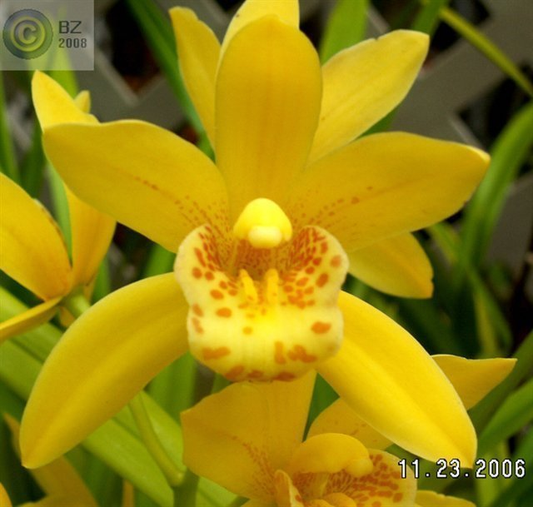
Cymbidium Pixie Dust ‘AE1435,’ unawarded
Photography by Barry Zimmerman
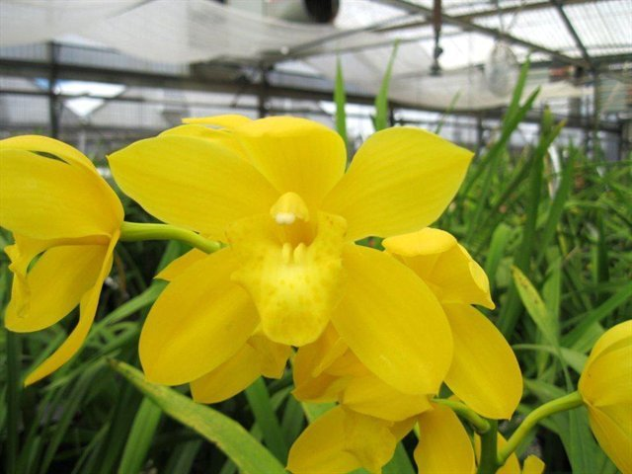
Cymbidium Golden Vanguard ‘Geyersland,’ unawarded
Photography by Andy Easton
Cymbidium madidum has 85 offspring and 504 progeny. Cymbidium madidum has nine awards (2 HCC; 3 AM; 1 CCE and 3 CCM).

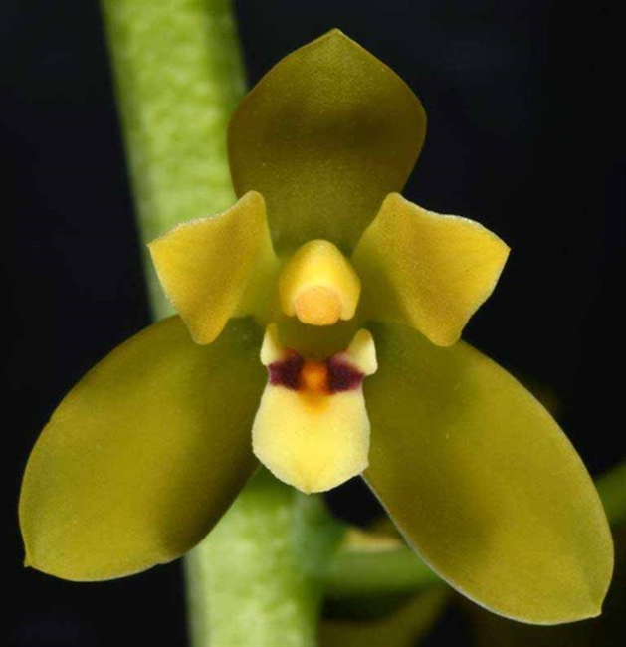
Cymbidium madidum ‘Magenta’ HCC/AOS, 75 points, 2018
Photography by G. Yong Gee

Hybridizing with Cymbidium madidum can produce progeny expressing degrees of yellow coloring. Some grexes of Cymbidium Pee Wee (Cymbidium madidum x Cymbidium floribundum) yield offspring with yellow flowers. Cymbidium Pee Wee originated by Mrs. H. Ireland and was registered by Mrs. H. Ireland in 1966. Cymbidium Pee Wee has 14 offspring and 15 progeny. Cymbidium Pee Wee holds six AOS awards (3 HCC; and 3 CCM).
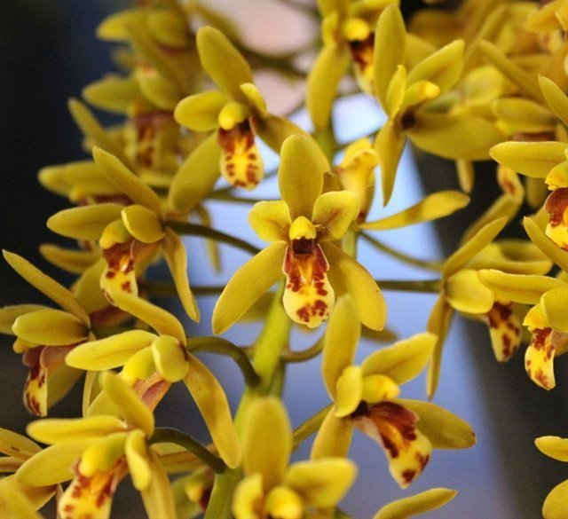
Cymbidium Pee Wee, no clonal name, unawarded
Photography by Chris Trudgian

An offspring of Cymbidium Pee Wee which expressed yellow coloration is Cymbidium Lloyd’s Persistance (Cymbidium Pee Wee x Cymbidium Peter Pan). Cymbidium Lloyd’s Persistance does not have registered offspring or progeny. OrchidWiz notes there are two awarded clones (2 HCC). Cymbidium Lloyd’s Persistance has a significant probability of producing offspring with yellow flower color expression.

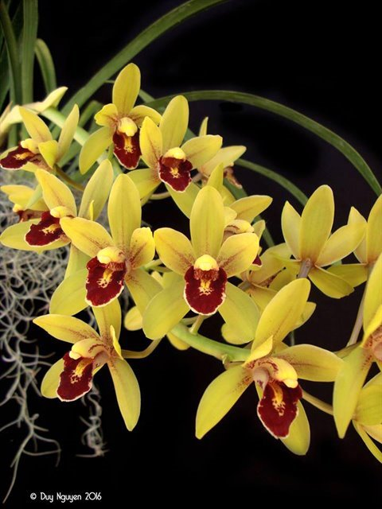
Cymbidium Lloyd’s Persistance ‘Ori Gem,’ unaward
Photography by Duy Nguyen
Another Cymbidium madidium offspring which produces offspring with yellow flowers is Cymbidium Cricket (Cymbidium devonianum x Cymbidium madidum). Cymbidium Cricket has 12 offspring and 19 progeny. Cymbidium Cricket was originated by Greenoaks and registered by Greenoaks in 1964. OrchidWiz notes Cymbidium Cricket has 40 awards, but only four of the awards are AOS awards (3 HCC and 1 CCM).

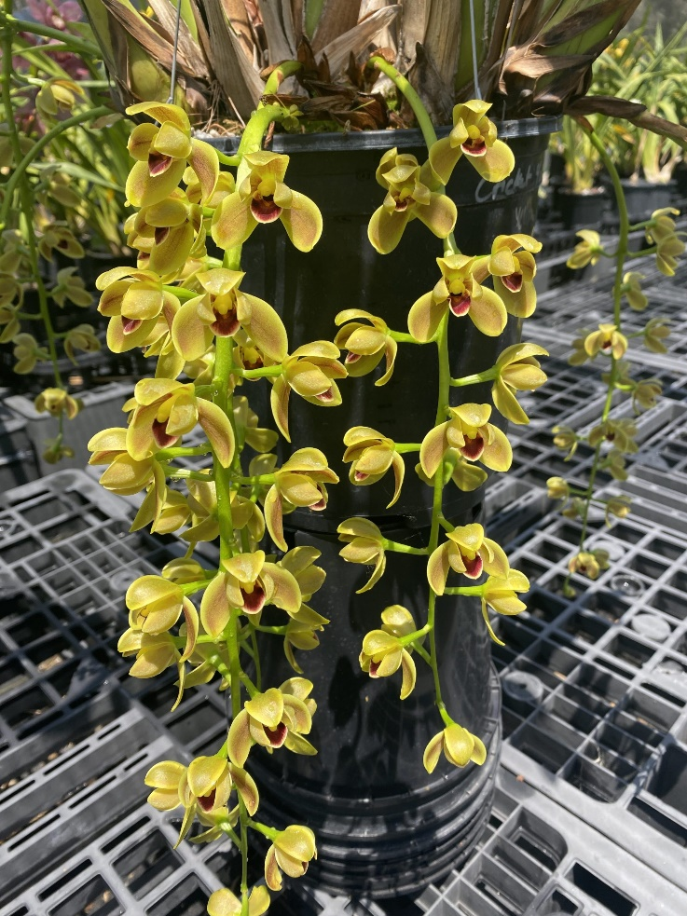
Cymbidium Cricket ‘Lemon Drop,’ unawarded
Photography by Santy Orchids

Further review noted another Cymbidium madidum offspring that produced yellow flowers is Cymbidium (Miss Taipei x madidum) originated by unknown and not registered at this time. Cymbidium (Miss Taipei x Cymbidium madidum) has no awards currently.

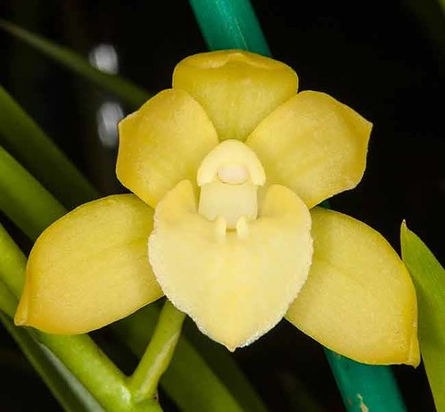
Cymbidium (Miss Taipei x Cymbidium madidum), no clonal name, unawarded
Photography by unknown

Cymbidium Fifi (Cymbidium madidum x Argonaut) has 75 offspring and 168 progeny. Cymbidium Fifi holds 26? AOS awards( 1 AM; 1 AD; and 4 CCM). Cymbidium Fifi was originated by Mrs. H. Ireland and registered by Mrs. H. Ireland in 1964. Most Cymbidium Fifi tend to have petals and sepals of various degrees of chartreuse hues; however, several offspring produce flowers of yellow coloration.

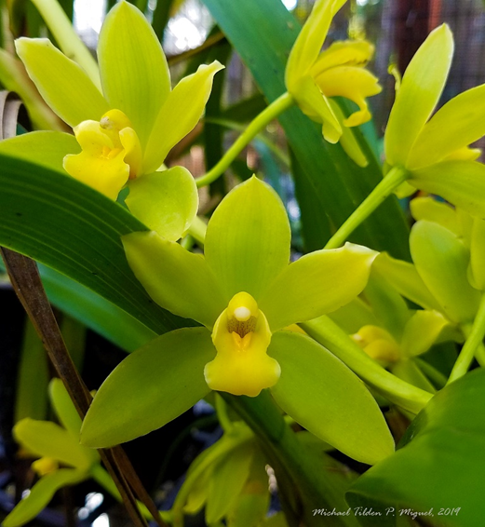
Cymbidium Fifi ‘Harry’ AM/AOS,
Photography by Michael-Til Miguel
Cymbidium suave, synonym Cymbidium gomphocarpum holds two AOS awards (1 HCC; and 1 AM). Cymbidium suave has 39 offspring and 84 progeny. Depending on the second parent used in hybridizing, offspring of Cymbidium suave have a high probability of flowering yellow.

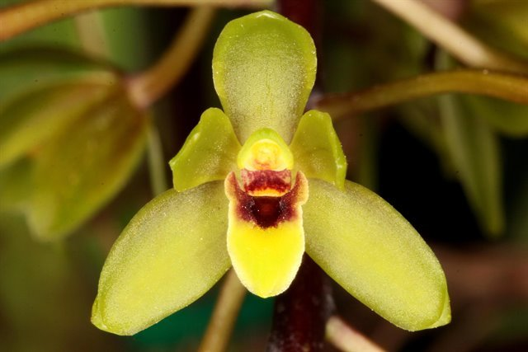
Cymbidium suave, no clonal name, unawarded
Photography by Jonathan Cara

Cymbidium Kuranada (Cymbidium suave x Cymbidium madidum) originated by Greenoaks and registered by Greenoaks in 1972. Cymbidium Kuranada has 9 offspring and 20 progeny. Cymbidium Kuranada holds eight AOS awards (2 HCC; 5 AM; and 1 CCM).

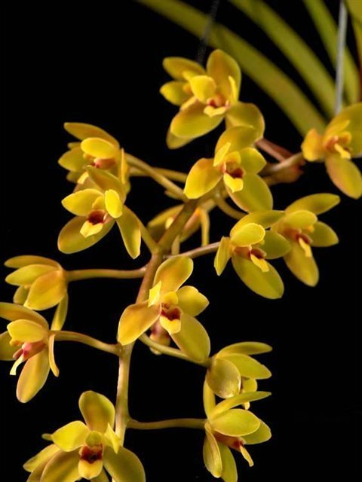
Cymbidium Kuranada, no clonal name, unawarded
Photography by Roberta Fox
Cymbidium sanderae has 81 offspring and 13,520 progeny. Cymbidium sanderae has one AOS award, HCC/AOS 81 points in 2019. Some clones of Cymbidium sanderae have cream to yellowish coloring. When clones selected for cream or yellow coloring are crossed with other Cymbidium species or hybrids with yellow pigmentation, the offspring can express yellow coloration.

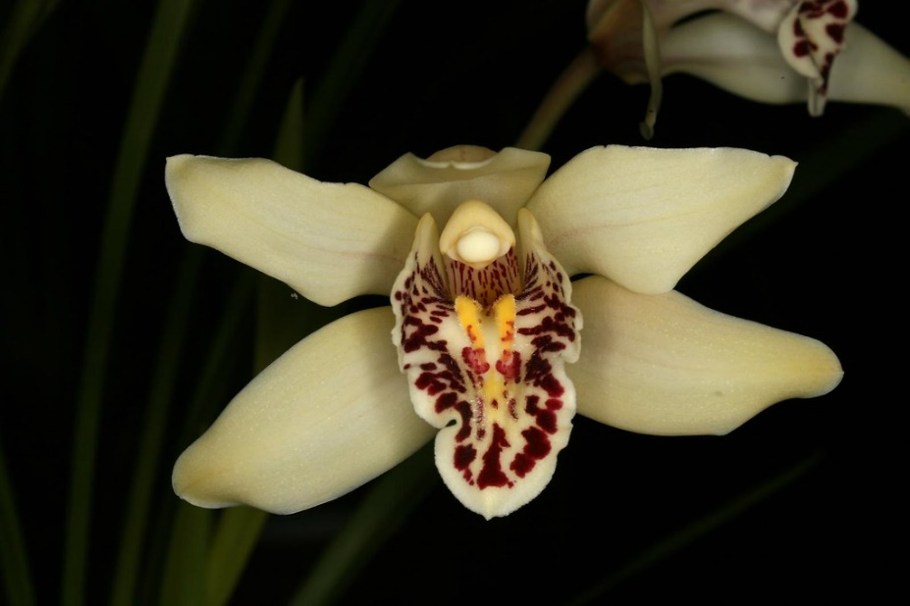
Cymbidium sanderae, clone name unknown, unawarded
Photography by Lourens Grobler

Cymbidium Devon Parish (Cymbidium devonsonianum x Cymbidium sanderae) has 17 offspring and 18 progeny. Cymbidium Devon Parish holds one AOS Award, an HCC/AOS of 75 points, which was received in 1993. Cymbidium Devon Parish was originated by Geyerland and registered by Geyerland in1983.

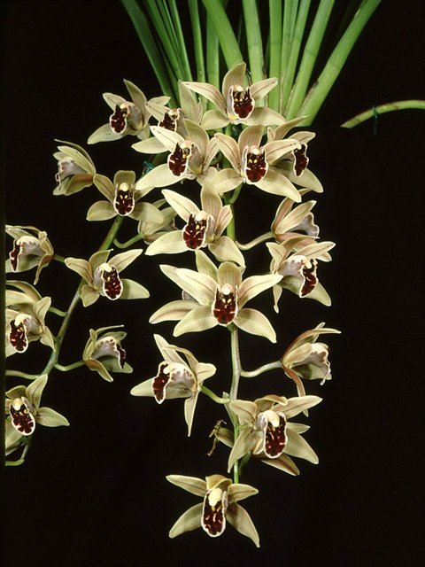
Cymbidium Devon Parish HCC/AOS, 75 points, 1993
Photography by unknown

An example of Cymbidium sanderae hybrid is Cymbidium Gladys Whitesell (Cymbidium Fifi x Cymbidium sanderae). Cymbidium Gladys Whitesell was originated by Geyerland and registered by Geyerland in 1983. Cymbidium Gladys Whitesell has 29 offspring and 41 progeny. Cymbidium Gladys Whitesell has 14 AOS awards (10 HCC; 3 AM; and 1 CCM). The Cymbidium Gladys Whitesell clone ‘Epigardent’ flowers expresses a chartreuse to yellow color.

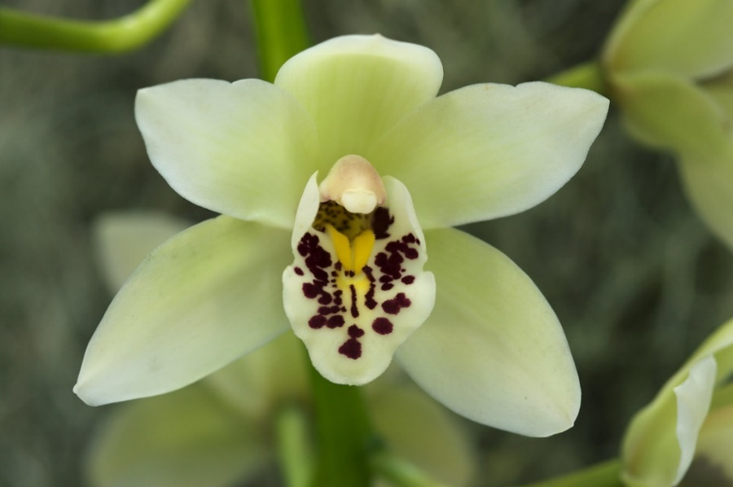
Cymbidium Gladys Whtiesell ‘Epigarden’ HCC/AOS, 78 points, 2010
Photography by Eric Hunt

Another example of a Cymbidium sanderae hybrid is Cymbidium Rod Stewart (Cymbidium sanderae x Cymbidium Fred Stewart). Cymbidium Rod Steward has 27 offspring and 90 progeny. Cymbidium Rod Steward has not received an award. Cymbidium Rod Steward was originated by Featherhil and registered by Featherhill in 1982. The coloration of the Cymbidium Rod Steward clone ‘The Wedding Party’ has a faint yellow coloration. Future hybridizing of Cymbidium Rod Steward ‘The Wedding Party’ has a high probability to produce offspring with yellow flower coloring, depending on secondary parent used in the cross.

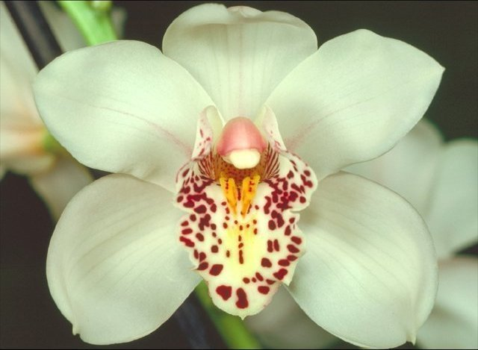
Cymbidium Rod Steward ‘The Wedding Party,’ unawarded
Photography by Milton Carpenter

Cymbidium Tiger Tail is a Cymbidium sanderae hybrid, (Cymbidium sanderae x Cymbidium Alexanderi) originated by Stewart Orchids, Inc. and registered by Stewart Orchids, Inc. in 1960. Cymbidium Tiger Tail has 32 offspring and 52 progeny. Cymbidium Tiger Tail has one AOS award, an AD/AOS. No points were noted for this award in OrchidWiz.

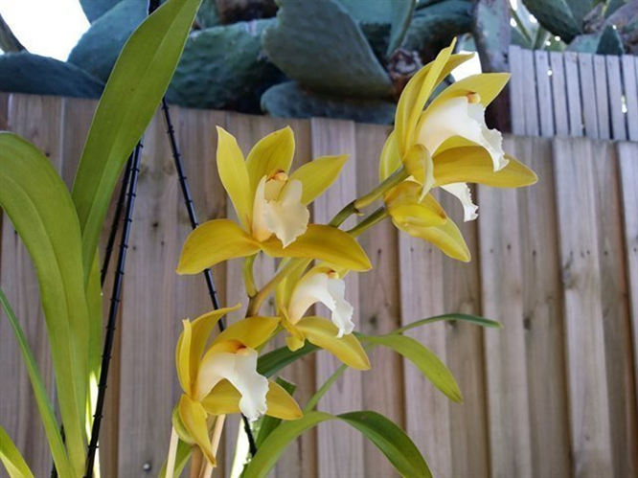
Cymbidium Tiger Tail ‘Gold and Silver,’ unawarded
Photography by Joshua White

Cymbidium Tiger Moth (Cymbidium sanderae x Cymbidium floribundum) was originated by C. Seth and registered by C. Seth in 1981. Cymbidium Tiger Moth has three offspring and four progeny. Cymbidium Tiger Moth has three AM/AOS awards ( 3 AM).

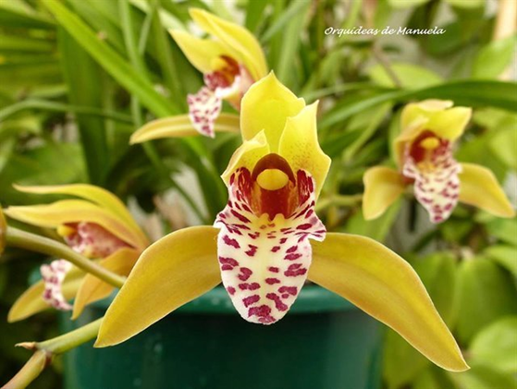
Cymbidium Tiger Moth ‘!,’ unawarded
Photography by Marla Martins

Cymbidium Tiger Orb (Cymbidium sanderae x Cymbidium Ormoulu) originated by K. Andrews O. and registered by K. Andrews O. in 1983. Cymbidium Tiger Orb has one known offspring and one known progeny. Cymbidium Tiger Orb has no AOS awards. If other clones of Cymbidium Tiger Orb have as intense and saturated golden yellow colorization as the clone ‘Yellow Bird,’ depending on the second parent used, I would expect offspring with rich, intense yellow flowers.

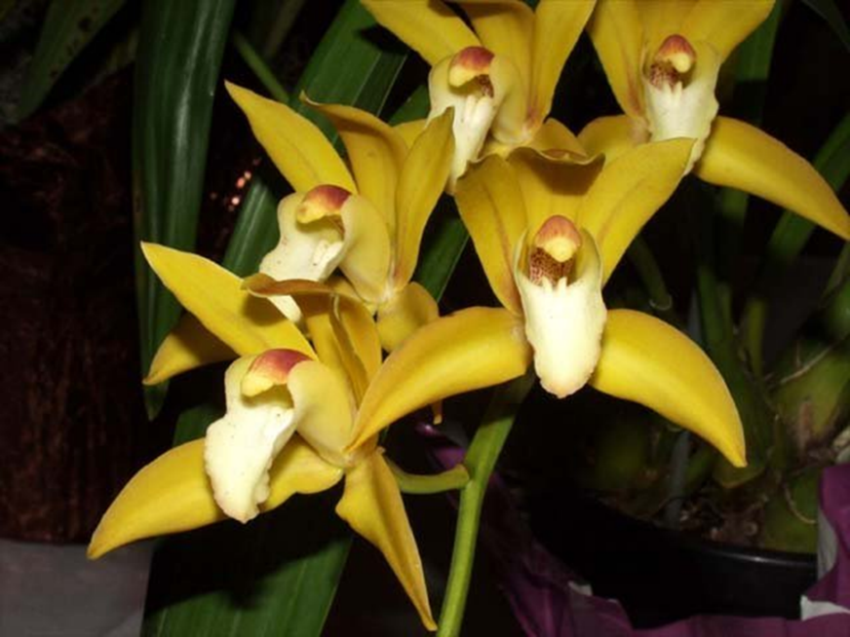
Cymbidium Tiger Orb ‘Yellow Bird,’ unawarded
Photography by Loren Batchman

Cymbidium sichuanicum described by Z. Liu and S. Chen in 2006 has 0 offspring and 0 progeny described at this time. Cymbidium sichuanicum has one AOS award, an AM/AOS in 2015. Due to the golden yellow coloration of Cymbidium sichuanicum, I believe its future use in hybridization to produce offspring with yellow flowers is highly probable.

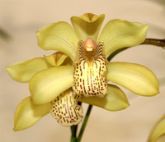
Cymbidium sichuanicum, ‘Uishima,’ unawarded
Photography by Nollie Cilliers

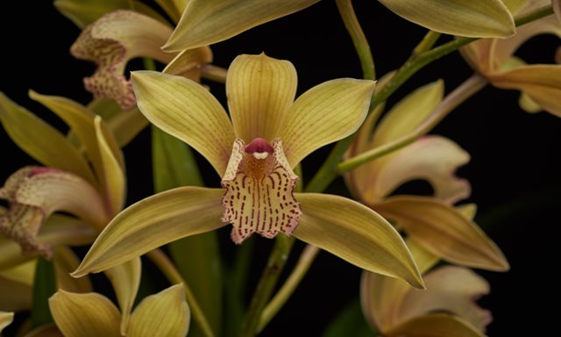
Cymbidium sichuanicum ‘Flying Tiger’ AM/AOS, 82 points, 2015
Photography by unknown
Cymbidium tigrinum has five AOS awards (3 HCC; and 2 CCM). Cymbidium tigrinum has 52 offspring and 219 progeny.

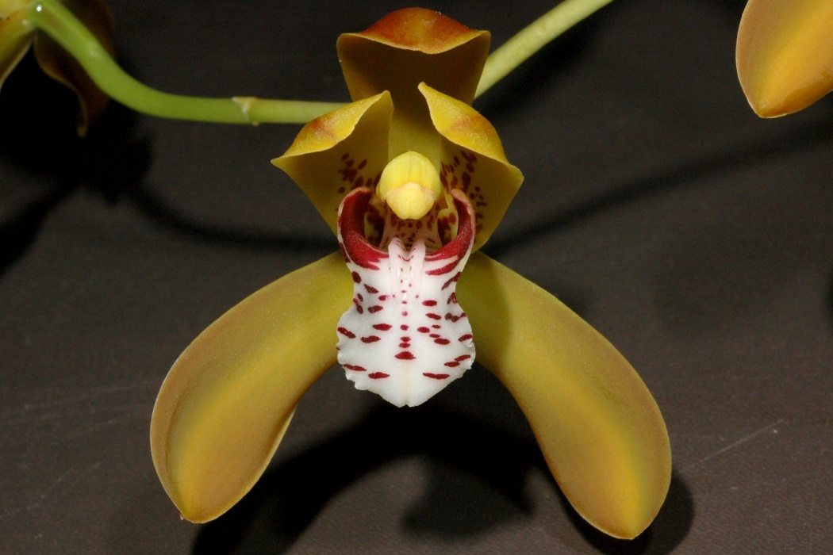
Cymbidium tigrinum ‘Hillside’ HCC/AOS, 76 points, 2005
Photography by Eric Hunt

An offspring of Cymbidium tigrinum with chartreuse to yellow flowers is Cymbidium Tiger Tail. Cymbidium Tiger Tail has 32 offspring and 52 progeny. Depending on the secondary Cymbidium used with Cymbidium Tiger Tail when hybridizing a considerable number of offspring have the propensity to flower yellow.

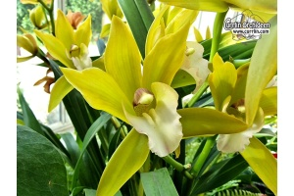
Cymbidium Tiger Tail, no clonal name, unawarded
Photography by unknown

Cymbidium tortisepalum, synonym Cymbidium longibracteatum has nine offspring and eleven progeny. Cymbidium tortisepalum holds 19 AOS awards (7 HCC; 4 AM; 3 FCC; 1 JC; 1 CBR; and 3 CHM) Cymbidium tortisepalum has no awarded offspring or progeny. It has been used limitedly in hybridizing, but there appears to be a possibility of producing offspring with yellow flowers.

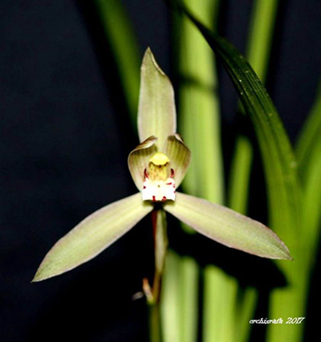
Cymbidium tortisepalum, clonal name unknown
Photography by Rafael Santos

Looking toward complex hybrids, certain clones of Cymbidium Balkis tend to produce offspring that flower in yellow to chartreuse colors. Cymbidium Balkis (Alexanderi x Rosanna) clone ‘Nevada’ HCC/AOS originated by L.de Rothschild and registered by L.de Rothschild in 1934. Thirty-eight AOS awards (28 HCC; and 10 AM). Clones vary from cream to pink. Cymbidium Balkis has 309 offspring and 3535 progeny.

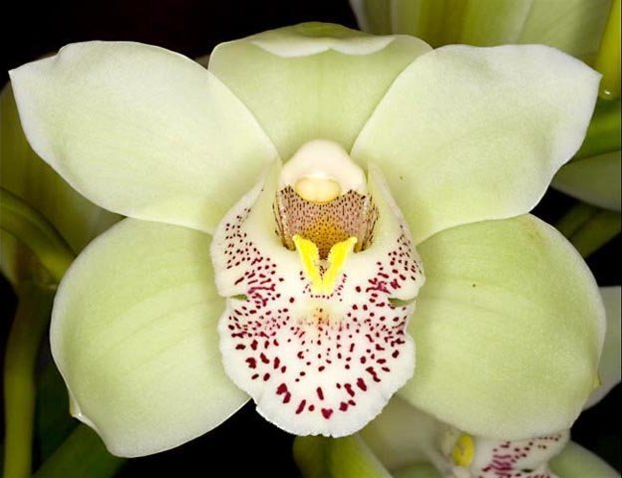
Cymbidium Balkis ‘Nevada’ HCC/AOS, 78 points, 1960
Photography by Bob Harris
An example of a Cymbidium Balkis hybrid which has yellow flowers includes Cymbidium Wallara (Cymbidium Balkis x Cymbidium Auriga) originated by Wondabah and registered by Wondabah in 1964. Cymbidium Wallara has 119 offspring and 711 progeny. Cymbidium Wallara has one AOS award, an HCC/AOS, 79 points, awarded in 1981.

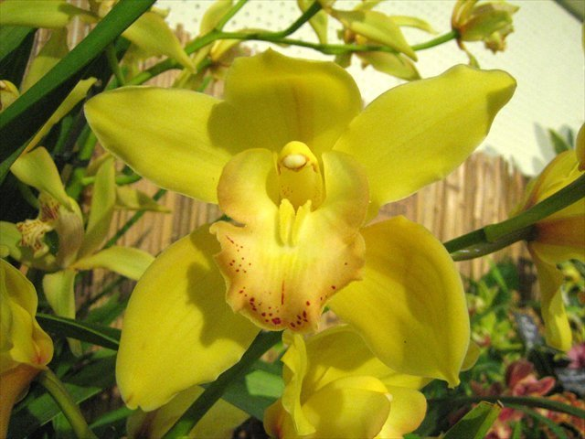
Cymbidium Wallara ‘Alice’
Photography by Dr. Elliot Atstupenas

Another example of a Cymbidium Balkis hybrid with yellow flowers is Cymbidium Valya Craig (Cymbidium Balkis x Cymbidium Cariga) originated by Southerland Orchids and registered by Southerland Orchids in 1962. Cymbidium Valya Craig has 25 offspring and 192 progeny. OrchidWiz notes Cymbidium Valya Craig has four AOS awards (2 HCC; 1 AM; and 1 CCM).

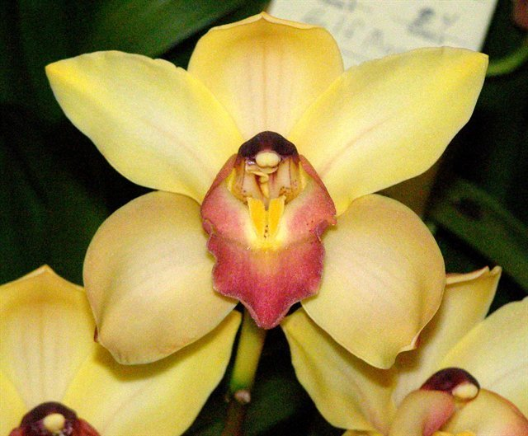
Cymbidium Valya Craig ‘Southerland’ AM/AOS, 80 points, 1979
Photography by L. Cinert

