Species Data Sheet

Cymbidium cancaliculatum
[kan-aal-kyew-LAY-tum]

Noted for striated or grooved on upper leaves.
Common Name: The small, grooved leaf Cymbidium, The Channeled Boat-lipped Orchid, or The Tiger Boat-lipped Orchid.

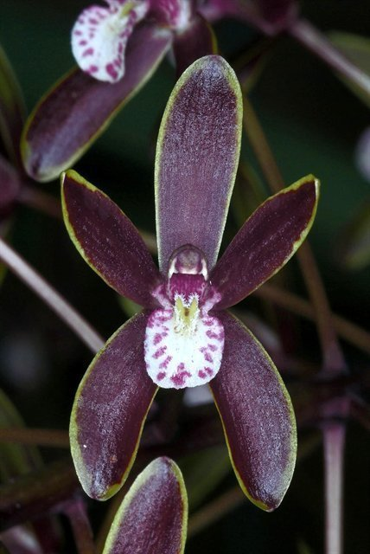
Cymbidium canaliculatum, photography by Jonathan Cara

General Information

Cymbidium cancaliculatum was described by Robert Brown in 1810 based on a specimen that he collected at Broad Sound, Queensland, during Matthew Flinders’ circumnavigation of Australia on which he was the ship’s botanist. It is vegetatively distinctive and can from large clumps, each new pseudobulb often producing more than one scape with 20-50 or more densely crowded flowers each. A single large plant may carry several hundred flowers.

It can be distinguished from the other Australian species by its highly characteristic leathery leaves, its densely crowded scapes, and by the presence of two, distinct, parallel callus ridges on the lip. It can further be distinguished from C. suave by its inflated pseudobulbs.

ORIGIN/HABITAT: Australia. Plants grow over a large area of northern and eastern Australia. Habitat extends from the northeast corner of Western Australia eastward through the Northern Territory to the Cape York Peninsula in Queensland. It then spreads southward to central New South Wales.

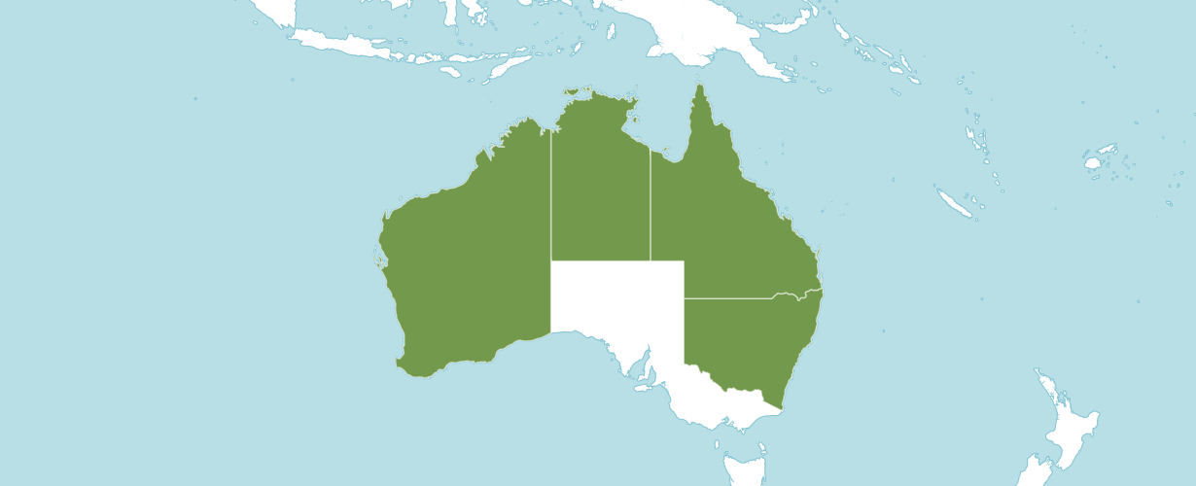
Distribution Cymbidium cancaliculatum from Kew

Botanical Varieties (if any)
Cymbidium canaliculatum f. viridiflorum D.P.Banks. 2012
Cymbidium canaliculatum f. sparkesii (Rendle) O.Gruss & M.Wolff. 2007
Cymbidium canaliculatum f. barrettii (Nicholls) O.Gruss & M.Wolff. 2007
Cymbidium canaliculatum var. barrettii Nicholls. 1942
Cymbidium canaliculatum f. purpurascens Rupp. 1934
Cymbidium canaliculatum f. aureolum Rupp. 1934
Cymbidium canaliculatum f. fuscum Rupp. 1934
Cymbidium canaliculatum f. inconstans Rupp. 1934
Cymbidium canaliculatum var. marginatum Rupp. 1934
Cymbidium canaliculatum var. sparkesii (Rendle) F.M.Bailey. 1913
Cymbidium canaliculatum R.Br. 1810
Cymbidium canaliculatum h.v. sparksii
Cymbidium canaliculatum h.f. album
Cymbidium canaliculatum h.f. auroleum

Synonyms
Cymbidium sparkesii Rendle. 1898
Cymbidium hillii F.Muell. ex Regel. 1879

Awards
Cymbidium canaliculatum has been awarded 24 times between 1964 to 2015 (AM – 4; HCC – 10; CBM – 2; CCM – 5; CHM – 1; and JC – 2 ).

Hybrids

Cymbidium canaliculatum has 75 first generation offspring and 106 total progeny. Cymbidium canaliculatum has been used 8 times as the seed parent and 67 times as the pollen parent.

Cymbidium Helen Bannerman (C. canaliculatum x C. madidum) registered in 1966 by Mrs. B. P. Cooper and originated by Bronsdon has the largest number of offspring and awards. Cymbidium Helen Bannerman has 6 first generation offspring and a total of 6 progeny. Cymbidium Helen Bannerman has 25 awards between 1965 and 2019 (AD – 1; AM – 10; FCC – 1; HCC – 7; CCE – 2; and CCM – 4).

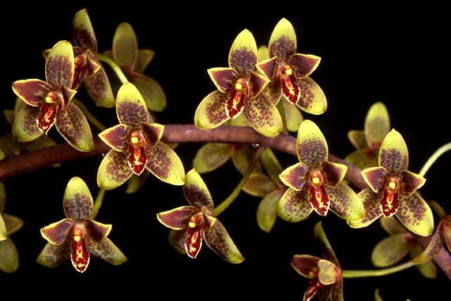
Cymbidium Oriental Elf, photography by Q.T. Luong

References
Arora, C. 1985. Flowering of some orchids in Dehra Dun, India. American Orchid Society Bulletin 54(3):322.

Bechtel, H., Cribb, P., and Launert, E. 1980. Manual of cultivated orchid species. MIT Press, Cambridge, Mass.
Du Puy, D., and Cribb, P. 1988. The genus Cymbidium. Timber Press, Portland, OR.

Du Puy, D., and Cribb, P. 2007. The genus Cymbidium. Kew Publishing, Richmond. Surrey, UK.
Hamilton, R. 1988. When does it flower? 2nd ed. Robert M. Hamilton, 9211 Beckwith Road, Richmond, B. C., Canada V6X 1V7.
Hawkes, A. [1965] 1987. Encyclopedia of cultivated orchids. Faber and Faber, London.

Jones, D. 1988. Native orchids of Australia. Reed books Pty. Ltd., 2 Aquatic Drive, Frenchs Forest, NSW 2086, Australia.

Jones, D. 2006. A complete guide to native orchids of Australia including island territories. Frenchs Forest, N.S.W. New Holland.

Jones, D., et al. 2006. Cymbidium, Australian tropical rainforest orchids. Centre for Australian National Biodiversity Research, Commonwealth Scientific and Industrial Research Organization. Australian Government.

Neptuen, W. M.D. 1982. The rewarding and easy-to-grow Cymbidiums. American Orchid Society Bulletin 51(4):367.

OrchidsPlus. 1.4

OrchidWiz X9.1
Schuhmacher, G. 1994. Australian native Cymbidium species and hybrids. The Orchadian 11(4):181-183.
The Cymbidium Society of America. 2001. Manual of judging. The Cymbidium Society of America.
Thorogood, E. 1992. Two views of cultivating Cymbidium canaliculatum R. Br. The Orchadian 10(8):288.

