GENUS SUMMARY
Pleurothallis, Brown, 1813
[Plu-roe-THALL-lis]

General Description
The Manual of Cultivated Orchid Species notes Pleurothallis is a small to medium-sized epiphytic or lithophytic herbs with tufted stems from a creeping rhizome. Stems erect, short, jointed, mostly t leafed. Leaves fleshy to coriaceous, erect to spreading sessile or petiolate. Inflorescence apical, short to exceptionally long, racemose, fasciculate, or one-flowered. Flowers are small, occasionally secund. Sepals subequal, spreading or ringent, connate; lateral sepals connate at base to completely united to apex forming a short mentum with the column-foot. Petals smaller than the sepals. Lip small, simple to three-lobed, mostly clawed. Column winged, foot mostly distinct, pollinia two, waxy, lacking a stripe, rostellum well-developed.

Distribution One of the largest genera in the Orchidaceae with about 900 species confined to the tropical Americas but commonest in Montane regions.

Derivation of Name. From the Greek pleuron (rib) and thallos (short, branch), in allusion to the many rib-like stems which arise in the tufts in many species.

Taxonomy Robert Brown described Pleurothallis in the second edition of W. Ainton’s Hortus Kewensis in 1813. Because of their small-sized flowers and great diversity, the species of Pleurothallis have remained relatively poorly known and little studied. Newly introduced plants are often exceedingly difficult or impossible to name as many species are poorly defined or undescribed.

Recently C. Luer has begun the monumental task of monographing the genus in a series of articles entitled Icones Pleurothallidinarum in the journal Selbyana. Here, each species delt with is fully described and illustrated and although only a few parts have so far been produced, many new species have already been described.

Pleurothallis is allied to Masdevallia but differs in having much smaller flowers which lack the characteristic sepaline tube of the latter.

The division of the genus most often used in that proposed by E. Pfitzer in A. Engler and K A. Prantl’s Die Naturalichen Pflanzenfamilien (1897), but P. Allen in the Flra of Panama (1949) states that it ‘is wholly artificial and quite impossible to use.’ Unfortunately, no system reflecting natural affinities within the genus has been proposed to replace Pfitzer’s system.

Type Species. P. ruscifolius (Jacq.) Robert Brown.

Synonyms Kraenzlinella O. Ktze.; Platystele Schltr.

The American Orchid Society notes that Pleurothallis is a conglomerate genus, a taxonomist’s dream (or perhaps nightmare) and in a constant state of flux. There is no simple description of Pleurothallis, as it is a huge genus comprising species from miniscule to exceptionally large, epiphytic to terrestrial, clumping to creeping in growth, thick or thin leaved, erect to pendent. The flowers can be delicate or thickly textured; racemes can be single flowered or many flowered, short to exceptionally long. At present, over 1,000 species have been described, classified into 27 subgenera with 25 sections (Luer). Recent genetic work suggests that Pleurothallis should be divided into approximately 17 different genera while Luer has recently suggested the creation of 49 segregates.
Pleurothallis species are found throughout the American tropics. It is easy to find trees with 5, 6, 7 or more distinct species on one branch! There are some species for just about any growing condition, from the warm to intermediate to cool greenhouse; from wet to dry growing areas. The one thing that brings these diverse plants together is flower size. Most Pleurothallis flowers are so small that a magnifying glass is often needed to appreciate their beauty and complexity. As with any small flowered species, it is a specimen-sized plant in full bloom that catches the eye and forces appreciation from even a die-hard Cattleya lover!
Pleurothallis was first described by Robert Brown in 1813. He named the genus from the Greek pleuron (rib) and thallos (short, branch) in allusion to the many rib-like stems which arise in tufts in many of the species. Pleurothallis is allied to Masdevallia but the flowers are much smaller and lack the characteristic sepaline tube of Masdevallia.
A favorite of the specialist hobbyist, some of the Pleurothallis species found in collections include P. allenii, P. endotrachys, P. grobyi, P. glandulosa (now all three considered members of Specklinia), and P. octomerioides (now considered to by Myoxanthus octomerioides).

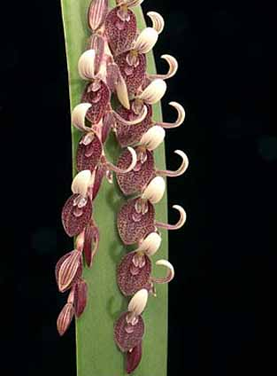
Pleurothallis strupifolia
Photography by Greg Allikas

Native to:

Argentina Northeast, Belize, Bolivia, Brazil North, Brazil Northeast, Brazil South, Brazil Southeast, Colombia, Costa Rica, Cuba, Dominican Republic, Ecuador, El Salvador, French Guiana, Guatemala, Guyana, Haiti, Honduras, Jamaica, Leeward Is., Mexico Central, Mexico Gulf, Mexico Northeast, Mexico Northwest, Mexico Southeast, Mexico Southwest, Nicaragua, Panamá, Paraguay, Peru, Puerto Rico, Suriname, Trinidad-Tobago, Venezuela, Venezuelan Antilles, Windward Islands.

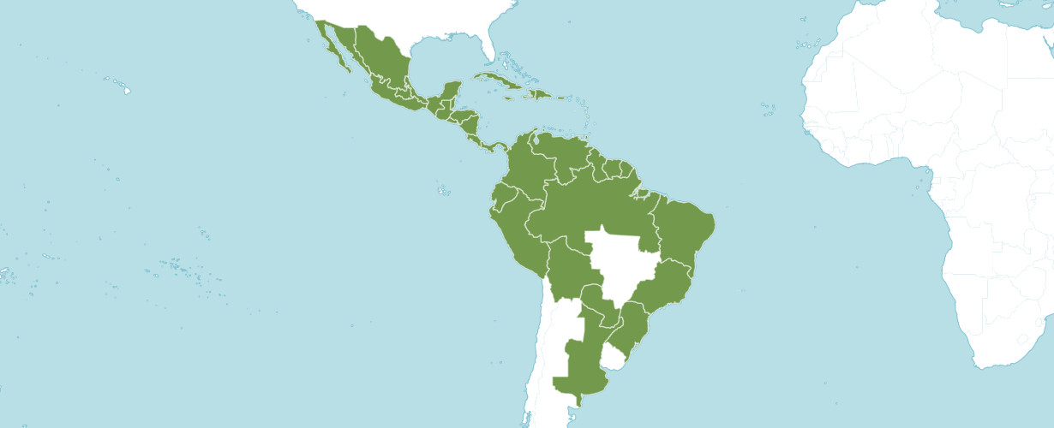
Distribution of Pleurothallis, image from Royal Botanical Gardens Kew
Pleurothallis is a genus of orchids commonly called bonnet orchids. The genus name is derived from the Greek word pleurothallos, meaning "riblike branches". This refers to the rib-like stems of many species. The genus is often abbreviated as "Pths" in horticultural trade.

This was a huge genus, which contained more than 1,200 species - the second largest in the Orchidaceae after Bulbophyllum. In 2004, it decreased by more than half when many species were moved into new genera.

As a group they show a vast range in vegetative form, terrestrial or epiphytic, and can be found as tall cane-like plants a meter or so high, clumped, or trailing, pendent, or climbing, erect or creeping, tufted and tiny, delicate moss-like species that can grow on the thinnest of twigs. They have one common denominator: they all have two pollinia.

They have reduced their pseudobulbs and instead, some species have thick succulent leaves.

Their flowers are among the most diverse and unusual, although often exceedingly small, and specialize in using tiny insects such as gnats, flies, or small wasps for pollination.

To bring some order to this extremely diverse genus, 29 subgenera and 25 sections had been created. Much of this work has been done by Dr. C. Luer of the Missouri Botanical Garden. A new analysis, based on DNA testing, confirmed overall the classification of the subtribe Pleurothallidinae, with Pleurothallis as the main difference. New genetic insight broke up this huge genus and made it more consistent with the principles of monophyletic genera and evolutionary relationships.

Several times before, a splitting up has been attempted, but there were always too many intermediate forms. In 2004 the genera Acianthera, Ancipitia, Antilla, Apoda-prorepentia, Areldia, Atopoglossum, Brenesia, Crocodeilanthe were created, incorporating a large number of former Pleurothallis species.[2] The subgenera Pleurothallis and Specklinia are becoming separate genera, and the subgenus Acuminatae might become the proposed genus Anathallis.

Other allied genera include Dracula, Masdevallia, Restrepia, and Stelis

Heterotypic Synonyms

Acronia C.Presl in Reliq. Haenk. 1: 103 (1827)

Ancipitia (Luer) Luer in Monogr. Syst. Bot. Missouri Bot. Gard. 95: 254 (2004)

Atopoglossum Luer in Monogr. Syst. Bot. Missouri Bot. Gard. 95: 255 (2004)

Centranthera Scheidw. in Allg. Gartenzeitung 10: 293 (1842)

Colombiana Ospina in Orquideologia 8: 230 (1973)

Lalexia Luer in Harvard Pap. Bot. 16: 358 (2011)

Lindleyalis Luer in Monogr. Syst. Bot. Missouri Bot. Gard. 95: 258 (2004)

Loddigesia Luer in Monogr. Syst. Bot. Missouri Bot. Gard. 105: 251 (2006), nom. illeg.

Mirandopsis Szlach. & Marg. in Polish Bot. J. 46: 117 (2001)

Mixis Luer in Monogr. Syst. Bot. Missouri Bot. Gard. 95: 258 (2004)

Orbis Luer in Monogr. Syst. Bot. Missouri Bot. Gard. 103: 308 (2005)

Pleurobotryum Barb.Rodr. in Gen. Spec. Orchid. 1: 20 (1877)

Proctoria Luer in Monogr. Syst. Bot. Missouri Bot. Gard. 95: 258 (2004)

Rhynchopera Klotzsch in J.H.F.Link, J.F.Klotzsch & C.F.Otto, Icon. Pl. Rar. 2: 103 (1844)

Talpinaria H.Karst. in Fl. Columb. 1: 153 (1859)

Tigivesta Luer in Monogr. Syst. Bot. Missouri Bot. Gard. 112: 121 (2007)

Vestigium Luer in Monogr. Syst. Bot. Missouri Bot. Gard. 103: 309 (2005), nom. illeg.

Zosterophyllanthos Szlach. & Marg. in Polish Bot. J. 46: 118 (2001)

References

American Orchid Society. 2023. Pleurothallis. Online: https://www.aos.org/orchids/orchids-a-to-z/letter-p/pleurothallis.aspx

Govaerts, R. 2003. World Checklist of Monocotyledons Database in ACCESS: 1-71827. The Board of Trustees of the Royal Botanic Gardens, Kew.

Luer, C. 2009. Icones Pleurothallidinarum XXX. Monographs in Systematic Botany from the Missouri Botanical Garden 115: 1-265. Missouri Botanical Garden.

Luer, C. 2004. Icones Pleurothallidinarum XXVI. Monographs in systematic botany from the Missouri Botanical Garden. Missouri Botanical Garden Press. 95: 253–265.

OrchidWiz X9.0

Pridgeon, A. & Chase, M. 2001. A phylogenetic reclassification of Pleurothallidinae. Lindleyana. 16: 235–271.

Pridgeon, A., Cribb, P., Chase, M. & Rasmussen, F. 2006. Epidendroideae (Part One). Genera Orchidacearum 4: 1-672. Oxford University Press, New York, Oxford.

Romero-González, G., Fernández-Concha, G., Dressler, R., Magrath, L., & Argus, G. 2003. Pleurothallis gelida: Flora of North America. 26: 616, 617.

Royal Botanical Gardens Kew. 2023. Plants of the World Online. Online: https://powo.science.kew.org/taxon/urn:lsid:ipni.org:names:325966-2

Viveros, P. & Higgins, W. 2007. Checklist of Pleurothallidinae from Colombia. Selbyana 28: 13-90.

