GENUS SUMMARY
Stelis, Schrader (Swartz), 1799
[STEE-lis ]
Nickname Leach Orchid

General Description
The Manual of Cultivated Orchid Species notes that Stelis is a small tufted epiphytic or lithophytic herbs, with a horizontal creeping rhizome (primary stem). Secondary stems erect, one-leafed. Leaf fleshy or coriaceous, suberect, subsessile or petiolate. Inflorescence axillary, 1 to many, racemose, slender. Flowers are minute to small, numerous. Sepals subequal, connate, mostly spreading, the most prominent segments of the flower. The petals and lip minute, fleshy, surrounding the column. Column short, thickened above; rostellum ligulate; anther terminal, pollinia two, waxy, pyriform, lacking a stipe.

Distribution About 206 species in the tropic of America from Mexico and the W. Indies south to Bolivia and Brazil.

Derivation of Name. From the Greek stelis (little pillar), a word used by the Ancient Greeks for the mistletoe which, like Stelis species, grows on trees.

Taxonomy. Stelis was described by O. Swartz in Schrader, Journal fur die Botanik in 1799. The small flowers and minute petals, lip and column make specific determinations in the genus exceedingly difficult. Indeed, as with Pleurothallis the genus has been bypassed by botanists and horticulturalists as the species are of little horticultural merit. It is, therefore, likely that many species remain to be described or, on the other hand, that many have been described more than once.

The first attempt to subdivide the genus was made by John Lindley in Folia Orchiacea (1858) who recognized three sections, (Eu) Stelis, Dialissa and Labiatae, each with several subdivisions. H. G. Reichenback in Walpers, Annales Botanices (1864) recognized but two sections, uniting the latter two of Lindley’s in sect. Disepaleae. L. Garay in the Canadian Journal of Botany (1956) REVIEWED THE PREVOUS ATTEMPTS TO TREAT Stelis at the subgeneric level and concluded that the previous groupings were largely unnatural and they were no longer useful, particularly in the light of the many new species described after Reichenbach’s work. Garay divided the genus into three subgenera: Stelis with all sepals similar; Inaequales with rigent flowers having dissimilar sepals and the lateral sepals shortly connate; and Dialissa with dissimilar sepals in which the dorsal and lateral sepals are connate for over half their lengths. Subgenus Stelis is further subdivided into three sections on lip shape; subgenus Inaequales is divided into two sections on the degree of connation of the lateral sepals; whilst subgenus Dialissa is not subdivided.

Type Species Stelis ophiolossoides.

Kew notes Stelis is a large genus of mainly epiphytic orchids containing about 500 species widely distributed throughout much of South America, Central America, Mexico, the West Indies. They are closely related to Pleurothallis and Masdevallia. The species within Stelis are some of the most taxonomically complex of all the orchids, however they have never been popular in the horticultural industry. Most species have long, dense racemes of small, translucent flowers in shades of white and yellow. The dorsal sepal is usually the most prominent part of the flower, with the other sepals and petals being minute. The tiny lip is often lobed and hairy. Some species have flowers that are light sensitive. They open only in the sunlight and close tightly at night.

Stelis, or leach orchids, is a large genus of orchids, with perhaps 500 species. The generic name Stelis is the Greek word for 'mistletoe', referring to the epiphytic habit of these species. These mainly epiphytic (rarely lithophytic) plants are widely distributed throughout much of South America, Central America, Mexico, the West Indies, and Florida.[1] Stelis is abbreviated Ste. in the horticultural trade.[2]

Many of the older species were named by Lindley, Ruiz & Pavon and Reichenbach, while many of the recent species were named by Carlyle A. Luer. An orchid of the genus Stelis was probably the first American orchid ever to be brought to Europe. An herbarium specimen was depicted in 1591 in Tabernaemontanus' herbal book.

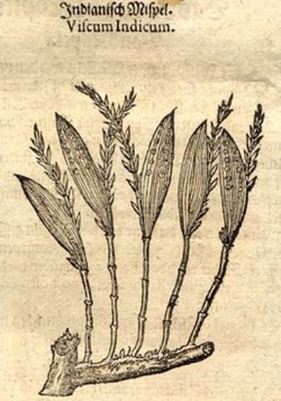
'Indian mistletoe'
First depiction of a Stelis orchid, published 625 in Herbal Book of Johannes Theodorus Tabernaemontanus.

Wikipedia provides information: a single oblanceolate leaf develops from narrow, leathery outgrowths from a creeping stem.

Most species grow long, dense racemes of small to minute flower in diverse shades of white. Other colors are rare. These flowers are photosensitive, only opening in the sunlight. Some close completely at night.

The three symmetrically rounded sepals generally form a triangle with a small central structure, made up of the column, small petals and small lip, though slight variation to this theme does occur.

This genus is not common in cultivation.

Cladistic research by A. Pridgeon, R. Solano and M. Chase has shown that the genus Stelis is monophyletic. But the distinction with several Pleurothallis subgenera is blurred.

Stelis are closely related to the massive genus Pleurothallis and Masdevallia. Although vegetatively the species show much variety, the flowers show a basic uniformity and are remarkably similar throughout. Apatostelis Garay, Dialissa Lindl., Humboldtia Ruiz & Pav. and Steliopsis Brieger are generally included into Stelis.

The genus Stelis was discovered with Charles Plumier, a French priest and botanist who was sent by Louis XIV, King of France, to study the flora of the Antilles in around 1690. He collected numerous species in Dominica, Caribbean island, and other islands, and published his findings in a catalogue called Nova Plantarum Americanarum Genera in 1703. Later, Nikolaus von Jacquin, a Dutch botanist who collected extensively in the Caribbean, published his findings in two separate works. In 1760, he published the first one called Enumeratio Systematica Plantarum quas in Insulis Caribeis, where he described the same plant as Plumier´s polynomial, Epidendrum ophioglossoides. In 1763, he published a more detailed second work called Selectarum Stirpium Americanarum Historia. Jacquin describes a plant of his own herbarium with the same name E. ophioglossoides.

Afterwards, on the “Expedición Botánica Española,” Spanish Botanic Expedition sent by King Carlos III to study the flora of Peru and Chile, Hipolito Ruiz and Joseph Pavon complete results established 11 small plants of a new genus which they named Humboltia in honor of the renowned German explorer and naturalist Alexander Von Humboldt. In 1799, Olof Swartz, a Swedish botanist, studied the genus proposed by Ruiz and Pavon and found that Vahl had already used it to designate a Leguminosae. Because of this, he proposed the name Stelis in replacement of Humboltia. The species Epidendrum ophioglossoides was later moved to the genus Stelis by Swarz, and it is now the type species of the genus.

Jay Pfahl describes this orchid species as "Miniature sized, hot to warm growing epiphyte with clustered, triquetreous above, ramicauls enveloped by 1 to 2 tubular basal sheaths and another at the middle and carrying a single, apical, erect, coriaceous, narrowly elliptic-oblong to elliptical, subobtuse to tridenticulate, narrowing below into the petiolate base leaf that blooms at any time of the year on 1 to 3, as long or slightly longer than the leaf, to 3.6 [9cm] long, slender, distichous, loosely many flowered inflorescence arising through an acute spathe and has cucullate, shortly apiculate floral bracts." Please see Sources in the bottom right box for quoted references.

Heterotypic Synonyms
Apatostelis Garay in Bot. Mus. Leafl. 27: 185 (1979), nom. illeg.
Condylago Luer in Orquideologia 15: 118 (1982)
Crocodeilanthe Rchb.f. & Warsz. in Bonplandia (Hannover) 2: 113 (1854)
Dialissa Lindl. in Ann. Mag. Nat. Hist. 15: 107 (1845)
Dracontia (Luer) Luer in Monogr. Syst. Bot. Missouri Bot. Gard. 95: 257 (2004)
Effusiella Luer in Monogr. Syst. Bot. Missouri Bot. Gard. 112: 106 (2007)
Elongatia (Luer) Luer in Monogr. Syst. Bot. Missouri Bot. Gard. 95: 257 (2004)
Humboltia Ruiz & Pav. in Fl. Peruv. Prodr.: 121 (1794), nom. rej.
Lomax Luer in Monogr. Syst. Bot. Missouri Bot. Gard. 105: 88 (2006)
Mystacorchis Szlach. & Marg. in Polish Bot. J. 46: 117 (2001)
Niphantha Luer in Monogr. Syst. Bot. Missouri Bot. Gard. 120: 154 (2010)
Physosiphon Lindl. in Edwards's Bot. Reg. 21: t. 1797 (1835)
Physothallis Garay in Svensk Bot. Tidskr. 47: 199 (1953)
Pseudostelis Schltr. in Anexos Mem. Inst. Butantan, Secç. Bot. 1(4): 36 (1922)
Salpistele Dressler in Orquideologia 14: 6 (1979)
Steliopsis Brieger in F.R.R.Schlechter, Orchideen Beschreib. Kult. Zücht., ed. 3, 8(29-32): 457 (1976), no Latin descr.
Unciferia (Luer) Luer in Monogr. Syst. Bot. Missouri Bot. Gard. 95: 265 (2004)

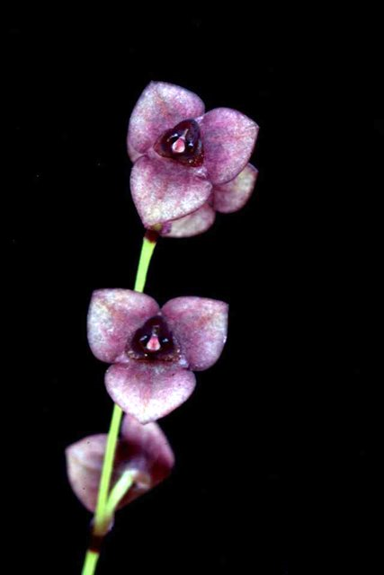
Stelis ophioglossoides
Photography by Wiel Dressen

Native to:

Belize, Bolivia, Brazil North, Brazil Northeast, Brazil South, Brazil Southeast, Brazil West-Central, Colombia, Costa Rica, Cuba, Dominican Republic, Ecuador, El Salvador, Florida, French Guiana, Guatemala, Guyana, Haiti, Honduras, Jamaica, Leeward Is., Mexico Central, Mexico Gulf, Mexico Northeast, Mexico Northwest, Mexico Southeast, Mexico Southwest, Nicaragua, Panamá, Peru, Puerto Rico, Suriname, Trinidad-Tobago, Venezuela, Venezuelan Antilles, Windward Islands.

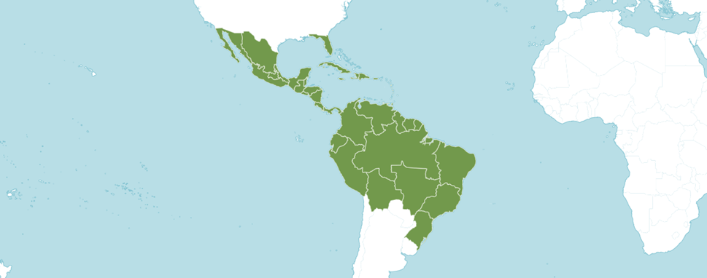
Distribution of Stelis, image from Royal Botanical Gardens Kew
References

Govaerts, R. (2003). World Checklist of Monocotyledons Database in ACCESS: 1-71827. The Board of Trustees of the Royal Botanic Gardens, Kew.

Karremans, A.P. (2019). To be, or not to be a Stelis. Lankesteriana 19: 281-343.

Luer, C. 2002. Pleurothallidinarum XXVI: Pleurothallis subgenus Acianthera and three allied subgenera.

Luer. C. 2018. Telis of Bolivia. Selbyana. The Journal of the Marie Selby Botanical Gardens. 32(1,2).

North American Orchid Conservation Center. 2013. Genus: Stelis. https://goorchids.northamericanorchidcenter.org/genus/stelis/

OrchidWiz. X9.0
Pridgeon, A.M., Cribb, P.J., Chase, M.C. & Rasmussen, F.N. (2006). Epidendroideae (Part One). Genera Orchidacearum 4: 1-672. Oxford University Press, New York, Oxford.

Royal Botanical Gardens Kew. 2023. Plants of the World Online. Online: https://powo.science.kew.org/taxon/urn:lsid:ipni.org:names:30000786-2

Swartz, O. 1799. Nova Acta Regiae Societatis Scientiarum Upsaliensis 6: 85, f. 6.

Wikipedia. 2023. Lepanthes. Online: https://en.wikipedia.org/wiki/Stelis

