GENUS SUMMARY
Lepanthes, Swartz, 1799
[le-PAN-theez ]

General Description
Dwarf or small, epiphytic or lithophytic herbs with a short rhizome. Secondary stems erect, slender, concealed by tubular sheaths which are dilated and mostly ciliate at the apex. Leaves sessile, suberect, coriaceous, linear to orbicular, tridentate at the apex. Inflorescences axillary, solitary or fasciculate. Flowers small, 1 to many, 2-ranked. Sepals are the most prominent segments of the flower, spreading, subequal, lateral sepals connate. Petals minute, mostly broader than long. Lip minute, two to three lobed. Column short, fleshy; pollinia two, waxy, pyriform; rosetellum linear, well developed, erect.

Lepanthes was described in 1799 by O. Swartz in Nova Acta Regiae Societtis Scientiarum Upsalinesis. A taxonomically complex group with many species which are little known and poorly defined or not yet described per The Manual of Cultivated Orchid Species. Lepanthes is allied to Pleurothallis being distinguished by its mostly strongly two-lobbed transverse petals from a very oblique base In many species of Lepanthes the flower opens widely to be almost flat.

Type Species L. concinna Sw. nom. Illeg.

The AOS notes Found in moist tropical forests over a large area stretching from Mexico to Brazil, the type species Lepanthes concinna was first described in 1799. Many of the species of this genus are obscure and little known, poorly defined, or not yet described. It is a genus in flux. Lepanthes is allied to Pleurothallis and derives its generic name from the Greek lepis (scale) and anthos (flower) referring to the very small flowers of many of the species in this genus. Yet, if one took the time to study the diminutive flowers at close range, it would be found they are most unusual and daintily attractive. The complex tiny flowers are often brightly hued but short lived.

Lepanthes from Greek "scaled-flower" is a large genus of orchids with about 800–1000 species, distributed in the Antilles and from Mexico through Bolivia with very few species in Brazil. The genus is abbreviated in horticultural trade as Lths. Almost all the species in the genus are small and live in cloud forests. Baby boot orchid is a common name.

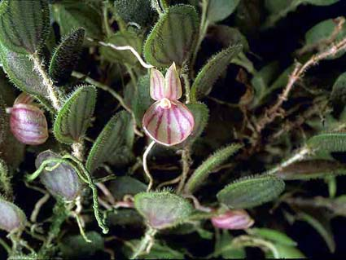
Lepanthes persimilis 'Free Spirit'
Photography by John Lewis

Native to:

Belize, Bolivia, Brazil North, Brazil Northeast, Colombia, Costa Rica, Cuba, Dominican Republic, Ecuador, El Salvador, French Guiana, Guatemala, Guyana, Haiti, Honduras, Jamaica, Leeward Is., Mexico Central, Mexico Gulf, Mexico Northeast, Mexico Southeast, Mexico Southwest, Nicaragua, Panamá, Peru, Puerto Rico, Suriname, Venezuela, Venezuelan Antilles, Windward Islands.

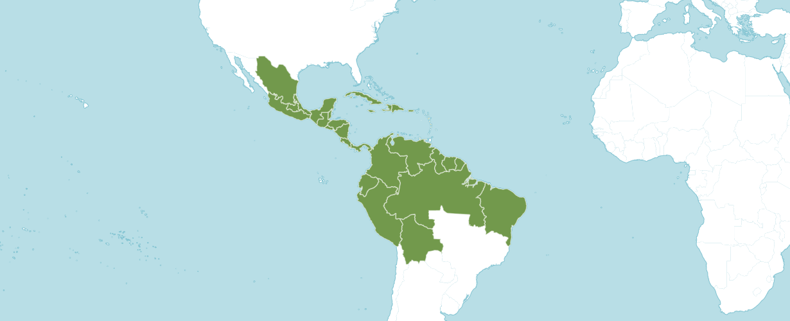
Distribution of Lepanthes, image from Royal Botanical Gardens Kew
References

American Orchid Society. 2023. Lepanthes. Online: https://www.aos.org/orchids/orchids-a-to-z/letter-l/lepanthes.aspx

Govaerts, R. 2003. World Checklist of Monocotyledons Database in ACCESS: 1-71827. The Board of Trustees of the Royal Botanic Gardens, Kew.

Kolanowska, M. & Szlachetko, D. 2014. Orchids of the department of Valle del Cauca (Colombia) 3: 1-469. Koeltz Scientific Books.

Luer, C. 2009. Icones Pleurothallidinarum XXX. Monographs in Systematic Botany from the Missouri Botanical Garden 115: 1-265. Missouri Botanical Garden.

Pridgeon, A., Cribb, P., Chase, M. & Rasmussen, F. 2006. Epidendroideae (Part One). Genera Orchidacearum 4: 1-672. Oxford University Press, New York, Oxford.

Royal Botanical Gardens Kew. 2023. Plants of the World Online. Online: https://powo.science.kew.org/taxon/urn:lsid:ipni.org:names:30000786-2

Swartz, O. 1799. Nova Acta Regiae Societatis Scientiarum Upsaliensis 6: 85, f. 6.

Viveros, P. & Higgins, W. 2007. Checklist of Pleurothallidinae from Colombia. Selbyana 28: 13-90.

Wikipedia. 2023. Lepanthes. Online: https://en.wikipedia.org/wiki/Lepanthes

