Class 710 Masdevallia and Dracula Five Sample Descriptions

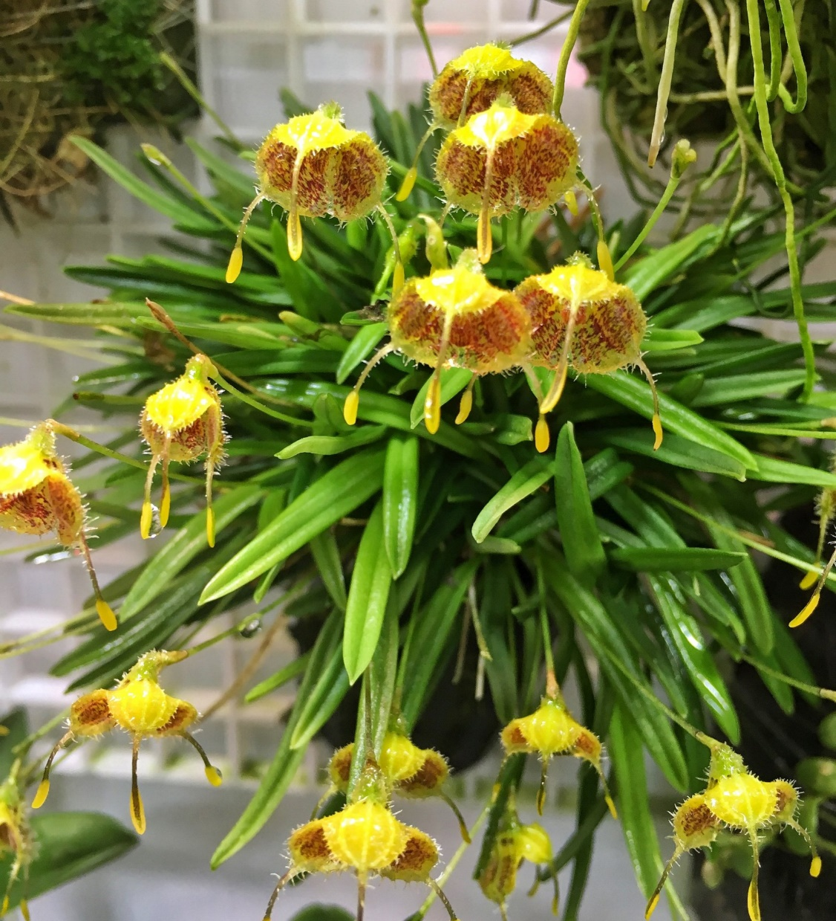

Masdevallia erinacea
Photography by Woodstream Orchids

Twenty-six flowers and eight buds on 34 inflorescences held above the foliage on a well grown plant mounted on a tree fern slab, flowers cupped forward; sepals yellow intensely spotted chestnut, pileous exteriorly, caudae green, bulbous apices yellow; petals minute, yellow; lip minute yellow intensely spotted chestnut; column green; substance firm; texture pileous.

Award: CCM/AOS, 84 points

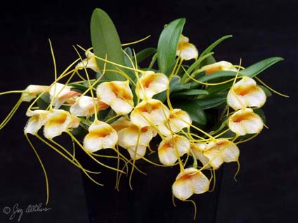

Masdevallia strobelii
Photography by Jerry Wilson

Seventy-five flowers and 20 buds on 95 inflorescences; sepals pileous, white, margins white picotee; interior of sepaline tube yellow, deepening to orange, caudae yellow; petals minute; lip white flushed lightly orange, sidelobes orange; column white flushed lightly orange; substance firm; texture crystalline.

Award: AM/AOS, 85 points

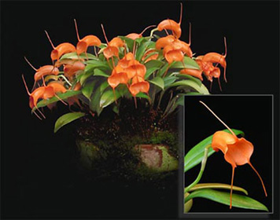

Masdevallia (hirtzii x decumana)
Photography by Ron

Twenty flowers and 2 buds on 22 inflorescences; sepals orange; caudae orange; petals minute, orange; interior of sepaline tube orange; lip minute, orange, sidelobes orange; column orange; substance firm; texture waxy.

Award: AM/AOS, 84 points
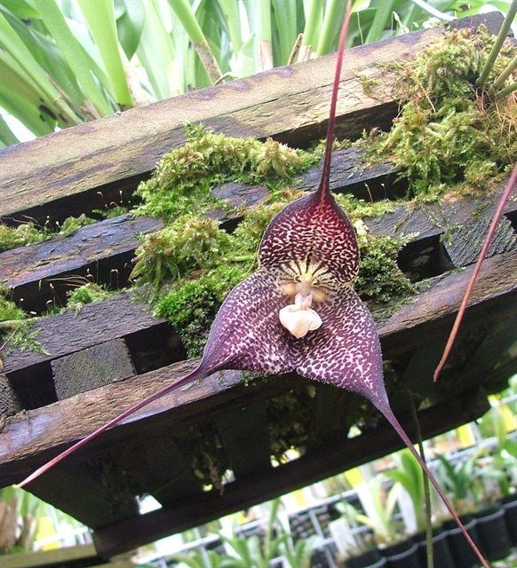

Dracula Transylvania
Photography by O. C. Woolf

Two flowers on two pendent inflorescences; sepals cream, heavily spotted maroon; caudae dark mahogany; petals pink suffused tan; lip pink; column tan; substance firm; texture matte.

Award: AM/AOS, 85 points

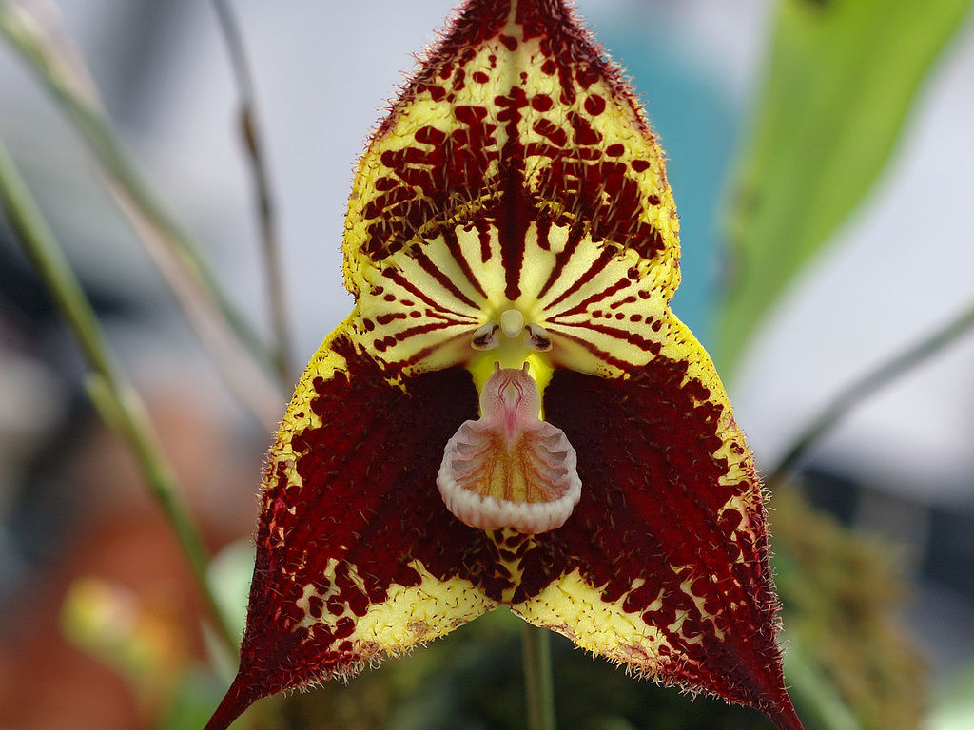

Dracula robledorum
Photography by Eric Hunt

One flower, three buds on four inflorescences; dorsal sepal yellow, striped proximal, spotted central, concentrated spotting distally maroon, pileous maroon, caudae maroon; lateral sepals yellow, concentrated spotting central maroon, pileous maroon, caudae maroon; petals chartreuse, maroon strip; lip pink, interior midline flushed yellow, veined chestnut; column ivory overlaid chartreuse; substance firm; texture matte.

Award: AM/AOS, 84 points
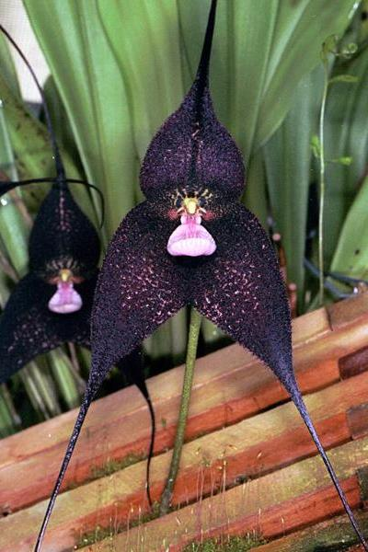

Dracula roezlii
Photography by unknown

Seven flat, full flowers and two buds on nine inflorescences; sepals pink, heavily overlaid spotted English violet, pileous English violet, caudae English violet; lip pink, interior veined magenta; petals pink suffused magenta; column ivory overlaid chartreuse; substance firm; texture velvety.

Award: AM/AOS, 85 points
Horticulture awards are more prevalent for Masdevallia and Dracula genus.

CBR (Certificate of Botanical Recognition)
Awarded to rare and unusual species with educational interest that has received no previous awards. The entire plant must be exhibited. This award is granted provisionally and filed with the judging center Chair pending taxonomic verification.

CHM (Certificate of Horticultural Merit)
Awarded to a well-grown and well-flowered species or natural hybrid with characteristics that contribute to the horticultural aspects of orchidology, such as aesthetic appeal. This award is granted provisionally and filed with the judging center Chair pending taxonomic verification.

CCM (Certificate of Cultural Merit)
Awarded to the exhibitor of a well-flowered specimen plant of robust health. The plant must have been in the care of the exhibitor at least 12 months immediately prior to the award and must score between 80 and 89 points inclusive on a 100-point scale.

CCE (Certificate of Cultural Excellence)
Awarded to the exhibitor of a well-flowered specimen plant of robust health. The plant must have been in the care of the exhibitor at least 12 months immediately prior to the award and must score at least 90 points on a 100-point scale. Plants receiving this award represent the highest level of orchid culture.

Common Award Descriptive Terms

- Caudae – tail or tail-like appendage

- Pileous – small hairs

- sepaline tube – fusion of sepals, resulting in a tube that encases the petals and column.

