Five Sample Descriptions for Catasetum, Cycnoches, Mormodes and Clowesia

- Catasetum pileatum var. semi alba CCE/AOS, 92 points

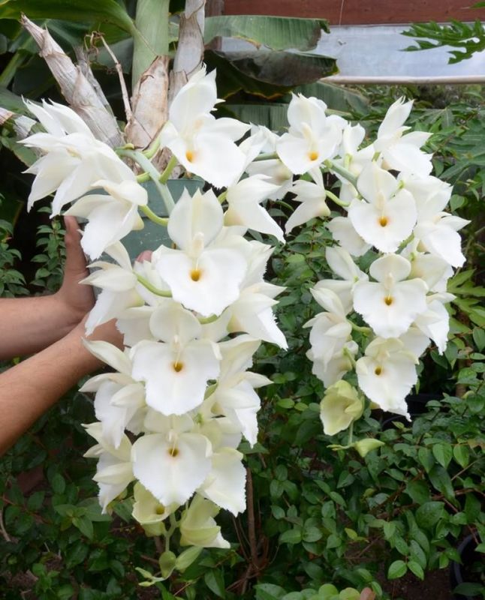

Description
Thirty-eight flowers and six buds on two pendulous inflorescences up to x cm in length; two leafless pseudobulbs and two grown pseudobulbs, leafless bulbs up to x cm tall, foliage dark green; plant grown in six-inch plastic pot; dorsal sepal white, blushed cream; petals porrect, white; lateral sepals white; lip white; column white, anther cap, white; substance firm, texture waxy.

- Cycnoches Swan Cascade AM/AOS, 82 points

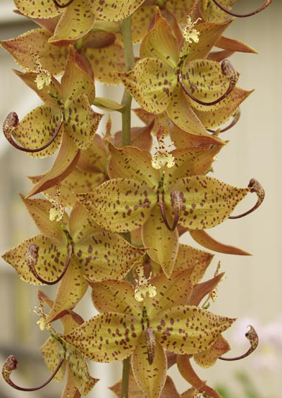

Description
Sixteen flowers and two buds on one pendulous inflorescence x cm long; Sepals and petals chartreuse overlaid raw sienna marginally, irregular maroon spotting, spotting more pronounced on petals; lip yellow, narrow, wings yellow, spotted maroon distally; substance firm; texture matte.

- Mormodes Exotic Treat HCC/AOS, 76 points

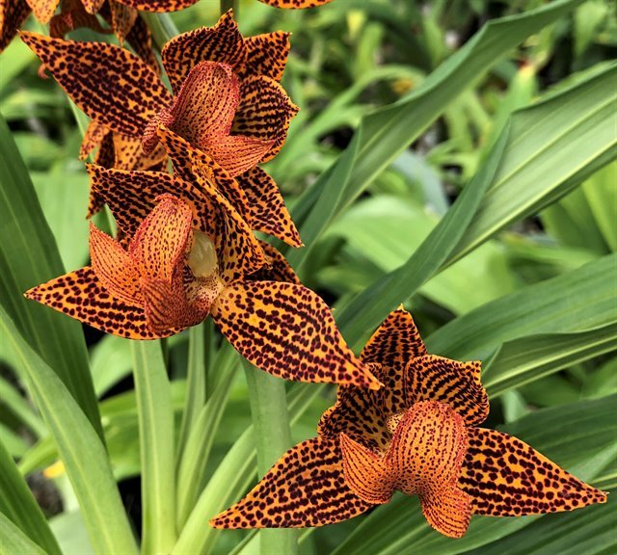

Description
Sixteen flowers on one x cm inflorescence; sepals and petals burnt orange, spotted dark maroon, spots coalesced along veins; petals porrect; lateral sepals recumbent; lip three lobed, burnt orange, lightly spotted dark maroon, spots coalesced along veins; midlobe reflexed toward column; column yellow; substance firm; texture matte.

- Clowesia russelliana HCC/AOS 78 points

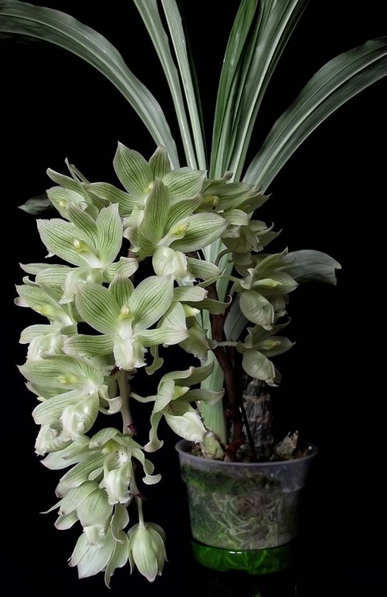

Description

Twenty-two flowers on one pendulous inflorescent x cm; sepals and petals white, overlaid green, striped green longitudinally; lip white, front skirt ruffled; column apple green, anther cap yellow; substance firm; texture matte.

- Cycnoches (Richard Brandon x Martha Clark) AM/AOS, 86 points

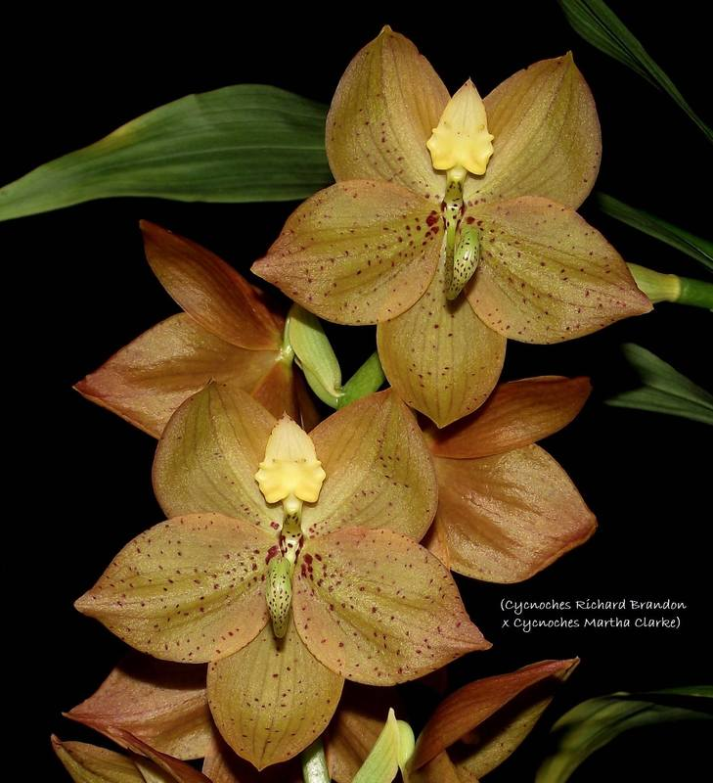

Description
Fifteen resupinate flowers on one x cm inflorescence; dorsal sepal chartreuse overlaid orange, lightly and finely spotted maroon; petals chartreuse, overlaid orange, darker at margins, finely spotted maroon; petals chartreuse, overlaid orange, darker at margins, finely spotted maroon, denser basally; lateral sepals chartreuse, overlaid orange, lighter on inner half, lightly spotting maroon, lip yellow, overlaid peach distally; column foot green, lightly spotted maroon; substance firm; texture matte.

