Clowesia, Catasetum, Cycnoches, and Mormodes are members of the Catastinae subtribe. They are used extensively in hybridizing. Catasetum and Cycnoches are known for producing male, female, and hermaphroditic flowers. They are known for projecting their pollinia at their pollinators, a unique characteristic to this orchid family. Clowesia and Mormodes will produce perfect flowers with both male and female segments.

Clowesetum (Catasetum x Clowesia)
Clowesetum is an artificial genus produced by the breeding of Catasetum with Clowesia. This group of orchids is an interesting breeding combination producing multiple flowers, vigorous growth, and the possibility of flowering two to three times a year. The now triggerless flowers have a flower life that is longer than for pure Catasetums. Presently OrchidWiz notes there are one hundred seventy-five registered Closets.
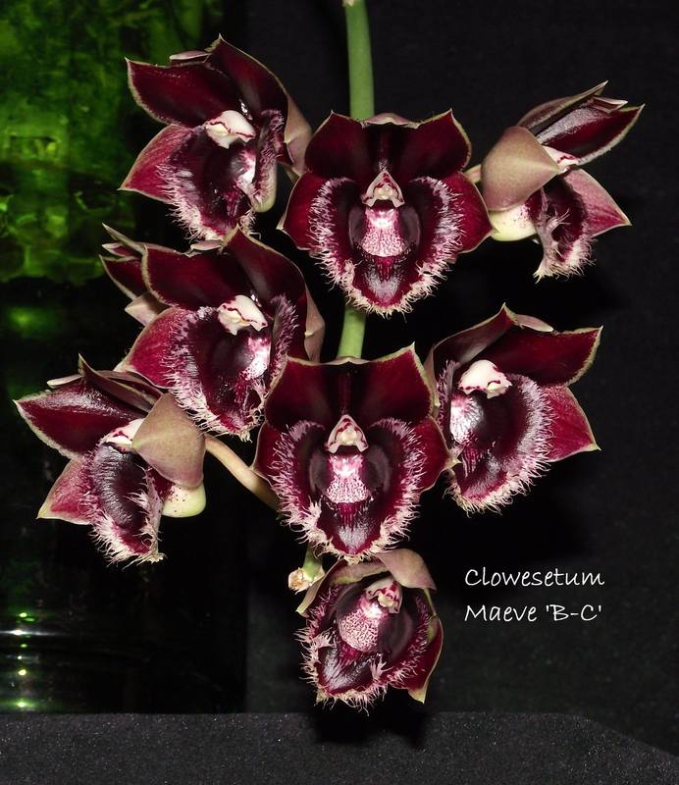
Clowesetum Maeve ‘B-C’
Photography by unknown
The Clowesetum that could be considered the most significant is Clowesetum Raymond Lerner. Clo. Raymond Lerner originated by P. Lerner and was registered by P. Lerner in 1983. Clo. Raymond Lerner holds 19 AOS awards (14 AM; 3 HCC; and 2 CCM). Clo. Raymond Lerner has four offspring and 5 progeny.
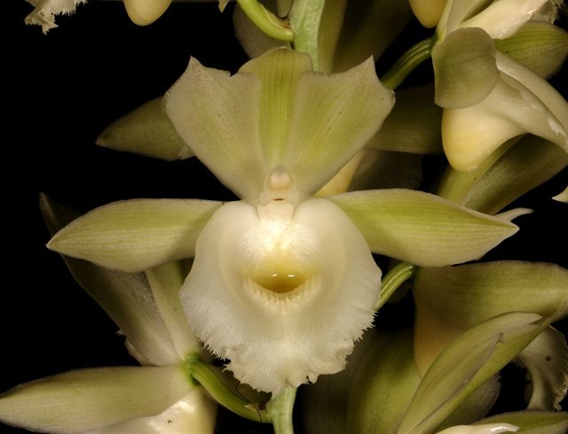
Clowesetum Raymond Lerner ‘Memoria Bret Pressman’ AM/AOS, 86 points, 2021
Photography by Kuligowski

Catamodes (Catasetum x Mormodes)
Catamodes is an artificial and typically smaller grown robust genus produced by breeding of Catsetum and Mormodes. This group of orchids is an interesting breeding combination with members having multiple and more brightly colored flowers, vigorous growth and flowering that may occur two to three times a year. The flower life is improved due to now triggerless flowers, a Mormodes influence compared to what is seen with the shorter lived Catasetum blooms. Catasetums impart these hybrids with greater flower sized and better flower shaped. Presently OrchidWiz notes there are thirty-one registered Catamodes.
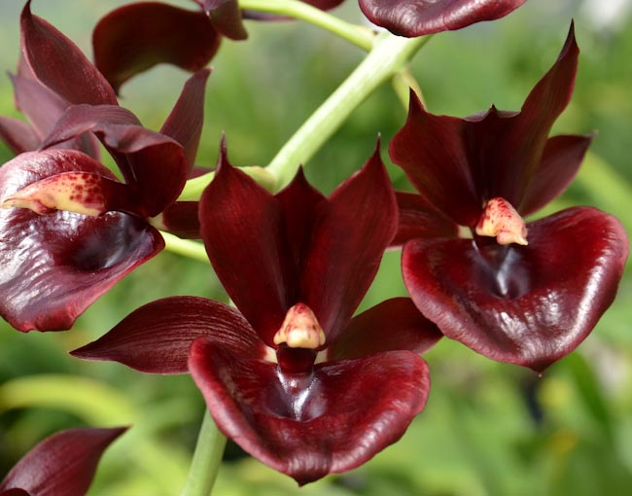
Catamodes Jumbo Riot ‘Sunrise’ HCC/AOS, 76 points, 2010
Photography by Fred Clarke

The Catamodes that could be considered the most significant is Catamodes Painted Desert. Ctmds. Painted Desert originated by JEM Orchids and was registered by Floradise in 1996. Ctmds. Painted Desert holds 7 AOS awards (4 AM; and 4 HCC). Ctmds. Painted Desert has eighteen offspring and seventy-two progeny.
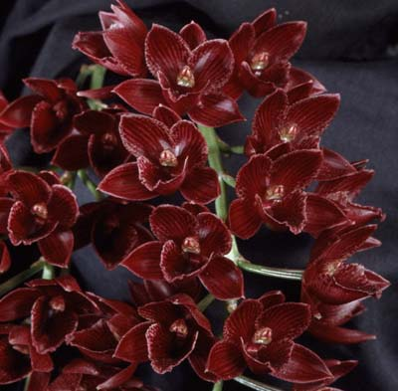
Catamodes Painted Desert ‘SVO’ HCC/AOS, 79 points, 1999
Photography by Fred Clarke
Catanoches (Catasetum x Cycnoches)
Catanoches is an artificial genus produced by the breeding of Catasetum with Cycnoches. This group of orchids is an interesting hybridizing combination producing multiple flowers, vigorous growth, and the possibility of flowering two to three times a year. Typically, their triggerless flowers have a flower life that is longer than for pure Catasetums. Presently OrchidWiz notes there are forty-one registered Catanoches.
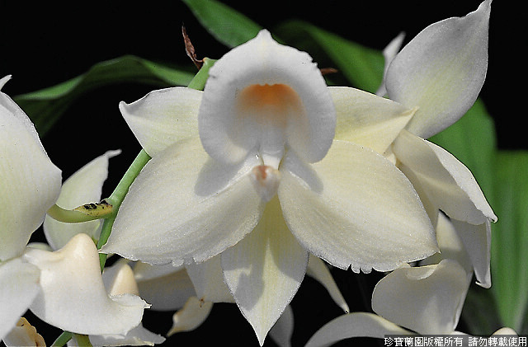
Catanoches Jumbo Chasity
Photography by Jumbo Orchids

The Catanoches that could be considered the most significant is Catanoches Rebecca Northen. Ctnchs. Rebecca Northen originated by W. W. G. Moir and was registered by W. W. G. Moir in 1971. Ctnchs. Rebecca Northen holds 10 AOS awards (3 AM; 2 HCC; 2 CCE; and 3 CCM). Ctnchs. Rebecca Northen has thirty-nine offspring and one hundred ninety-eight-two progeny.

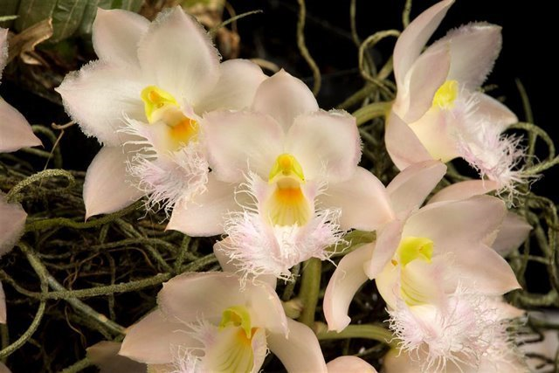
Catanoches Rebecca Northen ‘Beepaw’ AM/AOS, 82 points, 2019
Photography by R. Noel
Cloughara (Catasetum x Clowesia x Cycnoches)
Cloughara is an artificial genus produced by breeding Catasetum and Clowesia and Cycnoches, a three-way cross. This group of orchids is an interesting hybridizing combination producing multiple flowers, vigorous growth, and the possibility of flowering two to three times a year. Typically, their now triggerless flowers have a flower life that is longer than for pure Catasetums. When hybridizing between the three genera, the work is more difficult with lower success rate in germination. Presently OrchidWiz notes there are six registered Cloughara.
Hybridizing that will produce the gens Cloughara:
Catanoches x Clowenoches Clowenoches x Catanoches Clowesetum x Catanoches
Catanoches x Clowesetum Clowenoches x Catasetum Clowesetum x Clowenoches
Catanoches x Clowesia Clowenoches x Clowesetum Clowesetum x Cycnoches

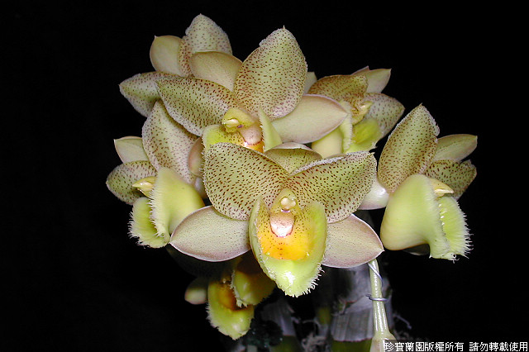
Cloughara Jumbo Pandora
Photography by Jumbo Orchids
There appears not to be a significant Cloughara. Of the six noted registered Cloughara in OrchidWiz, none are noted to have received an AOS award. There are no noted offspring or progeny. Jumbo Orchids has registered five of the six noted registered Cloughara.

Clowenoches (Clowesia x Cycnoches)
Clowenoches is an artificial genus produced by the hybridizing of Clowesia with Cycnoches. This group of orchids is an interesting hybridizing combination producing multiple flowers, vigorous growth, and the possibility of flowering two to three times a year. Typically, their triggerless flowers have a flower life that is longer than for pure Catasetums. Presently OrchidWiz notes there are eleven registered Clowenoches.
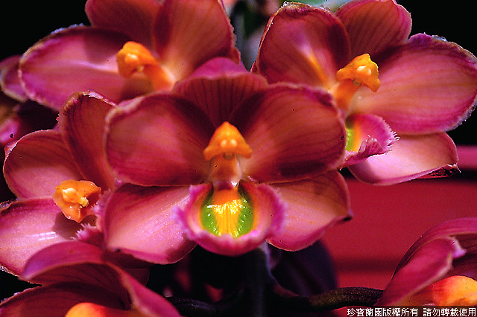
Clowenoches Jumbo Valor
Photography by Jumbo Orchids

The Clowenoches that could be considered the most significant is Clowenoches Rebecca Northen. Clw. Rebecca Northen originated by J. Furrow and was registered by J. Furrow in 1973. Clw. Rebecca Northen holds no AOS awards. Clw. Rebecca Northen has two offspring and three progeny.
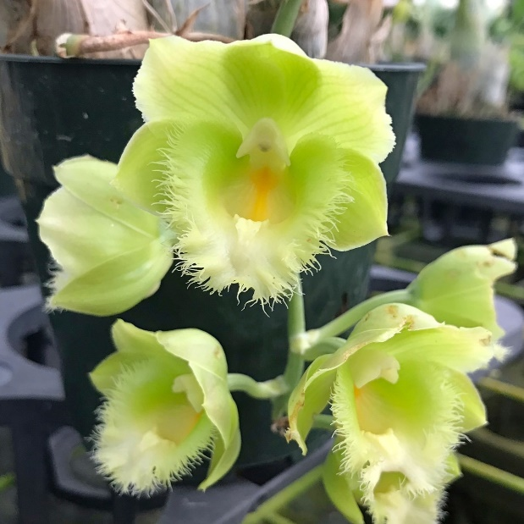
Clowenoches Rebecca Northen, unawarded
Photography by unknown

Cyclodes (Clowesia x Cycnoches x Mormodes)
Cyclodes is an artificial genus produced by hybridizing Clowesia, Cycnoches and Mormodes, a three-way cross. This group of orchids is an interesting hybridizing combination producing multiple flowers, vigorous growth, and the possibility of flowering two to three times a year. Typically, their now triggerless flowers have a flower life that is longer than for pure Catasetum. When hybridizing between three genera, the work is more difficult with lower success rate in germination. Presently OrchidWiz notes there are five registered Cyclodes.
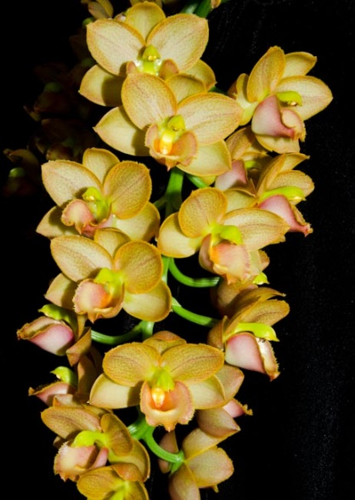
Cyclodes Jumbo Freedom ‘Sunset Valley Orchids’ AM/AOS
Photography by Fred Clarke
The Cyclodes that could be considered the most significant is Cyclodes Jumbo Freedom. Cld. Jumbo Freedom originated by Jumbo Orchids and was registered by Jumbo Orchids in 2006. Cld. Jumbo Freedom holds three AOS awards (2 AM; and 1 CCM). Cld. Jumbo Freedom has two offspring and two progeny.

Cycnodes (Cycnoches x Mormodes)

Cycnodes is an artificial genus produced by hybridizing Cycnoches with Mormodes. This group of orchids is an interesting hybridizing combination producing multiple flowers, vigorous growth, and the possibility of flowering two to three times a year. Typically, their triggerless flowers have a flower life that is longer than for pure Catasetums. Presently OrchidWiz notes there are one hundred two registered Cycnodes.

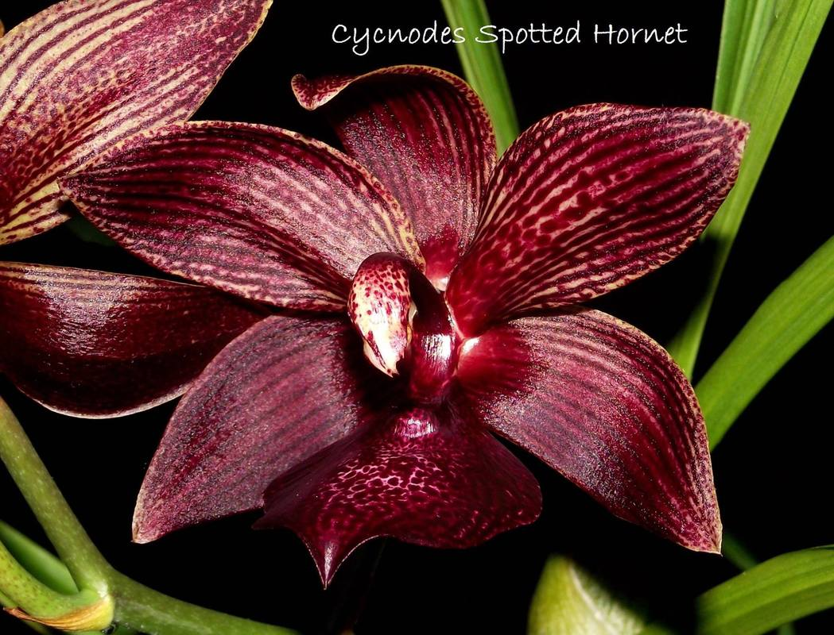
Cycnodes Spotted Hornet
Photography by unknown

There are two Cycnodes that could be considered the significant. The first is Cycnodes Taiwan Gold. Cycd. Taiwan Gold originated by Orchids Floricultural Incorporated was registered by Orchids Floricultural Incorporated in 2004. Cycd. Taiwan Gold holds ten AOS awards (5 AM; 3 HCC; and 2 CCM). Cycd. Taiwan Gold has five offspring and six progeny.
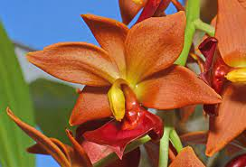
Cycnodes Taiwan Gold ‘Orange,’ unawarded
Photography by David Peterson
The second Cycnodes that could be of significant is Cycnodes Wine Delight. Cycd. Wine Delight originated by F. J. Fuchs, Jr. and was registered by R. Coffman in 1980. Cycd. Wine Delight holds fourteen AOS awards (6 AM; 1 HCC; 1 FCC; 5 CCM and 1 JC). Cycd. Wine Delight has ten offspring and thirteen progeny.
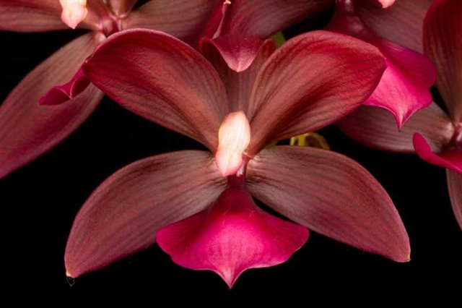
Cycnodes Wine Delight ‘Coo Chan’ HCC/AOS, 78 points, 2017
Photography by R. Noel
Fredclarkeara (Catasetum x Clowesia x Mormodes)

Fredclarkeara is an artificial genus produced by hybridizing Catasetum, Clowesia and Mormodes, a three-way cross. This group of orchids is again an interesting hybridizing combination producing multiple flowers, vigorous growth, and the possibility of flowering three to four times a year. Typically, their now triggerless flowers have a flower life that is longer than for pure Catasetums, some up to six weeks. When hybridizing between three genera, the work is more difficult with lower success rate in germination. Presently OrchidWiz notes there are eighty-seven registered Fredclarkearas.

Hybridizing that will produce the genus Fredclarkeara:

Catamodes x Clowesia Clowesetum x Catamodes Mormodia x Catamodes
Catamodes x Clowesetum Clowesetum x Mormodes Mormodia x Catasetum
Catamodes x Mormodia Clowesetum x Mormodia Mormodia x Clowesetum

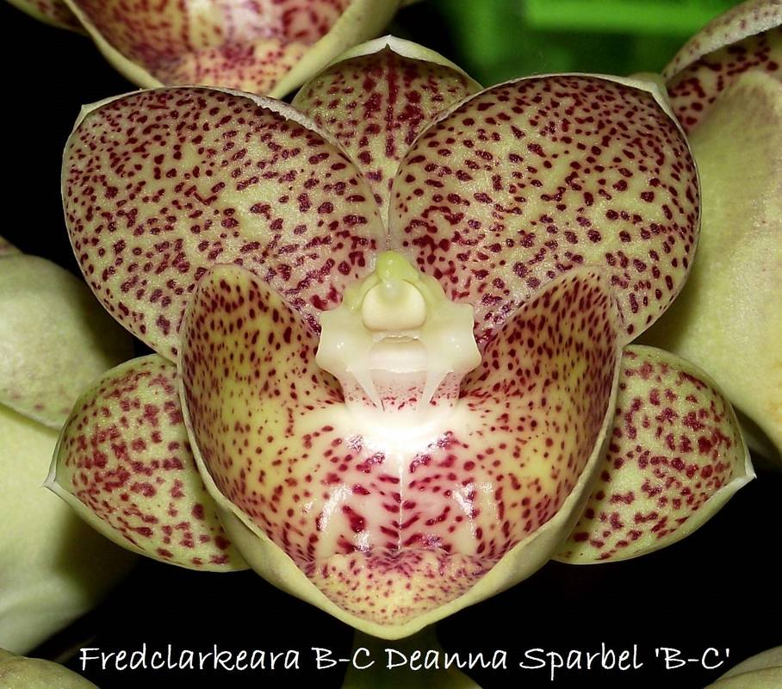
Fredclarkeara B-C Deanna Sparbel ‘B-C’

The Fredclarkeara that could be considered the most significant is Fredclarkeara After Dark. Fdk. After Dark originated by Fred Clarke and was registered by Fred Clarke in 2002. Fdk. After Dark holds fifty-seven AOS awards (31 AM; 7 HCC; 9 FCC; 1 AD; 7 CCE; and 2 CCM). Cld. Jumbo Freedom has eighteen offspring and thirty-two progeny.
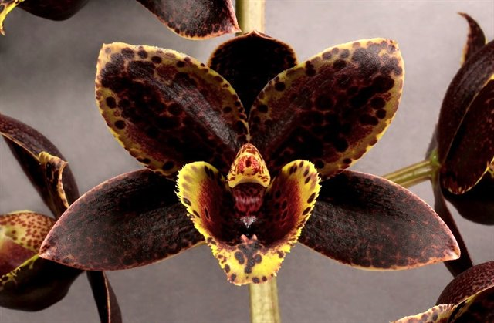
Fredclarkeara After Dark ‘Red Hawk’ HCC/AOS, 94 points, 2015
Photography by Kuligowski

Georgecarrara (Catasetum x Clowesia x Cycnoches x Mormodes)

Georgecarrara is an artificial genus produced by hybridizing Catasetum, Clowesia, Cycnoches, and Mormodes, a four-way cross. This group of orchids are an interesting hybridizing combination producing multiple flowers, vigorous growth, and the possibility of flowering two to three times a year. Typically, their no triggerless flowers have a flower life that is longer than for pure Catasetums. When hybridizing between four genera, the work is more difficult with lower success rate in germination. Presently OrchidWiz notes there are ten registered Georgecarraras.

Hybridizing that will produce Georgecarrara:

Catamodes x Cloughara Cloughara x Cycnodes Clowesetum x Cycnodes
Catamodes x Clownoches Cloughara x Fredclarkeara Clowesetum x Monnierara
Catamodes x Cyclodes Cloughara x Monnierara Clowesia x Monnierara
Catanoches x Cyclodes Cloughara x Mormodes Cyclodes x Fredclarkeara
Catanoches x Fredclarkeara Cloughara x Mormodia Cyclodes x Monnierara
Catanoches x Mormodia Clowenoches x Fredclarkeara Cycnoches x Fredclarkeara
Catasetum x Cyclodes Clowenoches x Monnierara Cycnodes x Fredclarkeara
Cloughara x Cyclodes Clowesetum x Cyclodes Fredclareara x Monnierara
Monnierara x Mormodia

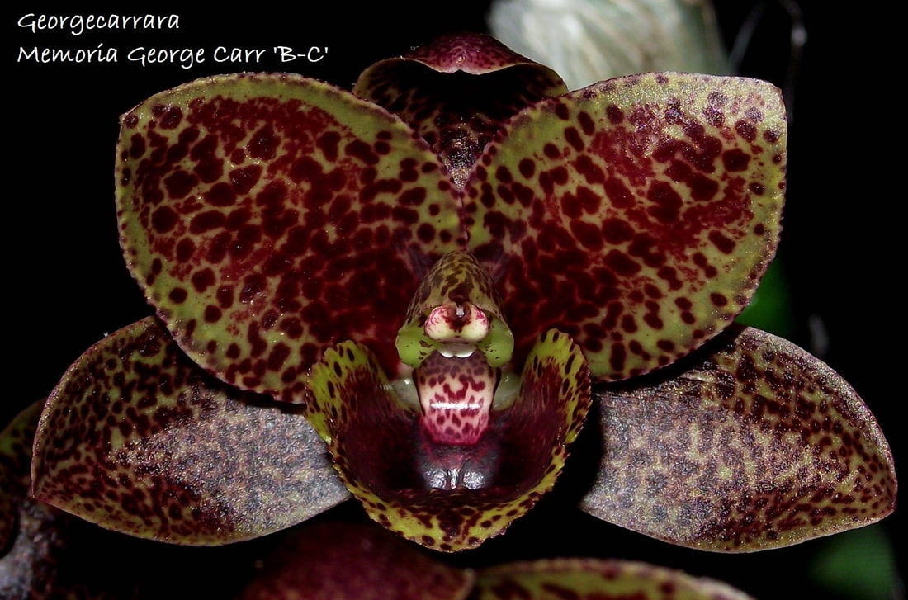
Georgecarrara Memoria George Carr ‘B-C,’ AD/AOS, 2018
Photography by unknown

Of the six registered Georgecarrara only one cross, Georgecarrara Memoria George Carr that has an award (1 AD). Georgecarrara is the only cross with one offspring and one progeny.

Monnierara (Catasetum x Cycnoches x Mormodes)

Monnierara is an artificial genus produced by hybridizing Catasetum, Cycnoches, and Mormodes, a three-way cross. This group of orchids is an interesting hybridizing combination producing multiple flowers, vigorous growth, and the possibility of flowering two to three times a year. Typically, their no triggerless flowers have a flower life that is longer than for pure Catasetum. When hybridizing between three genera, the work is more difficult with lower success rate in germination. Presently OrchidWiz notes there are fifteen registered Monnieraras.

Hybridizing that will produce the genus Monnierara:

Catamodes x Catanoches Catanoches x Catamodes Cycnodes x Catamodes
Catamodes x Cycnoches Catanoches x Cycnodes Cycnodes x Catanoches
Catamodes x Cycnodes Catanoches x Mormodes Cycnodes x Catasetum

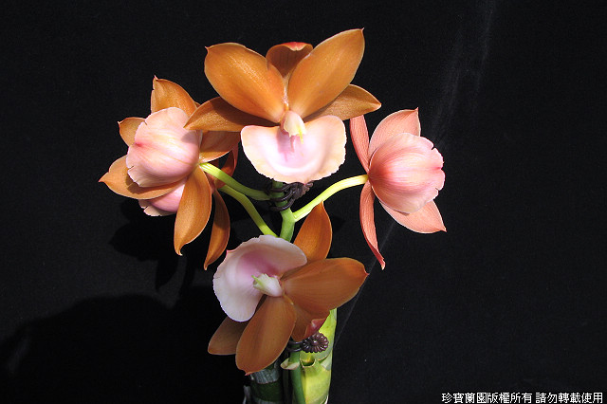
Monnierara Jumbo Delight
Photography by Jumbo Orchids

The Monnierara that could be considered the most significant is Monnierara Millennium Magic. Monn. Millennium Magic originated by G. Monnier and was registered by L. Sanford in 1999. Monn. Millennium Magic holds four AOS awards (1 AM; 2 FCC; and 1 CCE). Monn. Millennium Magic has no known offspring or progeny.
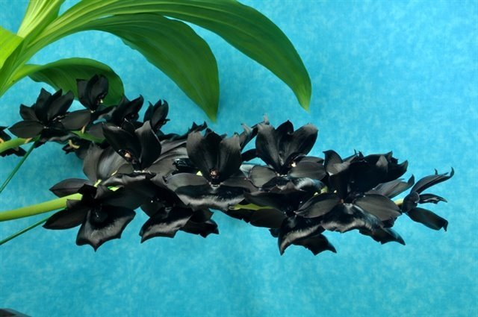
Monnierara Millennium Magic ‘Witchcraft’ FCC/AOS, 90 points, 2013
Photography by G. Barfield

Mormodia (Closesia x Mormodes)

Mormodia is an artificial genus produced by hybridizing Clowesia with Mormodes. This group of orchids is an interesting hybridizing combination producing multiple flowers, vigorous growth, and the possibility of flowering two to three times a year. Typically, their now triggerless flowers have a flower life that tis longer than for the pure Catasetum. Presently OrchidWiz notes are forty-one registered Mormodias.

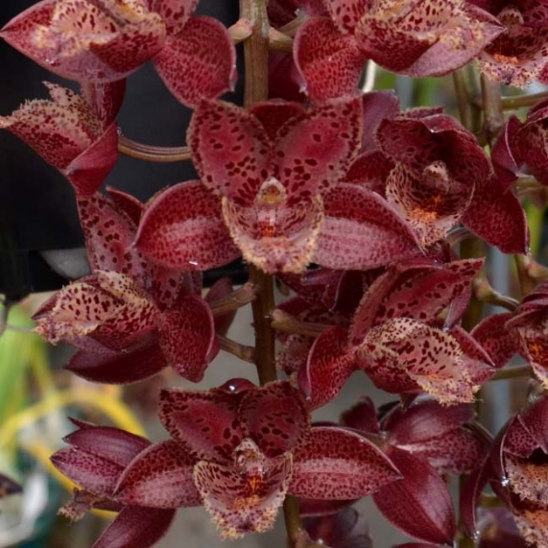
Mormodia Leopard Drops ‘Sunset Valley Orchids’ AM/AOS
Photography by Fred Clarke
The Mormodia that could be considered the most significant is Mormodia Painted Desert. Mo. Painted Desert originated by JEM Orchids and was registered by Floradise in 1996. Mo. Painted Desert holds four AOS awards (4 AM; and 3 HCC). Mo. Painted Desert has eighteen offspring and seventy-two progeny. This may be an error as OrchidWiz has the same information for Catamodes Painted Desert.

Because of the apparent confusion of the genus, Mormodia or Catamodes for Painted Desert, the next significant Mormodia is Mormodia Jumbo Ruby. Mo. Jumbo Ruby originated by Jumbo Orchids and was registered by Jumbo Orchids in 1996. Mo. Jumbo Ruby holds four AOS awards (2 AM; and 2 HCC). Mo. Jumbo Ruby has four offspring and four progeny.

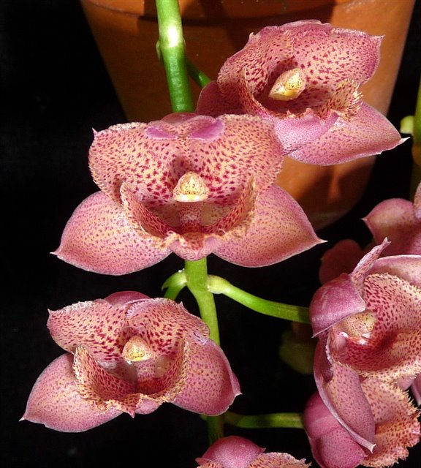
Mormodia Jumbo Ruby, unawarded
Photography by Dr. Thomas Ott

References

Alien, P. 1952. The swan orchids: a revision of the genus Cycnoches, The Orchid Journal, volume 1, issue 7,8, page 273.

American Orchid Society. 2023. Catasetum Culture Sheet. On-line: https://www.aos.org/orchids/culture-sheets/catasetum.aspx .

Batchelor, S. 1983. Catasetum and Cynoches: the hydras of Cycnoches. American Orchid Society.

Catasetinae Canada. 2013. Your Catasetinae orchid collection. On-line: https://catasetinaecanada.weebly.com/ .

Dodson, C. 1975. Dressleria and Clowesia: A new genus and an old one revived in the Catasetinae. Selbvana, volume 1, issue 2, page 30.

Milet-Pinheiro, P. and Gerlach, G. 2017. Biology of the Neotropical orchid genus Catasetum: A historical review on floral scent chemistry and pollinators. Perspectives in Plant Ecology, Evolution and Systematics, volume 27, pages 23 – 34.

Napa Valley Orchid Society. 2023. Welcome to the Clowesetum. On-line:
http://nv-os.org/index.php/the-potting-bench/culture-information/cymbidiums/catasetinae/clowesetum .

Romero, G. 1992. Non-functional flowers in Catasetum orchids. Botanical Journal of Linnean Society, volume 109, issue 2, pages 305 – 313.

Romero, G. and Nelson, C. 1986. Sexual dimorphism in Catasetum orchids: Forcible pollen emplacement and male flower competition, Science, volume 232, issue 4757, pages 1538 – 1540.

