Species Data Sheet

Catasetum (Ctsm.) denticulatum (F.E. L. Miranda), Lindleyana 1: 152 (1986)
[kat-a-SEE-tum den-tick-yoo-LAH-tum]

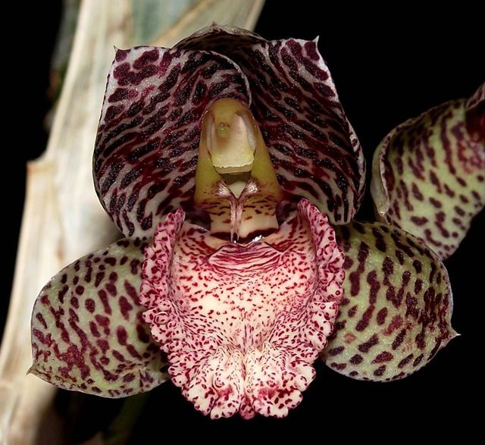
Catasetum denticulatum, photography by Bernie Butts and C. Lefaive

General Information

Found in Rondônia state of Brazil in Amazonian rain forest at elevations of 100 to 300 meters as a medium sized, hot growing epiphyte with clustered fusiform pseudobulbs that are enveloped basally by several deciduous leaf sheaths and carries 5 to 10, plicate, arched, oblanceolate leaves that blooms in the late spring and early summer on a basal, erect to suberect, several flowered, racemose inflorescence arising basally on a new pseudobulb lead.

Found in Brazil in the State of Rondônia near Ji-Paraná at 500 ft. (160 m). The plant was growing epiphytically in a dead tree located on land being used as a coffee plantation. -- Source: Charles Baker

PLANT SIZE AND TYPE: A rather large, up to 17 in. (42 cm) tall sympodial epiphyte with thick, fleshy roots.

PSEUDOBULB/STEM: Up to 7 in. (17 cm) tall by 1.6 in. (4 cm) wide. The clustered pseudobulbs are elliptic to spindle shaped.

LEAVES: Up to 10 in. (25 cm) long by 1.7 in. (4.3 cm) wide. About 6 linear-lanceolate leaves are carried on each pseudobulb. They are medium green with 3 prominent longitudinal nerves.

INFLORESCENCE: Male inflorescences are up to 8 in. (20 cm) long on adult plants but may be only about 3 in. (8 cm) long on young plants. The peduncle is up to 0.1 in. (0.3 cm) in diameter. Flowers are clustered in a raceme on the apical two-thirds of the spike, each one with a pedicel that is about 0.4 in. (0.9 cm) long. The flower spike emerges from the base of a new growth not long after the leaf shoot appears.

FLOWERS: 5-15 per inflorescence. Usually, the male flowers have rose-colored sepals and petals that are marked with many rather small dark red, irregularly shaped spots. The petals have fewer but somewhat larger spots than the sepals. The lip is orange-rose with fine dark red spotting, and the antennae at the base of the column are pale rose. Flower color in this species may vary considerably, however, and clones without spots are known to exist. The flowers are somewhat cup-shaped with broadly lanceolate to egg-shaped sepals and petals that curve forward above and on each side of the column, flaring outward only near their sharply pointed tips. The concave dorsal sepal is about 0.8 in. (2 cm) long by 0.3 in. (0.7 cm) wide and, except for its tip, is hidden behind the slightly convex petals that are 0.9 in. (2.2 cm) long by 0.4 in. (1.1 cm) wide. The petals rise somewhat obliquely in front of the dorsal sepal and overlap for most of their length, hiding the dorsal sepal except for a short section near its apex. The dorsal sepal and the petals curve forward from the base to be held rather hoodlike over the column. The concave lateral sepals are about 0.8 in. (2 cm) long by 0.5 in. (1.3 cm) wide and spread horizontally at the base but curve forward along their length so that their apical part points forward on each side of the column. The lip is 0.8 in. (2 cm) long by 0.6 in. (1.5 cm) wide. It is concave to somewhat troughlike with unevenly serrated margins that curve upward along most of its length but curve downward near the apex. There is an almost trapezoidal callus near the base. The column is 0.5 in. (1.3 cm) long by 0.2 in. (0.6 cm) wide with a beaked anther. There is a pair of antennae on the column that converge and then become parallel and are about 0.2 in. (0.6 cm) long.

Native: Bolivia and North Brazil

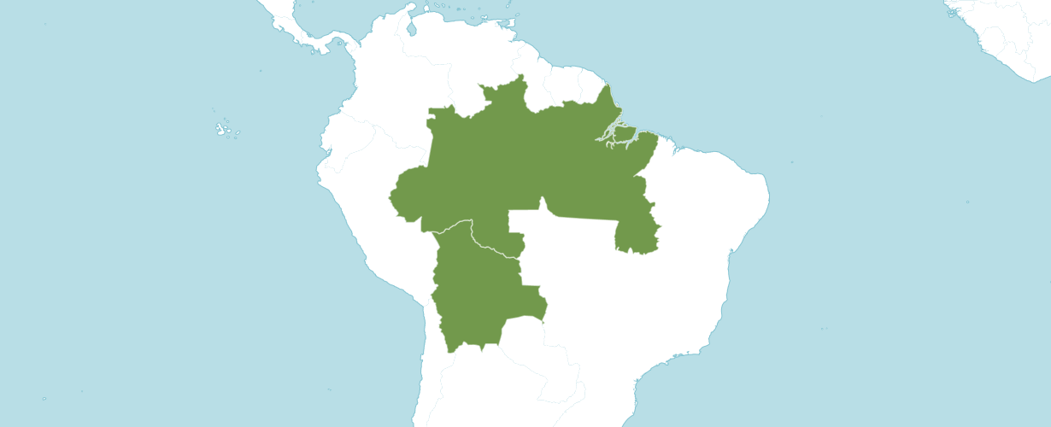
Distribution of Catasetum denticulatum from Kew

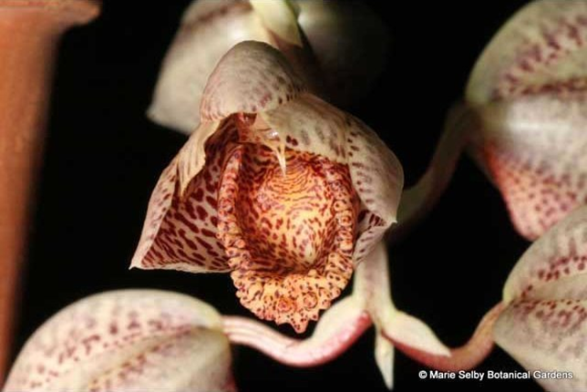
Catasetum denticulatum ‘Sunset Valley Orchids’ AM/AOS, 80 points, 2003,
photography by Phil Nelson, MD
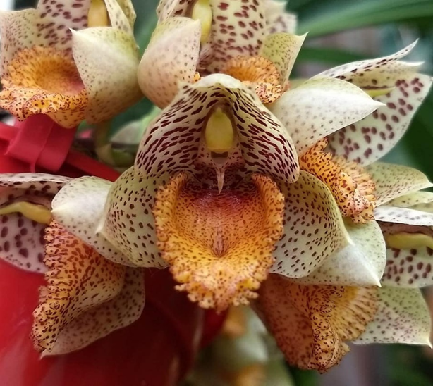
Catasetum denticulatum – male flower, photography by Tulio Kengi Malaspina

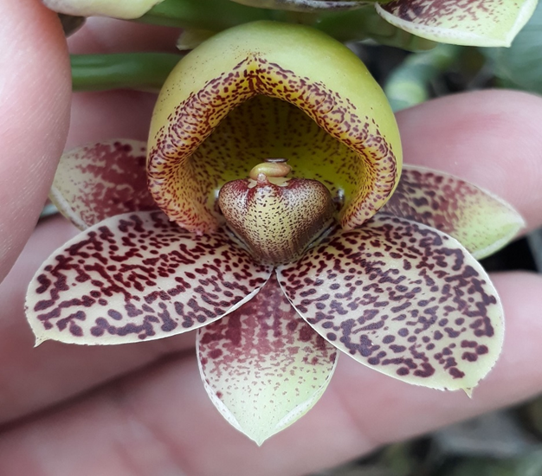
Catasetum denticulatum – female flower, photography by Jânio Araújo Catasetum
Synonyms:
None noted.
Varieties / forms:
None noted.
Awards:
Catasetum denticulatum has received three AOS awards, see table below for details.
 | FCC | AM | HCC | AQ | JC | CCM | CCE | CHM | CBM | Total
AOS | - | 2 | - | - | - | - | - | 1 | - | 3
Year(s) Awarded | - | 2003-2008 | - | - | - | - | - | 1997 | - | -

Hybrids
Ctsm. denticulatum has 58 F1 offspring and 136 progeny. All offspring have been registered since 1996. Of the 58 F1 crosses 16 or 27.6% were awarded. Ctsm. denticulatum was used 14 times as the seed parent and 44 times as the pollen parent.

Major Hybrids:
Catasetum Melana Davison (Ctsm. denticulatum x Ctsm. Penang), has 10 F1 offspring. Catasetum Melana Davison has been used 7 times as the see parent and 3 times as the pollen parent. Catasetum Melana Davison’s offspring, the intergeneric hybrid Clowesetum Melana’s Daughter (Ctsm. Melana Davison x Clw. Rebecca Northern) was originated by Fred Clark; has received 5 awards (AM -4; and FCC -1).
Between 2014 and 2021, Catasetum Melana Davison has 11 awards (AM – 10; and HCC -1).

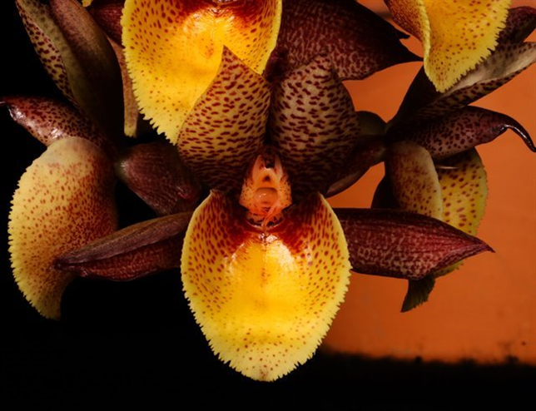
Catasetum Melana Davison ‘Nicola’ AM/AOS, 81 points, 2020,
photography by Richard Fulford
Catasetum Karen Armstrong (Ctsm. denticulatum x Ctsm. Susan Fuchs), has 23 F1 offspring and a total of 36 progeny. The originator of Catasetum Karen Armstrong was Fred Clarke. The hybrid was registered by K. Armstrong. Catasetum Karen Armstrong offspring, Catasetum Dark Odyssey (Ctsm. Karen Armstrong x Ctsm Darkness) was originated by Fred Clarke and registered by Fred Clarke.
Between 2011 and 2021, Catasetum Karen Armstrong has 8 awards (AM – 2; and HCC – 6).
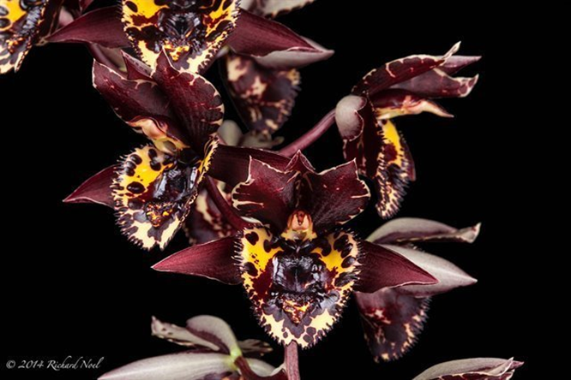
Catasetum Karen Armstrong ‘Jordan’s Chocolate Sunday’ HCC/AOS; 78 points; 2014 – photography by Richard Noel
References
Baker, C. 2023. Charles Baker culture sheet. Online: www.orchidculture.com.

Hills, H. 1995. Culture of Catasetinae, Schlechter. hhills@iastate.edu.
Holst, A. 1999. The World of Catasetums. Timber Press, Portland, Oregon.
Lindleyana, 1(3): 148-157. (1986)
Romero, G. & Jenny, R. 2001. Contributions toward a monograph of Catasetum (Catasetinae, Orchidaceae)

