Species Data Sheet

Clowesia rosea
[klo-wes-ee-ah ROH-zee-ah]

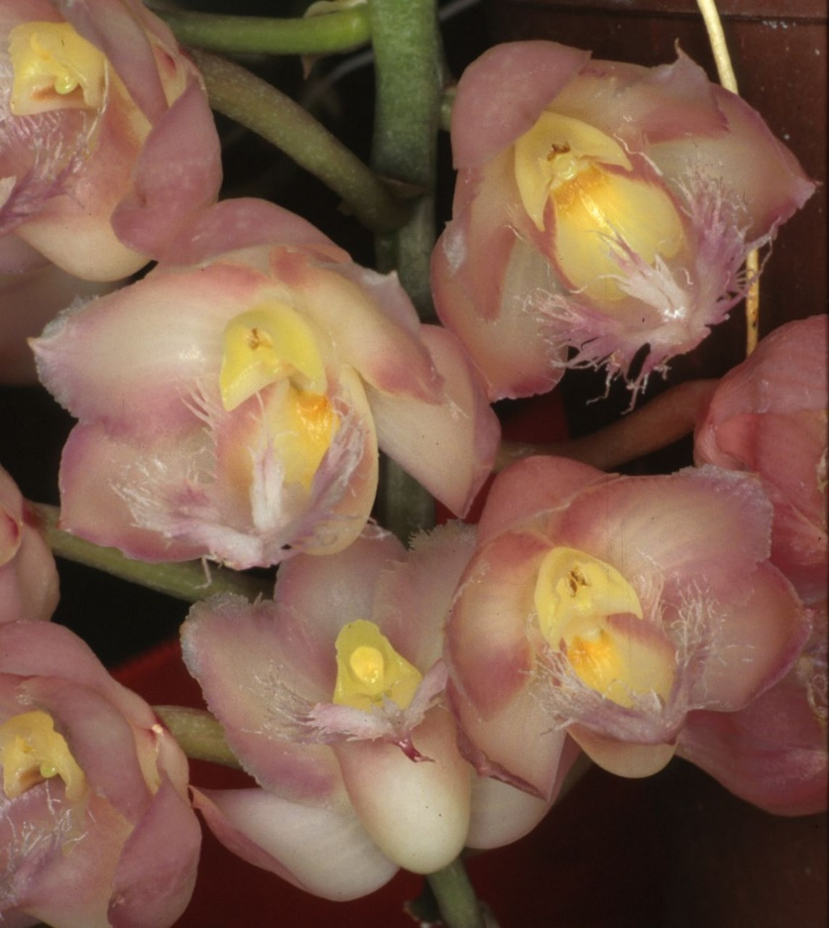
Clowesia rosea, photography by Lorens Grobler

General Information

PLANT SIZE AND TYPE: A 7-18 in. (18-46 cm) sympodial epiphyte. These plants, while very similar vegetatively to Catasetum, have bisexual flowers instead of the male or female blossoms normally found in Catasetum species.

PSEUDOBULB: 1.6-2.4 in. (4-6 cm) long, but occasionally growing to 4 in. (10 cm) tall. They are 0.6-1.0 in. (1.5-2.5 cm) thick at the base but taper to a relatively sharp point at the tip. The conical pseudobulbs have several nodes which are concealed by grayish overlapping sheaths. The tops of these sheaths bear flat, triangular apical spines 0.1-0.3 in. (0.2-0.7 cm) long after the leaves fall.

LEAVES: 6-16 in. (15-40 cm) long. 4-5 thin, heavily veined, deciduous leaves, sometimes even more, are carried on the upper part of each pseudobulb. The blades are 1.2-2.4 in. (3-6 cm) wide but taper to a sharp point at the tip. They narrow gradually toward the base and are attached to the pseudobulb at a joint when they are only 0.1-0.3 in. (0.3-0.8 cm) wide.

INFLORESCENCE: 3.5-4.7 in. (9-12 cm) long. The pendent inflorescence is produced from the basal nodes of the most recently matured pseudobulbs, which have usually lost their leaves by the time flowering occurs. Plants may sometimes bloom before the leaves have dropped, however. Well grown, healthy plants may produce more than one inflorescence from each pseudobulb.

FLOWERS: 6-7 pleasantly fragrant blossoms are normally carried on each 1.2-3.1 in. (3.8 cm) raceme, but as many as 15 have been recorded. The bell-shaped flowers vary from deep rose pink to light pink. The flower parts are usually lightly colored at the base, with darker colors appearing at the tips. The sepals and petals all spread rather widely at their bases but then curve to point forward at their sharply pointed tips to form the cup-like flowers. The elliptic, boat-shaped dorsal sepal is about 0.7 in. (1.7 cm) long and 0.3 in. (0.8 cm) wide. The lateral sepals are about 0.8 in (2 cm) long and are also about 0.3 in. (0.8 cm) wide. They are connected to each other at the base for a short distance to form a mentum (projection) that is about 0.1 in. (0.2 cm) wide. The elliptic to egg-shaped petals are also about 0.7 in. (1.8 cm) long but are 0.5 in. (1.2 cm) wide, which is somewhat wider than the sepals. The transparent or translucent margins are irregularly notched and appear to be narrowly incised or slashed for a short distance in from the edge. The 0.7-0.8 in. (1.7-2.0 cm) long lip is obscurely 3-lobed and is egg-shaped in outline when flattened. It is almost 0.8 in. (2 cm) wide including the tips of the long marginal cilia (or hair-like projections) which are abundant on the small lateral lobes and especially on the terminal lobe as well as the callus in the apical region. The green column has a yellow spot at the base. It is 0.3-0.4 in. (0.8-0.9 cm) long and has a pair of wing-like projections at the tip. The pale, irregularly notched terminal appendage is about 0.1 in. (0.3 cm) long.

ORIGIN/HABITAT: This species is known to occur in southwestern Mexico and has been reported from locations in Central America and South America to as far south as Brazil. Modern writers, however, question its occurrence outside of Mexico where plants have been collected on the Pacific-facing slopes of the mountains in the States of Michoacan and Oaxaca. They grow on trees in seasonally dry oak or tropical deciduous forests at 1650-4250 ft. (500-1300 m).

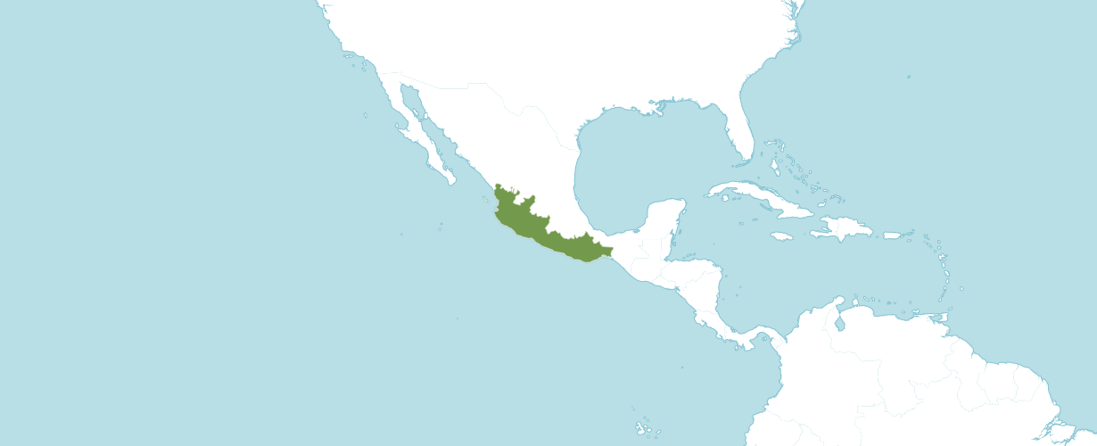
Distribution Southwest Mexico from Kew

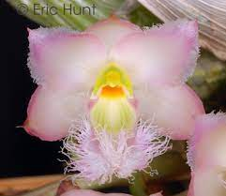
Clowesia rosea, unawarded, photography by Eric Hunt (permission to use
photograph provided by photographer)

Awards:
Clowesia rosea has seven AOS awards. See table below.
 | FCC | AM | HCC | AQ | JC | CCM | CCE | CHM | CBM | Total
AOS |  |  |  |  |  | 6 |  |  | 1 | 7
Year(s) Awarded |  |  |  |  |  | 1971 - 2006 |  |  | 1958

Clowesia has 12 F1 offspring and 264 progeny. All offspring have been registered between 1959 and 2021. Clowesia rosea was used 7 times as the seed parent and 5 times as the pollen parent.

Of the 12 F1 crosses seven or 58.3% have been awarded.
G | Grexes | Awarded | % Awarded | Awards
1 | 12 | 7 | 58.3% | 54
2 | 86 | 40 | 46.5% | 125
3 | 88 | 27 | 30.7% | 138
4 | 59 | 13 | 22% | 37
5 | 19 | 2 | 10.5% | 4

Major Hybrids:
Clowesia Rebecca Northern (Cl. rosea x Cl. Grace Dunn) originated by W. W. G. Moir and registered by W. W. G. Moir in 1971. Clowesia Rebecca Northern has 39 offspring and 198 total progeny. Clowesia Rebecca Northern has 10 awards (AM – 3; HCC – 2; CCE – 2; and CCM – 3).

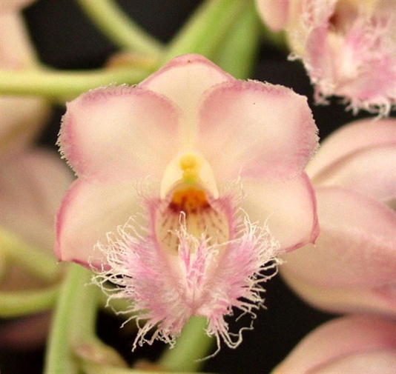
Clowesia Rebecca Northern ‘Grapefruit Pink’ CCM/AOS, 82 points; 2022,
photography by Fred Clarke

Clowesia Grace Dunn (Cl. rosea x Cl. warczewiczii) was originated by W. W. G. Moir and registered by W. W. G. Moir in 1959. Clowesia Grace Dunn has 9 awards (AM – 3; HCC – 1; CCE – 1; and CCM – 4).

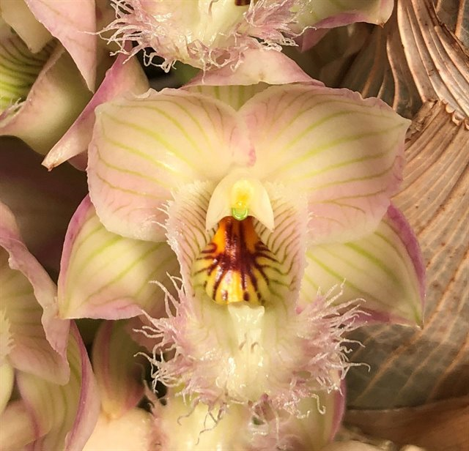
Clowesia Grace Dunn ‘Live Oak’ HCC/AOS, 77 points; 2003,
photography by Fred Clarke
Webinar: Catasetums: Growing and Loving
By Fred Clarke
Summary
- Wait to irrigate until new roots ae 3 – 8” long.
- Well drained potting media.
- When in active growth, water and fertilize frequently.
- Scout for insects early, treat accordingly.
- Reduce irrigation when leaves begin to yellow.
- Stop watering when bulbs are leafless.
- Dimorphic
Re-pot and divide when new roots begin.

References

American Orchid Society. 2023. Catasetum. On-line: https://www.aos.org/orchids/orchids-a-to-z/letter-c/catasetum.aspx .

American Orchid Society. 2006. Kew Monocot list, Icones Orchidacearum Brasilenses Vol I Plate 042 Castro & Campacci 2000; AOS Bulletin Vol 77 No 11.

American Orchid Society 2023. Mormodes. On-line: https://www.aos.org/orchids/orchids-a-to-z/letter-m/mormodes.aspx

Ames, O. and D. Correll. [(1952-1953, and 1965) 1985]. Orchids of Guatemala and Belize. Dover Publications, New York. Originally in Fieldiana 26(1 and 2) and 31(7).

Batchelor, S. R. 1983. Catasetum and Cycnoches - Part 1 - Catasetums with "Perfect" flowers. American Orchid Society Bulletin 52(6):605.

Bechtel, H., P. Cribb, and E. Launert. 1980. Manual of cultivated orchid species. MIT Press, Cambridge, Mass.

Dunsterville, G., and L. Garay. 1959. Venezuelan Orchids Illustrated vol. 1. Orchid Herbarium of Oakes Ames, Botanical Museum , Cambridge, Mass.

Dunsterville, G., and L. Garay. 1965. Venezuelan orchids illustrated, vol. 3. Orchid Herbarium of Oakes Ames, Botanical Museum, Harvard University, Cambridge, Mass.

Dunsterville, G., and L. Garay. 1979. Orchids of Venezuela: an illustrated field guide. Orchid Herbarium of Oakes Ames, Botanical Museum, Harvard University, Cambridge, Mass.

Foldats, E. 1969-1970. Flora of Venezuela —Orchidaceae vol. 15, parts 1-6. Instituto Botanico, Direcceion de recursos Naturales Renovables. Ministerio De Agricultura y Cria, Caracas.

Gen. et Sp. Orch. 156. 1832. Cogniaux, A. (1893–1906) 1975. Martii, Flora Brasiliensis-Orchidaceae plates for vol. I–3, parts 4–6. Otto Koeltz Science Publishers, D-624 Koenigstein, West Germany.

Hamilton, R. 1988. When does it flower? 2nd ed. Robert M. Hamilton, 9211 Beckwith Road, Richmond, B. C., Canada V6X 1V7.

Hawkes, A. [1965] 1987. Encyclopaedia of cultivated orchids. Faber and Faber, London.

Hills, H. G. 1995. Culture of Catasetinae, Schlechter. hhills@iastate.edu.

Holst, A. 1999. The World of Catasetums. Timber Press, Portland, Oregon.

Kew Data Base. 2008. http.//apps.kew.org/wcsp/home.do

McQueen, J., and B. McQueen. 1993. Orchids of Brazil. Timber Press, Portland, OR.

McVaugh, R. (1985) 1989. Orchidaceae in Flora Novo-Galiciana vol. 16, a descriptive account of the vascular plants of western México. Ed. W. R. Anderson. University of Michigan Press, Ann Arbor, Michigan, U. S. A.

OrchidsPlus. 1.4

OrchidWiz. 2022. OrchidWiz X9.1. Orchid Wiz.
Pabst, G., and F. Dungs. 1975-1977. Orchidaceae Brazilienses, book 1-2. Brücke-Verkag Kurt Schmersow, Hildesheim, Germany.

Paget, F. 1995. Catasetum Culture. The newsletter of the Oregon orchid society March 1995.

Pridgeon, A. ed. 1992. The illustrated encyclopedia of orchids. Timber Press, Portland, OR.

Romero, G. and R. Jenny. 10/20/01. Contributions toward a monograph of Catesetum (Catasetinae, Orchidaceae) 1. A checklist of species, varieties, and natural hybrids. http://www.herbaria.harvard.edu/ Publications/catdbase1.html. PHOTOS/DRAWINGS:
Edwards's Bot. Reg. 30: Misc. 38. 1844.

Schweinfurth, C. 1958–1961. Orchids of Peru. Fieldiana: Botany 30(1–4). Chicago Natural History Museum Press, Chicago. w3 Tropicos. 1999. Missouri Botanical Garden, Nomenclatural Data Base, at http://mobot.mobot.org/cgi-bin/search_pick.

Werkhoven, M. 1986. Orchids of Surinam. VACO, Uitgeversmaatschappij, Paramaribo, Surinam. PHOTOS/DRAWINGS:

Wiard, L. 1987. An introduction to the orchids of México. Comstock Publishing Assoc. Ithaca and London.

Williams, L. [1951] 1986. The Orchidaceae of México. CEIBA 2(1-4):1-256.

Mechanics of Judging

Houston Orchid Society Show
- Did not attend.

Greater North Texas Orchid Society Show and Sale
- Attended.
- Set up.
- Took down.
- Ribbon judged.
- AOS student judged.
- Developed and constructed Student Judges’ Display.
- Constructed and presented two tabletop displays.
- Entered plants in the GNTOS exhibit.
- 9 ribbons: 2 selected for AOS judging, 4 first place ribbons, 2 second place ribbons and 1 third place ribbon.
- 3 trophies: best amateur floral arrangement, best amateur tabletop display, and best grown Phalaenopsis.

Sociedad Dominicana de Orquideología National Botanical Gardens in Santo Domingo
- Attended.
- AOS student judged.
- Toured Orchidom – Nancy Montford, owner.
- Toured Orquideas Santo Domingo – Alex Wang , owner.

