Species Data Sheet

Cycnoches pentadactylon (Lindl.) (1843)
[SIK-no-keez pen-ta-DAK-til-on]

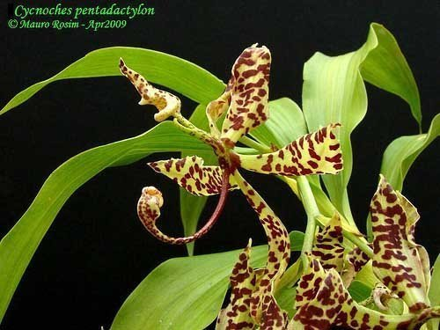
Cycnoches pentadactylon, photography by Mauro Rosim

General Information

DESCRIPTION: Jay Pfahl describes this orchid species as "This epiphytic, medium sized, warm growing species comes from the Amazon basin of Brazil and Peru in wet montane forests at elevations around 750 to 1000 meters with a fusiform pseudobulb enveloped by imbricate leaf-bearing sheaths with deciduous, elliptic, petiolate, acuminate leaves that blooms in the spring and summer on a 2 1/2 to 12 [6.75 to 30 cm] long, arching to pendant, racemose many flowered inflorescence with the fragrant flowers arising from the leaf nodes near the apex of the newest, mature pseudobulb." Please see Sources in the bottom right box for quoted references.

ORIGIN/HABITAT: This epiphytic, medium sized, warm growing species comes from the Amazon basin of Brazil and Peru in wet montane forests at elevations around 750 to 1000 meters.

FLOWER SIZE: To almost 4 inches across [to 10 cm across]
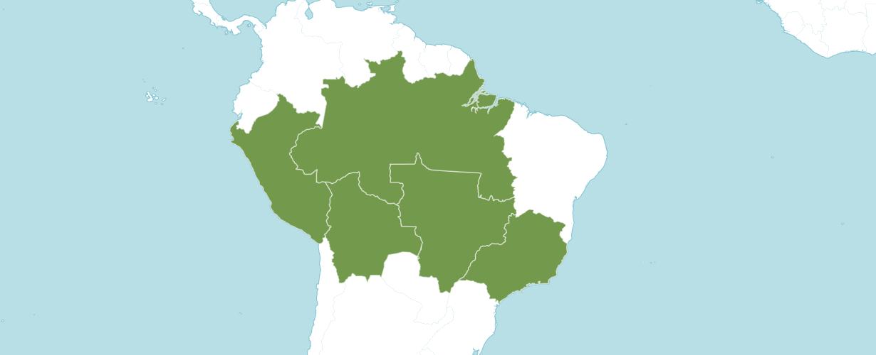
Distribution Cycnoches pentadactylon from Kew

Synonyms:
Cycnoches espiritosantense
Cycnoches amesianum

Varieties / forms:
Cycnoches pentadactylon h.f. album
Cycnoches pentadactylon h.v. peruvian
Cycnoches pentadactylon var. cooperi is Cyc. cooperi.

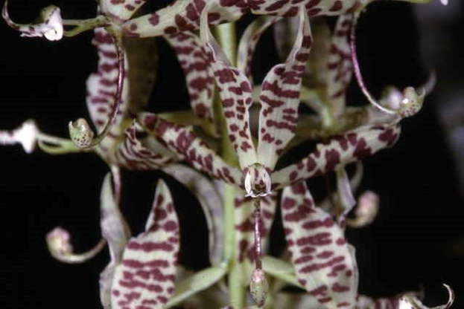
Cycnoches pentadactylon ‘Dr. John Doherty’ AM/AOS, 87 points, 1993 and CCM, 89 points, 1993, photography by OWZ Lib
Cycnoches pentadactylon has seven AOS awards from 1985 to 2022 (AM - 3; HCC – 1; CCM – 2; and CHM – 1). See table below.
 | FCC | AM | HCC | AQ | JC | CCM | CCE | CHM | CBM | Total
AOS |  | 3 | 1 |  |  | 2 |  | 1 |  | 7
Year(s) Awarded |  | 1993  2004  2022 | 2001 |  |  | 1989  1993 |  | 1985

Cycnoches pentadactylon has 29 F1 offspring and 83 progeny. All offspring have been registered since 1982. Cycnoches has been used 17 times as the see parent and 12 times as the pollen parent.
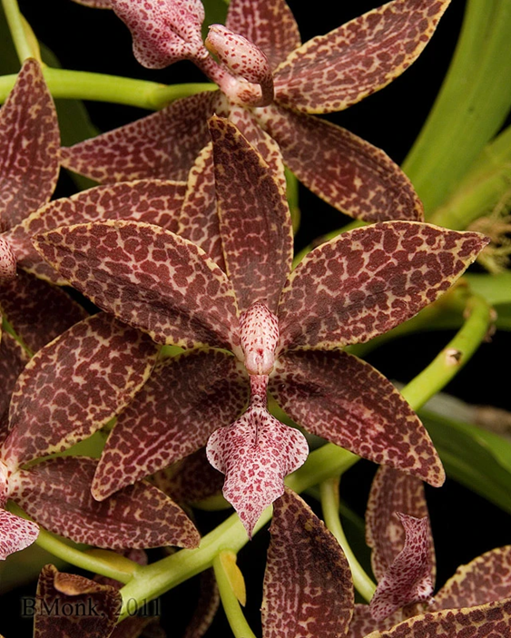
Cychodes Jumbo Canaan ‘Que Linda’ AM/AOS, 81 points, 2011,
Photography by Brian Monk

Major Hybrids:
Cychodes Jumbo Canaan (Cyc. pentadactylon x Mormodes sinuata) originated by Jumbo Orchids and registered by Jumbo Orchids has obtained six awards (AM – 5 and HCC – 1).

Cycnoches Rocky Clough (Cyc. ergertonianum x Cyc. pentadactylon) was originated by H&R Orchids and registered by G. Garr in 1995. Cycnoches Rocky Clough has 2 awards (HCC – 2).

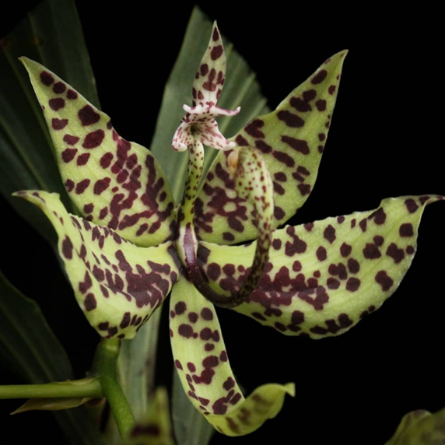
Cycnoches Rocky Clough, unawarded, photography by Orchid Roots

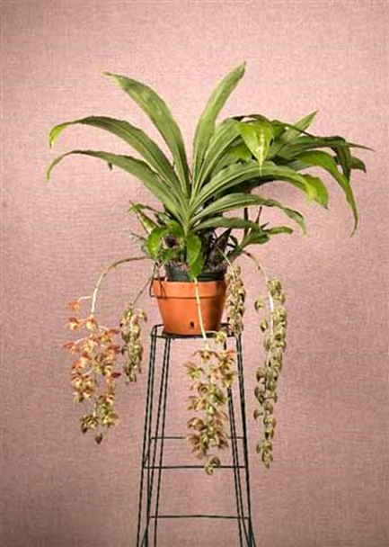
Cycnoches Rocky Clough ‘Nicola’ CCM/AOS, 82 points, 2017,
photography Brian Monk

References
AOS Bulletin Vol 27 No 9 1958.

AOS Bulletin Vol 33 No 1 1964.

AOS Bulletin Vol 52 No 9 1983.

Bennett, D. & Christenson, E. 1995. Icones orchidacearum Peruvianum. Part 2. A. Pastorelli de Bennett, Lima, pp. 201–400.

Bennett, D. & Christenson, E. 1998. Icones orchidacearum Peruvianum. Part 3. A. Pastorelli de Bennett, Lima, pp. 401–600.

Bennett, D. & Christenson, E. 2001. Icones orchidacearum Peruvianum. Part 4. A. Pastorelli de Bennett, Lima, pp. 601–800.

Hawkes, A. 1965. Encyclopedia of cultivated orchids. Faber and Faber. London, England.

Hohne, R. 1940. Flora Brasilica, vol. XII, part 6. F. Lazara. San Paulo, Brazil.

Pfahl, J. 2023. Jay Pfahl's Internet Orchid Species Encyclopedia (IOSPE). Online: www.orchidspecies.com

Zelenko, H. & Bermundez, P. 2009. Orchid species of Peru. Zai Publications. Beijing, China.

