Species Data Sheet

Mormodes sinuata Reichenbachia & Warm. 1881

[Mor-moe-deez Sin-YEW-AH-ta]

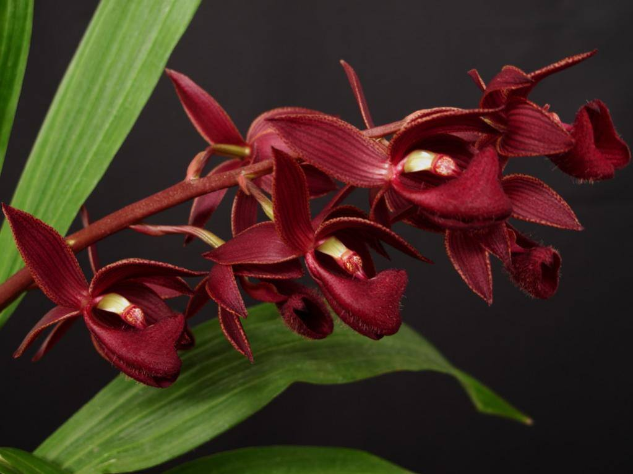
Mormodes sinuata, photography by Sorocaba Orquideas

General Information

PLANT SIZE AND TYPE: A large, 18 in. (45 cm) sympodial epiphyte.

PSEUDOBULB: To 8 in. (20 cm) long by 1.6 in. (4 cm) wide. The clustered, spindle-shaped pseudobulbs have several internodes which are covered by gray, prominently nerved sheaths when young. The sheaths are short-lived, however, and drop from the pseudobulb as it ages.

LEAVES: To 10 in. (25 cm) long by 1.6 in. (4 cm) wide. Several thin, sharply pointed, erect to arching leaves are carried at the apex of each pseudobulb. The midvein and one vein on either side are slightly grooved on the upper surface with a keel on the lower surface.
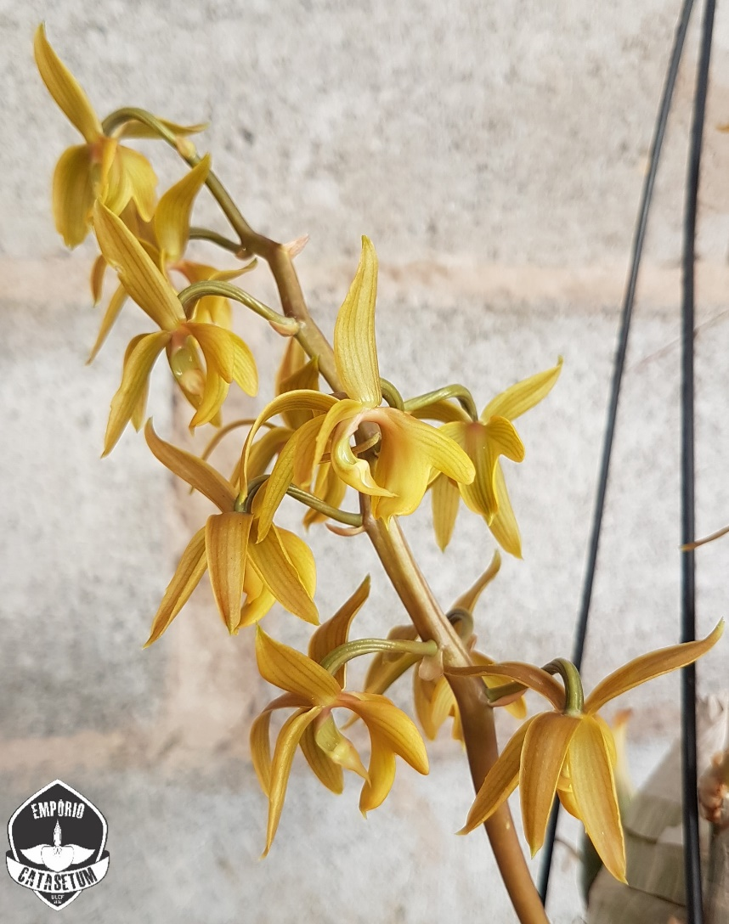
Mormodes sinuata f. Gold, photography by Ulisses Ferreira

INFLORESCENCE: Up to 6 in. (16 cm) long. Mature pseudobulbs may produce one or more arching to nearly horizontal flower spikes, which emerge from nodes along the length. The stout, terete peduncle and rachis are dark maroon, but floral bracts are cream-colored. Flowers are carried in a closely spaced raceme on the upper two-thirds of the inflorescence.

FLOWERS: Many. Each inflorescence carries numerous rather small, cup-shaped blossoms. Pridgeon (1992) shows flowers with deep red sepals and petals marked with many narrow, darker-colored longitudinal veins and a whitish pink lip marked with many narrow, longitudinal, bright-red veins. Dunsterville and Garay (1972), however, reported that flowers they had seen were very dark wine-red, and Pridgeon reported that flowers can vary in color from yellow to wine red. Flowers hold their petals and lip in forward-pointing positions on each side of and below the column. The dorsal sepal arches forward over the column. The lateral sepals may be widely spread or strongly reflexed. Flowers are about 1.3 in. (3.3 cm) across the tips of the lateral sepals. The sharply pointed, lanceolate sepals and petals are similarly shaped. The sepals are 0.7 in. (1.9 cm) long by 0.2 in. (0.6 cm) wide near the base. The petals, which are a little shorter but wider, are 0.7 in. (1.8 cm) long by 0.3 in. (0.8 cm) wide. The strongly 3-lobed lip is rolled into a tube around the column. When spread, the lip is about 0.8 in. (1.8 cm) long by 0.3 in. (1.7 cm) wide across the lateral lobes. The midlobe, which is only about 0.3 in.(0.75 cm) wide, has a small, sharply pointed extension in the center of the otherwise rounded apical margin.

ORIGIN/HABITAT: Brazil and Venezuela. In Brazil, this orchid is found in the plains and savannas of the interior at 1650-3300 ft. (500-1000 m) in the states of Minas Gerais, Goiás, and the Federal District. In Venezuela, plants have been reported above Bejuma in the State of Carabobo.

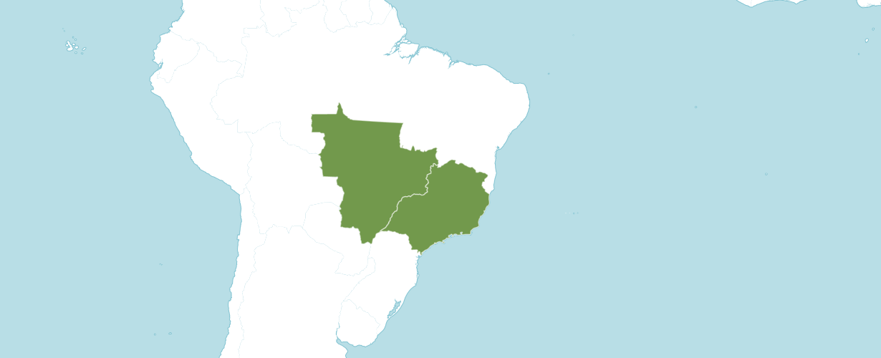
Distribution Mormodes sinuata from Kew
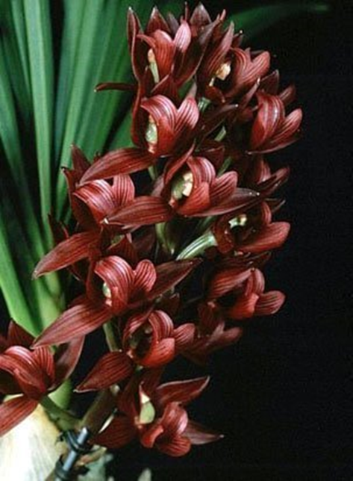
Mormodes sinuata ‘Sunset Valley Orchids’ HCC/AOS, 77 points, 1999,
photography by William Merritt
Synonyms:
Mormodes sinuata h.f. vinicolor
Mormodes sinuatum
Asarca sinuata
Gav. longibracteata

Varieties / forms:
None noted.

Awards:
From 1975 to 1999 Mormodes sinuata has received 9 awards (AM – 5; HCC – 2; CBM - 1; and CCM -1).

Mormodes sinuata has 20 F1 offspring and 150 progeny. All offspring have been registered since 1980. Of the 20 F1 crosses nine or 45% have been awarded. Mormodes sinuata was used 7 times as the seed parent and 13 times as the pollen parent.

Major Hybrids
The Mormodes sinuata hybrid with the most awards is an intergeneric offspring Cycnodes Wine Delight (Morn. Sinuata x Cyc. lehmannii) originated by F. J. Fuchs, Jr. and registered in 1980 by R. Coffman. Cycmodes Wine Delight has 10 offspring and 13 progeny. It has been used 6 times as a seed parent and 4 times as a pollen parent.

Awards
Cycmodes Wine Delight has received 14 AOS awards from 1980 to 2022(AM – 6; HCC – 1; FCC – 1; CCM – 5; and JC – 1).

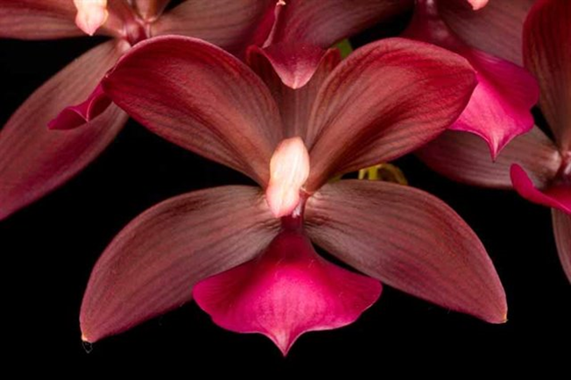
Cycmodes Wine Delight ‘Coo Chan’ HCC/AOS, 78 points, 2018,
photography by Richard Noel
References
Baptista, J.A.N., Bianchetti, L.B. & Pellizzaro, K.F. (2005). Orchidaceae da Reserva Ecológia do Guará, D.F., Brasil. Acta Botanica Brasilica 19: 221-232.
Ferreira, A.W.C., Lima, M.I.S. & Pansarin, E.R. (2010). Orchidaceae na região central de São Paulo, Brasil. Rodriguésia; Revista do Instituto de Biologia Vegetal, Jardim Botânico e Estaçao Biologica do Itatiaya 61: 243-259.
Govaerts, R. (2003). World Checklist of Monocotyledons Database in ACCESS: 1-71827. The Board of Trustees of the Royal Botanic Gardens, Kew.
Nelson Sutherland, C.H. (2008). Catálogo de las plantes vasculares de Honduras. Espermatofitas: 1-1576. SERNA/Guaymuras, Tegucigalpa, Honduras.
Pfahl, J. 2023. Jay Pfahl's internet orchid species encyclopedia (IOSPE). Online: www.orchidspecies.com.

