Bifrenaria aureofulva (Hook.) Lindl., 1843
(syn. Bifrenaria aureo-fulva)

Common Name: The Golden-Red-Yellow Bifrenaria

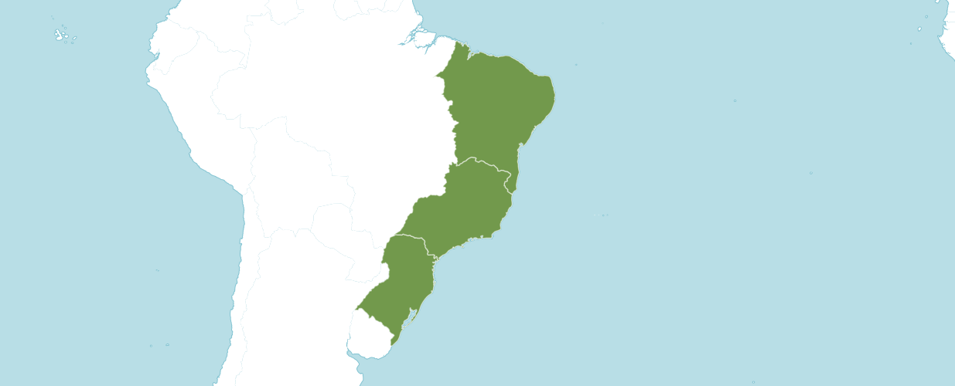

Native

Brazil Northeast, Brazil South, Brazil Southeast

Homotypic Synonyms

Adipe aureofulva (Hook.) M. Wolff in Orchidee (Hamburg) 41: 36 (1990)

Maxillaria aureofulva Hook. in Bot. Mag. 65: t. 3629 (1838).

Heterotypic Synonyms

Bifrenaria secunda (Hoehne) Pabst in Orquídea (Rio de Janeiro) 29: 165 (1967)

Maxillaria stenopetala Knowles & Westc. in Fl. Cab. 2: 112 (1838)

Stenocoryne secunda Hoehne in Arq. Bot. Estado São Paulo, n.s., f.m., 2: 13 (1944)

OrchidWiz noted Origin/Habitat: Brazil. Plants grow in the mountains of southern Brazil in the states of Minas Gerais, Espírito Santo, Rio de Janeiro, São Paulo, Paraná, Santa Catarina, and Rio Grande do Sul. We have been unable to locate specific habitat elevations, but Pabst and Dungs (1975) indicate that Bifrenaria aureo-fulva grows in intermediate conditions. These conditions are also recommended by the McQueens (1993). Therefore, we have estimated habitat elevation to coincide with the reported growing temperatures, but the temperature extremes resulting from this estimation should be used cautiously until more exact information is available. The other elements in the climate table reflect seasonal weather patterns in the habitat.

Plant Size and Type: A 28 in. (71 cm) sympodial epiphyte.

Pseudobulb: 1.0-1.5 in. (2.5-3.8 cm) long. The clustered, strongly four-angled pseudobulbs are dark yellow-green or brown-green.

Leaves: Up to 28 in. (71 cm) long. This includes the petiole at the base, which may be up to 18 in. (46 cm) long, and the leaf blade, which is up to 10 in. (25 cm) long. Each growth carries a single rather leathery, oblong-lanceolate leaf with a prominent midvein and a sharply pointed tip at the top of each pseudobulb.

Inflorescence: 5-12 in. (12-30 cm) long. The slender, usually erect but sometimes pendulous inflorescence emerges from the base of the pseudobulb.

Flowers: 3-15. The nodding blossoms, which may not open fully, are carried on the upper third of each inflorescence. The orange or brownish yellow flowers, have a green tinge on the outside, may be marked with a dull red flush lines. Blossoms are up to 1 in. (2.5 cm) long by approximately 0.8 in. (2 cm) across the reflexed tips of the sepals and petals. The elongated sepals and petals, which are up to 0.6 in. (1.6 cm) long and taper to sharply pointed tips, point forward at the base then spread outward toward the tip. Lateral sepals join together at the base to form a spur. The lip is about 0.6 in. (1.6 cm) long, which is shaped like an elongated diamond with a narrow base, has rounded lateral lobes and a sharply pointed, triangular midlobe. The callus at the base of the lip is 3-lobed at its apex.

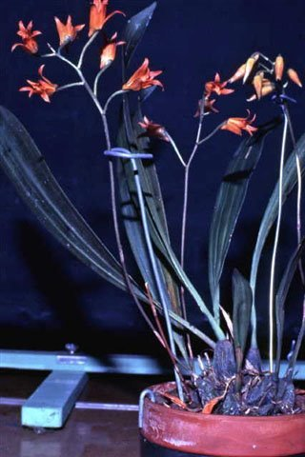
Bifrenaria aureofulva ‘Skokie Bells’ HCC/AOS, 70 points, 1970
Photography by OWZ Libs
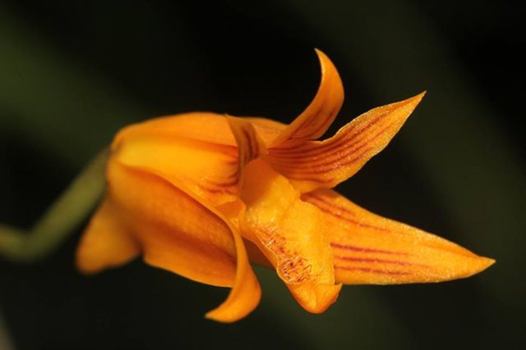
Bifrenaria aureofulva
Photography by Roland Amsler

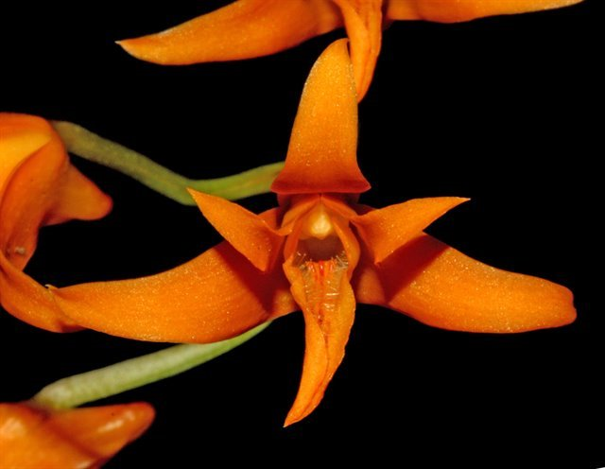
Bifrenaria aureo-fulva
Photography by Ed Cott

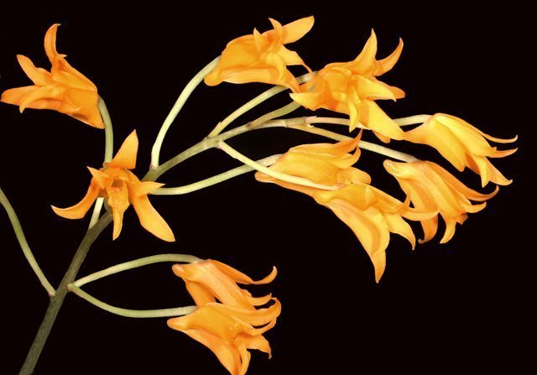
Bifrenaria aureo-fulva
Photography by Lynn O’Shaughnessy

AOS Awards

Bifrenaria inodora
 | FCC | AM | HCC | AQ | JC | CCM | CCE | CHM | CBR | TOTAL
AOS | - | - | 1 | - | - | - | - | - | 1
Years Awarded |  |  | 1970 |  |  |  |  |  | 2002

Hybrids
There are five Bifrenaria aureofulva FI generation offspring. All have been registered since 1987. Only one of the Bifrenaria aureofulva crosses has received an AOS award. Lycastenaria Tropical Honey, an intergeneric hybrid with parents (Bifrenaria aureofulva x Lycaste Jason). Lycastenaria Tropical Honey received an AD/AOS in 2004. Lycastenaria Tropical Honey has no AOS awards and no registered offspring.

Of the Bifrenaria aureofulva crosses, only one, Bifrenaria Haslemere has a registered offspring, which is Bifrenaria (calcarata x auerofulva). Bifrenaria Haslemere has one offspring Bifrenaria Jack Kings Legacy (Haslemere x villosula). Bifrenaria Jack Kings Legacy has no offspring and not received an AOS award.

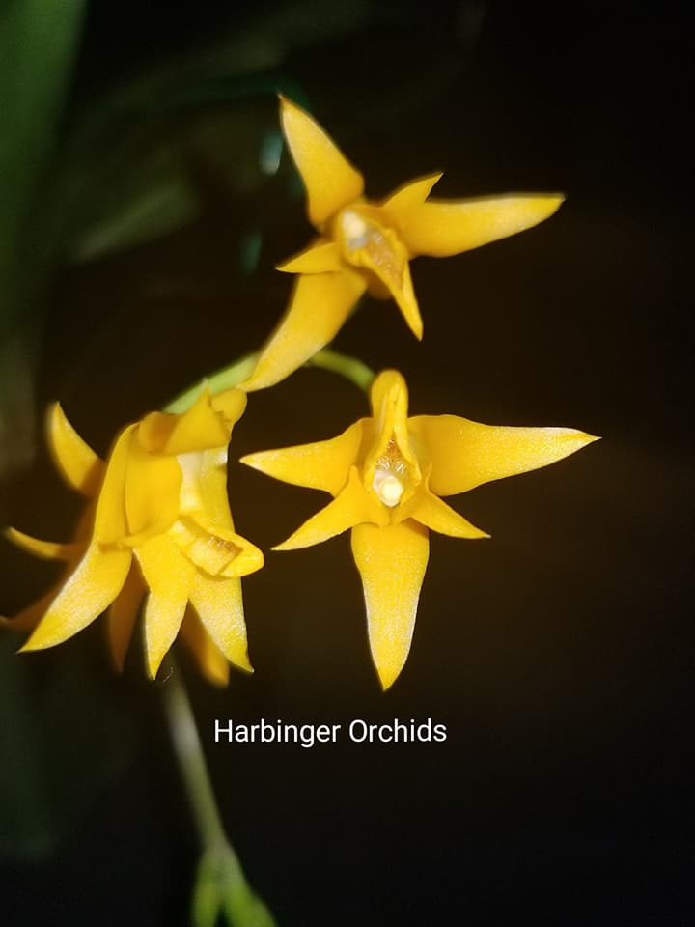
Bifrenaria Haslemere
Photography by Harbinger Orchids

References

da Rocha Fiuza de Melo, M., and et. al. (2007). Flora Fanerogâmica da Ilha do Cardoso 12: 1-289. Instituto de Botânica, São Paulo, Brasil.

Govaerts, R. (2003). World Checklist of Monocotyledons Database in ACCESS: 1-71827. The Board of Trustees of the Royal Botanic Gardens, Kew.

Govaerts, R. (1996). World Checklist of Seed Plants 2(1, 2): 1-492. MIM, Deurne.

Kew (n.d.). Bifrenaria aureofulva. Royal Botanical Gardens Kew: Plants of the World Online. Retrieved May 26, 2023, from https://powo.science.kew.org/taxon/urn:lsid:ipni.org:names:617537-1.

Koehler, S. and do Camaro Estanislau do Amaral, M. (2004). A taxonomic study of the South American genus Bifrenaria Lindl. (Orchidaceae). Brittonia 56: 314-345.

OrchidWiz. X9.0.

Toscano de Brito, A., and Cribb, P. (2006). Orquídeas da Chapada Diamantina: 1-400. Nova Fronteira, Brazil.

Zappi, D.C., and et. al. (2003). Lista das plantas vasculares de Catoles. Boletim de Botânica da Universidade de São Paulo 21(2): 345-398.

