Bifrenaria inodora Lindl., 1843

[in-oh-DOR-ra]

Common Name: The Odorless Bifrenaria

Native

Brazil South, Brazil Southeast

Homotypic Synonyms

Bifrenaria fragrans Barb. Rodr. in Gen. Spec. Orchid. 2: 213 (1882), nom. illeg.

Heterotypic Synonyms

Bifrenaria fuerstenbergiana Schltr. in Orchis 1: 25 (1906)

OrchidWiz noted Origin/Habitat: Brazil. This epiphytic orchid is found in mountainous rainforest from the state of Espirito Santo southward through the states of Rio de Janeiro, Minas Gerais, São Paulo, Paraná, Santa Catarina, and Rio Grande do Sul. Plants have been found from near sea level to about 3300 ft. (1000 m).

Plant Size and Type: A rather large epiphyte that may grow to near 14 in. (40 cm) tall. Growths are closely spaced on a short rhizome.

Pseudobulb: 2.4 in. (6 cm) long by 1.2 in. (3 cm) wide. The pseudobulb is conical to tetragonal.

Leaves: Usually about 8 in. (20 cm) long by 3 in. (8 cm) wide. A single elliptical-elongate leaf is carried at the apex of each pseudobulb. The leaves taper rather abruptly to a sharply pointed tip, have several longitudinal, fanlike folds, and taper below to form a short, narrow, longitudinally folded stem at the base. .

Inflorescence: in. (cm) long. The rather short flower spike emerges from the base of a mature pseudobulb and is stiff and erect. Flowers are carried in a raceme toward the apex of the spike

Flowers: 4-6 per inflorescence. The showy, long-lasting blossoms have sepals and petals that are uniformly colored green to greenish yellow. They have spreading lateral sepals, a concave dorsal sepal that curves forward over the column, and petals that are held in forward-pointing positions on each side of the column. The dorsal sepal is egg-shaped, rounded at the apex, and about 1.4 in. (3.6 cm) long by 0.8 in. (2 cm) wide. The egg-shaped lateral sepals are rounded at the apex, are about 1.6 in. (4 cm) long by 0.6 in. (1.6 cm) wide and are inserted into the foot of the column. The elliptical petals are 1.3 in. (3.2 cm) long by 0.7 in. (1.8 cm) wide. The 3-lobed lip is concave, hairy, and has a somewhat rectangular midlobe with a rounded apical margin, is about twice as long as it is wide, and has a base that is inserted in the column foot. The rounded lateral lobes, which in their natural positions, are held in erect positions, are subtrapezoidal when flattened and have purple veins in the portion between the claw and the

AOS relates this beautiful little Brazilian jewel is flowering now (May). It, along with some 20 other species in Bifrenaria belongs to the Maxillaria tribe. While it should be theoretically possible to create hybrids with other genera in this tribe, very little has been done and the only intergeneric hybrids of Bifrenaria are those with Lycaste (Lycastenaria). Bifrenarias, especially Bifrenaria inodora, are scarce in cultivation, though their attractive flowers and ease of cultivation should make them much better known to collectors.

These plants are sympodial epiphytes or terrestrials. Their 5-7 cm (2-3”) pseudobulbs are distinctly conical and strongly four-angled. Each pseudobulb is topped by a single short-stalked somewhat leathery, pleated leaf up to 30cm long (12”). The inflorescences, as is characteristic of the genus, are produced from the base of the pseudobulb matured last year and carry one or two long-lasting flowers up to 7.5cm (3”) across. While there's very little variation in the green color of the sepals and petals, the lip can vary from white to yellow and even a light rose. The only thing this beautiful species is missing is fragrance. Unlike Bifrenaria harrisoniae whose fragrance can be overpowering, Bifrenaria inodora commonly has no fragrance (the name inodora means “without fragrance”).

Plants are easily grown in intermediate conditions, with good light and high humidity. Their basic requirements are very similar to the warm-growing Lycastes and they should be much more common in cultivation than they are. They flower best if pot-bound and resent having their roots disturbed so they should be repotted only when it is absolutely necessary to avoid stale conditions at the roots. Any good epiphytic mix will work well for these plants as long as it doesn't break down too rapidly. While in active growth, they should be given as much water and humidity as possible without decomposing the potting mix. Once growth is completed, they should be kept drier for several weeks with occasional misting and only enough water to keep the pseudobulbs from wrinkling. During this dry rest period, they can be kept in slightly cooler temperatures.

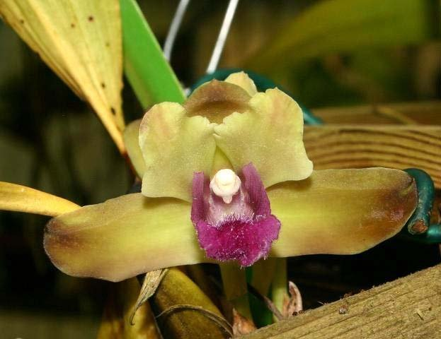
Bifrenaria inodora
Photography by Patricia Harding

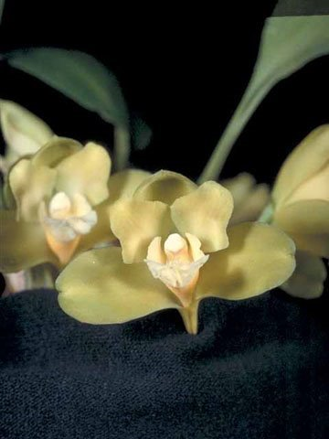
Bifrenaria inodora ‘Alfredo’ HCC/AOS, 78 points, 1987
Photography by OWZ Lib
AOS Awards

Bifrenaria inodora Awards
 | FCC | AM | HCC | AQ | JC | CCM | CCE | CHM | CBM | TOTAL
AOS | - | 1 | 2 | - | - | 1 | - | 1 | 1 | 5
Years Awarded |  | 1989 | 1987  &  1989 |  |  | 1996 |  | 1999 | 1967

Hybrids

Of the five Bifrenaria inodora hybrids registered, all were made since 1989. Four of the five Bifrenaria inodora crosses were registered since 2004. Of the Bifrenaria inodora crosses and offspring only three AOS awards have been given. Bifrenaria Jane Ann Cook (tyrianthina x inodora) originated by G. Webb and registered in 2004 by J. Cook holds two AOS awards (AM – 1 and CCM – 1). Both awards were given to the cultivar ‘Carsyn Elise’ in 2004.

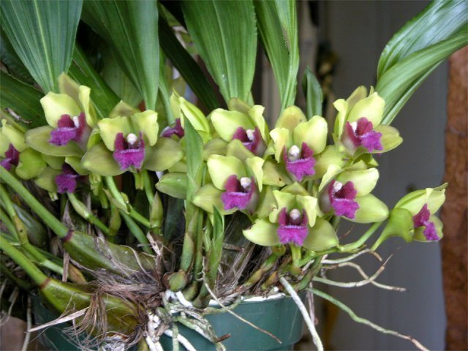
Bifrenaria Jane Ann Cook AM/CCM/AOS, 85 and 84 points, 2004
Photography by Judy Cook, MD

The second Bifrenaria inodora offspring awarded is intergeneric hybrid Bifreniella Aurora (Rudolfiella aurantiaca x Bifrenaria inodora). Bifreniella Aurora has no registered offspring and holds one AOS award, an AD/AOS given in 1989.

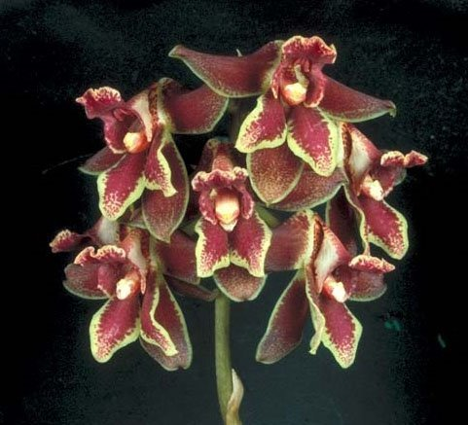

Bifreniella Aurora AD/AOS, 1989
Photography by OWZ Lib

References

American Orchid Society. (n.d.). Bifreniella inodora. Retrieved May 26, 2023, https://www.aos.org/orchids/collectors-items/bifrenaria-inodora.aspx#:~:text=Bifrenarias%2C%20especially%20Bifrenaria%20inodora%2C%20are,much%20better%20known%20to%20collectors.&text=These%20plants%20are%20sympodial%20epiphytes,conical%20and%20strongly%20four%2Dangled.

Castro, V., and Campacci, M. Undated. Icones Orchidacearum Brasilienses I. Coordenadoria das Associacoes Orquidofilas do Brasil.

Govaerts, R. (2003). World Checklist of Monocotyledons Database in ACCESS: 1-71827. The Board of Trustees of the Royal Botanic Gardens, Kew.

Govaerts, R. (1996). World Checklist of Seed Plants 2(1, 2): 1-492. MIM, Deurne.

Kew (n.d.). Promenaea stapelioides. Royal Botanical Gardens Kew: Plants of the World Online. Retrieved May 26, 2023, from https://powo.science.kew.org/taxon/urn:lsid:ipni.org:names:617552-1.

Koehler, S. & do Camaro Estanislau do Amaral, M. (2004). A taxonomic study of the South American genus Bifrenaria Lindl. (Orchidaceae). Brittonia 56: 314-345.

Yearron, S. (1999). Long blooming and frequent blooming orchid species. http://www.chebucto.ns.ca//Recreation/OrchidSNS/a-g-long.html.

