GENUS SUMMARY
Bifrenaria Lindl. 1832
[bi-fren-AIR-ee-ah]

General Description
Bifrenaria was first described in 1832. The genus has presented taxonomic puzzles with some species being recently transferred to Rudolfiella, Coelia, Lacaena, Stenocoryne and Teuscheria. Bifrenarias are not too common in cultivation but Bif. harrisoniae with its lovely, large, white to pink fragrant blooms is more often seen. This and other species can be a challenge to flower but once a grower develops the knack, blooming is as regular as clockwork. The plants have a characteristic single, leathery, dark green leaf per squat, conic to somewhat flattened pseudobulb. Flower color varies from ivory through green, yellow, and pink. Other species that can be found in collections include Bif. atropurpurea (3-6 medium reddish-purple blooms that open best when grown cool), Bif. aureofulva (6-10 small orange blooms), Bif. charlesworthii (4-6 small, fringed cream blooms), Bif. inodora (4-6 medium greenish blooms), Bif. tetragona (2-3 large purple-spotted green blooms) and Bif. tyrianthina ( 1-4 large rose-purple blooms).
Bifrenaria harrisoniae is a Brazilian species found growing on east-facing rocky cliffs at 700-2600 ft. The plants grow exposed to sun and wind but their roots anchor them firmly by penetrating cracks in the rock face. There is near perfect drainage, constant air movement, and bright light. Temperatures range from a high 80 F to a low of 60 F and quite a bit cooler in the months before flowering. Rainfall is concentrated in the warmer months and after the blooming season, which is in spring in the Northern Hemisphere. Humidity is high year-round.
At the website of Delfina de Araujo , we found a Portuguese/English account of a floristic survey of the Bananal River margins in Rio de Janeiro Province, Brazil by Maria da Penha Fagnani. Although this part of Bananal river runs through an area of environmental protection, they found partial destruction of the forest in some areas but the big trees which followed the river margin had been preserved. The river margin ecosystem is dependent upon the constant high humidity. Just 100 ft back from the river, the climate is dry by day. Three Bifrenarias found in this region are described as being rupicolous and growing above the water. They are spring-blooming Bif. harrisoniae, winter blooming Bif. tetragona, and Bif. aureo-fulva which is also known from south and southeastern Brazil. It is clear from this Brazilian account that some Bifrenarias not only can grow lithophytically but they also grow over water where there is a steady year-round supply of humid air irrespective of rainfall. We should bear in mind that these tough orchids like it humid and breezy even when watering is being withheld.

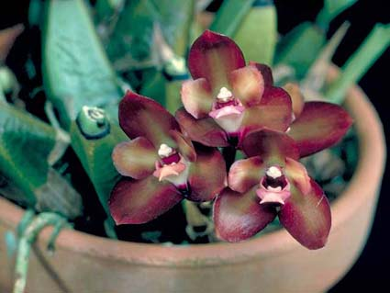
Bifrenaria atropurpurea ‘Lil’ CBR/AOS, points unknown, 1981
Photography by OWZ Lib

Native

Bolivia, Brazil North, Brazil Northeast, Brazil South, Brazil Southeast, Brazil West-Central, Colombia, French Guiana, Guyana, Peru, Suriname, Trinidad-Tobago, Venezuela

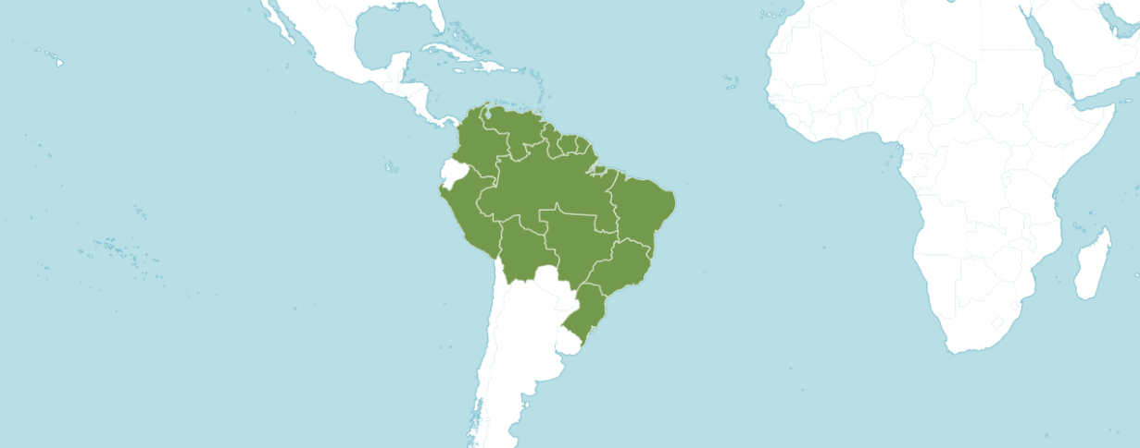
Distribution of Bifrenaria , image from Royal Botanical Gardens Kew

Synonyms

Adipe Raf. in Fl. Tellur. 2: 101 (1837)

Colax Lindl. ex Spreng. in Syst. Veg., ed. 16. 3: 727 (1826)

Cydoniorchis Senghas in J. Orchideenfr. 1: 11 (1994)

Stenocoryne Lindl. in Edwards's Bot. Reg. 29(Misc.): 53 (1843)

Accepted Species

Bifrenaria atropurpurea Lindl.

Bifrenaria aureofulva (Hook.) Lindl.

Bifrenaria calcarata Barb.Rodr.

Bifrenaria charlesworthii Rolfe

Bifrenaria diamantinensis Campacci & Rosim

Bifrenaria grandis (Kraenzl.) Garay

Bifrenaria harrisoniae (Hook.) Rchb.f.

Bifrenaria inodora Lindl.

Bifrenaria leucorrhoda Rchb.f.

Bifrenaria longicornis Lindl.

Bifrenaria mellicolor Rchb.f.

Bifrenaria parthonii (Dumort.) Ormerod

Bifrenaria racemosa (Hook.) Lindl.

Bifrenaria silvana V.P.Castro

Bifrenaria stefanae V.P.Castro

Bifrenaria steyermarkii (Foldats) Garay & Dunst.

Bifrenaria tetragona (Lindl.) Schltr.

Bifrenaria tyrianthina (Lodd. ex-Loudon) Rchb.f.

Bifrenaria venezuelana C.Schweinf.

Bifrenaria verboonenii G.A.Romero & V.P.Castro

Bifrenaria vitellina (Lindl.) Lindl.

Bifrenaria wittigii (Rchb.f.) Hoehne

Bifrenaria Awards
 | FCC |  | AM |  |  | HCC |  |  | AQ | JC |  |  |  | CCM | CCE |  | CHM | CBM |  | CBR | TOTAL
atropurpurea | - |  | - |  |  | - |  |  | - | - |  |  |  | 1 | - |  | - | - |  | 1 | 2
aurantiaca | - |  | - |  |  | - |  |  | - | - |  |  |  | - | - |  | - | 1 |  | 1 | 2
aurea,  ~ harrisoniae | - |  | 7 |  |  | 4 |  |  | - | 1 |  |  |  | 8 | - |  | - | 2 |  | - | 22
aureofluva,  ~aureo-fluva,  ~secunda | - |  | - |  |  | 1 |  |  | - | - |  |  |  | - | - |  | - | - |  | 1 | 2
barbosae,  ~ calcarata | - |  | - |  |  | - |  |  | - | - |  |  |  | - | - |  | - | - |  | - | 0
bella | - |  | 3 |  |  | 3 |  |  | - | - |  |  |  | 4 | 1 |  | - | 1 |  | - | 12
bicornnaria | - |  | - |  |  | 1 |  |  | - | - |  |  |  | - | - |  | - | - |  | - | 1
calcarata,  ~barbosae | - |  | - |  |  | - |  |  | - | - |  |  |  | - | - |  | - | - |  | - | 0
charlesworthii |  | - | - |  | 1 |  |  | - |  |  |  | - | - |  |  | - | - | - |  | 1 | 2
caparaoensis,  ~atropupurea |  | - | - |  | - |  |  | - |  |  |  | - | - |  |  | - | - | 1 |  | 1 | 2
clavigera,  ~davigera |  | - | - |  | - |  |  | - |  |  |  | - | - |  |  | - | 1 | - |  | - | 1
florabunda |  | - | - |  | 2 |  |  | - |  |  |  | - | - |  |  | 1 | 1 | 1 |  | 1 | 6
fragrans,  ~fuerstenbergiana,  ~furstenbergiana,  ~inodora |  | - | 1 |  | 2 |  |  | - |  |  |  | - | 1 |  |  | - | 1 | 1 |  | - | 6
fuerstenbergiana,  ~fragrans,  ~furstenbergiana,  ~inodora |  | - | 1 |  | 2 |  |  | - |  |  |  | - | 1 |  |  | - | 1 | 1 |  | - | 6
grandis |  | - | - |  | - |  |  | - |  |  |  | - | - |  |  | - | - | - |  | - | 0
hadwenii |  | - | 1 |  | - |  |  | - |  |  |  | - | 1 |  |  | - | 1 | 1 |  | - | 4
harrisoniae,  ~aurea |  | - | 7 |  | 4 |  |  | - |  |  |  | 1 | 8 |  |  | - | - | 2 |  | - | 22
inodora,  ~fragrans,  ~fuerstenbergiana,  ~furstenbergiana |  | - | 1 |  | 2 |  |  | - |  |  |  | - | 1 |  |  | - | 1 | 1 |  | - | 6
leucorhoda |  | - | - |  | - |  |  | - |  |  |  | - | - |  |  | - | - | - |  | - | 0
lindmaniana |  | - | - |  | - |  |  | - |  |  |  | - | - |  |  | - | - | - |  | - | 0
longicornis |  | - | - |  | - |  |  | - |  |  |  | - | - |  |  | - | - | - |  | - | 0
magnicalcarata,  ~tyrianthina |  | - | - |  | 2 |  |  | - |  |  |  | - | - |  |  | - | - | - |  | - | 2
maguirei |  | - | - |  | - |  |  | - |  |  |  | - | - |  |  | - | - | - |  | - | 0
melanopoda,  ~racemosa |  | - | - |  | - |  |  | - |  |  |  | - | - |  |  | - | 1 | 1 |  | - | 2
mellicolor |  | - | - |  | - |  |  | - |  |  |  | - | - |  |  | - | - | - |  | - | 0
minuta |  | - | - |  | - |  |  | - |  |  |  | - | - |  |  | - | - | - |  | - | 0
parvula |  | - | - |  | - |  |  | - |  |  |  | - | - |  |  | - | - | - |  | - | 0
petiolaris |  | - | - |  | - |  |  | - |  |  |  | - | - |  |  | - | - | - |  | - | 0
 |  | FCC | AM |  | HCC |  |  | AQ |  |  |  | JC | CCM |  |  | CCE | CHM | CBM |  | CBR | Total
pickiana |  | - | - |  | - |  |  | - |  |  |  | - | - |  |  | - | - | - |  | - | 0
picta |  | - | 3 |  | - |  |  | - |  |  |  | - | 2 |  |  | - | - | - |  | 1 | 6
racemosa |  | - | - |  | - |  |  | - |  |  |  | - | - |  |  | - | 1 | - |  | 1 | 2
rudolfii |  | - | - |  | - |  |  | - |  |  |  | - | - |  |  | - | - | - |  | - | 0
sabulosa |  | - | - |  | - |  |  | - |  |  |  | - | - |  |  | - | - | - |  | - | 0
saxicola,  ~floribunda |  | - | - |  | 2 |  |  | - |  |  |  | - | 1 |  |  | - | 1 | 1 |  | 1 | 6
secunda,  ~aureoluva |  | - | - |  | 1 |  |  | - |  |  |  | - | - |  |  | - | - | - |  | 1 | 2
silvana |  | - | - |  | - |  |  | - |  |  |  | - | - |  |  | - | - | - |  | 1 | 1
stefanae | - |  | - | - |  |  | - |  |  |  | - |  | - |  |  | - | - | - | - |  | 0
steyermarkii | - |  | - | - |  |  | - |  |  |  | - |  | - |  |  | - | - | - | - |  | 0
teragona | - |  | - | - |  |  | - |  |  |  | - |  | 1 |  |  | - | 1 | 1 | - |  | 3
tyrianthina | - |  | - | 2 |  |  | - |  |  |  | - |  | - |  |  | - | - | - | - |  | 2
venezueliana | - |  | - | - |  |  | - |  |  |  | - |  | - |  |  | - | - | - | - |  | 0
verboonenii | - |  | - | - |  |  | - |  |  |  | - |  | - |  |  | - | - | - | 1 |  | 1
villosula,  ~charlesworthii | - |  | - | 1 |  |  | - |  |  |  | - |  | - |  |  | - | - | - | 1 |  | 1
vitellina | - |  | - | - |  |  | - |  |  |  | - |  | - |  |  | - | - | - | 1 |  | 1
wageneri | - |  | - | - |  |  | - |  |  |  | - |  | - |  |  | - | 1 | - | - |  | 1
wendlandiana,  ~clavergia,  ~divergia | - |  | - | - |  |  | - |  |  |  | - |  | - |  |  | - | 1 | - | - |  | 1
wittigii | - |  | 1 | - |  |  | - |  |  |  | - |  | - |  |  | - | - | - | - |  | 1

Bifrenaria Hybrids

Bifrenaria aurea, synonym harrisoniae appears to be the important example the genus having nine F1 generation offspring. Lycastenaria Darius (Bifrenaria aurea x Lycaste virginalis) was registered by Cooke in 1954 and originated by McBean’s. Lycastenaria Darius holds one AOS award; a JD, received in 1977. Lycastenaria Darius has two registered offspring: Lycastenaria Alkina (Lycastenaria Darius x Lycaste Auburn) and Lycastenaria Balliae (Lycastenaria Darius x Lycaste Nancy Marie).

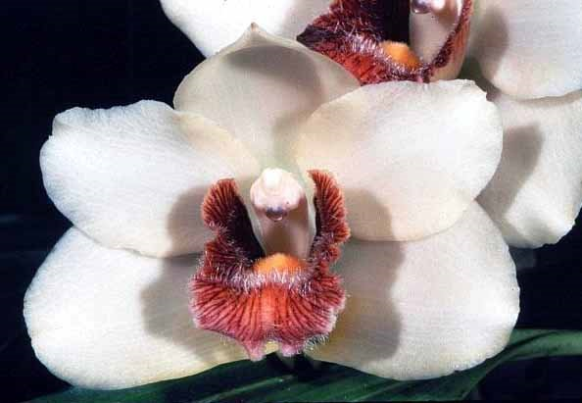
Bifrenaria harrisoniae (aurea) ‘Laima’ AM/AOS, 81 points, 1996
Photography by John Stewart

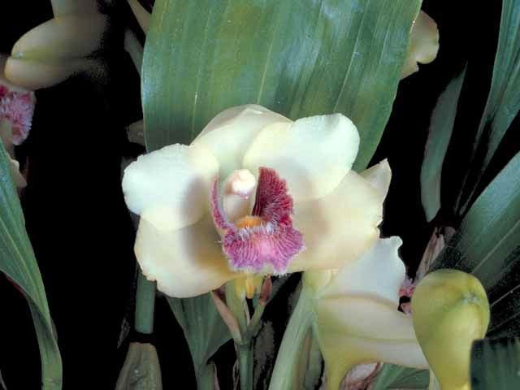
Bifrenaria harrisoniae (aurea) ‘Howie’ AM/AOS, 80 points, 1985
Photography by OWZ Lib

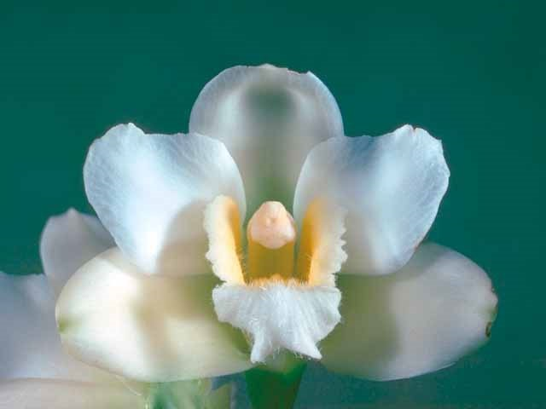
Bifrenaria harrisoniae (aurea) var. alba ‘Mitzi’ AM/AOS, 80 points, 1976
Photography by OWZ Lib

References

American Orchid Society. (n.d.). Bifrenaria. Retrieved May 14, 2023, from https://www.aos.org/orchids/orchids-a-to-z/letter-b/bifrenaria.aspx.

Govaerts, R. 1996. World Checklist of Seed Plants 2(1, 2): 1-492. MIM, Deurne.

Govaerts, R. 2003. World Checklist of Monocotyledons Database in ACCESS: 1-71827. The Board of Trustees of the Royal Botanic Gardens, Kew.

Kew (n.d.). Bifrenaria. Royal Botanical Gardens Kew: Plants of the World Online.
Retrieved May 14, 2023, from https://powo.science.kew.org/taxon/urn:lsid:ipni.org:names:617551-1.

American Orchid Society (n.d.). Orchid Pro. Orchid Pro. Retrieved May 14, 2023, from https://op.aos.org/.

OrchidWiz X9.0

Pfahl, J. 2023. Jay Pfahl's Internet Orchid Species Encyclopedia (IOSPE). Online: www.orchidspecies.com.

Pridgeon, A., Cribb, P., Chase, M. & Rasmussen, F. 2009. Epidendroideae (Part two). Genera Orchidacearum 5: 1-585. Oxford University Press, New York, Oxford.

