GENUS SUMMARY
Promenaea Lindl. 1843
[Pro-men-EYE-ah]

General Description
Various botanists list this genus as being native to the lowlands of Brazil in the intermediate to warm-growing climate. All species are diminutive and grow as epiphytes in moist forest and care should be taken not avoid allowing plants to completely dry out. Early publications mention 4-6 species, most recently 22. Intergeneric hybrids are being created with Zygopetalum, Colax, Cochleanthes, Chondrorhyncha, etc. The two most well-known species are P. xanthina (yellow) and P. stapelioides (spotted and barred wine-red). The resulting hybrid is Promenaea Crawshayana.

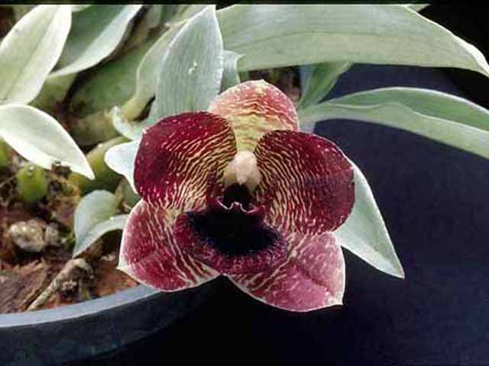
Promenaea stapellioides ‘Killer Bees’ AM/AOS, 80 points, 2003
photography by James Osen
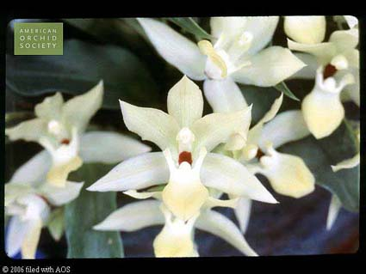
Promenaea xanthina ‘Light Year’ CCM/AOS, 84 points, 2004
Photography by unknown

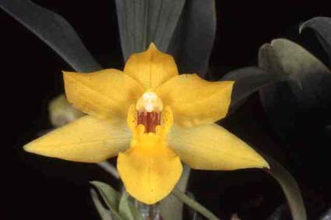

Promenaea silvana “Ben’ CHM/AOS, 84 points, 2002

Photography by unknown

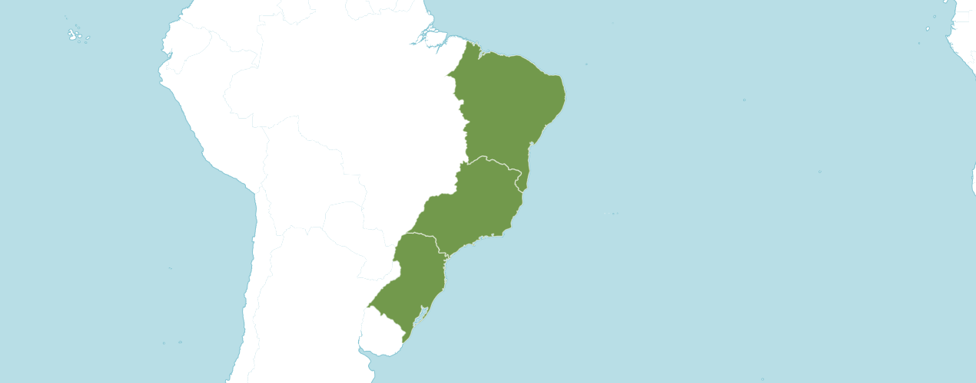
Distribution of Promenaea image from Royal Botanical Gardens Kew

Native
Brazil Northeast, Brazil South, Brazil Southeast
Accepted Species
Promenaea stapelioides (Link & Otto) Lindl.
Currently the WCSP recognizes 16 species and 2 varieties. (2/2020)

Type Species

Several species were cited by Lindley when he described Promenaea.

Promenaea Species Awards
 | FCC | AM | HCC | AQ | JC | CCM | CCE | CHM | CBM | CBR | TOTAL
~albescens, rollissonii, ~citrina,  ~lentiginosa, ~paranaensis var. albescens, paulensis, ~riograndensis | - | - | 1 | - | - | - | - | 2 | - | 3 | 6
florida | - | - | - | - | - | - | - | - | - | 1 | 1
guttata | - | - | - | - | - | - | - | 1 | - | - | 1
ovatiloba | - | 1 | - | - | - | 1 | - | 1 | - | - | 3
silvana | - | - | - | - | - | 1 | - | 1 | - | - | 2
*stapelioides | - | 6 | 2 | - | 2 | 6 | - | - | 1 | - | 17
*xanthina | - | 1 | 4 | - | - | 6 | 1 | 2 | 3 | - | 17

Promenaea Species Offspring and Progeny
 | F1 Offspring | Progeny
acuminata | 0 | 0
~albescens, rollissonii, ~citrina,  ~lentiginosa, ~paranaensis var. albescens, paulensis, ~riograndensis | 5 | 22
catharinensis | 0 | 0
dusenii | 0 | 0
florida | 0 | 0
fuerstenbergiana | 0 | 0
guttata | 5 | 12
malmquistiana | 0 | 0
microptera | 0 | 0
nigricans | 0 | 0
ovatiloba | 3 | 22
paranaensis | 0 | 0
silvana | 0 | 0
sincorana | 0 | 0
* stapelioides | 22 | 92
viridiflora | 0 | 0
* xanthina | 21 | 121

References

American Orchid Society. (n.d.). Promenaea. Retrieved May 16, 2023, from https://www.aos.org/orchids/orchids-a-to-z/letter-p/promenaea.aspx

American Orchid Society (n.d.). Orchid Pro. Orchid Pro. Retrieved May16, 2023, from https://op.aos.org/.

Govaerts, R. 2003. World checklist of monocotyledons database in ACCESS: 1-71827. The Board of Trustees of the Royal Botanic Gardens, Kew.

Kew (n.d.). Promenaea. Royal Botanical Gardens Kew: Plants of the World Online.
Retrieved May 16, 2023, from https://powo.science.kew.org/taxon/urn:lsid:ipni.org:names:30430-1.

Pridgeon, A., Cribb, P., Chase, M., & Rasmussen, F. 2009. Epidendroideae (Part two). Genera Orchidacearum 5: 1-585. Oxford University Press, New York, Oxford.

OrchidPro.

OrchidWiz X9.0.

