Pescatoria coelestis Rchb.f., 2005
[see-LESS-tis]

Common Name: The Sky-Blue Pescatoria

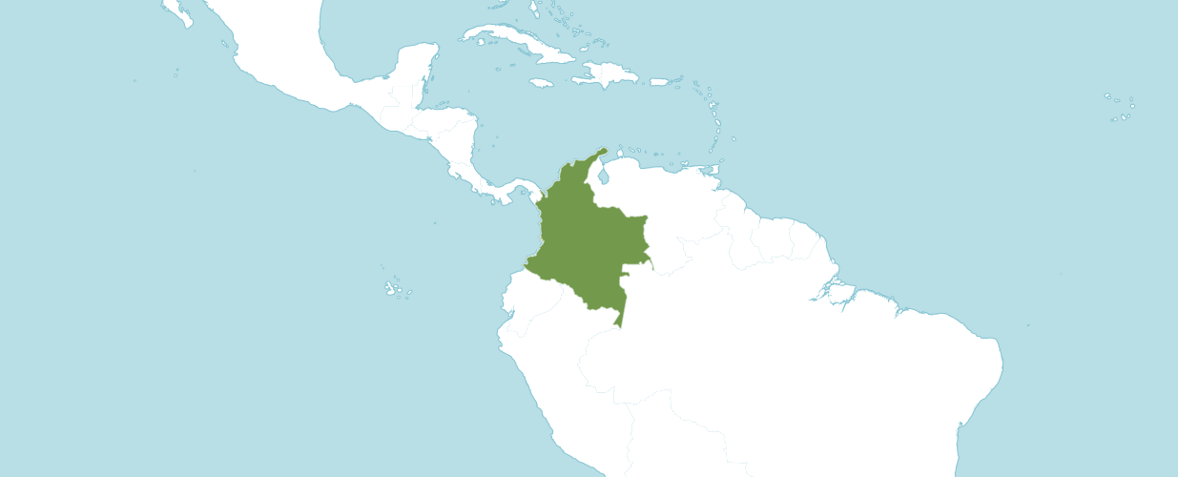

Native to:

Colombia

Homotypic Synonyms

Bollea coelestis Rchb.f. in Gard. Chron., n.s., 5: 756 (1876)

Zygopetalum coeleste (Rchb.f.) Rchb.f. in Linnaea 41: 5 (1876)

Found in Colombia and Ecuador as a tufted, small to medium sized, warm to cool growing epiphyte without pseudobulbs, occurring in extremely wet forests with a heavy night fog, that requires humid, shady well-watered conditions, found at around 900 to 1900 meters, with 6 to 10, oblong-lanceolate, acuminate leaves arranged in a fan shape that blooms in the spring and summer on a stout, shorter than the leaves, 4 to 10" [10 to 25 cm] long, ascending, sheathed stalk with a solitary, fleshy, long-lived, fragrant flower that is best put in a basket so as to display the low held flowers to the best advantage.

OrchidWiz notes Origin/Habitat: Colombia. Discovered between Buenaventura and Cali in the Cordillera Occidental at about 6250 ft. (1900 m). Escobar (1990), however, reported its occurrence in the department of Narino, which is somewhat south of the reported original discovery site.

Plant Size and Type: An epiphytic plant with growths to about 12 in. (30 cm) tall.

Pseudobulb/Stem: These plants have a very short stem and do not have a pseudobulb.

Leaves: 6-12 in. (15-30 cm) long by 1.2-2.0 in. (3-5 cm) wide. Six to ten rather fragile, oblong to lanceolate leaves that taper to sharply pointed tips are arranged in a rather loose fan on each growth.

Inflorescence: Shorter than the leaves. Several rather stout, suberect to somewhat nodding scapes with several joints on the peduncle are produced from the base of the growth, sometimes simultaneously.

Flowers: 1 per inflorescence. The very fleshy, strongly fragrant, long-lived blossoms are 3-4 in. (7.5-10.0 cm) in diameter. The wide-spreading sepals and petals vary in color from deep violet-blue to almost sky-blue but their basal parts and wavy margins usually are olive-green or yellowish green, and they often have yellowish tips. The lip is bluish violet with a buff-yellow crest, while the column is bluish violet above, yellow in front, and spotted with red toward the base. The dorsal sepal is broadly obovate, curves forward, and is about 1.8 in. (4.5 cm) long by 0.8 in. (2 cm) wide. The lateral sepals are oval to oblong. The spreading petals are similar to the dorsal sepal. The egg-shaped lip, which is shorter than the other segments, is recurved along the margins and at the apex. There is a large semicircular crest covering the basal three-quarters of the lip that is deeply grooved longitudinally forming numerous rounded ridges that are about 1 in. (2.5 cm) long. The column is broad, arching, convex, hairy toward the base, and about 0.9 in. (2.3 cm) long.

AOS Awards

Pescatoria coelestis Awards
 | FCC | AM | HCC | AQ | JC | CCM | CCE | CHM | CBM | TOTAL
AOS | 5 | 8 | 1 | - | 2 | 4 | 1 | 1 | - | 22
Years Awarded | 1986  2005  2006  2013  2015 | 1981to  2017 | 2013 |  | 1980  1998 | 19862005 2011  2011 | 2017 | 2019

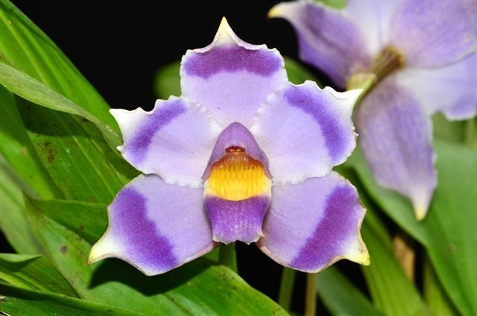
Pescatoria coelestis ‘Cruz’ HCC/AOS, 79 points, 2013
Photography by Juan Carlos Uribe

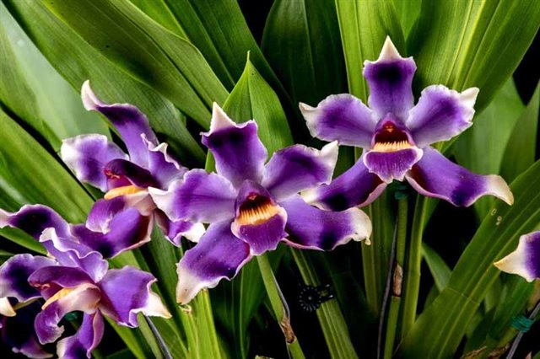
Pescatoria coelestis ‘Piedrahita’ AM/AOS, 80 points, 2017
Photography by Nicholas Gomez Rios
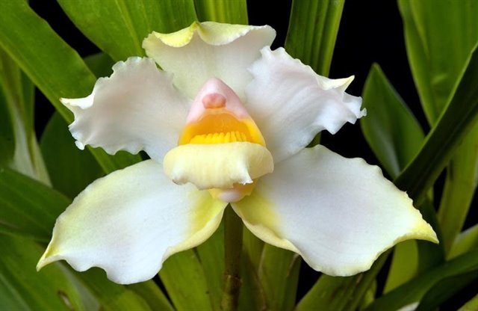
Pescatoria coelestis ‘San Isidro’ FCC/AOS, 91 points, 2013
Photography by Nicholas Gomez Rios

Pescatoria coelestis Hybrids

Pescatoria coelestis has eight F1 generation offspring and twelve progeny. The first registered hybrids of Pescatoria coelestis was in 1902. The hybrid was an intergeneric hybrid named Pescascaphe Froebeliana (Pescatoria coelestis x Chondroscaphe chestertonii). Another hybrid of Pescatoria ceoelestis was not registered again until 1990. The last six Pescatoria coelestis hybrids were not registered until after 2000. Two additional hybrids were registered in the 1990’s.

The only Pescatoria coelestis hybrid awarded was Pescatoria Alice Hipkins, which is (coelestis x lehmannii). This hybrid was registered in 2005 by Royale Orchids and made by Robert Hamilton. Only one clone of Pescatoria Alice Hipkins received an award by the AOS, clone ‘San Isidro’ received an FCC/AOS of 93 points in 2017.

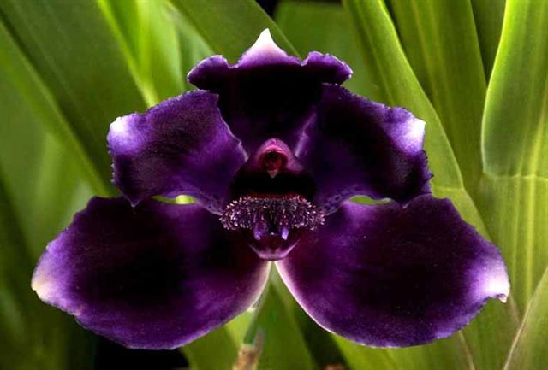

Pescatoria Alice Hipkins ‘San Isidro’ FCC/AOS 93 points, 2017
Photography by Nicolas Gomez Rios
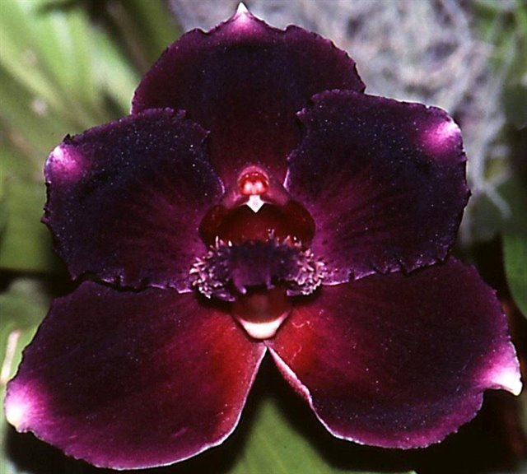
Pescatoria Alice Hipkins ‘Peats Ridge’ AM/AOC 80 points, 2005
Photography by Australian Orchid Council

References

Bernal, R., Gradstein, S., and Celis, M. (2015). Catálogo de plantas y líquenes de Colombia. Instituto de Ciencias Naturales, Universidad Nacional de Colombia, Bogotá. http://catalogoplantasdecolombia.unal.edu.co.

Bechtel, H., Cribb, P., and Launert, E. (1980). Manual of cultivated orchid species. MIT Press, Cambridge, Mass.

Escobar, R. (1990). Native Colombian Orchids, vol. 1: Acacallis—Dryadella. Colombian Orchid Society. Medellin, Colombia.

Govaerts, R.H.A. (2011). World checklist of selected plant families published update Facilitated by the Trustees of the Royal Botanic Gardens, Kew.

Hamilton, R. (1988). When does it flower? 2nd ed. Hamilton. Richmond, B. C., Canada.

Hawkes, A. (1987). Encyclopaedia of cultivated orchids. Faber and Faber, London.

Internet Orchid Species Encyclopedia
http://www.orchidspecies.com › bolcoelestis.

Peterson, K. (1988). The 1986 Nax Trophy and Butterworth Prize. American Orchid Society Bulletin 57(4): 391-392.

