Pescatoria lehmannii Rchb.f., 1879
[LAY-mahn-ee-eye]

Common Name: Lehman’s Pescatoria

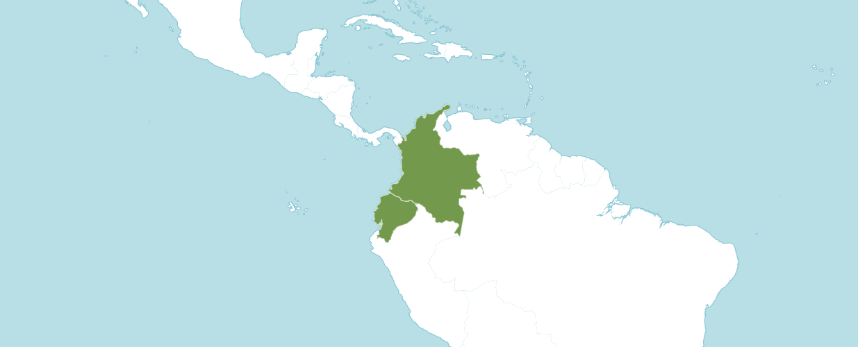

Native to:
Colombia, Ecuador

Homotypic Synonyms
Zygopetalum lehmannii (Rchb.f.) G.Nicholson in Ill. Dict. Gard. 4: 246 (1887)

Heterotypic Synonyms
Pescatoria dormaniana Rchb.f. in Gard. Chron., n.s., 15: 330 (1881)

Zygopetalum dormanianum (Rchb.f.) G.Nicholson in Ill. Dict. Gard. 4: 245 (1887)

Found in Colombia and Ecuador as a tufted, small to medium sized, warm to cool growing epiphyte without pseudobulbs, occurring in extremely wet forests with a heavy night fog, that requires humid, shady well-watered conditions, found at around 900 to 1900 meters, with 6 to 10, oblong-lanceolate, acuminate leaves arranged in a fan shape that blooms in the spring and summer on a stout, shorter than the leaves, 4 to 10" [10 to 25 cm] long, ascending, sheathed stalk with a solitary, fleshy, long-lived, fragrant flower that is best put in a basket so as to display the low held flowers to the best advantage.

OrchidWiz notes Origin/Habitat: Extremely wet, humid cloud forests in the coastal mountains of southern Colombia and northern Ecuador, at 3500-4500 ft. (1065-1372 m). The plant usually grows near water on moss-covered, horizontal tree limbs.

Plant size and type: A moderately sized sympodial epiphyte.

Leaves: 10 per growth. The leaves are 12-18 in. (30-45 cm) long, narrow, elliptic-lanceolate, distichous, and arranged in a fan.

Inflorescence: Several. Each one-flowered, horizontal spike is 4-6 in. (10-15 cm) long. In cultivation, plants may bloom several times during the year, making them seem nearly ever blooming.

Flowers: 1 per inflorescence. The long-lasting, waxy, fragrant flowers are 2.5-3.5 in. (6-9 cm) across. The somewhat cupped blossoms are white, with numerous parallel lines of plum-purple extending along most of the length of the sepals and petals, sometimes merging to almost hide the white. The oval lip is whitish cream to deep mauve with long hairs, while the yellow callus is trimmed with red. Color, size, and markings are variable.

AOS Awards

Pescatoria lehmannii Awards
 | FCC | AM | HCC | AQ | JC | CCM | CCE | CHM | CBM | TOTAL
AOS | - | 6 | 3 | - | - | 2 | - | 1 | - | 12
Years Awarded |  | 1990 to  2000 | 1995  2003  2012 |  |  | 1996  & 2009 |  | 1986

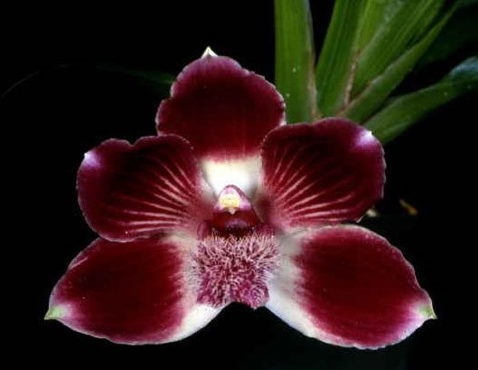
Pescatoria lehmannii ‘Majestic’ AM/AOS, 82 points, 1990
Photography by OWZ Lib
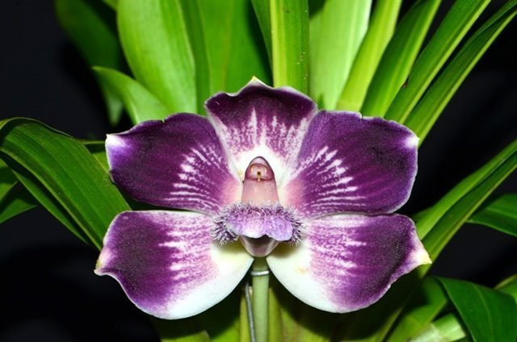
Pescatoria lehmannii ‘Adelaida’ HCC/AOS, 78 points, 2012
Photography by Jauna Carlos Uribe

Pescatoria lehmannii Hybrids

Pescatoria lehmannii has nine F1 generation offspring and sixteen progeny. The first registered hybrids of Pescatoria lehmannii was in 1996. Two additional hybrids were registered in the 1990’s. The other thirteen hybrids were registered since 2000.

The Pescatoria lehmannii hybrid with the most offspring and awards is Wtz. Star Sapphire (Warczatoria Painted Lady x Pescatoria lehmannii). This hybrid was made and registered by Arnold Klehm in 1996. Wtz. Star Sapphire received five AOS awards (AM – 2; and HCC – 3). Warczatoria Star Sapphire has three offspring and five progeny.

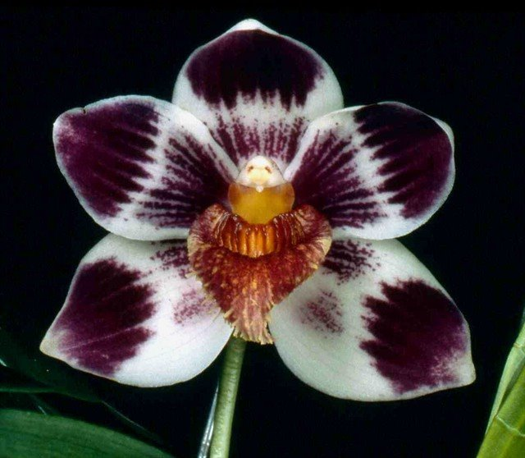
Warczatoria Star Sapphire ‘E. F. G.’ AM/AOS, 82 points, 1998
Photography by James McCulloch

The Pescatoria lehmannii hybrid with the next most is Pescatoria Alice Hikins (lehmannii x coelestis). This hybrid was made by Robert Hamilton and registered by Royale Orchids in 2005. Pescatoria Alice Hipkins has received one AOS awards by clone, ‘San Isidro,’ which received an FCC/AOS of 93 points in 2017.

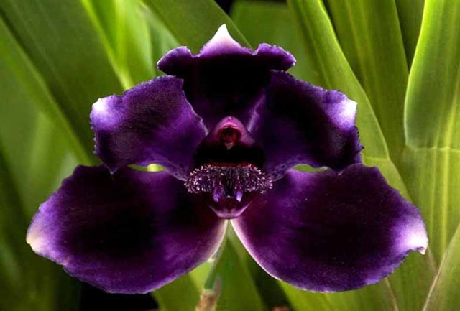

Pescatoria Alice Hipkins ‘San Isidro’ FCC/AOS 93 points, 2017
Photography by Nicolas Gomez Rios
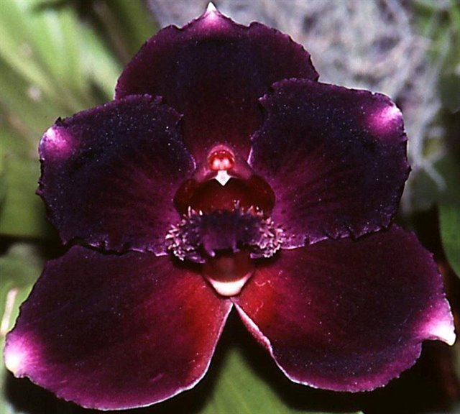
Pescatoria Alice Hipkins ‘Peats Ridge’ AM/AOC 80 points, 2005
Photography by Australian Orchid Council

References

Bernal, R., Gradstein, S.R. & Celis, M. (eds.). 2015. Catálogo de plantas y líquenes de Colombia. Instituto de Ciencias Naturales, Universidad Nacional de Colombia, Bogotá. http://catalogoplantasdecolombia.unal.edu.co.

Diazgranados et al. (2021). Catalogue of plants of Colombia. Useful Plants and Fungi of Colombia project. In prep.

Govaerts, R.H.A. (2011). World checklist of selected plant families published update Facilitated by the Trustees of the Royal Botanic Gardens, Kew.

Internet Orchid Species Encyclopedia http://www.orchidspecies.com/bolcoelestis.htm.

Kew (n.d.). Pesctoria Lehmannii. Royal Botanical Gardens Kew: Plants of the World Online. Retrieved May 24, 2023, from https://powo.science.kew.org/taxon/urn:lsid:ipni.org:names:650351-1.

